Mini Project Report
On

Local Coffee Shop Daily Sales Tracker

Submitted in partial fulfillment of the requirements for the mini-project
By
Amol Sharan – 2500100100075


Under the Supervision of:
Ms. Shaikh Nishat Bano.MS
Assistant Professor, UCER

Department Of Computer Science & Engineering
UNITED COLLEGE OF ENGINEERING AND RESEARCH, PRAYAGRAJ
Session-2026-27

CERTIFICATE
This is to certify that the mini-project report entitled Local Coffee Shop Daily Sales Tracker submitted by Amol Sharan is a record of bona fide work carried out by him under my supervision. This project has been submitted in partial fulfillment of the academic requirements of United Group of Institutions, affiliated with Dr. A.P.J. Abdul Kalam Technical University, Lucknow.

________________________
Ms. Shaikh Nishat Bano.MS
Assistant Professor, UCER

DECLARATION
I hereby declare that the mini-project entitled Local Coffee Shop Daily Sales Tracker submitted to United Group of Institutions is my original work. The data and insights presented in this report have been analyzed and formulated by me, and it has not been submitted previously to any other university or institution for the award of any degree or diploma.

________________________
Amol Sharan - 2500100100075

ABSTRACT
In the era of data-driven decision-making, small businesses like local coffee shops often struggle to extract actionable insights from their daily sales data. This project focuses on performing Exploratory Data Analysis (EDA) on a coffee shop's daily sales dataset using Python. The objective is to clean the raw data, compute descriptive statistics, and generate clear visual insights using libraries such as Pandas, Matplotlib, and Seaborn. Through this process, we identified peak sales trends, highly demanded items, and overall operational efficiency metrics. The automated script developed in this project reduces manual errors and provides a robust foundation for adopting modern data standards in small-scale business operations.

________________________
Ms. Shaikh Nishat Bano.MS
Assistant Professor, UCER

TABLE OF CONTENTS

1.INTRODUCTION 6
2. OBJECTIVES 7
3. METHODOLOGY 8
4. TECHNOLOGY STACK 9
5. IMPLEMENTATION & SOURCE CODE 10
6.FUTURE WORK 12
7. REFERENCE 13
8. CONCLUSION 14
9. RESULTS & VISUALIZATIONS 15

1.INTRODUCTION
In today's highly competitive and digitalized world, data acts as the backbone of any successful business operation. Even small-scale businesses generate a vast amount of data on a daily basis. However, this raw data is often messy and unstructured, making it difficult to comprehend directly. This project revolves around tracking and analyzing the daily sales data of a local coffee shop.
By leveraging the power of Python and robust data visualization tools, we aim to transform raw, disconnected numbers into coherent, easy-to-understand trends. This analytical approach not only helps small businesses comprehend their day-to-day operations but also empowers them to make informed, strategic choices aligned with modern data standards.

2. OBJECTIVES
The primary objectives of this mini-project are as follows:
• Data Cleaning: To preprocess the dataset by removing missing values and formatting the data structures, ensuring it is primed for accurate analysis.
• Descriptive Statistics: To compute core metrics such as total daily sales, moving averages, and the highest-selling items to effectively summarize business performance.
• Visual Insights: To graphically represent sales trends, customer preferences, and popular item categories using intuitive bar charts, line graphs, and boxplots.
• Operational Efficiency: To develop an automated Python script that eliminates the need for manual calculations, thereby preventing human errors and saving valuable operational time.

3. METHODOLOGY
The project follows a structured, step-by-step approach to perform Exploratory Data Analysis (EDA):
Phase 1: Data Loading
• Step 1: The dataset, provided in a CSV format, is imported into the Python environment using the pd.read_csv() command from the Pandas library.
Phase 2: Data Cleaning
• Step 2: The raw data is scrubbed of missing, null, or blank values utilizing the df.dropna() function to maintain data integrity.
• Step 3: The "Date" column is converted into a standard datetime format, enabling chronological sorting and time-series analysis.
Phase 3: Data Aggregation
• Step 4: Grouping functions, specifically groupby(), are applied to aggregate total sales by specific dates and item categories, providing a macro-level view of daily performance.
Phase 4: Visualization
• Step 5: The aggregated data is transformed into visually appealing charts highlighting key trends and outliers in the sales data.

4. TECHNOLOGY STACK
To ensure a smooth and efficient development process, the following technologies and libraries were utilized:
• Programming Language: Python
• Operating Environment: Google Collaboratory (Google Colab).
• Primary Data Libraries: Pandas (for data manipulation), NumPy (for numerical operations).
• Visualization Libraries: Matplotlib, Seaborn (for crafting statistical graphics).

5. IMPLEMENTATION & SOURCE CODE
import pandas as pd
import matplotlib.pyplot as plt
import seaborn as sns

pd.set_option('display.max_columns', None)
pd.set_option('display.width', 1000)
pd.set_option('display.float_format', lambda x: '%.2f' % x)

df = pd.read_csv('index_1.csv')
df1 = pd.read_csv('index_2.csv')

df['time'] = pd.to_datetime(df['datetime']).dt.time
df = df.drop(columns=['datetime'], errors='ignore')

print("--- Dataset Info ---")
print(df.info())

print("\n--- First 5 Rows ---")
print(df.head().to_string())

df['date'] = pd.to_datetime(df['date']).dt.round('s')
df['DayOfWeek'] = df['date'].dt.day_name()

print("\n--- Missing Values ---")
print(df.isnull().sum())
df = df.dropna()

print("\n--- Summary Statistics ---")
print(df.describe(include='number'))

daily_sales = df.groupby('date')['money'].sum().reset_index()
category_sales = df.groupby('coffee_name')['money'].sum().reset_index()

sns.set_theme(style="whitegrid")

plt.figure(figsize=(10, 5))
plt.plot(daily_sales['date'], daily_sales['money'], marker='o', color='b', linestyle='-')
plt.title('Daily Total Sales Trend')
plt.xlabel('Date')
plt.ylabel('Total Sales ($)')
plt.xticks(rotation=45)
plt.tight_layout()
plt.show()

plt.figure(figsize=(10, 5))
sns.barplot(
x='coffee_name',
y='money',
data=category_sales,
palette='viridis',
hue='coffee_name',
legend=False
)
plt.title('Total Sales by Coffee Type')
plt.xlabel('Coffee Name')
plt.ylabel('Total Sales ($)')
plt.xticks(rotation=45)
plt.tight_layout()
plt.show()

plt.figure(figsize=(10, 5))
sns.boxplot(
x='coffee_name',
y='money',
data=df,
palette='Set2',
hue='coffee_name',
legend=False
)
plt.title('Sales Distribution by Coffee Type')
plt.xticks(rotation=45)
plt.tight_layout()
plt.show()

6.FUTURE WORK
While the current system provides a solid foundation for data analysis, there are several avenues for future enhancement:
- GUI Implementation: Developing a Graphical User Interface (GUI) with interactive buttons and dashboards, allowing end-users to operate the tool seamlessly without requiring any programming knowledge.
- Live Database Integration: Migrating from static CSV files to a live SQL database to enable real-time sales tracking and dynamic data updates.
- Sales Forecasting: Integrating machine learning to predict future sales trends, inventory requirements, and customer footfall based on historical data patterns.

7. REFERENCE
1.Kaggle (Yaroslav Isaienkov):
https://www.kaggle.com/datasets/ihelon/coffee-sales
2. IEEE Research Papers:
- Sharma and P. Kumar, "Exploratory Data Analysis and Sales Trend Visualization for Small-Scale Retail Businesses using Python,”.
R. Desai and M. Patel, "Leveraging Pandas and Seaborn for Actionable Insights in E-commerce and Local Retail,".
3.YouTube Learning Resources:
Keith Galli, "Pandas Data Science Tutorial (Analyzing Sales Data) - Real World Project," YouTube. [Online]. Available: https://www.youtube.com/watch?v=eMOA1pPVUc4
Programming with Mosh, "Python for Data Science - Course for Beginners (Learn Pandas, Matplotlib, Seaborn)," YouTube. [Online]. Available: https://www.youtube.com/watch?v=LHBE6Q9XlzI

8. CONCLUSION
This project successfully demonstrates the practical application of Exploratory Data Analysis (EDA) on a real-world local coffee shop dataset. By systematically applying data cleaning, aggregation, and visualization techniques using Python, we successfully transitioned from raw data points to highly useful business insights. The automated nature of this process ensures speed and accuracy, proving that data analytics is not just for large corporations, but is also a reliable, practical, and highly beneficial solution for small businesses striving to track and accelerate their daily growth.

9. RESULTS & VISUALIZATIONS

- Initial Data Inspection & Validation
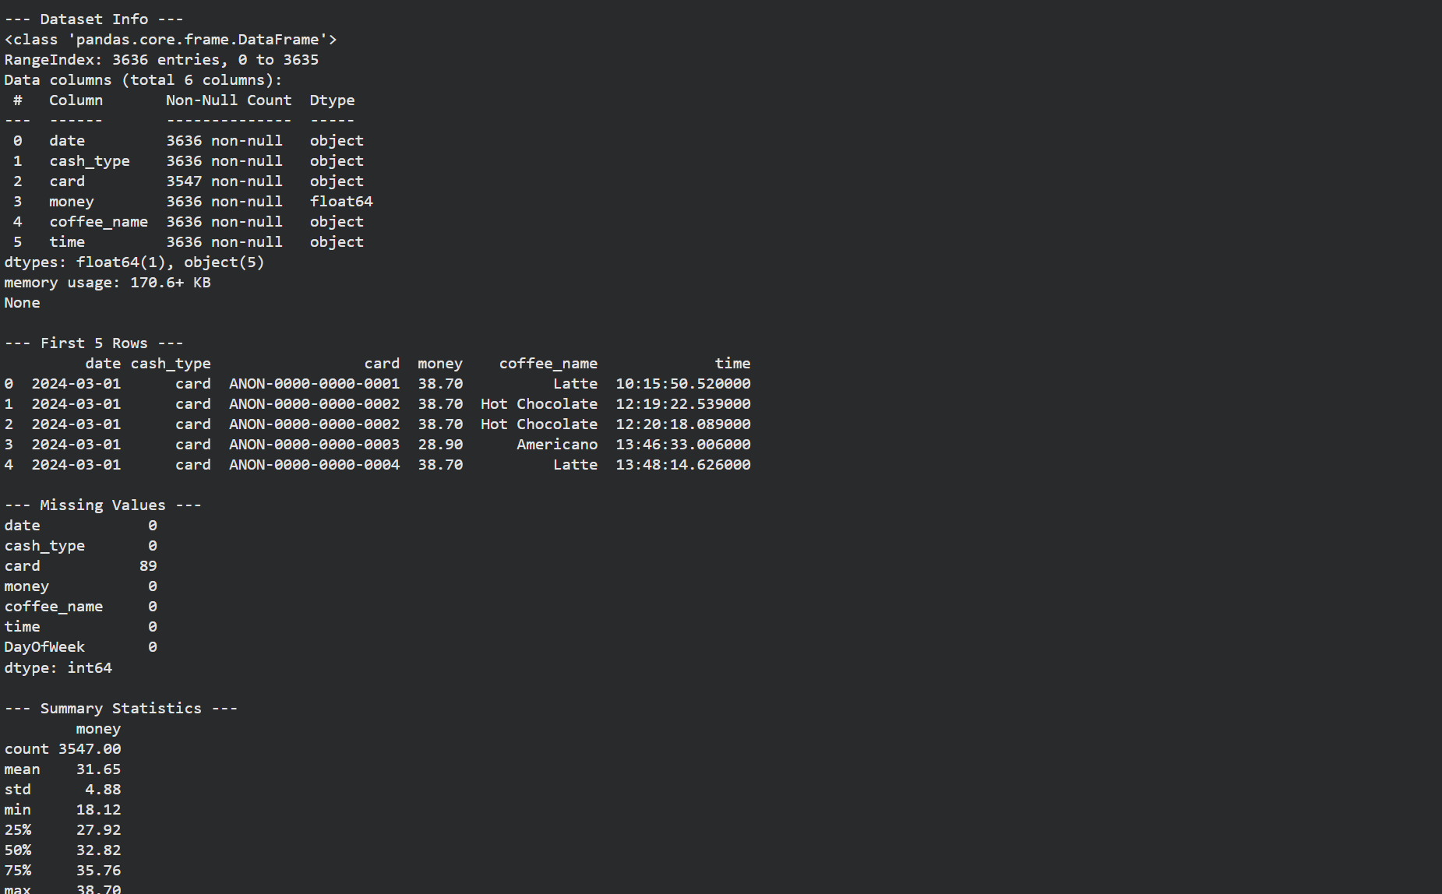
Figure: Console output displaying the initial dataset inspection, including data structure (info), sample records (first 5 rows), missing value counts, and core summary statistics.

- Daily Total Sales Trend
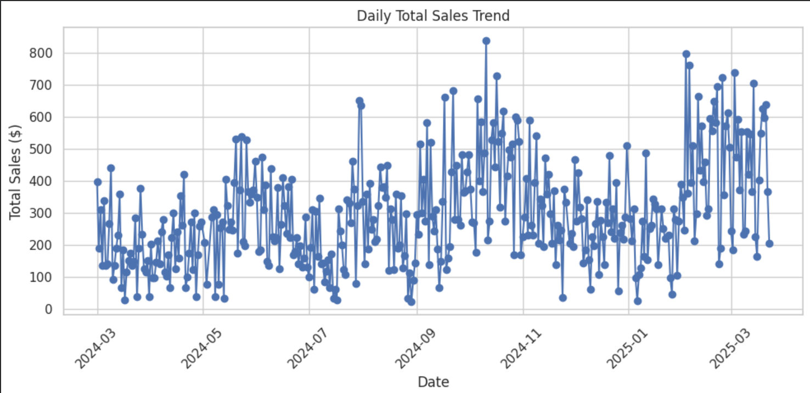
Figure 1: Line chart illustrating the day-to-day total sales revenue, highlighting peak sales days and overall business performance over the given time period

- Total Sales by Coffee Type
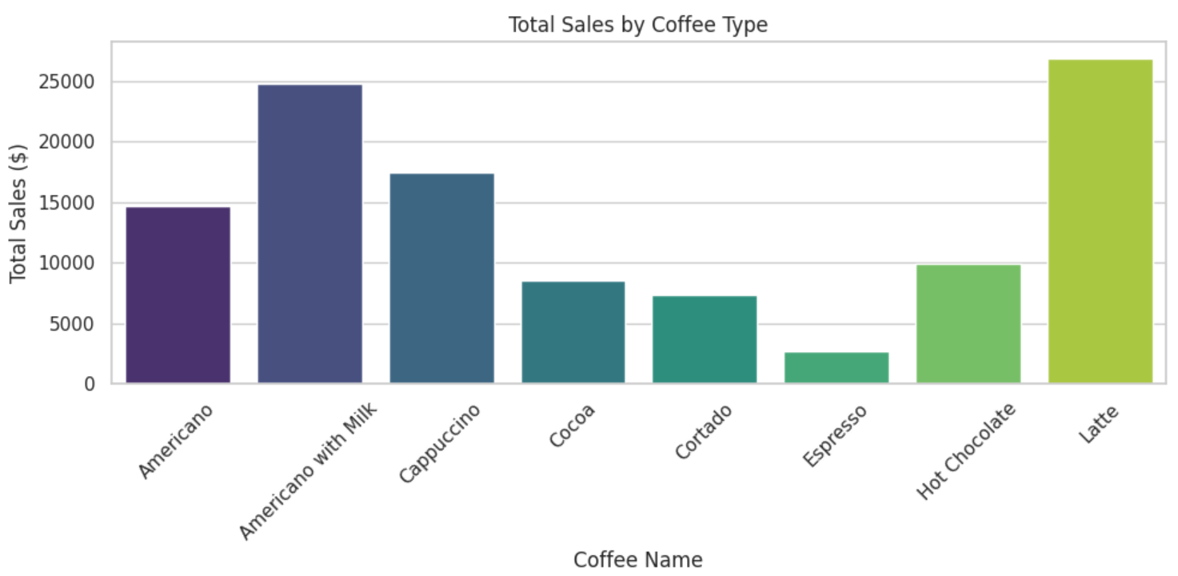
Figure 2:Bar chart displaying the total revenue generated by each coffee category, clearly identifying the most popular and profitable items on the menu.

- Sales Distribution by Coffee Type
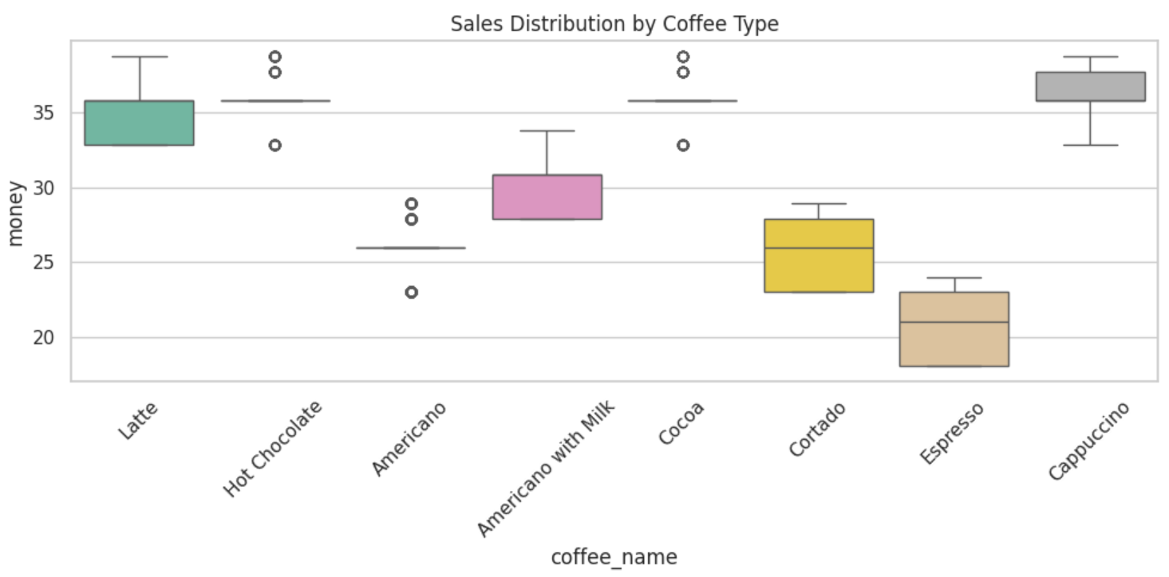
Figure 3:Boxplot representing the distribution and variance of sales across different coffee types, revealing average transaction values and potential sales outliers.

