# AKQA Tech Challenge User Guide

Contents

AKQA Tech Challenge User Guide 1

1. Tools and Technology used in the project. 1

2. Development Setup 1

3. Service Deployment 1

3. Troubleshooting/Known issues: 2

Incorrect API url/port 2

4. High Level Design. 2

4.Sample Result: 2

5. Solution Structure 2

6 Sample Result: 3

## 1. Tools and Technology used in the project.

* Visual Studio 2017
* NET Framework 4.6.1
* Jquery- 3.3.1
* WebAPI 2
* Xunit
* Chrome browser

## 2. Development Setup

* Download or clone repository from Github and open the solution in Visual Studio 2017.
* Press F5 and wait until Client application and WebAPI both are up and running.(Client and WebAPI both projects are setup as Multiple Startups Projects)

## 3. Service Deployment

Service has been deployed on the Azure cloud. However current solution still refers to the locally hosted service url. Please replace local service url in case of any issues with local service like port change etc.

Azure deployed Service url: [**https://testnumberservice.azurewebsites.net/api/number/**](https://testnumberservice.azurewebsites.net/api/number/)

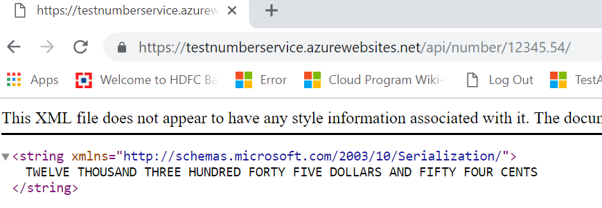

## 3. Troubleshooting/Known issues:

### Incorrect API url/port

Please check VS hosted WebAPI url if it is running on some other port than 55435 <http://localhost:55435/> please replace the url in UI.html page.

1. Replace below line with correct url:

var apiUrl = "http://localhost:55435/api/number/";

1. Or Please replace the url with below url of service which I have deployed on cloud:

**https://testnumberservice.azurewebsites.net/api/number/**

## 4. High Level Design.

WebAPI

http://localhost:55435/api/number/12345.56/

Client

Controller

HttpResponse

HttpGet Method

## 4.Sample Result:

## 5. Solution Structure

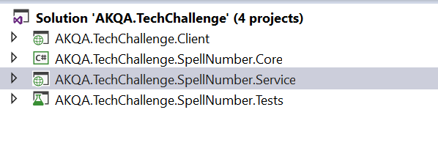

* Client Application: Lightweight UI which utilizes Jquery and consumes WebApi. UI is very basic and has been created to demo the service call using AJAX.
* Core: It is the core part of project which consists of main logic and utilities which is being utilised by service.
* Service: Service has been created using WebAPI 2 which exposes HttpGet method for number to words conversion which is consumed by the client.
* Tests- Test project utilizes xunit and has the test cases for the controller classes.

## 6 Sample Result:

