## Signing and retrieving a X509 certificate from an assembly

### Creating a test X509 certificate:

makecert.exe -r -pe -ss MY -sky exchange -n CN=TestCertAks CodeSign.cer

### Signing:

### Install SignTool.exe if not present. (E.g. Check at C:\Program Files (x86)\Windows Kits\10\bin\x86)

### Command for signing the dll:

### SignTool sign /n TestCertAKS C:\_D\VerifyCalersAuthenticode.dll

Fetch certificate from signed assembly:

Run the console ClientApp and pass the signed dll path as input.

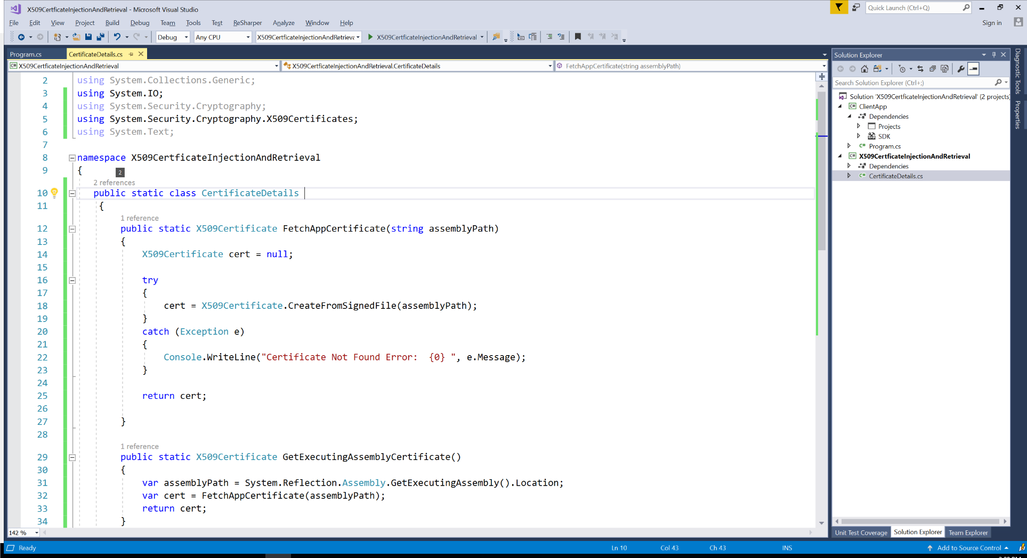

Import certificate:

Provide the certificate file path. (Certificate path can be injected to sensitive constant file.)

