**Assessment Parameters**

* *Solution Completeness (all requirements addressed) – 20 %*
* *Working solution for each requirement – 50 %*
* *Comments – 10%*
* *Coding standards – 20 %*

AirSpace Telecommunication systems wants to provide their customers with an online site for customer registration and for Bill Payment. The mobile numbers and bill amount for these numbers are stored in bills table. When a user registers online his mobile number is used to fetch his pending bill amount from the bills table.Design a webpage for AirSpace.

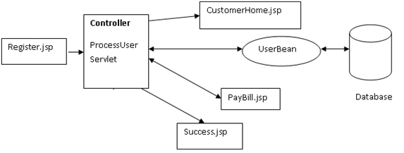

1. **Register.jsp** accepts customer details and invokes **ProcessUser.java(Controller)** servlet.After inserting customer details, it displays **CustomerHome.jsp. (15 marks)**

**Register.jsp**

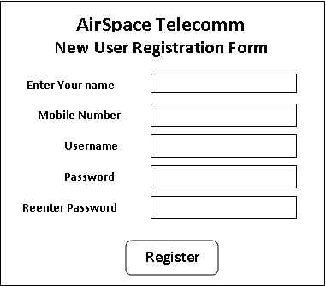

Take Care of the below validations: **(8 marks)**

1. All fields are mandatory
2. Username can contain only characters
3. Password and Reenter Password should contact same data
4. Mobile number should be a ten digit number

While inserting the User Details to the database, generate a random number between 100 to 999 and store that as bill amount for the user in the database**. (5 marks)**

1. The **ProcessUser.java(Controller)** servlet accepts user details from **Register.jsp** and will use **UserBean** and then inserts it to the database . The UserBean is stored in session and the **CustomerHome.jsp** is displayed. **(10 Marks)**
2. The **CustomerHome.jsp** displays the Customer details along with the pending Bill Amount. It has an option to Pay Bill that takes to **PayBill.jsp** **(12 Marks)**

**CustomerHome.jsp**

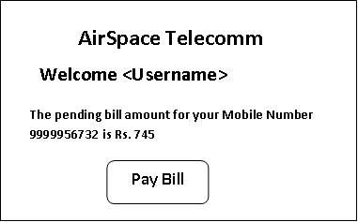

1. **PayBill.jsp** accepts the Amount to pay and upon submission updates the customers bill amount as (Existing Bill Amount)- Amount paid. It then displays the **Success.jsp** page with a message “Thank You for Paying your Bill. Your Balance amount is <(Existing Bill Amount)- Amount paid>”  **(15 Marks)**

**PayBill.jsp**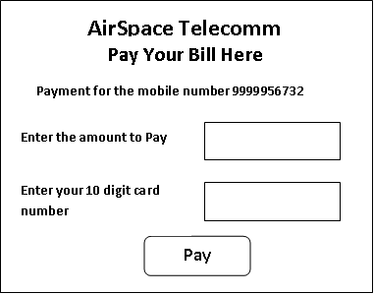

**Part B**

1. Develop a **LoggingFilter** which will create a Log file to store all customer login details with Username, date and time of Login **(5 Marks)**

**Queries for database creation/insertion of records:**

1. create table users(name varchar2(40),username varchar2(40) primary key, password varchar2(15),mobilenumber varchar2(12));
2. create table bills(mobilenumber varchar2(12),billamt number(5));

insert into bills values(‘9876543234’,2345);

insert into bills values(‘9999956732’,745);

insert into bills values(‘9841089540’,399);

insert into bills values(‘9999489540’,1209);