**Assessment Parameters**

* *Complete flow of the application with exception handling -70%*
* *Comments/best practice, coding standards- 10%*
* *Execution of the application (Output) – 20%*
* *Screen Shot should be submitted along with the solution*
* *The solution(Project) created by the trainee should have the name like AppName_Empid Ex:ABCCorp_675467*
* *Code with compilation errors will not be considered for evaluation*

**Problem Statement: ETech Company** needs an application to maintain the time sheet activity. The application should provide the features of maintaining the working hours and activities of the employees. This requirement is focused only for submitting the current week Time sheet.

**Table Script:**

CREATE TABLE Timesheet(employee_code NUMBER(6)PRIMARY KEY, entry_date DATE not null, mon_hrs NUMBER(2) not null, tue_hrs NUMBER(2)not null, wed_hrs NUMBER(2)not null, thur_hrs NUMBER(2)not null, fri_hrs NUMBER(2)not null, sat_hrs NUMBER(2)not null, sun_hrs NUMBER(2)not null,Activity varchar2(100),short_fall VARCHAR(1)not null)

**Architecture: MVC**

Develop a Spring Application that displays a Home page which accepts the Employee id and provide the following links .Employee ID must be 6 digit number and mandatory field

* 1. Add Time sheet for the current week.
  2. View Time sheets

**Functionalities:**

1. **Add Time Sheet for the current week [Marks:42]**

* Time Sheet entry date i.e current date should be displayed in the beginning (Refer screen )
* Activity– Following activities should be displayed in drop down box

Requirement Analysis

Coding

Review

Testing

Others

* Hours for Monday,Tuesday,Wednesday,Thursday,Friday,Saturday,Sunday must be accepted [range 0 – 24]. On successful addition of record total no of hours for that week should be displayed and if the total hours is less than 45 hours short fall message is must be printed. short_fall column must be updated as “Y”[refer table script].All Activities should be concatenated separated with comma and stored in Activity field. If the hour is 0 accordingly comma should be added .Refer sample data.

**All validations must be done with spring validations and not with JavaScript.**

**Screens:**

**Home Page :**

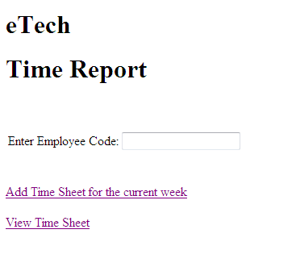

**Time Sheet Entry Page:**

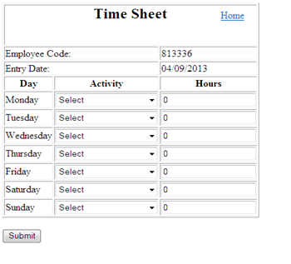

**Sample data in table:**

|  |  |  |  |  |  |  |  |  |  |  |
| --- | --- | --- | --- | --- | --- | --- | --- | --- | --- | --- |
| EmpID | Entry date | Mon hrs | TueHrs | WedHrs | ThuHrs | FriHrs | SatHrs | SunHrs | Activity | Shortfall |
| 879678 | 9/3/2013 | 9 | 0 | 9 | 9 | 9 | 0 | 0 | coding, ,coding,coding,review, , | Y |
| 890788 | 9/3/2013 | 9 | 9 | 9 | 9 | 0 | 0 | 9 | review,coding,coding,coding, , ,coding | N |

* **Mark Distribution:**

|  |  |
| --- | --- |
| Home page design | 2 |
| Emp Id validation | 3 |
| Showing user defined Exception message on JSP(if emp does not exists) | 4 |
| Displaying correct emp Id on time sheet entry page | 2 |
| Time sheet entry page design | 5 |
| Field validations | 6 |
| SQL query and its processing | 8 |
| Inserting proper activities | 6 |
| Calculation of Shortfall | 4 |
| Coding standards/Best practices | 2 |

[Note: Please solve one of the following-2.1 or 2.2]

* 1. **View Time Sheet for short_fall hours(set 2.1) [Marks : 15]**

The following fields must be listed for all the timesheet entries of that particular employee id .

* Timesheet Entry Date
* Total no of hours for that week
* Short fall hours for that week
* **Mark Distribution:**

|  |  |
| --- | --- |
| Page design | 3 |
| SQL query and its processing | 5 |
| Displaying data on JSP | 3 |
| Calculation of total hours | 2 |
| Calculation of Short fall hours | 2 |

* 1. **View Time Sheet for working hours entered for Saturdays/Sundays(set 2.2) [Marks:15]**

The following fields must be listed for all the timesheet entries of that particular employee id.

* Timesheet entry date
* Saturday hours
* Sunday hours
* Total hours worked on Saturday and Sunday.
* **Mark Distribution:**

|  |  |
| --- | --- |
| Page design | 3 |
| SQL query and its processing | 5 |
| Displaying data on JSP | 3 |
| Calculation of total hours | 2 |
| Displaying only those entries where Saturday and Sunday worked | 2 |

**Standards and Application Architecture: [Marks:13]**

* **Mark Distribution:**

|  |  |
| --- | --- |
| Package structure according to coding standard | 2 |
| Service layer and Dao Layer interface created | 3 |
| Creation of User defined Exceptions | 5 |
| Following Naming convention | 3 |

JSP

TimeSheetController

Client

ITimeSheetService

TimeSheetServiceImpl

ITimeSheetDAO

TimeSheetImpl

Database

Spring Controller

Service Layer

DAO Layer

Note:

* Use DAO Support classes for persisting data.
* Use appropriate package structure for each of the applications components.