Assessment Parameters

- Complete flow of the application with exception handling -70%
- Comments/best practice, coding standards- 10%
- Execution of the application (Output) – 20%
- ScreenShot should be submitted along with the solution
- The solution(Project) created by the trainee should have the name like AppName_Empid Ex:ABCCorp_675467
- Code with compilation errors will not be considered for evaluation
__________________________________________________________________________________
Develop an application for the training team in an organization, to manage scheduled session’s and update the session details. The basic requirement of the application will be:
- View Scheduled session. (Session details has to be fetched from database.)
- Update Session details.
Following are the screenshot(s) and descriptions related to the requirement of an application.
Scheduled Sessions Page:
Scheduled sessions page will display the list of scheduled sessions by fetching the available scheduled session details from database. On Executing the application, the ScheduledSessions page is displayed initially as shown below:
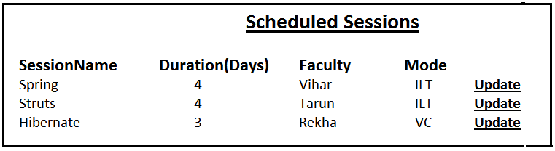
Navigate to UpdateSession page, once “Update” link is clicked.
- Mark Distribution: [Marks: 22 ]
Home Page design | 1
Mapping link to controller class method | 1
Correct class level annotations and autowiring used | 3
Correct Controller class method signature | 1
Correct service and DAO layer method signatures | 1
Correct SQL query and its processing | 8
Correctly displaying data on page | 7

UpdateSession Page:

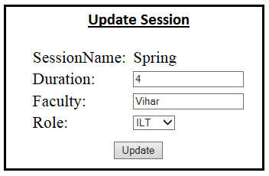
Perform validation for the following:
- All fields are mandatory.
- Faculty Name should accept only alphabets.
- Duration should accept only digits greater than 0 and less than 10
- Role should be populated with list of values such as ILT,VC and WBT.
- Session Name should be a non-editable field.
Use the validation support provided by the spring to implement the above requirement.

After the update button is clicked, update all the details in the database. After updation, display the View Scheduled Sessions page with updated data.

- Mark Distribution: [Marks: 35]
Mapping user actions to controller class methods | 2
Correct method signatures and use of annotations in Controller class method | 2
Update Session Page Design with selected session Name | 10
Field validation using Spring validation framework | 6
Correct service and DAO layer method signatures | 3
Correct SQL query and its processing | 8
Display View Scheduled Sessions page after successful updation of data | 4

Table Script:
CREATE TABLE ScheduledSessions(id NUMBER PRIMARY KEY,name VARCHAR2(20),duration NUMBER,faculty VARCHAR2(30),mode1 VARCHAR2(20));

INSERT INTO ScheduledSessions VALUES(1,'Spring',4,'Vihar','ILT');
INSERT INTO ScheduledSessions VALUES(2,'Struts',4,'Tarun','ITL');
INSERT INTO ScheduledSessions VALUES(3,'Hibernate',3,'Rekha','VC');
COMMIT;

Application Architecture
- Mark Distribution: [Marks:13]
Package structure according to coding standard | 2
Service layer and DAO Layer interfaces created with proper delegation between the layers | 3
Handling User defined Exceptions | 5
Following Naming convention/coding standards | 3

JSP
TrainingController
Client
ITrainingService
TrainingServiceImpl
ITrainingDAO
TrainingDAOImpl
Database
Spring Controller

Service Layer
DAO Layer

Note:
- Use DAO Support classes for persisting data.
- Use appropriate package structure for each of the applications components.

