Assessment Parameters

- Complete flow of the application with exception handling -70%
- Comments/best practice, coding standards - 10%
- Execution of the application (Output) – 20%
- ScreenShot should be submitted along with the solution
- The solution(Project) created by the trainee should have the name like AppName_Empid Ex:ABCCorp_675467
- Code with compilation errors will not be considered for evaluation

Employee Leave Management Application
Problem Statement: An XYZ Company needs an application to maintain their Employee leave Management System. The application should provide the feature to View Leave History. Develop a Spring Application that displays a Home page which provides links to perform the following functionalities to user.

- View Leave History Details.

Table Script:
Create table employee_details (empid number primary key, ename varchar2 (20), address varchar2 (20), leaves_avail number);

INSERT INTO employee_details VALUES (898913,'Tina',’Pune’, 10);
INSERT INTO employee_details VALUES (121212,'Sachin',’Mumbai’, 10);
INSERT INTO employee_details VALUES (755532,'Aasha',’Pune’, 6);
INSERT INTO employee_details VALUES (876421,'Yogesh',’Bangalore’, 13);

CREATE TABLE employee_leave_details (leave_id number primary key, empid number references employee_details (empid), start_date date, end_date date, description varchar2 (50), leaves_applied number);

INSERT INTO employee_leave_details VALUES (1,121212,’8-Sep-2014’,’11-Sep-2014’,’sick ’, 4);
INSERT INTO employee_leave_details VALUES (2,121212,’14-Sep-2014’,’15-Sep-2014’,’Family Function’, 2);
INSERT INTO employee_leave_details VALUES (3,755532,’3-Dec-2016’,’14-Dec-2016’,’Seek Leave’, 12);
INSERT INTO employee_leave_details VALUES (4,876421,’6-Sep-2016’,’6-Sep-2016’,’Function at home’, 1);
INSERT INTO employee_leave_details VALUES (5,876421,’21-Oct-2016’,’23-Oct-2016’,’LOP’, 3);
INSERT INTO employee_leave_details VALUES (6,755532,’4-Apr-2016’,’5-Apr-2016’,’Personal’, 2);
INSERT INTO employee_leave_details VALUES (7,121212,’9-Oct-2014’,’9-Oct-2014’,’Festival’, 1);

Note: Participants are kindly requested to follow the same table structure.

Screen Prototype:[Home Page]

When User Run application first page is Home.jsp

Home.jsp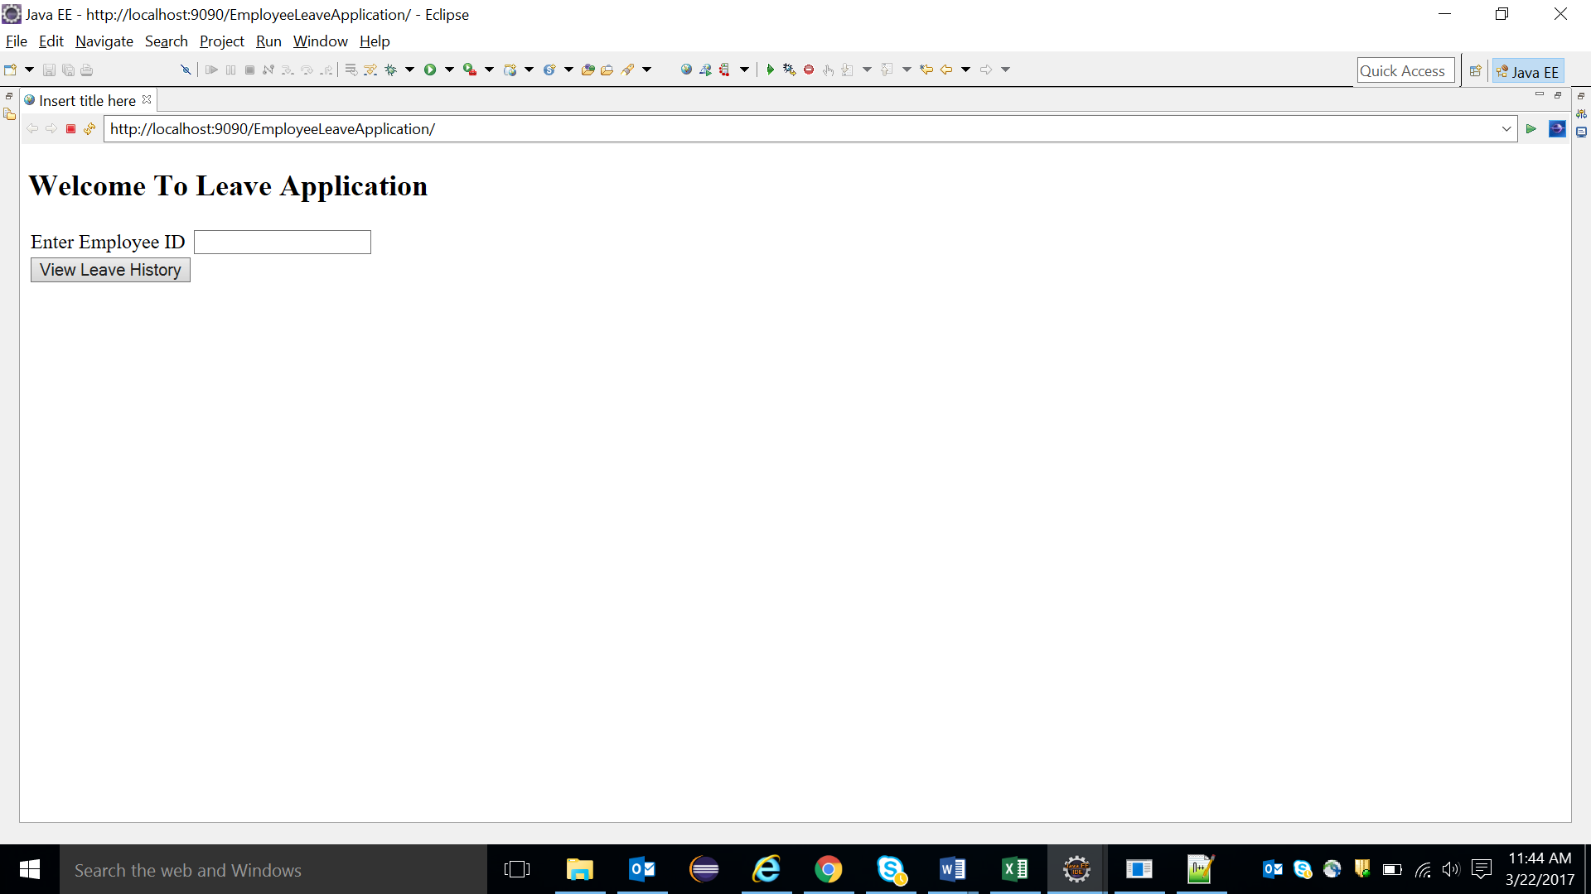

If Employee ID doesn’t exist.then
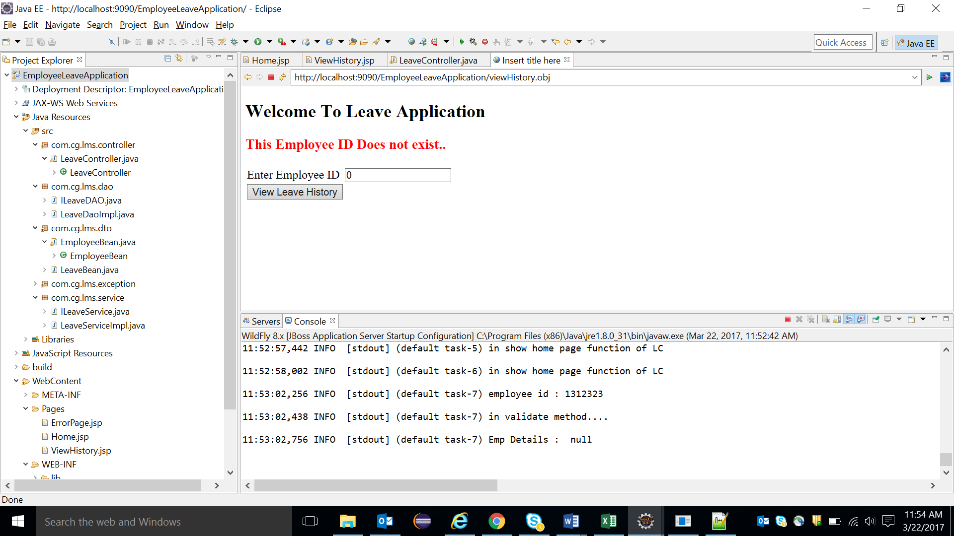

For Valid Employee ID, Application should display all the leave details as follow. (ViewLeaveDetails.jsp)

ViewLeaveDetails.jsp
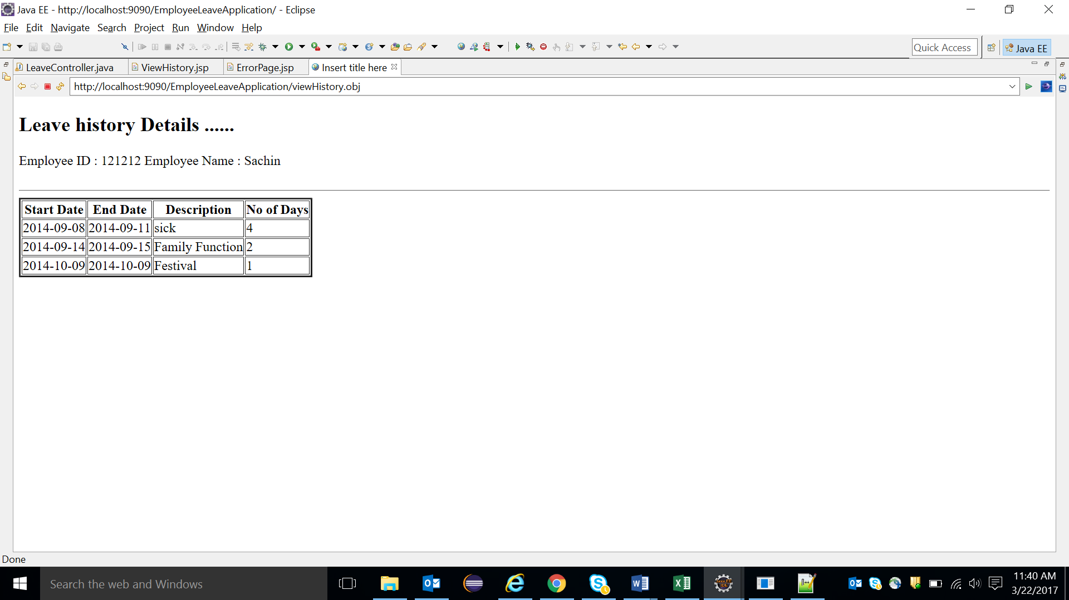
If No leave history details found then Display the message accordingly.

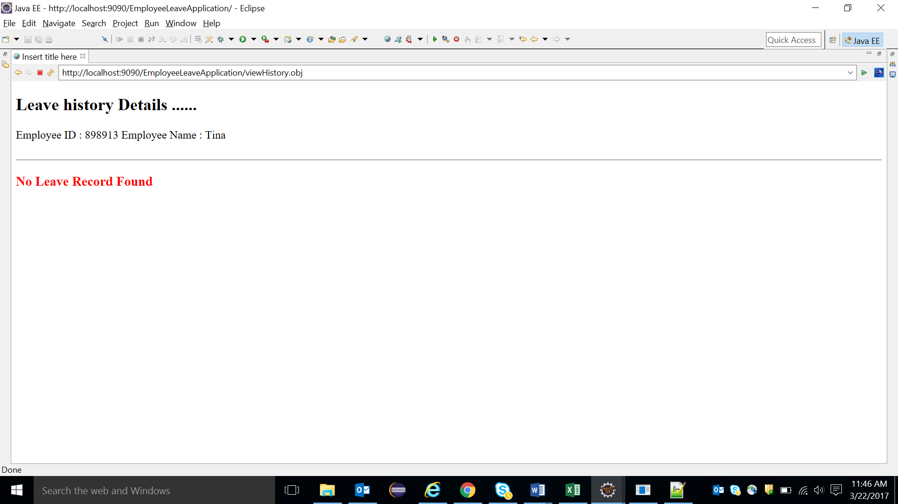

Mark Distribution: [Marks :57]
Home Page Design | 5
Mapping user actions to controller class methods | 5
Correct class level annotations and auto wiring used | 5
Correct method signatures and use of annotations in Controller class method | 5
Display ViewLeaveDetails.jsp page | 10
Field Validations using Spring Validator framework | 10
Correct service and DAO layer method signatures | 2
Correct Spring JPA logic in DAO layer to persist the question in the table | 10
Employee ID Validation and displaying correct error message | 5

JSP
QueryController
Client
IQueryService
QueryServiceImpl
IQueryDAO
QueryDAOImpl
DB
Spring Controller

Service Layer
DAO Layer

Standards and Application Architecture: [Marks: 13]
- Mark Distribution:
Package structure according to coding standard | 2
Service layer and DAO Layer interfaces created with proper delegation between the layers | 3
Exception Handling | 5
Following Naming convention/coding standards | 3

Note:

- Use appropriate package structure

