**ELECTRIC VEHICLE MARKET SEGMENTATION ANALYSIS**

Srivathsa S H

17th November, 2024

GitHub Link: <https://github.com/srivathsa26/EV_market_analysis.git>

***Abstract***

This project analyzes India's electric vehicle market, focusing on segmentation based on sales data, customer reviews, and technical specifications. The study highlights the rapid growth of the two-wheeler market as a key revenue source. By applying the k-means algorithm, the market was segmented into four categories, with Segment 1 being the most significant, representing 39% of consumers. This segment is identified as the ideal target for our strategy, leading to recommendations for electric two-wheeler specifications that align with its preferences. The proposed specifications and price range ensure affordability and competitiveness, positioning our venture effectively within India’s electric vehicle market.

1. **Introduction**

India is experiencing a transportation revolution driven by the growing popularity of Electric Vehicles (EVs) due to rapid urbanization, population growth, and higher incomes. Electric two-wheelers are leading the way as a cost-effective and appealing choice for consumers. This shift is reshaping mobility in India by offering a green solution to pollution and emissions. The government's support through policies promoting local manufacturing and building a robust network of industry players has been crucial. The electric two-wheeler market in India has achieved a major milestone by 2023, highlighting the success of these efforts and the growing acceptance of clean transportation options.

**2.0 Problem Statement and Fermi Estimation**

**2.1 Problem Statement**

The challenge at hand is to strategically position our Electric Vehicle Startup in the Indian market by utilizing data-driven insights derived from sales data, customer reviews (encompassing behavioral and psychographic data), and technical specifications of electric vehicles. Our objective is to employ these insights to effectively segment the market and recommend target segments for our electric vehicles.

**3.0 Data Sources and Collection**

For this project, data was collected from three separate sources. The primary dataset, sourced from the Society of Manufacturers of Electric Vehicles, covers the period from 2017 to 2023 and includes sales data for electric two-wheelers, three-wheelers, four-wheelers, and buses. This dataset offers an extensive overview of market dynamics and consumer preferences over time. The second dataset, obtained from bikewale.com, consists of customer reviews for electric two-wheelers, providing essential behavioral and psychographic insights. These qualitative data were crucial for gaining a deeper understanding of consumer behavior. Finally, the third dataset from bikewale.com includes comprehensive technical specifications and pricing details for electric two-wheelers. This information enabled us to evaluate the technical viability and pricing strategies necessary for our market segmentation approach. By synthesizing these datasets, we developed a thorough understanding of the electric vehicle market. The combination of actual sales data, customer feedback, and technical details formed the basis of our analysis, ensuring a data-driven and market-relevant segmentation strategy.

**4.0 Data Pre-processing**

The data preparation phase of this project involved a systematic approach utilizing Python libraries such as numpy, pandas, matplotlib, seaborn, and nltk. The initial task was to consolidate the sales data, which was initially spread across 10 separate Excel sheets. By leveraging pandas, the data was merged into a unified dataset, laying the foundation for subsequent analysis. A key focus was placed on ensuring the accuracy of electric vehicle manufacturer names through meticulous data cleansing operations.

Following the data consolidation, essential aggregation operations were performed on the electric two-wheeler sales data. This step provided a detailed perspective on market trends. The next phase centered on data preparation for market segmentation. Customer reviews and responses were integrated with corresponding electric vehicle technical specifications. To maintain data integrity, null values were handled using specific logical values, ensuring a complete dataset.

Sentiment analysis of customer reviews was conducted using the natural language processing capabilities of nltk. This analysis provided valuable qualitative insights into customer sentiments. Subsequently, behavioral variables such as Visual Appeal, Reliability, Performance, Service Experience, Extra Features, Comfort, Maintenance Cost, and Value for Money were isolated and carefully prepared. These variables were fundamental in laying the groundwork for the market segmentation analysis, providing a nuanced understanding of customer preferences and attitudes toward electric vehicles.

**5.0 Segment Extraction**

**5.1 Using Sales Data**

In this segment, a detailed analysis was conducted based on three significant figures representing India's electric vehicle market.

**Figure 5.1 India’s electric vehicle market**

Figure 5.1 showcased the remarkable growth trajectory of India's two-wheeler market in 2023, underscoring its leading position within the industry.

**Figure 5.2 India’s electric vehicle industry in crores**

Figure 5.2 delved into the market's financial perspective, representing the industry's total value in crores. Notably, two-wheelers emerged as the primary revenue generators, highlighting their economic significance.

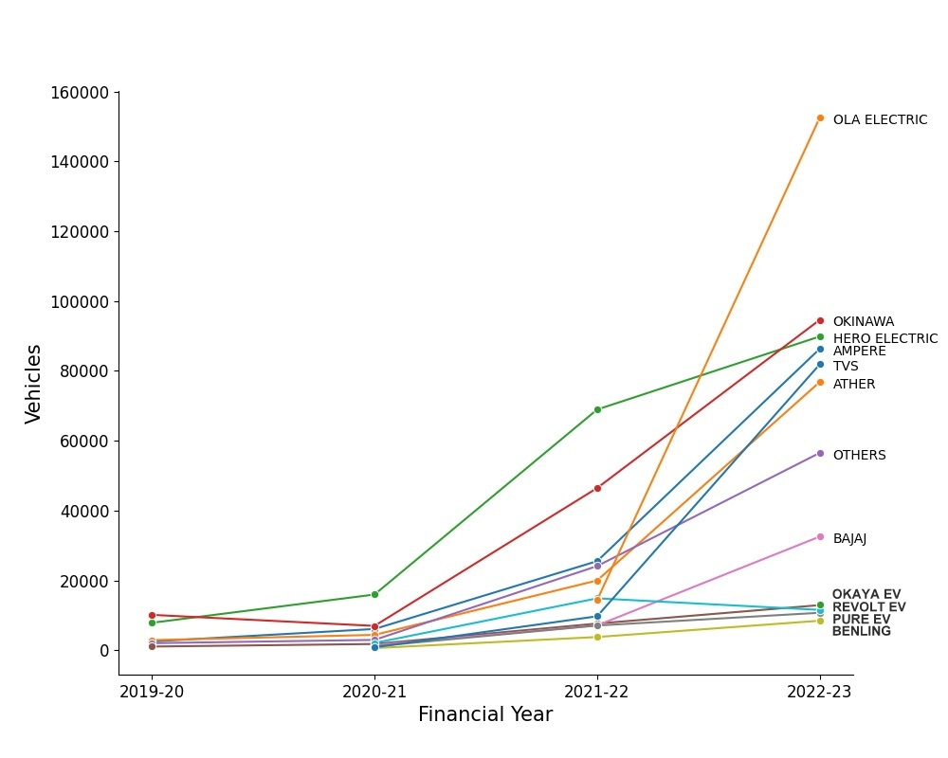

**Figure 5.3 Top electric two-wheeler companies**

In 2023, Ola Electric emerged as the market leader among specific electric two-wheeler companies, showcasing industry leadership and competitiveness. The electric two-wheeler segment was identified as the most promising area for detailed study due to robust growth, revenue dominance, and market leadership. Using the k-means algorithm, market segmentation possibilities within electric two-wheeler customer reviews data were explored. The scree plot Figure 5.4 indicated a distinct elbow at four segments, guiding the decision-making process towards the optimal number of segments for analysis. By incorporating insights from these analyses, focus remained on the electric two-wheeler segment, ensuring precision and relevance in market segmentation.

**Figure 5.4 Scree plot for the electric vehicle data set**

**6.0 Profiling and Describing Segmentation**

**6.1 Profiling Segments**

This section provides a detailed analysis of consumer segments outlined in Figure 6. 1. Segment 0 (15%) values electric two-wheelers for visual appeal, reliability, performance, service, and comfort. Segment 1 (39%) is the largest but least satisfied group. Segment 2 (33%) appreciates visual appeal, reliability, service, comfort, and sees value for money. Segment 3 (13%) values visual appeal, reliability, performance, service, features, and maintenance cost, displaying unique perspectives on features and costs.

**Figure 6.1 Segment profile plot for the four-segment solution**

Figure 6. 2 highlights differences in segments using principal components. Despite Segment 1's size, they lack specific opinions, setting them apart in satisfaction levels. These insights shape our strategy, aligning our electric vehicles with varied values and priorities accurately.

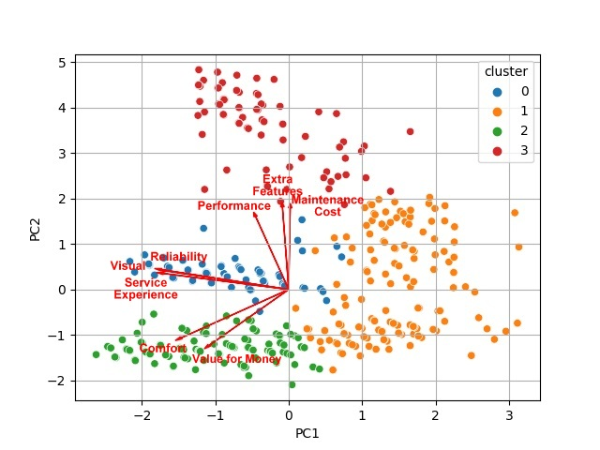

**Figure 6.2 Segment separation plot using principal components 1 and 2**

**7.0 Selection of Target Segment**

Our strategic target segments for the electric vehicle market are Segment 1 and Segment 2, which make up 39% and 33% of consumers, respectively. Segment 1 has diverse perceptions and preferences, presenting opportunities to understand and address their specific demands for improved customer satisfaction and loyalty. Segment 2 values visual appeal, reliability, service experience, and comfort, offering insights for customizing our electric vehicles to cater to their expectations and create resonance within this group. Addressing Segment 1's dissatisfaction points and enhancing Segment 2's positive perceptions will help refine our offerings and ensure a competitive edge. By aligning with the unique needs of these segments, our strategy aims to enhance existing features, address dissatisfaction, and amplify positive elements to drive sustained market growth and customer loyalty.

**8.0 Potential Early Market Customer Base**

In our electric vehicle market strategy, customization is key to targeting Segment 1 and Segment 2. We plan to tailor product features to address specific desires within each segment, focusing on performance and service for Segment 1, and visual appeal and value for money for Segment 2. Diverse offerings cater to varied tastes and budgets.

Price customization involves setting competitive prices, with affordable options for Segment 1 and slightly higher prices for value-added features in Segment 2. Promotions will be tailored to emphasize reliability and service for Segment 1, and aesthetics and affordability for Segment 2. Distribution channels will be established in urban areas for Segment 1 and suburban/semi-urban regions for Segment 2, with a strong online presence for seamless purchasing and customer support.

Training customer service representatives to address segment-specific concerns empathetically is essential for People and Process customization. Efficient processes for customization requests and service appointments enhance customer satisfaction and loyalty. This approach ensures that our electric vehicles meet the distinct needs of Segment 1 and Segment 2, driving market relevance and customer preference.

Segment 1, with 330 members (39% of consumers), and Segment 2, with 277 members (33% of consumers), represent the primary target segments in the early market. Target price ranges have been determined for each segment, guiding potential sales and profits. Segment 1 shows a larger market share and customer base, with a calculated potential profit of ₹39. 60 crores, while Segment 2 has a potential profit of ₹30. 47 crores.

Given the substantial market opportunity within these segments, our focus will be on Segment 1 for early market penetration efforts. The analysis of potential profits underscores the importance of targeted marketing strategies and pricing structures to maximize success in appealing to these key segments.

**9.0 Most Optimal Market Segments**

Thorough analysis identifies Segment 1 as the optimal market for our electric two-wheeler vehicles, with 39% consumer representation. This segment offers significant opportunities and a large customer base, making it strategic for market penetration. Its balance of technical specifications and price range positions it as the most promising market. Table 10. 1 outlines the recommended technical specifications for Segment 1, catering to diverse market needs. This analysis ensures our market entry strategy aligns with Segment 1's demands, setting the stage for a successful venture into the electric vehicle market.

**Table 10.1 Technical specification of electric vehicle two-wheeler for segment 1**

|  |  |
| --- | --- |
| **Specification** | **Recommended Range (in INR)** |
| Price | 70,688 – 1,29,063 |
| Riding range | 89 - 180 km |
| Top speed | 58 - 116 kmph |
| Weight | 76 - 120 kg |
| Battery charging time | 3 - 5 hours |
| Rated power | 1200 - 5500 W |

**10.0 Conclusion**

* After analyzing India's electric vehicle market, we found that Segment 1 is the most promising target, with a 39% consumer base
* By customizing our electric two-wheeler specifications to suit this segment's preferences, we can tap into a significant market opportunity
* This strategic choice is based on a thorough understanding of market segmentation, consumer behavior, and technical requirements, guiding our product development and marketing strategies
* These insights pave the way for a focused market entry, positioning us to succeed in India's dynamic electric vehicle market