Assignment 3

Sri Seshadri

8/5/2018

# Problem 1

Here there are two scenarios that will be inspected using Integer Linear Programming (ILP) to model total cost. Scenario 1 - plant in Baltimore, Scenario 2 - plant in Seattle.

## Scenario 1

### Formulation:

The model is formulated as a network flow model as shown in the figure below, where nodes 1 through 5 are Los Angeles, Baltimore, Atlanta, Tulsa and New York respectively

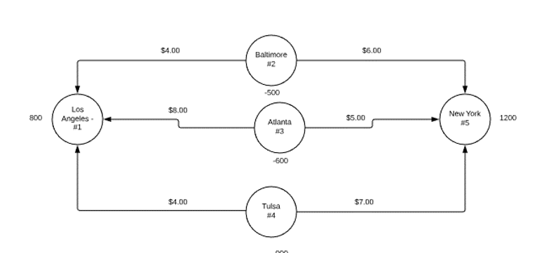

#### Decision variables:

Let $X_{ij}$ be the flow from node $i$ to $j$ where $i∈\{2,3,4\}$ and $j∈\{1,5\}$

$X_{ij}$ are the decision variables.

#### Other variables

Let $C_{ij}$ be the cost variable for distribution of toys between $X_{i}j$ Let $D_{i}$ be the supply at $i$ and $D_{j}$ be the demand at $j$. $D_{i}$ is denoted with a negative number and the $D_{j}$ as positive number for modeling as a network flow problem.

#### Objective function

$Min$ $TotalCost$ = $X_{ij}C_{ij}$

#### Constraints:

Since the supply equals the demand ( $\sum_{i}{D_{i}}$ $+$ $\sum_{j}{D_{j}}=0$), the model will be constrained as $Inflow−Outflow=Supply$ $or$ $Demand$.

The constraints in explicit form are:

$X_{21}+X_{31}+X_{41}−0=D_{1}$ where $D_{1}=800$ $X_{25}+X_{35}+X_{45}−0=D_{5}$ where $D_{5}=1200$

$0−X_{21}−X_{25}=D_{2}$ Where $D_{2}=−500$ $0−X_{31}−X_{35}=D_{3}$ Where $D_{3}=−600$ $0−X_{41}−X_{45}=D_{4}$ Where $D_{2}=−900$

$X_{ij}>=0$ and $X_{ij}$ are integers

### ASME Modeling

Figures 1 and 2 show the model set up in ASPE

Problem 1 ASPE formulation

Problem 1 ASPE formulation

Problem 1 ASPE Model setup

Problem 1 ASPE Model setup

### Scenario 1 Results

The Total cost for a plant in Baltimore was $9900

## Scenario 2

Problem 1 ASPE formulation

Problem 1 ASPE formulation