Basics of a Software
Software
It is collections of programs such as C , C++ , Java, SQL and other programs.
Software basically two categories

Software
System software | Application Software
it interacts with hardware components  Eg: device drivers and operating systems | for the purpose of application development  Eg: C, C++, Java, .Net , ERP package and others

Device driver:
- These are programs to communicate with hardware components
- Every deice device has it’s own drivers.
- Device drivers are supplied by hardware vendors

Eg: printer driver, network drivers.

Operating System:

It is an interface between hardware and application software.
It is a platform where we can run the application software.
Every Operating System has its own libraries to communicate between Application software and Hardware components.

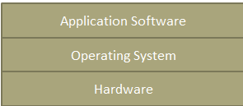

Operating Systems are basically two categories :

Operating Systems
Character user interface ( CUI )  It is command line user interface, where user issues commands |  | Graphical User Interface ( GUI )  Here users working with folder and files ICONS
Single user Operating system | Multiuser Operating systems | Single user Operating system | Multiuser Operating systems
Only user can use this type of operating system  It is a standalone operating system  Files or data cannot be shred | Multiple users can use this operating system.  It is a server. It works in network  amd64/binFiles and data can be shared by multiple clients. | Eg:  Win95, Win98 | Eg:  WinNT, Win2000, WinXP, Win2003, Win7, 8 and 10  LINUX and Solaris
Eg:  MS-DOS ( Microsoft Disk Operating System)  Wired connection 1 | Eg: UNIX, LINUX, SOLARIS,  IBM-AIX, HP-UX  the operating systems LINUX, SOLARIS, IBM-AIX, HP-UX, are flavors of UNIX O/S

LINUX /UNIX

Linux is one of the most popular version of UNIX operating System. It is an open source operating system as its source code is freely available, It can be customized as per the requirements and can also be redistributed in the market . It is free to use. Linux was designed considering UNIX compatibility. It's functionality is quite similar to that of UNIX.

Features of Linux Operating System:

1) Multi-User
Linux is a multiuser operating system, which means multiple users can share the system resources at same time, such as memory (Hard Disk ), ram , application programs, Database and files

2) Multiprogramming ( Tasking )

Linux is a multiprogramming system means multiple applications can run at same time.
It provides facility to run multiple jobs at a time.

3) Open Source

Linux source code is freely available. It can be customized as per the requirements and can also be redistributed in the market.

4)Security

Linux provides user security using authentication features like password protection/ controlled access to specific files/ encryption of data.

5) Portable -

Portability means software can works on different types of hardware in same way. Linux kernel and application programs supports their installation on any kind of hardware platform.

6) Programming

Linux provides a Shell which can be used to execute commands of the operating system.
Shell works like a programming language. It can be used to do various types of operations, call application programs etc.

7) User friendly :
It provides CUI as GUI

LINUX/UNIX Architecture :

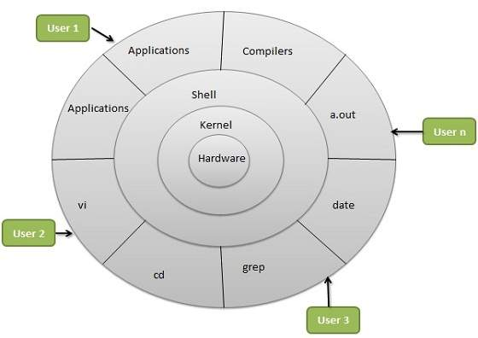

Linux System Architecture is consists of following layers

Hardware layer -
Hardware consists of all peripheral devices (RAM/ HDD/ CPU and etc).

Shell -
It is an interface between user and kernel.

Takes commands from user and interprets then passes to kernel.

It is an interpreter; it interprets the commands and passes to kernel.

All the command are executed by kernel functions.

Difference between compiler and interpreter:

S.no | Interpreter | Compiler
1 | It interprets line by line and executes | Whole program at a time
2 | It gives the result line by line | It gives whole output at a time
3 | If any error occurs interpreter stops  Hence it shows only one error | It checks all statements in the program and shows all the errors in the program.
4 | It will not generate executable file | If no errors in the program then it generates executable file
5 | It always executes only source code | It executes exe file
6 | Eg: all scripting languages such as HTML, PERL, Java Script, Linux Shell scripting | All programming languages.  Eg: C, C++ and .Net C#

Java is depends on both, compiler as well as interpreter

Kernel -
Core component of Operating System, interacts directly with hardware, provides low level services ( functions ) to upper layer components.

Kernel contains two layers
1) Device Drivers and 2) Libraries

Device Drivers interacts with Hardware Components
Libraries communicates with Application software.

Utilities -
Utility programs ( Commands ) giving user most of the functionalities of an operating systems.

Linux Distributions

1. Ubuntu

Ubuntu has become the poster child for Linux these days,

Ubuntu is actually a relatively late arrival on the Linux scene, having been announced in just 2004, but it's more than made up for that shorter history. Founded by South African millionaire Mark Shuttleworth, Canonical--the company behind Ubuntu--for many years shipped Ubuntu CDs to interested users for free, thus speeding its market penetration.

2.Linux Mint
Mint is a Linux distribution built on top of Ubuntu. It uses Ubuntu’s software repositories, so the same packages are available on both. Originally, Mint was an alternative distribution loved mainly because it included media codecs and proprietary software that Ubuntu didn’t include by default.

This distribution now has its own identity. You won’t find Ubuntu’s own Unity desktop here — instead, you get a more traditional Cinnamon or MATE desktop

3.Red Hat Enterprise Linux

Red Hat Enterprise Linux is a commercial Linux distribution intended for servers and workstations. It’s based on the open-source Fedora project, but is designed to be a stable platform with long-term support.

4. Fedora

Fedora is the free version of Red Hat, whose RHEL (Red Hat Enterprise Linux) has been a commercial product since 2003. Because of that close connection, Fedora is particularly strong on enterprise features, and it often offers them before RHEL does.

5.Debian

Debian is an operating system composed only of free, open-source software. The Debian project has been operating since 1993 — over 20 years ago! This widely respected project is still releasing new versions of Debian, but it’s known for moving much more slowly than distributions like Ubuntu or Linux Mint. This can make it more stable and conservative, which is ideal for some systems.

6.CentOS

CentOS is a community project that takes the Red Hat Enterprise Linux code, removes all Red Hat’s trademarks, and makes it available for free use and distribution. It’s a free version of RHEL, so it’s good if you want a stable platform that will be supported for a long time. CentOS and Red Hat recently announced they’re collaborating, so CentOS is now part of Red Hat itself.

7.SUSE Linux Enterprise

OpenSUSE is a community-created Linux distribution sponsored by Novell. Novell purchased SUSE Linux in 2003, and they still create an enterprise Linux project known as SUSE Linux Enterprise. Where Red Hat has the Fedora project that feeds into Red Hat Enterprise Linux, Novell has the openSUSE project that feeds into SUSE Linux Enterprise.

Linux File System

In the Linux everything is a file.

There are three types of files in Linux :

1) Ordinary file :
also called as regular file. It contains data

These are be divided into two types

1) Text files and 2) binary files

2) Directory:

This is similar to folder. It contains directories and sub directories

3) Device Files:

These are used with Hardware components. Every device has file to communicate with it.

Login into Linux:

userid: demo
password: ******

# --> command prompt for root user ( admin )

$ --> command prompt for standard user

Creation of new user

step1:
system settings --> user accounts --> unlock --> provide password ( admin passwrod ) --> authenticate -->

step2:

- ( minus ) --> to delete existing user

+ ( plus ) --> to add the new user

step3:
adding user --> account type : admin user
full name : sample
user name :sample

click on add button

step4:
go to terminal and set the password

$sudo passwd <user_name>

eg:
$sudo passwd sample

login as new user:

$ ls -l

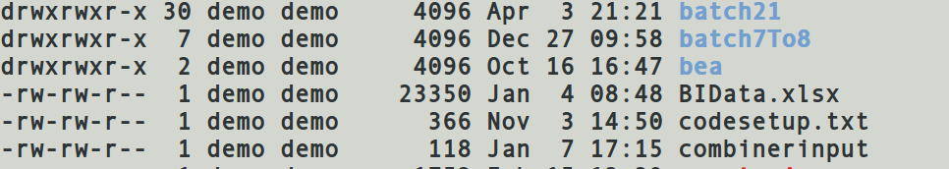

here first character denotes type of file.

Eg:

d ==> directory

- ==> Regular file ( Text / Binary )

l ==> Link file ( like short cut in windows )

c ==> Character special file.

b ==> block special files.

s ==> socket files.

Linux file system is like a tree structure.

It starts with / ( root ). it is like a root of tree.

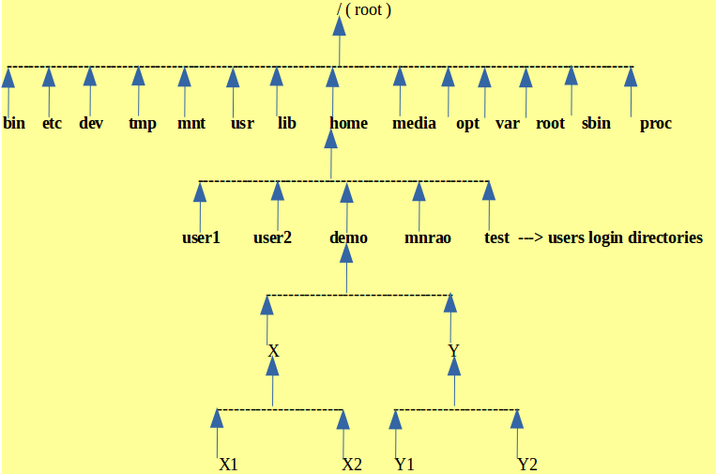

/ ( root ) --> top most directory of linux of file system

/bin --> bin stands for binary, it is a directory. It contains all binary files of linux OS ( Linux Commands )

/etc --> etc is directory. It contains all system files.

/dev --> dev stands for device, it is a directory. It contains all device files ( drivers )

/tmp --> tmp stands for temporary, it is a directory. It contains all temporary files. These files will be
deleted automatically when system is shutdown.

/mnt --> mnt stands mount, it is a directory. This is to mount devices such CD, PEN Drive, printer etc

/usr --> usr stands for user, it is a directory. It is a default directory for all user softwares

/lib --> lib stands for library, it is a directory. It is contains linux OS libraries
every software contains two directories
1) bin 2) lib

bin --> contains commands of that software.
lib --> contains libraries of that software

/home --> it is directory, it contains all user login directories.

/media --> it contains meadia files such as vedios, audio etc

/opt --> opt stands for optional. Contents this directory is an optional ( it can be empty )

/var -->var stands for variable, it is a directory. Its contents varies form user to user.

/root --> system admin login directory

/sbin --> sbin stands for secondary bin, it contains all secondary binary files .
bin --> contains old version commands
sbin --> contains recent version commands.

/proc --> proc stands for process. It contains all directories related to current running jobs.

Login as user :

userid: demo
password: ******

# --> command prompt for root user ( admin )

$ --> command prompt for standard user

Current login user

$logname
demo

$ whoami
demo

difference between logname and whoami

logname --> gives login user name

whoami --> gives current working user.

Eg:
Login as user :
userid: demo
password: ******

$logname
demo

$su test --> switching to other user test

$logname
demo

$whoami
test

all current login users
$ users
demo mnrao test

all current login users including time of login
$who

nrit :0 2016-04-28 08:35 (:0)
demo :1 2016-04-28 08:38 (:1)
mnrao :2 2016-04-28 09:20 (:2)

$last --> it shows recent login history

$ clear --> to clear the screen

(or)

ctrl + l --> short cut to clear the screen

$exit --> to quit from the current session

Help in linux:
$man <command_name>

eg:

$man ls

$man uname

$man date

q --> is to quit from manual page

current O/s
$ uname
Linux

more info about current O/s
$ uname -a

$uname --version

$ hostname
hadoop

ls --> Displaying list of file

different options

$ls --> list of files

$ls | more --> paging option ( line by line )

$ls |pg --> page wise

$ls -l

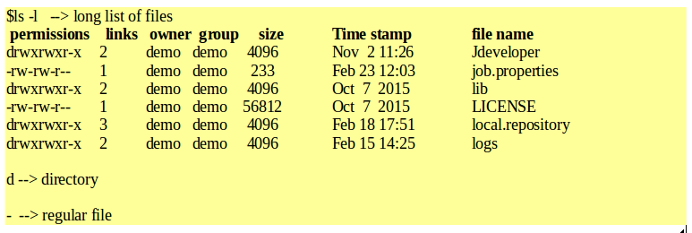

$ls -a --> to display all files including hidden file like . And .. files

$ls -f --> disabling colour

$ls -F --> to display all files including exe files marked with “*”

$ls -i --> to display including i-node of the file

i-node is a address of a location, where file attributes are stored
file attributes can see by using ls -l

$ls -r --> to display in reverse order ( z- a )

$ls -R --> including sub directories recursively

$ls -t --> displaying based on date and time of creation.

$ls -lrt --> combined options

$ls -s --> no.of blocks used by the file ( size )

size of each block is 4kb.

$ls -x --> multiple columns output ( default ) instead of single column output.

Date Command :

$date ---> It shows system date.

Date different options:

$date +%D ----> date; same as %m/%d/%y

$date +%T --> time HH:MM:SS

$date +%d --> day

$date +%m --> month

$date +%y --> year ( yy)

$date +%Y --> year ( YYYY )

$date +%H --> hours

$date +%M --> min

$date +%S --> sec

$man date --> for more options .

$date "+%Y-%m-%d %H:%M:%S"
2017-12-15 10:59:40

Calendar Command:

$cal --> current month calendar

$cal 2016 --> complete year calendar.

$cal 10 2016 --> oct month of 2016

$cal 2000 ---> 2000 year calendar

$cal 10 --> 10th year calendar

$cal 1 --> 1st year calendar

$cal 9000 --> 9000 year calendar

$cal 10000

cal: year `10000' not in range 1..9999

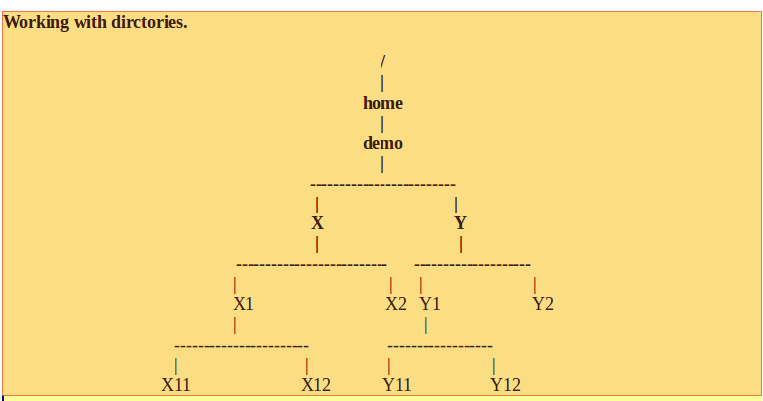

$pwd
/home/demo

creation of directories :

$mkdir <dir_name>

$mkdir x y

$ ls

x y

Changing ino directory:

$cd <dir_name>

$cd x

$pwd
/home/demo/x

$mkdir x1 x2

$ ls

x1 x2

$cd x1

$pwd
/home/demo/x/x1

$mkdir x11 x12

$cd .. --> to go to parent directory

$cd . . / . . / . . / --> to go to three levels up

$cd / --> to go to top most / ( root ) location

$cd ---> to go to user home directory ( user login dir or initial directory )

$cd - Brings you to your previous directory of the current directory.

$pwd
/home/demo

$ls x --> it shows contents of x directory

$ ls -R x --> it shows tree structure .

x:
x1 x2

x/x1:
x11 x12

x/x1/x11:

x/x1/x12:

x/x2:

$ls -R y

y:
y1 y2

y/y1:
y11 y12

y/y1/y11:

y/y1/y12:

y/y2:

Renaming a directory:
$mv <old_name><new_name>
eg:
$mv x z

$mv z x

Deleting a directory:
$rmdir <dir_name> --> to delete a directory it should be empty.

Eg:
$rmdir x

Absolute path and Relative Path :

Absolute Path :
It is a path from /(root) to destination directory.

Relative Path :
It is a path from current working directory to destination directory.

For eg1:
$pwd
/home/demo/x/x1/x11

Requirement :
to change into Y2 directory

$cd /home/demo/y/y2 ----> Absolute Path

check it.
$pwd
/home/demo/y/y2

eg2:
$pwd
/home/demo/x/x1/x11

Requirement :
to change into Y2 direcory

$cd . . / . . /. ./y/y2 -----> Relative path

check it.
$pwd
/home/demo/y/y2

eg:
$pwd
/home/demo/y/y2

to change into x11

$cd /home/demo/x/x1/x11 ---> Absolute Path

check it.
$pwd
/home/demo/x/x1/x11

eg:
$pwd
/home/demo/y/y2

$cd . . / . . /x/x1/x11 ------> Relative Path

check it.
$pwd
/home/demo/x/x1/x11

eg:
$pwd
/home/demo/x/x1/x11

requirement :
to create y21 in a Y2 directory from current working directory with out changing into Y2 location

$mkdir /home/demo/y/y2/y21 ---> Absolute Path

$mkdir . ./ . . / . . /y/y2/y21 ----> Relative Path

eg:
$pwd
/home/demo/x/x1/x11

Requirement:
to see the contents of Y2 dir from current working directory .

$ls /home/demo/y/y2 --> Absolute Path

$ls . . / . . / . . /y/y2 ----> Relative path

Creating multiple directories using path:

$pwd
/home/demo

$mkdir x y x/x1 x/x2 x/x1/x11 x/x1/x12 y/y1 y/y2 y/y1/y11 y/y1/y12

$ls -R x y

x:
x1 x2

x/x1:
x11 x12

x/x1/x11:

x/x1/x12:

x/x2:

y:
y1 y2

y/y1:
y11 y12

y/y1/y11:

y/y1/y12:

y/y2:

Removing multiple directories using path

$rmdir x/x1/x11 x/x1/x12 x/x1 x/x2 x y/y1/y11 y/y1/y12 y/y1 y/y2 y

Deleting directory including sub directories

$rm -r <dir_name>

$rm -rf <dir_name> → remove directory forcefully

$rm -r x

Creating directory including path

$mkdir –p x/x1/x11

-p → to create entire path
Working with files:

File operations
1) creating a file
2) Displaying file
3) Copying files
4) comparison of files
4) renaming files
6) deleting file

creation of a file:

$cat > file_name

eg:
$cat > file1
dfd sfj dfsdf fdfsd d fasdf js
d ad sdfj df df df fd fdf d sd jf df sdf aj
kd k fk fsdkfd assd da df df dffd f f
ctrl + d ---> to make end of creation and save the file

displaying file data :

$cat < file_name

eg:
$cat < file1 (or) $ cat file1 --> in displaying < is an optional

dfd sfj dfsdf fdfsd d fasdf js
d ad sdfj df df df fd fdf d sd jf df sdf aj
kd k fk fsdkfd assd da df df dffd f f

$cat file1 file2 file3 file4 --> to display multiple files

cat command for concatenation of multiple file and display

cat is the word derived from concatenation

touch --> to create empty files

$touch filex filey filez

creation of hidden files:

$touch .filexx .fileyy

$cat > .file11

$cat >.file22

$gedit .file1

$vi .file2

Creation of a hidden direcotries

$mkdir .a .b

to check it:
$ls -a

Copying files :

$ cp <source_file><destination_file>

$cp file1 file2

in copying, if file already exist, then it overwrites
if not exist it creates new file

$cp -i file1 file2
overwrite file2 ?

-i --> to get confirmation from the user in-order to overwrite on existing file

Comparison of files:

$cmp file1 file2 --> It shows first difference between the files

$diff file1 file2 ---> It shows all the differences between two files

renaming files :

$mv <old_name ><new_name>

$mv file1 filexx

if new_name already then it overwrites.

$mv -i file1 filexx
overwrite filexx ?

Removing files :

$rm <file_name>

eg:

$rm filex filey ---> multiple files can be deleted

$rm -i filex filey filez
remove filex ?
remove filey ?
remove filez ?

Creation of link files:

There are two types link files
- Hard link files
- Soft link files

Hard link file:
It point to original data file

$ln <original_file> <link_file>

Eg:
$ln file1 file11

file11 is a link file on file1

all attributes of file1 copies to file11

When Hard link file created no of links will increase by 1 on file1

here file1 and file11 works with same data

even original file “file1” deleted it won’t effect on file11.

When file deleted link counter decrement by 1.

Only name (file1 ) removes from entry but data will not be deleted.

once link counter reduces to 0 then data will delete

Soft link File:

Soft link is like a short cut in windows

It is a link to original file

Syntax

$ln -s <original_file> <link_file>

$ln -s file1 filex

Here “filex” is a link on file1

When soft link file created no of links will not be increased on file1

$ls –l file1

-rw-rw-r-- 1 demo demo 204 Jan 8 17:26 file1

Here 1 →no of links

When original file deleted link file will not work.

copying files between directories from one location to another location.

Eg: following structure :

Requirement:

Ccopying “file1 “ from x11 directory to “y2” directory

using absolute path ( it works for any present working directory ):

$cp /home/demo/x/x1/x11/file1 /home/demo/y/y2

using Relative path :
eg1:
$pwd
/home/demo

$cp x/x1/x11/file1 y/y2

eg2: from current working directory to “y2” directory

$pwd
/home/demo/x/x1/x11
$cp ./file1 /home/demo/y/y2
(or)
$cp ./file1 . . /. . / . . /y/y2

here . / --> represents current working directory.

$pwd
/home/demo/y/y2

copying file1 from “/home/demo/x/x1/x11” to current Workig directory

$cp /home/demo/x/x1/x11/file1 ./
(or)
$cp /home/demo/x/x1/x11/file1 .

moving file from one location to another location:

use same path concept:

using absolute path ( it works for any present working directory ):

$mv /home/demo/x/x1/x11/file1 /home/demo/y/y2

using Relative path :
eg1:
$pwd
/home/demo

$mv x/x1/x11/file1 y/y2

eg2: from current working directory to “y2” directory
$pwd
/home/demo/x/x1/x11
$mv ./file1 /home/demo/y/y2
(or)
$mv ./file1 . . /. . / . . /y/y2

similarly copying and moving directories

$cp -R <source_path><destination_path>

$mv -R <source_path><destination_path>

-R --> including sub directories recursively

file Command:

$file <file_name>

Eg:

$file file1
ASCII text

$file x
X is a dir

$file filexx
filexx: symbolic link to file1

Wildcards characters (or) pattern matching characters:

* ---> zero or more no. of chars
? ---> only single char
[] ---> range of characters
{} --> list of files with comma ( , ) separation.

$ls f* --> all files starting with f

$ls *e --> all files ending with e

$ls ????* --> all files with at least 4 chars and followed by any chars.

$ls f????* --> files with at least 5 chars and followed by any no. of chars

$ls file* ---> starting with name “file”

$ls file[1-9] --> files ranging from 1 to 9

file1 file2 file3 file4 file5 file6 file7 file8 file9

$ls file[3-5]
file3 file4 file5

$ls file[!3-5]

file1 file2 file4 file6 file7 file8 file9

$ls file[a-z]

$ls file[g-m]

$ls file[!d-k]

$ls file[!a-z]

$ls {*.sh, *.txt}

$ls {f*,t*}

$ls {file[2-4],file[a-d],*.c,*.txt}

same characters can also be used with following commands :

cp, rm, mv

Editing file data :

$gedit <filename> (or) $vi <file_path>

eg:

$gedit file1
1
Using path:

$gedit /home/demo/file1

(or)

$gedit /home/demo/x/x1/file1

/home/demo --> user home directory, it can be represent with tilde ( ~ )

$gedit ~/file1
$gedit ~/x/x1/file1

Word Count Command :

to count no. of lines, words and chars

$ wc file1
6 24 114 file1

here 6 --> lines, 24 --> words and 114 --> chars

multiple files :

$wc file1 file2 file3 file4
5 14 122 file1
4 10 95 file2
6 31 167 file3
2 5 44 file4
17 60 428 total

wc options :

$wc -l <file_name> --> lines only

-l --> lines only
-w --> words only
-c --> chars only
-lw --> lines and words
-lc --> lines and chars
-wc --> words and chars

Working with vi-editor

$vi <file_name>

$vi file1

if file is a new file, it will create
if file is already exist then editor opens the file for editing

$vi file1
jsf sdjf sdfhsdhf
sdfl sadkf asdkjfkasdjf
asdf kasdjf asdkfjasdkjf
asd fjasdf aksdjfkasdjfk
asdlkf jasdlkfjaskddjfjkasdjd
~
~
~
~
~
~
~
~
~
~
"file1" 5 lines, 122 characters

How to edit the file:

there are three types modes in file editing

1) command mode ( default )
in this mode we can execute editor commands

to get into command mode press <esc key >

2) input mode
in this mode we can modify the file data
again to get into command mode press <esc key >

3) exit mode
to quit from the editor
first press <esc key >get into command and then :
( hold shift key and : )

jsf sdjf sdfhsdhf
sdfl sadkf asdkjfkasdjf
asdf kasdjf asdkfjasdkjf
asd fjasdf aksdjfkasdjfk
asdlkf jasdlkfjaskddjfjkasdjd
~
~
~
~
~
~
~
~
~
: --> exit mode

1) command mode:

Commands to modify the file data

A --> to append the data at the end of the line
a --> to append the data to the right of the cursor position
I --> to insert the data at the beginning of the file
i --> to insert the data to the left of the cursor position.

Opening lines:
O --> to open a line above the cursor position
o --> to open a line below the cursor position

Replacing data :

S --> replacing current line
R -->replacing from current position
r --> replacing a character

Copying data:

yy --> yanking ( copying a line )
3yy --> to copy 3 lines
yw --> to copy a word
3yw --> to copy 3 words
p --> to paste copied data

Deletion of data:

x --> to delete a single char
dw --> to delete a word
dd --> to delete current line
2dd --> to delete two lines from current position
3dd --> to delete three lines from current position
cc --> to clear a data in the line but not removes line

u--> undo the previous transaction

Cursor Navigation (how to go to particular line)

b --> back to beginning of word
w --> forward to beginning of next word
e --> end of current word
at exit mode
: 1 --> to go to first line
: 10 --> to go to 10th line

G --> move to end of the file

ctrl + f --> one page forward ( page down )
ctrl + b --> one page backward ( page up )

Saving and quitting:

at exit mode
:w --> save file data
:q --> quit from the editor
:wq --> to save and quit from the editor
:q --> some time quit with out saving
:q! --> force quit
:set nu --> to set line numbers in the editor
:!<linux_command> --> to execute linux command
eg:
:! date --> to check system date.
:! ls

nano editor:

it is a text editor used to create new file and also used to modify the file data

$nano file1

Ctrl + o → to save the file
Ctrl + x → to quit from the editor

Steps to develop C-Program in linux

Step1 :
Writing program

$gedit test.c
(or)
$vi test.c

#include<stdio.h>
void main()
{
printf("Hello World");
}

Step2:
Compile and generate exe file

$cc test.c
It generates a.out file

a.out → it is an exe file,which contains recent compiled c-program

step3:
execution:

$./a.out

O/P;
Hello World

Steps to create separate exe file for every program

Step1:
Write the program

$gedit hello.c

#include<stdio.h>
void main()
{
printf("Hello World");
}

Step2:
Compile the program and generate .obj file

$cc –c hello.c

Result file is “hello.o”

Step3
Create exe file

$cc –o <result_exe_name> <obj_file1, obj_file2,obj_file3........>

$cc –o hell hello.o

$ls
hello.c hello.o hello

Step4:
Execution

$./hello

Working with python in Linux:

There are two modes of python
- Interactive mode
- Script mode

Working in interactive mode

$python3

Python 3.5.2 (default, Nov 23 2017, 16:37:01)
[GCC 5.4.0 20160609] on linux
Type "help", "copyright", "credits" or "license" for more information.
>>>

>>> print("Hello World")
Hello World

>>> a=10
>>> type(a)
<class 'int'>
>>> id(a)
10919712

>>> name="hello"
>>> type(name)
<class 'str'>
>>> id(name)
139854716854088

>>> b=10.5
>>> type(b)
<class 'float'>
>>> id(b)
139854753708552
>>>

>>> exit() → to quit from the Python command prompt ( interactive mode )

Working in script mode:

Developing Python Script in Linux :

$gedit test.py

script to dispaly hello world
print("Hello World")

$ python3 test.py

Hello World

Program to file grater of two number:

$gedit test.py

#script to dispaly hello world
#begining
a=input("Enter first number")
b=input("Enter second number")

if a==b:
print("both are equal")
elif a>b:
print(a," greater than ",b)
else:
print(b," greater than ",a)

#ending

Running script

$python3 test.py

demo@hadoop:~/x$ python3 test.py
Enter first number10
Enter second number20
20 greater than 10

demo@hadoop:~/x$ python3 test.py
Enter first number10
Enter second number10
both are equal

demo@hadoop:~/x$ python3 test.py
Enter first number10
Enter second number20
20 greater than 10

demo@hadoop:~/x$ python3 test.py
Enter first number20
Enter second number10
20 greater than 10

Working with java in Linux

Step1:
Update OS

$sudo apt-get update

Step2:

Install ssh

$sudo apt-get install ssh

Step3

Installing java in linux

$ sudo apt-get install default-jdk

Oracle JDK 8
$sudo apt-get install oracle-java8-installer

Oracle JDK 9

$ sudo apt-get install oracle-java9-installer

Default location of java installation

/usr/lib/jvm/java-8-openjdk

Java path setting

Go to home directory

$cd ~

$ls –a → to display all files including hidden files
You can see the “.bashrc” file

$gedit .bashrc

(or)

$gedit ~/.bashrc

export JAVA_HOME=/usr/lib/jvm/java-8-openjdk-amd64
export PATH=$PATH:$JAVA_HOME/bin

Writing Java program

$gedit Test.java

//import java.lang.*; optional package
public class Test
{

public static void main(String []args)
{

System.out.println("Hello World");
}

}

Compilation

$javac Test.java

Execution
$java Test

Working with mysql in linux

Installing mysql in linux

$sudo apt-get install mysql-server mysql-client

Connect to mysql server

$mysql –u root -p
Password : ********

Mysql>show databases

Mysql>create database mnrao

Mysql>use mnrao

Mysql>select database() from dual

Mysql>show tables

pipe ( | ) :

pipe used to chaining the output of jobs

$cmd1 | cmd2 | comd3 ..........
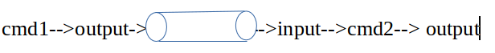

eg:

$cat file1 | wc -l --> no.of lines in file1

$ls | wc -l --> no.of files in current working directory

$cat file1 | wc -l | wc -l
1

$cat file1 | wc -l | wc -l |wc -l
1

$who |wc -l --> It gives no.of current working users.

Redirections operators:
< --> to the left

> --> to the right

eg :
$cat > file1

data sending from console to file ( right side )

$cat < file1
data sending from file to console ( to the left )

eg:

$cat file1 --> displaying on the screen

$cat file1 > filex
data sending to filex.
If filex already exist then it overwrites.

$cat file1 >> filex
to append the data to the existing file.

> --> overwriting data
>> --> appending data

head command :
to display beginning lines of the file
$head -4 file1 --> to display first 4 lines of file1

to store into file
$head -4 file1 > result1

tail command :
to display ending lines of the file.
$tail -5 file1 --> to get last four lines of a file

to store into file
$ tail -5 file1 > result2

to get middle lines:
eg :
4th line to 7th line

$head -7 file1 | tail -4

to store into result file :
$head -7 file1 | tail -4 > result3

$last -a |head -1 ---> recent login user details.

tee command :

to get the data from the pipe and display as well as to storing into text file.

$cat file1 | tee result.txt

translate :
replacing single chars

$tr “a” “b” <file1

grep - Searching pattern command

$grep “searching text” <filename>

--> shows the lines on which searching pattern is found.
eg:
$grep “hello” file1

$grep -n “hello” file1 --> including line numbers.

$grep -v “hello” file1 --> invert match ( except those lines )

$grep -vn “hello” file1 --> with line num

$grep “demo” /etc/passwd

$grep -i “DEMO” /etc/passwd --> ignore case sense

$cat file1 | grep “hello”

$grep -c "this" file1 --> No.of line, on which occurred.

$grep -o "this" file1 --> only matched part ( all words in files)

$grep -o "mnrao" /etc/passwd
mnrao
mnrao
mnrao

$grep -R “hello” x --> search including sub directories recursively.

$grep -4 "mnrao" /etc/passwd --> display 4 lines before and after

tar command ( Packing and unpacking files )

tar --> tape archive
tar is to archive files
packing files:
creation of archive files;
extension is .tar
$tar -cvf <archive_name.tar><source_folder/files>

eg:
$tar -cvf myarchive.tar ./x

unpacking ( extracting )

$ tar -xvf myarchive.tar

c --> create
x --> extract
v --> Verbose ( It is security protocol )
f --> files.

Appending to existing tar file.
Option ( r )
$tar -rvf <existing_tar><new_files_to_be_added>
eg:
$ tar -rvf myarchive.tar ./y

Compressing files:
default extension is .gz
$gzip <file/folder>

eg:
$gzip myarchive.tar

$ls

result file is --> myarchive.tar.gz

Un Compressing:
$gunzip myarchive.tar.gz

$ls

result file is --> myarchive.tar

extracting :

$tar -xvf myarchive.tar

Un compressing and un packing
unzip and extract
$tar -xzvf myarchive.tar.gz
z--> zip

File Permissions:

chmod is a command to change the file permissions

syntax:
$chmod [category] [operation] [permission] <file_name/dir_name>

category:
u --> user ( owner of the file )
g --> group member
o --> other than owner and group member.
a --> all

Operation:
+ --> adding permission
- --> Removing permission
= --> assigning permission
( removes all old permissions and assigns new permissions)

permission:
r --> read
w --> write
x --> execute
- --> no permission

$ls -l file1
---------- 1 demo demo 145 Apr 14 23:04 file1

$chmod u+r file1
$ ls -l file1
-r-------- 1 demo demo 145 Apr 14 23:04 file1

$chmod u+w,g+rw,o+r file1
$ ls -l file1
-rw-rw-r-- 1 demo demo 145 Apr 14 23:04 file1

$chmod u+x,g-w,o+w file1
$ ls -l file1
-rwxr--rw- 1 demo demo 145 Apr 14 23:04 file1

assignment:
$chmod u=rw,g=rw,o=r file1
$ ls -l file1
-rw-rw-r-- 1 demo demo 145 Apr 14 23:04 file1

assignment will remove the existing permissions and will give the new permissions.

$chmod u=rw,g=r,o=- file1
$ ls -l file1
-rw-r----- 1 demo demo 145 Apr 14 23:04 file1

$chmod a=- file1
$ ls -l file1
---------- 1 demo demo 145 Apr 14 23:04 file1

$chmod a=rwx file1
$ ls -l file1
-rwxrwxrwx 1 demo demo 145 Apr 14 23:04 file1

Octal notations :

$chmod <mode><filename>

mode is a three digits number

read --> 4
write --> 2
execute --> 1
-------
Total (all) 7
-------
$chmod 765 <file_name/dir_name>

7 --> user
6 -->group
5 --> others
req:
on file1
u --> read and write
g -->read and write
o ---> read

$chmod 664 file1
$ ls -l file1
-rw-rw-r-- 1 demo demo 145 Apr 14 23:04 file1

$chmod 777 file1 --> all permissions to all
$ ls -l file1
-rwxrwxrwx 1 demo demo 145 Apr 14 23:04 file1

$chmod 77 file1
$ ls -l file1
----rwxrwx 1 demo demo 145 Apr 14 23:04 file1

$chmod 77 file1 ===> $chmod 077 file1
$chmod 7 file1 ===> $chmod 007 file1
$chmod 0 file1 ===> $chmod 000 file1

default permissions depends on current umask values
$umask --> to check current umask
default umask -->002

This value is an octal (base 8, digits 0-7) value which is subtracted from a base value of 777 for directories, or subtracted from a base value of 666 for files.

default permissions of the directory --> 775 ( 777-002)
default permissions of the file --> 664 (666-002)

changing umask value:

$umask 231

$umask
231
New:
default permissions of the directory --> 546 ( 777-231)
default permissions of the file --> 435 (666-231)

ps --> checking current processes in linux
$ps -ef --> all running processes

killing jobs

$kill -9 <process_id>

-9 --> represents sure kill
eg:
$kill -9 45637

$kill -9 45637 35645 56734 --> killing multiple jobs

Shell:
Name of shell Command name Description

Bourne shell :
command : sh
The most basic shell available on all UNIX systems

Korn Shell:
command :ksh / pdksh
Based on the Bourne shell with enhancements

C Shell:
Command : csh
Similar to the C programming language in syntax

Bash Shell:
bash Bourne Again Shell combines the advantages of the Korn Shell and the C Shell. It is a default shell on most Linux distributions.

Tcsh:
Command: tcsh
Similar to the C Shell

Type of shell using in my Operating system.

$echo $0
bash

(or)
$echo $SHELL
/bin/bash

Working with bash shell:

Shell scripting :

echo command ( displaying text )

$echo “hello world “

$echo “hello unix and linux “

How to write shell scripting

program to say hello

step1:
$gedit hello.sh (or) $vi hello.sh

#this is my first programme
#Writing comment
echo “hello world “
echo “hello unix and linux “

Step 2:
$chmod 766 hello.sh

Step3:
$./hello.sh
hello world
hello unix and linux

Welcome by current user

$vi welcome.sh
echo "Hello this is $USER"
echo "Welcome to Ameerpet"
echo "Welcome to Bigdata and Hadoop"

Shell variables:

There are two types of variables:
1) System variables ( environment variables )
2) user defined variables

$env --> displays all environment variables

Users defined variables

eg:
$mypath=/home/demo/x/x1

$cd $mypath

$pwd
/home/demo/x/x1

Eg:
demo@nrit:~$ a=10
demo@nrit:~$ b=20

here value of variable a is 10 and value of variable b is 20.

How to get the value of the variable:

$ is an operator to read the value from variable memory.

To display value of the variable:

$ echo $a and $b
O/P : 10 and 20

There are no data types in shell, everything treats as text.

scope of a variable.

There are three levels of variable scope

1) Session level

2) User level

3) System level

1) Session level:

These are the variable defined at the command line
eg:

demo@nrit:~$ a=10
demo@nrit:~$ b=20

These variable scope is applicable to current session only. Once session closed, we can not get back these variables.

2) User level:

Scope of these variables is applicable to all sessions of current login user.

Defining User level variables:

.bashrc is file located inside the home directory of every user. It differs from user to user.

demo@nrit:~$pwd
/home/demo

demo@nrit:~$ gedit .bashrc

$gedit /home/demo/.bashrc
(or)
$vi /home/demo/.bashrc

$gedit ~/.bashrc
(or)
$vi ~/.bashrc

go to end of .bashrc file and use export

export a=10
export b=20

save the above and exit
open new terminal and check the following.

$echo a=$a and b=$b
a=10 and b=20

3) system level
Scope of these variables is applicable to all users of system.

Defining System level variables:

profile is file located at the “ /etc/profile ” .

root user ( admin ) is a owner of this file. Only root user ( admin) can update this filename

demo@nrit:~$ sudo gedit /etc/profile

export a=10
export b=20

command substitution into text message:

command quotations are used to substitute the result of the command into text.
` --> below esc key

$echo "today date is `date +%D` "
today date is 04/14/16

$echo "file1 has `cat file1|wc -l` lines"
file1 has 7 lines

$echo "Total files in current directory `ls |wc -l` "
Total files in current directory 13

Reading command line parameters:

$./test.sh hello linux world

The above command creates following variables:

$# --> Parameter count ( 3 )
$0 --> name of scripting file ( ./test.sh )
$1 --> first parameter ( hello )
$2 --> second parameter ( linux )
$3 →third parameter ( world)
$* --> all parameters ( hello linux world )

program to read command line parameters

$vi test.sh
echo "Number of Parameters : $#"
echo "Script Name : $0"
echo "The first parameter : $1"
echo "The second parameter : $2"
echo "The second parameter : $3"
echo "All parameters : $*"

$chmod 766 test.sh

$./test.sh hello linux world

program to create file with time stamp:

$vi test.sh
#!/bin/bash
timeStamp=`date +%d-%m-%Y-%H-%M-%S`
echo "this is unix" >>$ timeStamp.log
echo "this is linux" >>$ timeStamp.log
echo "this is hadoop" >>$ timeStamp.log

$chmod 766 test.sh

$./test.sh

$ls
14-04-2016-23-28-41.log

$cat 14-04-2016-23-28-41.log
this is unix
this is linux
this is hadoop

read command --> reading variable from keyboard
read var1 var2 ...

eg:
$ read a b
input is:
hello world

$ echo a=$a and b=$b
a=hello and b=world

read only variables

$x=10
$readonly x
$x=30 --> error

$readonly --> to display all read only variables

$env

$echo $PWD

$echo $HOME

changing command prompt
$PS1=#
$PS1=”<>”

program to read emp info and store into text file

$gedit empinfo.sh (or) $vi empinfo.sh

echo "Enter employee information "
echo "Enter empno :"
read empno
echo "Enter emp name:"
read ename
echo "Enter emp salary:"
read salary
echo "Enter emp deptname"
read dept
echo "Enter emp contact no:"
read cno
echo "below details are saved to data base"
echo $empno:$ename:$salary:$dept:$cno
echo $empno:$ename:$salary:$dept:$cno >>emp.dat

$./empinfo.sh

check the data in the file :

$gedit emp.dat

Operators:

1) Arithmetic (or) Mathemetical operators

+ --> Addition

- --> Substraction

\* --> multiplication ( * --> refer to pattern matching chars )

/ ---> Division

% ---> modulo ( remainder )

eg:
10%3 =1
3%10 = 3
9%10 = 9
10%10 = 0

Relational operators ( Numeric comparision )

-gt --> Greater than

-ge --> Greater than or equal to

-lt --> Less than

-le --> Less than or equal to

-eq --> is equal to

-ne --> not equal to

these operators return Boolean value ( true /false )

Logical Operators :

-a ---> And

-o ---> Or

! ---> Not

Mathematical Operations:

expr is a command to perform mathematical operations.

expr $var1 op $var2

$vi math.sh

echo "enter two numbers"
read a b
c=`expr $a + $b`
echo "addition : $c"
c=`expr $a - $b`
echo "subtraction :$c"
c=`expr $a \* $b`
echo "multiplication : $c"

$chmod 766 math.sh

$./math.sh

Control statements:

1) if-statement
2) case -statement
3) while loop
4) for loop
5) until loop

if statement:

There are four types of if statements

1) simple -if

2) if-else

3) Nested – if

4) Ladder – if

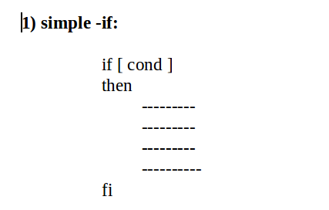

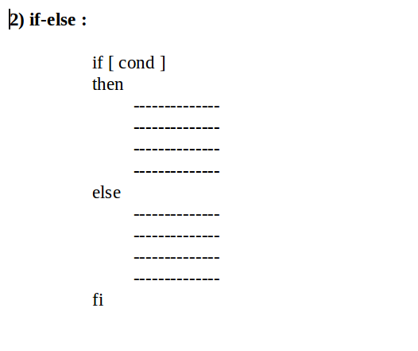

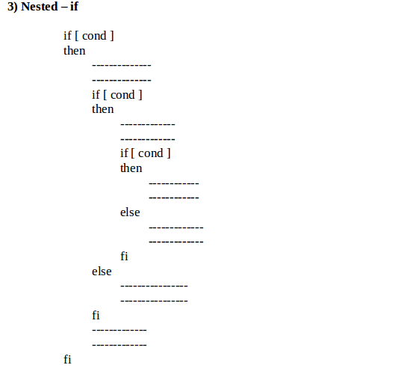

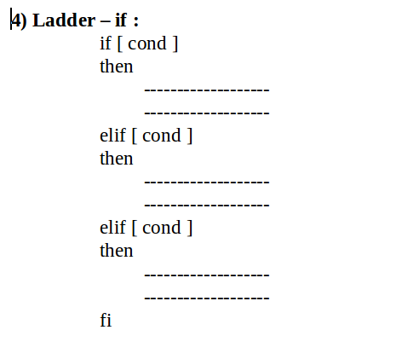

Program to find greater of two numbers

$vi greater2.sh

echo enter two numbers
read a b

if [ $a -gt $b ]
then
echo "greater number $a"
else
echo "greater number $b"
fi

$ chmod 766 greater2.sh

$ ./greater2.sh

Program to find greater and equal of two numbers

$vi grteq.sh

echo enter two numbers
read a b

if [ $a -eq $b ]
then
echo "both are equal"

elif [ $a -gt $b ]
then
echo "greater number $a"
else
echo "greater number $b"
fi

$chmod 766 grteq.sh

$./grteq.sh

Program to find greater of three numbers

$vi greater3.sh

echo enter three numbers
read a b c

if [ $a -gt $b ]
then
if [ $a -gt $c ]
then
echo "greater number $a"
else
echo "greater number $c"
fi
elif [ $b -gt $c ]
then
echo "greater number $b"
else
echo "greater number $c"
fi

$ chmod 766 greater3.sh

$ ./greater3.sh

Program to find the result of the students base on their marks
All subjects marks are greater than or equal to 40 then pass otherwise fail

$gedit result.sh

echo "Enter three subjects marks"
read m1 m2 m3

if [ $m1 -ge 40 ]
then
if [ $m2 -ge 40 ]
then
if [ $m3 -ge 40 ]
then
echo "pass"
else
echo "fail"
fi
else
echo "pass"
fi
else
echo "fail"
fi

$chmod 766 result.sh

$./result

using logical operators :

$vi result.sh

echo enter three subject marks
read m1 m2 m3
if [ $m1 -ge 40 -a $m2 -ge 40 -a $m3 -ge 40 ]
then
echo "Result is Pass"
else
echo "Result is Fail "
fi

$chmod 766 result.sh

$./result.sh

Eg:

echo enter three subject marks
read m1 m2 m3
if [ $m1 -lt 40 ]
then
echo "Result is FAIL"
elif [ $m2 -lt 40 ]
then
echo "Result is Fail "
elif [ $m3 -lt 40 ]
then
echo "Result is Fail"
else
echo "Result is Pass"
fi

eg:

echo enter three subject marks

read m1 m2 m3

if [ $m1 -lt 40 -o $m2 -lt 40 -o $m3 -lt 40 ]
then
echo "Result is FAIL"
else
echo "Result is Pass"
fi

File Test:

-e ---> returns true if file/directory exists

-s --- > returns true if file size is more than zero bytes ( if not empty )

-f ---> Returns true if the file is a regular file

-d ---> Returns true if file a directory

-r ---> Returns true if current user has read permission

-w ---> Returns ture if current user has write permission

-x ---> Retunrs true if current user has execute permission

-o ----> Returns true if current user is a owner of the file

file1 -ot file2 --> Returns true if file1 is older than file2

file1 -nt file2 ---> Returns true if file1 is newer than file2

String test:

1) str1 = str2 --> Returns true if both strings are same

2) str1 != str2 ---> Returns true if strings are different

3) -z str ---> Returns ture if string is empty

4) -n str ----> Returns true if string is not empty

Script to check file existence

$vi ftest.sh

if [ $# -ne 1 ]
then
echo "syntax error : usage ftest <file_path>"
exit 0
fi

if [ -e $1 ]
then
echo "$1 exist"
else
echo "$1 does not exist"
fi

$chmod 766 ftest.sh

$./ftest.sh /home/demo/file1

(or)

$./ftest.sh ~/file1

Checking file or directory :

$vi fdtest.sh

if [ $# -ne 1 ]
then
echo "Invalid syntax, Usage $./ftesh.sh <file/dir>"
exit 0
fi

if [ ! -e $1 ]
then

echo "$1 does not exist"
exit 0

fi

if [ -d $1 ]
then
echo "$1 exist and it is dir "
elif [ -f $1 ]
then
echo "$1 exist and it is a file"
else
echo "$1 exist and it is special"
fi

$chmod 766 fdtest.sh

$./fdtest.sh

copying all file and directories one location to another location
zip all the source files and copy to destination then extract
remove the zip file at source as well destination.

eg:

$./mycopy /home/demo/x home/demo/y

==========================
$vi mycopy.sh

timeStamp=`date +%Y-%m-%d-%H`
errorfileName=$timeStamp"_error.log"
successfileName=$timeStamp"_success.log"
errorLogPath=$HOME/$errorfileName
successLogPath=$HOME/$successfileName

if [ $# -ne 2 ]
then
echo "syntax error, usage : $0 <source_path><dest_path>"
echo "syntax error, usage : $0 <source_path><dest_path>" >>$errorLogPath
exit 0
fi

if [ ! -e $1 ]
then
echo "source $1 does not exist "
echo "source $1 does not exist " >>$errorLogPath
exit 0
fi

if [ ! -e $2 ]
then
echo "dest $2 does not exist "
echo "dest $2 does not exist " >>$errorLogPath
exit 0
fi

if [ ! -d $1 ]
then
echo "source $1 is not a dir "
echo "source $1 is not a dir " >>$errorLogPath
exit 0
fi

if [ ! -d $2 ]
then
echo "dest $2 is not a dir "
echo "dest $2 is not a dir " >>$errorLogPath
exit 0
fi

if [ ! -r $1 ]
then
echo "source $1 read permission denied, can not copy "
echo "source $1 read permission denied, can not copy " >>$errorLogPath
exit 0
fi

if [ ! -x $1 ]
then
echo "source $1 execute permission denied, can not copy "
echo "source $1 execute permission denied, can not copy " >>$errorLogPath
exit 0
fi

if [ ! -w $2 ]
then
echo "dest $2 write permission denied, can not copy "
echo "dest $2 write permission denied, can not copy " >>$errorLogPath
exit 0
fi

if [ ! -x $2 ]
then
echo "dest $2 execute permission denied, can not copy "
echo "dest $2 execute permission denied, can not copy " >>$errorLogPath
exit 0
fi

cd $1
echo "creating archive ....................."

tar -cvf temp.tar ./*

if [ $? -ne 0 ]
then
echo "creation of archive failed, location : tar -cvf temp.tar ./* " >>$errorLogPath
exit 0
fi

gzip temp.tar

echo "moving data ....................."
mv temp.tar.gz $2

echo "successfully moved into destination"

echo "successfully moved into destination ">>$successLogPath

cd $2

tar -xzvf temp.tar.gz

rm ./temp.tar.gz

echo "successfully completed: `date` ">>$successLogPath

exit 0

===================

$chmod 766 mycopy.sh

$./mycopy.sh

Case Statement :

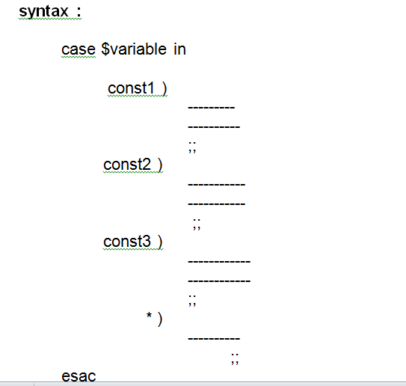

in the above if variable value is not matching any constant the control goes to default case ( * )

;; --> to take the control out of case, it is an optional for default case
esac --> is end of case statement.

$vi casetest.sh

echo enter two numbers
read a b
echo "This program will calculate"
echo "1. Addition"
echo "2. Subtraction"
echo "3. Multiplication"
echo "Please enter your choice 1/2/3"
read choice

case $choice in

1 )
echo "sum = `expr $a + $b`" ;;
2 )
echo "subtraction = `expr $a - $b`" ;;
3 )
echo "multiplication = `expr $a \* $b`" ;;
* )
echo "wrong choice";;
esac

$chmod 766 casetest.sh

$./casetest.sh

$vi commands.sh
echo "1. count of files in current directory"
echo "2. Present working user count"
echo "3. Today date"
echo "4. Current login Name and other users"
echo "Please enter your choice 1/2/3/4"
read choice

case $choice in
1 )
echo "Total files : ` ls | wc -l`"
;;
2 )
echo "Present working users count : `who |wc -l` "
;;
3 )
echo "Today date is `date`"
;;
4)
echo "Current login name : `logname`"
echo "Other login users :"
users
;;
* )
echo "wrong choice"
;;
esac

$chmod 766 commands.sh

$./commands.sh

loops:
while loop:
while [ cond ]
do
---------------
---------------
---------------
done

display numbers from 1 to 10.
$vi 1to10.sh
i=1
while [ $i -le 10 ]
do
echo $i
i=`expr $i + 1`
done
$ chmod 766 1to10.sh

$ ./1to10.sh

$vi 1ton.sh

echo enter the limit
read n
i=1
while [ $i -le $n ]
do
echo $i
i=`expr $i + 1`
done

$chmod 766 1ton.sh

$./1ton.sh

$vi EvenOddSum.sh

echo "enter the limit"
read n
i=1
esum=0
osum=0
while [ $i -le $n ]
do
if [ `expr $i % 2` -eq 0 ]
then
esum=`expr $esum + $i`
else
osum=`expr $osum + $i`
fi
i=`expr $i + 1`
done

echo "even sum = $esum and odd sum $osum"

$chmod 766 EvenOddSum.sh

$./EvenOddSum.sh

true command --> to set infinite loop
false command -->to make the condition as false

$vi hello.sh

while true
do
echo "Welcome"
done

$vi welcome.sh
while true
do
clear
printf "\n\n\n\n\n\n\n\t\t\t\t\t\tWelcome"
sleep 1
clear
printf "\n\n\n\n\n\n\n\t\t\t\t\t\tLinux"
sleep 1
done

$chmod 766 hello.sh

$./hello.sh

to display timer ( digital timer )

while true
do
clear
printf "\n\n\n\n\n\n\n\n\n\t\t\t\t\t\t\t\t\t `date +%H:%M:%S` "
sleep 1

done

until loop:

it works until condition is true.

until [ cond ]
do
-----------
-----------
-----------
done

eg:

until fasle
do
echo "hello"
done

for loop :

syntax:

for variable in const1 const2 const3 const4
do
==========
==========
==========
done

eg:

$vi fortest.sh

for i in 1 2 3 4 5
do
echo $i
done

$chmod 766 fortest.sh

$./fortest.sh

Eg:

for name in unix java linux hadoop python
do
echo $name
done

checking for file existence and to display type of file

$vi ftest.sh

for fname in $*
do
if [ ! -e $fname ]
then
echo "$fname not found "
continue
fi

if [ -f $fname ]
then
echo "$fname is file "
elif [ -d $fname ]
then
echo "$fname is dir"
else
echo "$fname is special file"
fi

done

$chmod 766 ftest.sh

$./ftest.sh file1 test1 x y file2 test2 z

program for displaying multiple files:

$vi display.sh

for fname in $*
do

if [ ! -e $fname ]
then
echo "$fname does not exist"
echo
continue
fi

if [ ! -f $fname ]
then
echo "$fname is not a file"
echo
continue
fi

if [ ! -r $fname ]
then
echo "$fname read permission denied can not disply"
echo
continue
fi

echo "$fname contents are:"
cat $fname
echo
done

$chmod 766 display.sh
$./display.sh

program to merge files:
=====================

$vi fmerge.sh

if [ -e result.txt ]
then
rm result.txt
fi

for fname in $*
do

if [ ! -e $fname ]
then
continue
fi

if [ ! -f $fname ]
then
continue
fi

if [ ! -r $fname ]
then
continue
fi

cat $fname >>result.txt

done

$chmod 766 fmerge.sh

$./fmerge.sh file1.dat file2.dat file3.dat file4.dat

Advanced Linux filters:

cut command :

cut command is used to extract particular fields in a file.

Cutting fields with delimiter:

$cat customers.txt

1:rahul:32:Ahmedabad
2:james:15:Delhi
3:scott:29:Chicago
4:krunal:32:Banglore
5:ahmed:27:Mubai
6:shekhar:51:california
7:murthy:26:Bhopal

To filter 1st and 3rd fields

$cut -d ":" -f 1,3 customers.txt
1:32
2:15
3:29
4:32
5:27
6:51
7:26

To filter 1st and 4th fields

$cut -d ":" -f 1,4 customers.txt
1:Ahmedabad
2:Delhi
3:Chicago
4:Banglore
5:Mubai
6:california
7:Bhopal

$cut -d ":" -f 1,4 customers.txt |tee cutlist.txt

1:Ahmedabad
2:Delhi
3:Chicago
4:Banglore
5:Mubai
6:california
7:Bhopal

$cat cutlist.txt

1:Ahmedabad
2:Delhi
3:Chicago
4:Banglore
5:Mubai
6:california
7:Bhopal

To change order of fields, 1st, 3rd, 2nd and 4th fields

$ cut -d ":" -f 1,3 customers.txt > cutlist1.txt

$cut -d ":" -f 2,4 customers.txt > cutlist2.txt

$ cat cutlist1.txt

1:32
2:15
3:29
4:32
5:27
6:51
7:26

$ cat cutlist2.txt

rahul:Ahmedabad
james:Delhi
scott:Chicago
krunal:Banglore
ahmed:Mubai
shekhar:california
murthy:Bhopal

using paste command we can place side by side

$ paste cutlist1.txt cutlist2.txt

1:32 rahul:Ahmedabad
2:15 james:Delhi
3:29 scott:Chicago
4:32 krunal:Banglore
5:27 ahmed:Mubai
6:51 shekhar:california
7:26 murthy:Bhopal

in the above command default delimiter is tab.
To get custom delimiter

$ paste -d":" cutlist1.txt cutlist2.txt

1:32:rahul:Ahmedabad
2:15:james:Delhi
3:29:scott:Chicago
4:32:krunal:Banglore
5:27:ahmed:Mubai
6:51:shekhar:California
7:26:murthy:Bhopal

$ paste -d":" cutlist1.txt cutlist2.txt

1:32:rahul:Ahmedabad
2:15:james:Delhi
3:29:scott:Chicago
4:32:krunal:Banglore
5:27:ahmed:Mubai
6:51:shekhar:california
7:26:murthy:Bhopal

$paste -d":" cutlist1.txt cutlist2.txt >final_list.txt

$ cat final_list.txt

1:32:rahul:Ahmedabad
2:15:james:Delhi
3:29:scott:Chicago
4:32:krunal:Banglore
5:27:ahmed:Mubai
6:51:shekhar:california
7:26:murthy:Bhopal

sort command : to sort the data
default sorting ,ASCII based sorting in ascending order

$sort -t":" -k 2 customers.txt

5:ahmed:27:Mubai
2:james:15:Delhi
4:krunal:32:Banglore
7:murthy:26:Bhopal
1:rahul:32:Ahmedabad
3:scott:29:Chicago
6:shekhar:51:California

To sort in descending order :

–r (reverse )

$ sort -rt":" -k 2 customers.txt

6:shekhar:51:california
3:scott:29:Chicago
1:rahul:32:Ahmedabad
7:murthy:26:Bhopal
4:krunal:32:Banglore
2:james:15:Delhi
5:ahmed:27:Mubai

Sorting based on number filed ( 3rd field)

The following is ASCII based sorting

$sort -t":" -k 3 customers.txt

2:james:15:Delhi
7:murthy:26:Bhopal
5:ahmed:27:Mubai
3:scott:29:Chicago
1:rahul:32:Ahmedabad
4:krunal:32:Banglore
6:shekhar:51:california

If age filed contains as below the sorting fails.

$ cat customers.txt

1:rahul:3:Ahmedabad
2:james:15:Delhi
3:scott:9:Chicago
4:krunal:32:Banglore
5:ahmed:27:Mubai
6:shekhar:5:california
7:murthy:26:Bhopal

Result of sort command as below

$ sort -t":" -k 3 customers.txt

2:james:15:Delhi
7:murthy:26:Bhopal
5:ahmed:27:Mubai
4:krunal:32:Banglore
1:rahul:3:Ahmedabad
6:shekhar:5:california
3:scott:9:Chicago

-n ( number based sorting )

$ sort -nt":" -k 3 customers.txt

1:rahul:3:Ahmedabad
6:shekhar:5:california
3:scott:9:Chicago
2:james:15:Delhi
7:murthy:26:Bhopal
5:ahmed:27:Mubai
4:krunal:32:Banglore

awk programming.

$cat customers.txt

1:ramesh:32:Ahmedabad
2:srinadh:25:Delhi
3:sarath:22:Hyderabad
4:kumar:25:Banglore
5:ravi:27:Mubai
6:shekhar:22:Khammam
7:murthy:26:Bhopal

$awk -F ":" ' {print $1}' customers.txt

$awk -F ":" '{print $1, $2}' customers.txt

$awk -F ":" '{print $1"#"$2"#"$3}' customers.txt

$awk -F ":" '{print $1"#"$2"#"$3}' customers.txt

$awk 'NR==4{print $1,$2,$3,$4}' customers.txt

$awk 'NR!=4{print $1,$2,$3,$4}' customers.txt

Shell script functions

Function is set of statements to to perform some task

Advantages :
With functions we can avoid repeated code

Defining a function

Function_name()
{
Statement1

Statement1

Statement1

Statement1

}

Calling a function

Function_name param1 param2 param3

Eg1:

$gedit test.sh

#!/bin/sh
# A simple script with a function...
display()
{
echo "I am in dispaly"
}

show()
{
echo "i am in show"
}

display
show

eg2:
$gedit test.sh

#beg

#!/bin/sh
# A simple script with a function...
display()
{
echo "I am in dispaly"
show
}

show()
{
echo "i am in show"
}

display
show

#end

$ ./test.sh
I am in dispaly
i am in show
i am in show

#beg
#!/bin/sh
# A simple script with a function...
display()
{
echo "I am in dispaly"
show
}

show()
{
echo "I am in show"
demo
}

demo()
{
echo "I am in demo"
}

display
show
demo
#end

Passing parameters to function

#beg

#!/bin/sh
# A simple script with a function...
display()
{
echo "I am in dispaly"
echo "param count = $#"
echo "first param = $1"
echo "Second param = $2"
echo "third param = $3"
echo "all params = $*"
}

display linux unix hadoop

#end

O/P:

I am in dispaly
param count = 3
first param = linux
Second param = unix
third param = hadoop
all params = linux unix hadoop

Parameters through for loop

#beg

#!/bin/sh
# A simple script with a function...
display()
{
for name in $*
do
echo $name
done
}

display linux unix hadoop

#end

O/P:

linux
unix
hadoop

#beg

#!/bin/sh
# A simple script with a function...
greater()
{
if [ $1 -eq $2 ]
then
echo "both are equal"
elif [ $1 -gt $2 ]
then
echo "$1 is greater "
else
echo "$2 is greater"
fi
}

echo "enter two numbers"
read a b

greater $a $b

#end

#beg

#!/bin/sh
# A simple script with a function...

sum()
{
temp=`expr $1 + $2 + $3`
}

sum 1 2 3

echo "sum = $temp"

#end

#beg

#!/bin/sh
# A simple script with a function...
addNum()
{

add=`expr $1 + $2 `

}

subNum()
{
sub=`expr $1 - $2`
}

mulNum()
{
mul=`expr $1 \* $2`
}

echo "Enter two numbers"
read a b
echo "Mathemetical operations"
echo "1.addition"
echo "2.subtraction"
echo "3.Multiplication"
echo "Enter your choice 1/2/3"
read choice

case $choice in

1 )
addNum $a $b
echo "addition = $add"
;;
2 )
subNum $a $b
echo "Subtraction = $sub"
;;
3 )
mulNum $a $b $c
echo "Multiplication=$mul"
;;
* )
echo "Wrong choice"
;;
Esac

#end

#beg

factorial()
{
fact=1
while [ $n -gt 1 ]
do
fact=`expr $fact \* $n `
n=`expr $n - 1 `

done

}

echo "Enter a number"
read n

factorial $n

echo "factorial of $n = $fact"

LINUX Administration

Admin is having all privileges , he can work any in the linux file system.

Admin Activities

Basic Knowledge for Linux Administrator :
- Basic commands (listing, cat, removing files/dir, nano, vi editor, more, tail etc )
- LVM
- User Authentication (user add, remove, lock, unlock, home dir, ssh access)
- Group Administration (group add, remove, sudo group)
- Using SSh, Disabling root for ssh access & using sudo
- Installing programs using rpm & yum (configuring yum)
- Configuring a network (basics)
- Types of process & Managing process (basics)
- Kill signals
- Backup and restore
- Types of Run levels
- NFS, Samba, NIS (basics)
- Cron and At Jobs
- FTP & using filezilla (easy)
- Booting process
- Kernel Parmeters (basics)
- Top, Nice values
- Services
- Scripting (very basic

Switching to admin:

$sudo –i
Password for root user:

#whoami
root

cron jobs:
it is job scheduling

eg:
$vi test.sh
echo “hello” >>/home/demo/mylog
$chmod 777 test.sh

$sudo -i
#crontab -e

# m h dom mon dow command
* * * * * sh /home/demo/test.sh
:wq

In the above
m→min (0-59)
h→hours (0-23)
dom →day of the month (1-31)
mon→moth ( 1-12)
dow →day of the week ( sun – 0 to Sat – 6 )

shutdown and reboot :

#init 0 → shutdown ( linux / unux)

#shutdown ( only linux )

Rebooting linux server
#reboot [will perform simple reboot]
#reboot -f [will perform fast reboot ]

#init 6 ( linux / unix )

This command restart the operating system. It also can only be run by root.

Looking for command location:

#which javac
/usr/bin/javac

checking disk free space:

#df -k
Filesystem 1K-blocks Used Available Use% Mounted on
/dev/sda6 449452784 67633912 358964936 16% /
none 4 0 4 0% /sys/fs/cgroup
udev 2011308 4 2011304 1% /dev
tmpfs 404168 1284 402884 1% /run
none 5120 0 5120 0% /run/lock
none 2020832 492 2020340 1% /run/shm
none 102400 44 102356 1% /run/user

disk usage by the file.

#du -sh /home/demo/myfile

checking for current user id

to user id
#id

As a sudo admin user

updating linux system:

$sudo apt-get update

installing softwares:

$ sudo apt-get install < package-name >

As root admin

#apt-get update

installing softwares:

#apt-get install < package-name >

eg:
1)update the linux o/s:
$sudo apt-get update

2) install ssh:
$sudo apt-get install ssh

3) Install Java :
$sudo apt-get install default-jdk

4)Install eclipse:
$sudo apt-get install eclipse

5) Install mysql:
$sudo apt-get install mysql-server mysql-client

create new group:
#addgroup grp1
#addgroup -gid 301 grp2

Deleting group:
#delgroup grp1

Note :
To delete group, it should be empy.

user management:

1) adding users:

#useradd -u 999 -d /home/mnrao1 -g 301 -c "mnrao hadoop" -s /bin/bash -m mnrao1

#passwd mnrao1
Enter new UNIX password:
Retype new UNIX password:
passwd: password updated successfully

another way with default details

#adduser <user_name>

#adduser mnrao1

2)deleting user:

#deluser <user_name>

3) Modifyinng user:

#usermod -g 1001 -c "mnrao hadoop1" mnrao1

# usermod -u 999 -g 305 -c "mnrao hadoop" -s /bin/bash -m mnrao1

setting the system date and time

# timedatectl set-time "YYYY-MM-DD HH:MM:SS"

eg:

#timedatectl set-time "2014-04-15 10:20:50"

#date

changing ouwner of the file:

current user must be a owner of the file or sysadmin

#chown <new_owner> <file_name>

changing group name of the file:
#chgrp <group_name><file_name>

Networking setup

Step1:
Procure the Hardware

- Computers
- Cables
- Switch

Step2:
Install linux on every computer

Step3:
Update OS every system

$sudo apt-get update

Step4:
Install ssh on every system

$sudo apt-get install ssh

Step5:
Power on switch

Step6:
Connect one end of the cable to switch and other end to computer

Step7:
Start all systems

Step8:
Configure IP-Address

Select Network icon



Edit connections

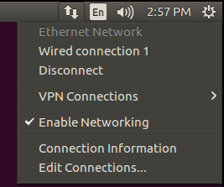

Select edit as below

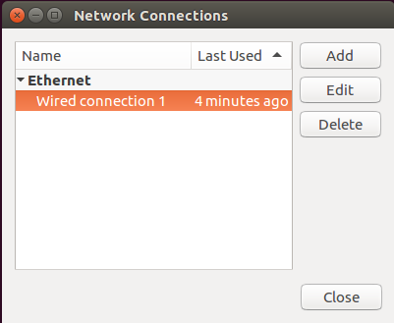

Configure IP address as below and save it

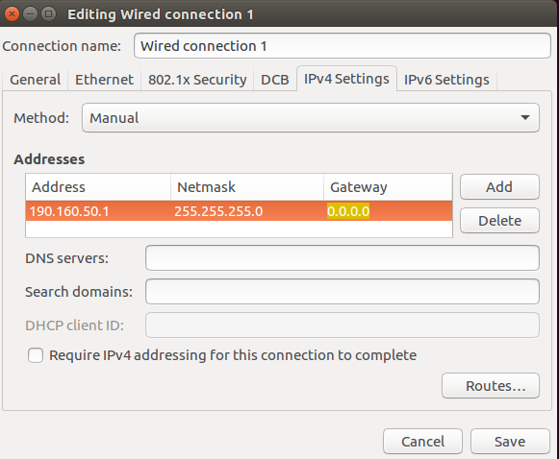

Repeat same procedure for all systems

Restart all systems

Step9:
Check the new IP- address

# ifconfig ---> shows ip – address

IP Address is a four octets number ranging from 0.0.0.0 to 255.255.255.255
First 3 octets are common for all system ( it is domain) and last octet is unique value.

Step10:
below is checking for network connectivity

$ ping <ip_address>
(or)
$ping <hostname>

$ping 160.10.20.1

$ping hadoop1

$ping www.facebook.com

use ctrl + C --> to terminate ping.

#hostname --> to check current host name.

To setup hostnames for all systems in network.

#vi /etc/hosts

127.0.01 localhost
127.0.01 hadoop

160.10.20.1 myhost1
160.10.20.2 myhost2
160.10.20.3 myhost2
160.10.20.4 myhost3
160.10.20.5 myhost4
160.10.20.6 myhost5
.
.
.
160.10.20.7 myhost100

Working with remote systems:

ssh --> secure shell

$ssh <user_name>@<host_name>
password : *******

$pwd
/home/test

the above is current working directory on remote system.

Working with putty

Putty tool will use ssh to connect from windows desk top to linux servers.

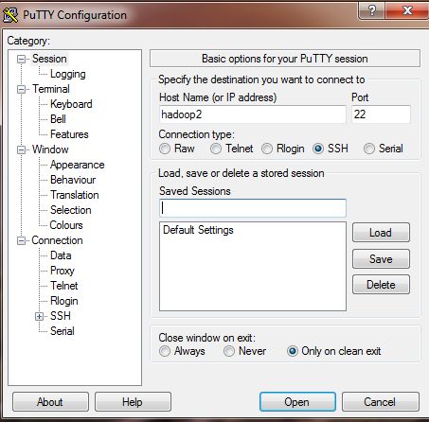

After getting connection

User: demo
Passwd: ******

$pwd

It opens session on remote system.

$ls

$touch file1 file2

$vi test.sh

$exit → to disconnect from remote host

Copying files to remote system:

scp --> secure copy

$scp <source_file><user_name>@hostname:<target_path>

source must be a file.
Destination must be a directory.

To copy folder, prepare .tar.gz using tar and gzip commands

$tar -cvf myproject.tar project

$gzip myproject.tar

result is myproject.tar.gz

now
$scp myproject.tar.gz mnrao@myhost100:~

~ --> home folder on remote system.

Myhost100 is hostname for remote system.
mnrao --> user name on remote system.

Working with FTP

ftp ---> file transfer protocol.

To upload the files into remote server and also to down load the file from remote server into local system.

$ ftp

ftp>

ftp>open 192.10.60.1

name : admin
password :******

ftp>user --> it shows current user.

ftp>pwd
“/”
the above shows current working direcory on ftp server

ftp>lcd

/home/demo

ftp> help --> shows list of ftp commands.

the above shows current working directory on local system.

ftp>cd /projects/hadoop

the above command is to change required directory in the ftp server

ftp>lcd /home/demo/project
the above command is to set current working directory in the local system.

ftp>bin --> to set transfer mode as binary
ftp>hash
Hash mark printing on (1024 bytes/hash mark)

ftp>put <local_path><ftp_sever_path> → to upload the file to server

ftp> get <file_path> →to down load the file from server to local system

here <file_path> is a path on ftp server.

ftp>ls --> to display list of files on ftp path.

ftp>delete <file_path> --> to delete a file on ftp server.

ftp> mget file1 file2 file3 --> to down load multiple files.

ftp>mput file1 file2 file3 --> to up load multiple files.

ftp> mkdir <dir_name> --> to create a directory on ftp server.

ftp>rename <old_name><new_name> --> to rename a file on ftp server.

ftp>mdelete file1 file2 file3 --> delete multiple files on ftp server path

ftp> rmdir <dir_name> --> to delete a diretory

ftp>chmod --> changing file permissions on ftp server.

ftp>chmod 777 <file_path>

ftp>! <linux_command> --> to execute linux command from ftp session ( on local system)

ftp> ! ls

ftp>!mkdir x

ftp>dir --> list of files in ftp server path

ftp> disconnect --> to disconnect from ftp server.

ftp> exit --> to exit from ftp

ftp>bye --> to exit from ftp

project using sell script

project to perform following activities on user

1.Adding new user
2.Search for user
3.modify user / resetting password
4.delete user
5.display all users
6.count of users
7.exit

#beg

add_user()
{
echo "User details"
echo "First Name :"
read fname
echo "last name :"
read lname
echo "User Id: "
read uid
echo "Password :"
read pwd
echo "retype password :"
read cpwd
if [ $pwd != $cpwd ]
then
echo "password not matching"
return
fi
echo "Zip Code"
read zipcode

if [ ! -e /home/demo/user/user.dat ]
then
touch /home/demo/user/user.dat
fi

count=`grep "$uid" < /home/demo/user/user.dat |wc -l`

if [ $count -eq 1 ]
then
echo "userid $uid already exist"
return
fi

echo "$uid:$pwd:$zipcode:$fname:$lname">>/home/demo/user/user.dat
echo "user added success fully"
}

search_user()
{
echo "Userid : "
read uid
echo "Password : "
read pwd

count=`grep "$uid" < /home/demo/user/user.dat |wc -l`

if [ $count -eq 0 ]
then
echo "userid $uid does not exist"
return
fi

count=`grep "$uid" < /home/demo/user/user.dat |grep "$pwd"|wc -l`

if [ $count -eq 0 ]
then
echo "Invalid password"
return
fi

grep "$uid" < /home/demo/user/user.dat
}

modify_user()
{
echo "Userid : "
read uid
echo "Password : "
read pwd

count=`grep "$uid" < /home/demo/user/user.dat |wc -l`

if [ $count -eq 0 ]
then
echo "userid $uid does not exist"
return
fi

count=`grep "$uid" < /home/demo/user/user.dat |grep "$pwd"|wc -l`

if [ $count -eq 0 ]
then
echo "Invalid password"
return
fi

record=`grep "$uid" < /home/demo/user/user.dat`

grep -v "$uid" < /home/demo/user/user.dat >temp.dat

rm user.dat

mv temp.dat user.dat

echo "Enter new password: "
read npwd

f1=`echo $record | cut -d":" -f1`
f2=`echo $record | cut -d":" -f2`
f3=`echo $record | cut -d":" -f3`
f4=`echo $record | cut -d":" -f4`
f5=`echo $record | cut -d":" -f5`

echo $f1:$npwd:$f3:$f4:$f5>>/home/demo/user/user.dat
echo "password updated successfully"
}

del_user()
{
echo "Enter user id : "

read uid

grep -v "$uid" < /home/demo/user/user.dat >/home/demo/user/temp.dat

rm -rf /home/demo/user/user.dat

mv temp.dat user.dat

echo "user deleted successfull"
}

show_all_users()
{
echo "USERID PASSWD FIRSTNAME LASTNAME ZIP"
cat </home/demo/user/user.dat

}

users_count()
{

count=`cat </home/demo/user/user.dat|wc -l`
echo "total no of users = $count"
}

echo "User Menu"
echo "1.add user"
echo "2.search user"
echo "3.modify user"
echo "4.del user"
echo "5.show all users"
echo "6.users count"
echo "7.exit"
echo "Enter choice 1/2/3/4/5/6/7s"

read choice

case $choice in

1 )
add_user
;;
2 )
search_user
;;
3 )
modify_user
;;
4 )
del_user
;;
5 )
show_all_users
;;
6 )
users_count
;;
7 )
echo "End of all Transactions"
;;
* )
echo "Wrong choice"
;;
esac
Linux Interview Questions

1. Compare Linux & Windows ?
Ans:
Criteria | Linux | Windows
Type of OS | Open Source | Proprietary
Customization | High level of customization | Cannot be changed
Security | Excellent | Cannot be changed

2) What is CLI?

CLI is short for Command Line Interface. This interface allows user to type declarative commands to instruct the computer to perform operations.

3) What is GUI?

Ans:
GUI, or Graphical User Interface, makes use of images and icons that users click and manipulate as a way of communicating with the computer. Instead of having to remember and type commands, the use of graphical elements makes it easier to interact with the system, as well as adding more attraction through images, icons and colors.

4) What is Linux?

Ans :
Linux is an operating system based on UNIX, and was first introduced by Linus Torvalds. It is based on the Unix Kernel, and can run on different hardware platforms manufactured by Intel, MIPS, HP, IBM, SPARC and Motorola. Another popular element in Linux is its mascot, a penguin figure named Tux.

5) What is the difference between UNIX and LINUX?

Ans:
Unix originally began as a propriety operating system from Bell Laboratories, which later on spawned into different commercial versions. On the other hand, Linux is free, open source and intended as a non-propriety operating system for the masses.

6) What are the basic components of Linux?

Ans:
Just like any other typical operating system, Linux has all of these components: kernel, shells and GUIs, system utilities, and application program.

7) What is the basic difference between BASH and DOS?

Ans:
The key differences between the BASH and DOS console lies in 3 areas:

– BASH commands are case sensitive while DOS commands are not;

– under BASH, / character is a directory separator and \ acts as an escape character. Under DOS, / serves as a command argument delimiter and \ is the directory separator

– DOS follows a convention in naming files, which is 8 character file name followed by a dot and 3 character for the extension. BASH follows no such convention.

8) What is Linux Kernel?

Ans:
The Linux Kernel is a low-level systems software whose main role is to manage hardware resources for the user. It is also used to provide an interface between appliation software and hardware.

9) What is BASH?

Ans:
BASH is short for Bourne Again SHell. It was written by Steve Bourne as a replacement to the original Bourne Shell (represented by /bin/sh). It combines all the features from the original version of Bourne Shell, plus additional functions to make it easier and more convenient to use. It has since been adapted as the default shell for most systems running Linux.

10) Describe the root account.

Ans:
The root account is like a systems administrator account, and allows you full control of the system. Here you can create and maintain user accounts, assigning different permissions for each account. It is the default account every time you install Linux.

11) How do you open a command prompt when issuing a command?

Ans:
To open the default shell (which is where the command prompt can be found), press Ctrl-Alt-F1. This will provide a command line interface (CLI) from which you can run commands as needed.

12) How do you open a command prompt when issuing a command?

Ans :
To open the default shell (which is where the command prompt can be found), press Ctrl-Shift-N. This will provide a command line interface (CLI) from which you can run commands as needed.

13) What are symbolic links?

Ans :
Symbolic links act similarly to shortcuts in Windows. Such links point to programs, files or directories. It also allows you instant access to it without having to go directly to the entire pathname.

14) Does the Ctrl+Alt+Del key combination work on Linux?

Ans :
Yes, it does. Just like Windows, you can use this key combination to perform a system restart.

15) How do you change permissions under Linux?

Ans:
Chmod is a command to change permissions of file or directory.

16) What are hard links?

Ans:
Hard links point directly to the physical file on disk, and not on the path name. This means that if you rename or move the original file, the link will not break, since the link is for the file itself, not the path where the file is located.

15) What is the maximum length for a filename under Linux?

Ans:
Any filename can have a maximum of 255 characters. This limit does not include the path name, so therefore the entire pathname and filename could well exceed 255 characters.

16)What are filenames that are preceded by a dot?

Ans:
In general, filenames that are preceded by a dot are hidden files. These files can be configuration files that hold important data or setup info. Setting these files as hidden makes it less likely to be accidentally deleted.

17) How do you check current workng directory?

Ans:
The pwd command is short for print working directory command and is used to display the current location in the directory tree.

$ pwd

18) What are the kinds of permissions under Linux?

Ans:
There are 3 kinds of permissions under Linux:
– Read: users may read the files or list the directory
– Write: users may write to the file of new files to the directory
– Execute: users may run the file or lookup a specific file within a directory

19) What are environmental variables?

Ans:
Environmental variables are global settings that control the shell’s function as well as that of other Linux programs. Another common term for environmental variables is global shell variables.

20) What are the different modes when using vi editor?

Ans:
There are 3 modes under vi:
– Command mode – this is the mode where you start in
– Edit mode – this is the mode that allows you to do text editing
– Ex mode – this is the mode wherein you interact with vi with instructions to process a file

21) What is redirection?

Ans:
Redirection is the process of directing data from one output to another. It can also be used to direct an output as an input to another process.

22) What is grep command?

grep a search command that makes use of pattern-based searching. It makes use of options and parameters that is specified along the command line and applies this pattern into searching the required file output.

23) How do you terminate an ongoing process?

Every process in the system is identified by a unique process id or pid. Use the kill command followed by the pid in order to terminate that process. To terminate all process at once,

use
$kill -9 pid.

24)Write a command that will display all .txt files, including its individual permission.

$ ls -a -l *.txt

25) What is the command to calculate the size of a folder?

To calculate the size of a folder use the command
$du –sh <folder_name>.

26) How can you find status of a process?

Use the command

$ ps - ux

27) How can you check the memory status ?

You can use the command

$free -m to display output in MB

$free -g to display output in GB

28) How can you append one file to another in Linux?

Ans:
To append one file to another in Linux you can use command
$cat file1 >> file2.
The operator >> appends the output of the named file or creates the file if it is not created.

29)Explain how you can find a file using Terminal?

Ans:
To find a file you have to use command,
$find . –name “process.txt” --> It will look for the current directory for a file called process.txt

30) Explain how you can create a folder using Terminal?

To create a folder, you have to use command mkdir.
It will be something like these :
~$ mkdir mnrao

31) Which account is created on Linux installation?
- With the installation of Linux, a super user account is created called as ‘root'

32) What is an INODE?

Ans:
- It is a structure which has the description of all the files and pointers to the data blocks of files stored in it.
- The information contained is file-size, access and modification time, permission and so on.

33) What are the fields in the/etc/passwd file?

Ans:
The main fields of /etc/passwd file are:

1. Username: It is used when user logs in. It should be between 1 and 32 characters in length.

2. Password: An x character indicates that encrypted password is stored in /etc/shadow file.

3. User ID (UID): Each user must be assigned a user ID (UID). UID 0 (zero) is reserved for root and UIDs 1-99 are reserved for other predefined accounts. Further UID 100-999 are reserved by system for administrative and system accounts/groups.

4. Group ID (GID): The primary group ID (stored in /etc/group file)

5. User ID Info: The comment field. It allow you to add extra information about the users such as user's full name, phone number etc. This field use by finger command.

6. Home directory: The absolute path to the directory the user will be in when they log in. If this directory does not exists then users directory becomes /

7. Command/shell: The absolute path of a command or shell (/bin/bash). Typically, this is a shell.

