Proceedings of the 14th International Conference on Nuclear Engineering
ICONE14
July 17-20, 2006, Miami, Florida, USA
Put paper number here

Put paper title here

Author Name  Affiliation  City, State, Country | Author Name  Affiliation  City, State, Country

Author Name  Affiliation  City, State, Country | Author Name  Affiliation  City, State, Country | Author name  Affiliation  City, State, Country

Abstract
Put abstract text here.

INTRODUCTION
Early prior research demonstrated the superiority of ceramics for bearings (1, 2) and the existence of elasto- hydrodynamic (ehd) lubricant films at ball and roller contacts (3), the calculation of which is now an accepted part of bearing engineering. These new concepts are now used in the design of lubrication systems with solid lubricants that operate in much more severe environments than oils and greases (4, 5). Proprietary computer codes and unique patented bearing configurations for optimizing the performance of bearing/solid-lubricant systems have been developed (6, 7 and 8). In this way, patented self-contained solid-lubricated all-steel and hybrid-ceramic ball and roller bearings are now available for environments that do not contribute to their lubrication, such as in air or vacuum.
Nomenclature
Put nomenclature here.
Put body of the paper here. Put body of the paper here. Put body of the paper here. Put body of the paper here. Put body of the paper here. Put body of the paper here. Put body of the paper here. Put body of the paper here. Put body of the paper here. Put body of the paper here. Put body of the paper here. Put body of the paper here.
Acknowledgments
Put acknowledgments here.
References
Put references here.

Annex 1
VEHICLE DYNAMICS MODELS
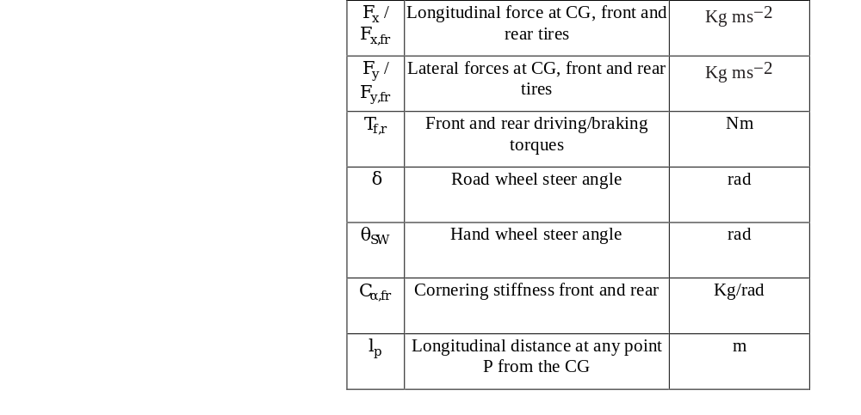

NOMENCLATURE
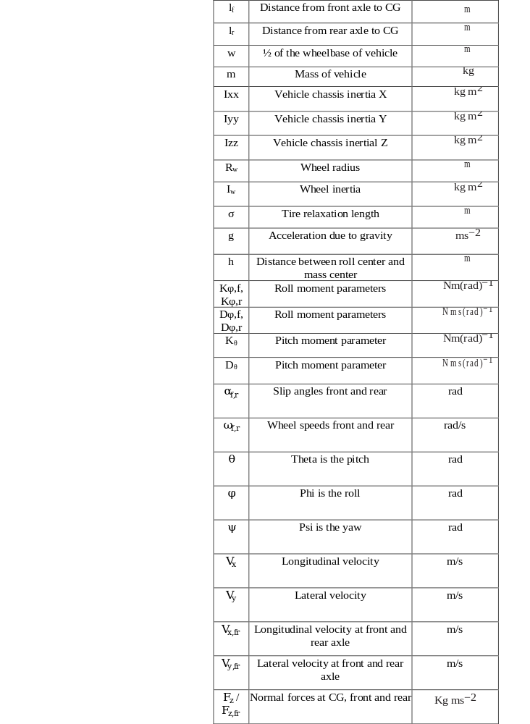

Non-Linear bicycle model
The non-linear bicycle model has 2 translational and 1 rotational degrees of freedom. The derivation and free body diagram (FBD) can be found detailed in [10].
Equations of Motion for the Chassis
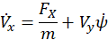
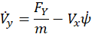

, and
The normal forces at front and rear are given by 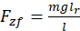 and 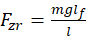 , where

Equations of Motion for the Wheels and Tires

The slip angles, slip ratios and wheel speeds are given by
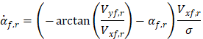

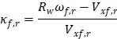

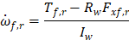

Where 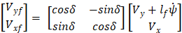 and 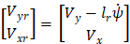
The nominal tire forces according to the Magic formula [7] are given by:
The lateral combined forces are given by the friction ellipse described by the ellipse equation

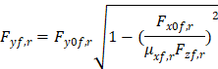

The longitudinal combined forces are given by and
The rotated lateral combined forces are given by and

FOUR-Wheel VEHICLE model
The Four-wheel vehicle model equations of motion are presented here. For derivations. FBD and details refer [11].

Equations of Motion for the Chassis

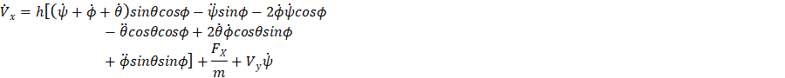

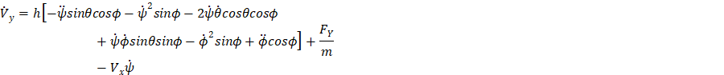

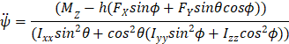

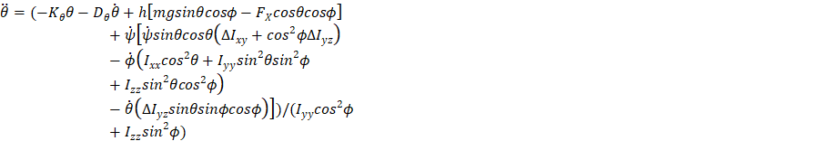

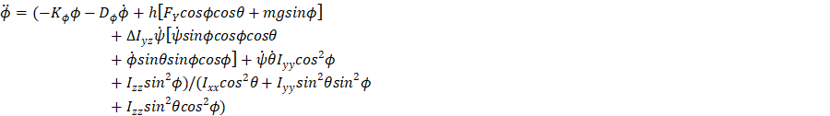

, and

The normal forces at the wheels are given by solving the set of following 4 equations

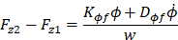
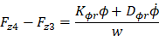

Equations of Motion for the Wheels and Tires

The slip angles, slip ratios and wheel speeds are given by (i=1,2,3,4):
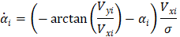

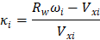

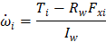

Where 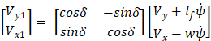 , 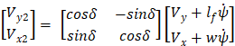,
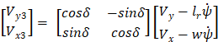 and 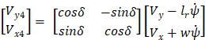

The nominal tire forces according to the Magic formula are given by:

The lateral combined forces are given by the friction ellipse described by the ellipse equation
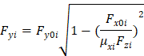

The rotated combined forces are given by

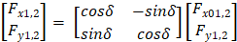 and 