**Execute the following**

**Installation:**

Install jenkins into Kubernetes using the following commands and deployment yaml files

kubectl apply -n kube-deploy -f jenkins-deployment.yaml

kubectl -n kube-deploy create -f jenkins-service.yaml

 

**Add plugins:**

Login http://192.168.1.60:30080 >> Manage Jenkins >> Manage Plugins

Select and Install the following plugins -

1. Unleash Maven

2. Job DSL

3. Simple Build DSL for Pipeline

4. GitHub Integration

5. GitHub

6. Kubernetes Continuous Deploy

7. Kubernetes Cli

**Configure the following pipeline and test:**

Add *srivatsabc_git_login* credentials as shown and configure the pipeline

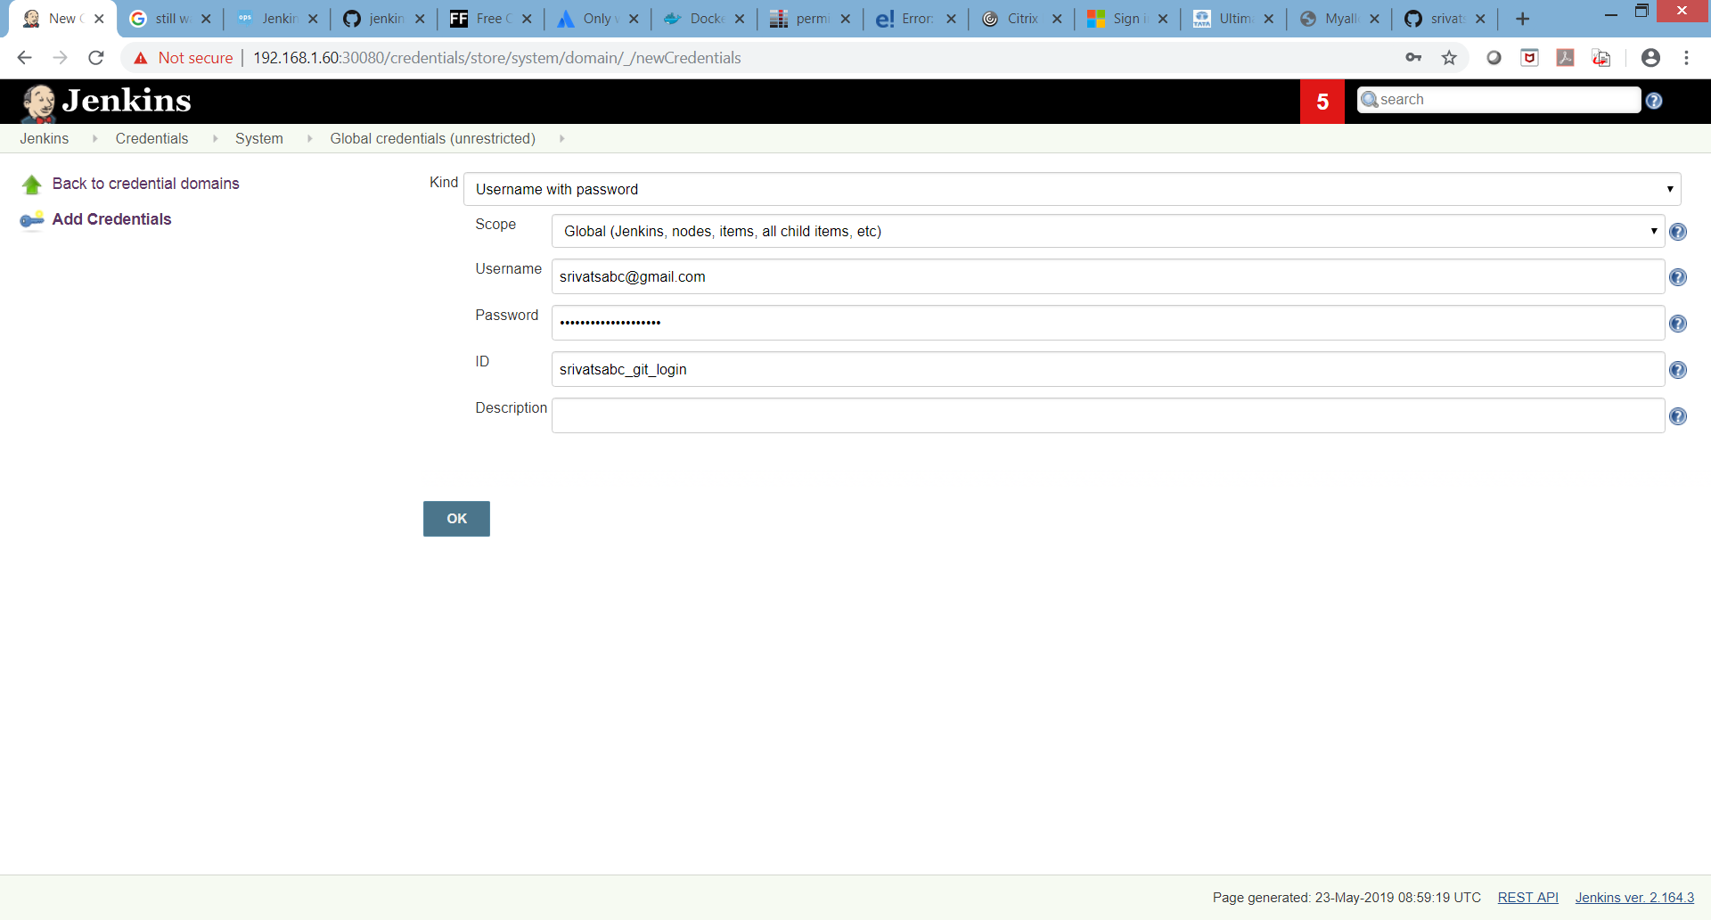

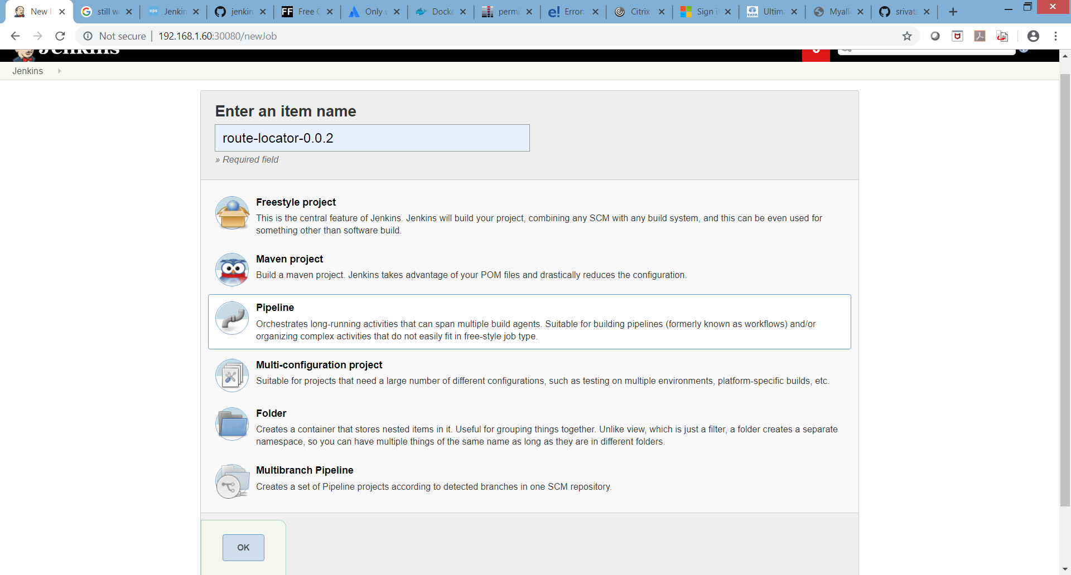

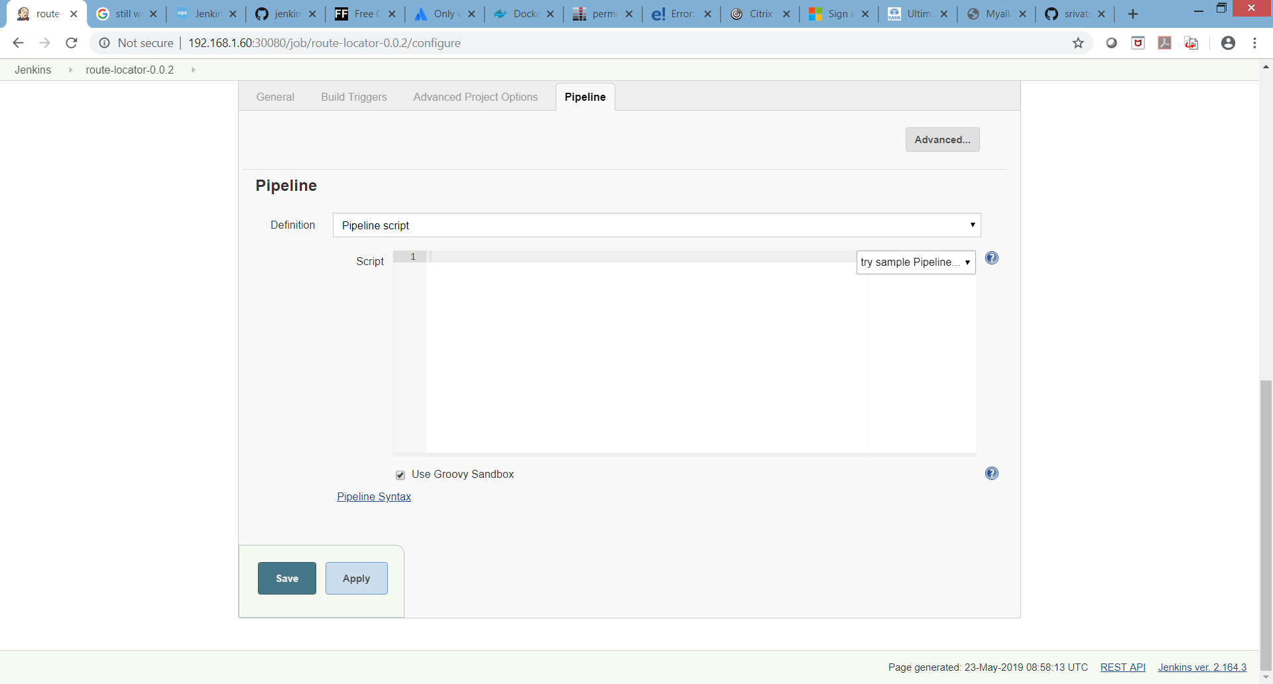



**Freestyle project example (same as above).**

