From Forecasts to Shelf Decisions:
Evaluating AI-Based Inventory Optimization from Traditional Methods to Neural Forecasting
AI Inventory Optimization Research Project
Evidence-freeze commit edb42ad Final public report
September 2026
Abstract
Retailers live or die by two questions: how much will customers want tomorrow, and how much stock should sit on the shelf waiting for them? Most forecasting research answers only the first question. This study answers both. We compare twelve forecasting approaches — from the humble moving average to a global long short-term memory (LSTM) neural network — on two retail demand environments: 500 intermittent-demand series from the Walmart M5 competition data and all 500 series of a dense store-item demand dataset. Every model faces identical conditions: the same calendar window, the same 28-day horizon over eight rolling origins, the same error metrics, and — crucially — the same downstream inventory policy, so that forecasts are finally judged by the costs they create, not just the errors they contain.
The headline result is a tale of two datasets. On sparse M5 demand, the LSTM is the best forecaster (mean absolute scaled error, MASE, of 1.316) and also the cheapest inventory driver (cost 152.83), holding first place across 25 of 27 tested inventory policies: a robust conclusion. On dense store demand, the LSTM is again the best forecaster (MASE 0.978) but only the fourth-cheapest inventory driver (cost 2,247.45), beaten by a simple moving average (2,084.49); leadership there changes hands with the policy (moving average 9, SES 7, naive 6, DES 5 of 27 policies): a fragile, policy-sensitive conclusion. In plain terms, forecast accuracy does not automatically buy better shelf decisions — sometimes the smartest predictor is not the cheapest stocker. Ninety-one paired statistical comparisons (Holm-corrected) separate real differences from noise, and a 27-policy sensitivity grid separates conclusions an executive can bank on from ones that flip when costs or lead times move. All data, code, and validation gates are frozen and traceable; the large-language-model phase of this research program is designed but deliberately unexecuted and appears here only as future work.
Keywords: retail demand forecasting; inventory optimization; intermittent demand; M5 competition; LSTM; Croston method; forecast evaluation; MASE; order-up-to policy; sensitivity analysis.

Research question
How does the effectiveness of AI-based inventory optimization change as we move from traditional forecasting models toward neural-network approaches, when effectiveness is measured at the level of inventory outcomes rather than forecast errors alone?

Hypotheses (neutral framing)
Forecast accuracy differs significantly across model generations on the same series and horizons.
Forecast-accuracy differences translate into measurable inventory-outcome differences under a common policy.
Increasing model sophistication yields monotonically improving inventory outcomes. (The claim under test — rejection is a publishable finding, not a failure.)
Observed patterns are consistent across the two retail environments.

At a glance
 | M5 (sparse, intermittent) | Store (dense, smooth)
Best forecaster | LSTM (MASE 1.316) | LSTM (MASE 0.978)
Best inventory driver | LSTM (cost 152.83) | Moving average (cost 2,084.49)
Verdict | Robust: LSTM first in 25/27 policies | Fragile: lead shared 9 / 7 / 6 / 5
Lesson | Best forecast $→$ best decision | Best forecast $↛$ best decision
Forecast accuracy does not necessarily imply inventory decision superiority.

Project Overview and Objective

Problem context
Every retailer runs the same daily gamble. Order too much and cash sits on shelves gathering dust; order too little and customers walk away empty-handed, taking their money to a competitor. The first mistake shows up as holding cost, the second as stockout cost, and the optimal order sits somewhere between them. Getting that balance right starts with predicting demand — but it does not end there. A forecast is a number on a screen; an order is money in motion. This study is about the full journey from number to money.
Two demand worlds make the problem interesting. In the first, captured by the Walmart M5 data, most items on most days sell nothing at all: demand is sparse, spiky, and intermittent, with a 64.5% zero rate across the studied series. Classical forecasting tools were built for smooth, every-day demand and often stumble here. In the second world, a store-item demand dataset, nearly every item sells every day (zero rate 0.02%): demand is dense and comparatively smooth. A method that shines in one world may embarrass itself in the other, and any serious claim about “the best model” must survive both.

Why forecast accuracy alone is insufficient
Consider two forecasters. Forecaster A misses by two units on average; forecaster B misses by three. By any accuracy metric, A wins. But suppose A’s errors are all under-predictions on high-margin rush days, while B’s errors are harmless over-predictions on quiet Tuesdays. Fed into a real ordering rule, B can easily produce the cheaper shelf. Accuracy metrics weight every unit of error equally; inventory costs do not. They punish stockouts and overstocks asymmetrically, filter forecasts through safety-stock formulas, and interact with lead times and reorder rhythms. Judging a forecasting model without running its forecasts through an inventory policy is like judging an engine without putting it in a car. This study therefore evaluates every model twice: once as a forecaster, once as a driver of inventory decisions under one shared, identical ordering policy.

Research question
How does the effectiveness of AI-based inventory optimization change as we move from traditional forecasting models toward neural-network approaches, when effectiveness is measured at the level of inventory outcomes rather than forecast errors alone?

Hypotheses
The study tests four neutrally framed claims so that any outcome is informative: H1, accuracy differs significantly across model generations; H2, accuracy differences move inventory outcomes under a common policy; H3, sophistication improves inventory outcomes monotonically (the claim under test — its rejection would be the finding, not a failure); H4, patterns hold across both retail environments. Verdicts appear in section 4.20.

Objectives
- Compare twelve forecasting approaches — baselines, exponential smoothing, ARIMA/SARIMA, Croston-family specialists, and a global LSTM — on identical footing across two demand environments.
- Evaluate each model twice: on forecast accuracy and on the inventory cost its forecasts generate under a shared ordering policy.
- Separate statistical significance from practical importance using paired tests, effect sizes, and confidence intervals.
- Separate robust conclusions from policy-sensitive ones using a 27-policy sensitivity grid.
- Publish a frozen, traceable evidence base any reader can audit.

Scope
The study covers univariate daily demand forecasting (no prices, promotions, or calendar features), a 28-day horizon over eight rolling origins, and a single family of inventory policies (daily-review order-up-to, lost sales). The M5 analysis uses a stratified sample of 500 series, not the full 30,490 catalog. SARIMA runs Store-only and the Croston family M5-only, each for documented methodological reasons. The planned large-language-model phase is designed but deliberately unexecuted; it appears only as future work (section 7.9).

Research contributions
Empirically, the study demonstrates the forecast–decision gap in both directions within one controlled design: alignment on M5, divergence on Store demand. Methodologically, it contributes a shared-policy evaluation harness that makes cross-model inventory comparison fair by construction, a leakage-safe rolling protocol with scale-free metrics, and a sensitivity-as-verdict discipline for robustness claims. Analytically, it pairs every significance statement with an effect size and every headline ranking with a policy-stability verdict. For reproducibility, the frozen evidence package (number sheet, figure and table audits, claim traceability) lets a skeptical reader check any number in this report back to its source file.

Datasets at a glance
M5 (primary). Walmart M5 competition data (Makridakis et al. 2022): thousands of item–store daily series, 2011–2016. This study uses 500 stratified series over the common window 2013-01-01 to 2016-05-22. Sparse and intermittent: the archetype split is 194 highly intermittent, 199 intermittent, 26 moderate, 80 variable, and 1 smooth series. Store Item Demand (secondary robustness environment). Kaggle Store Item Demand Forecasting Challenge: 10 stores $×$ 50 items = 500 series, complete panel of 913,000 rows, 2013-01-01 to 2017-12-31, analyzed over the same common window. Dense: essentially no zero-demand days. [fig:rep-m5,fig:rep-store,fig:diversity] show the contrast.
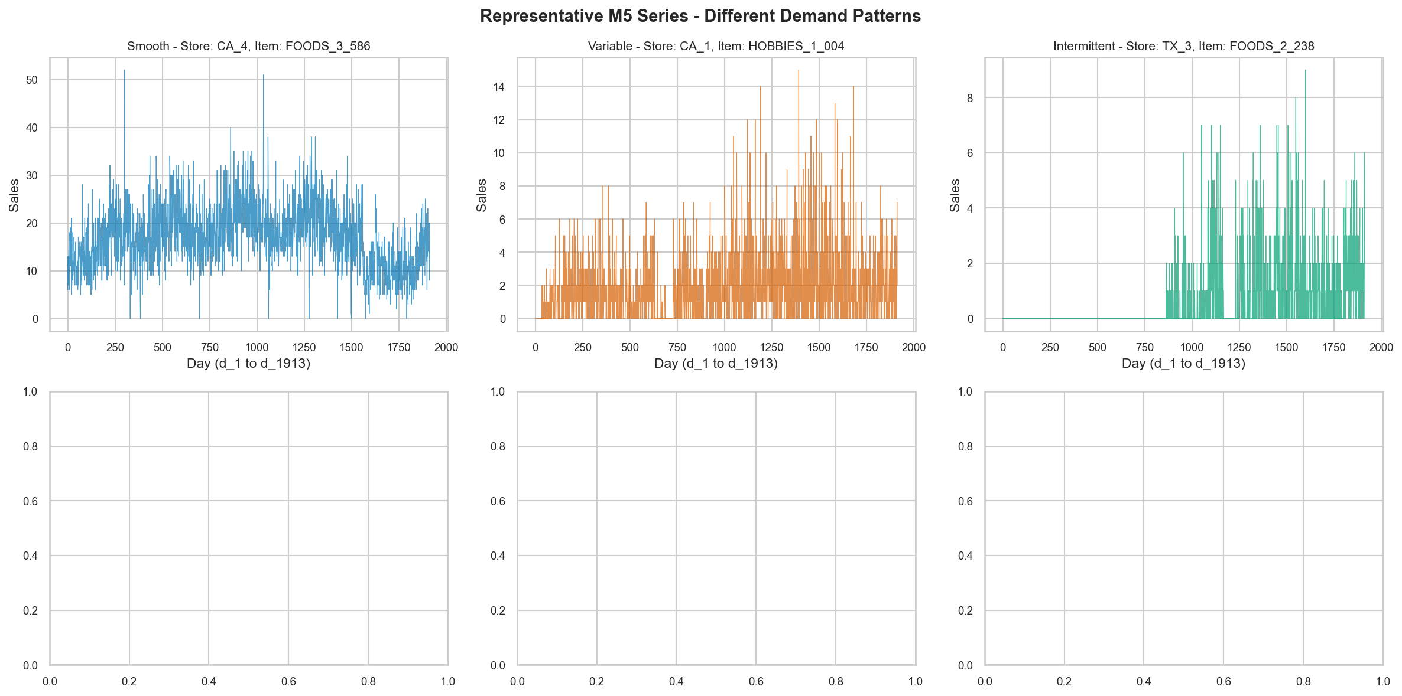
Representative sparse M5 series: long stretches of zero demand broken by spikes. Source: 07_figures/eda/m5 (notebook 03).
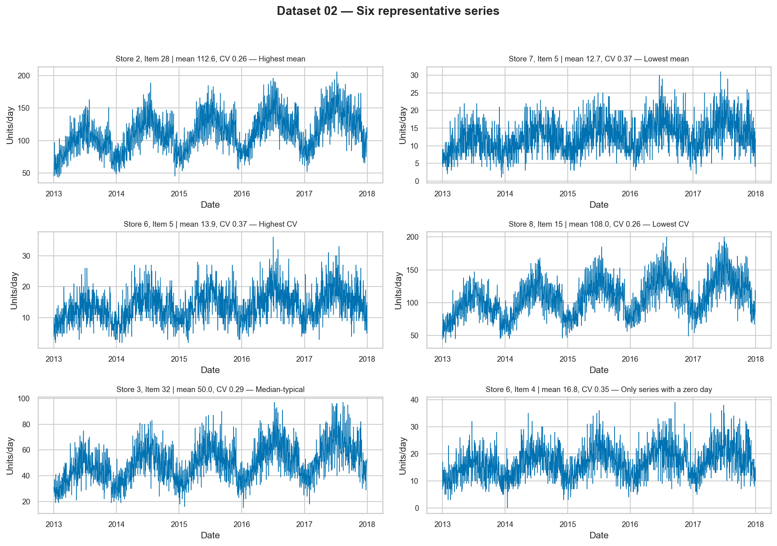
Representative dense Store series: demand every day with weekly rhythm. Source: 07_figures/eda/store_item_demand (notebook 03).
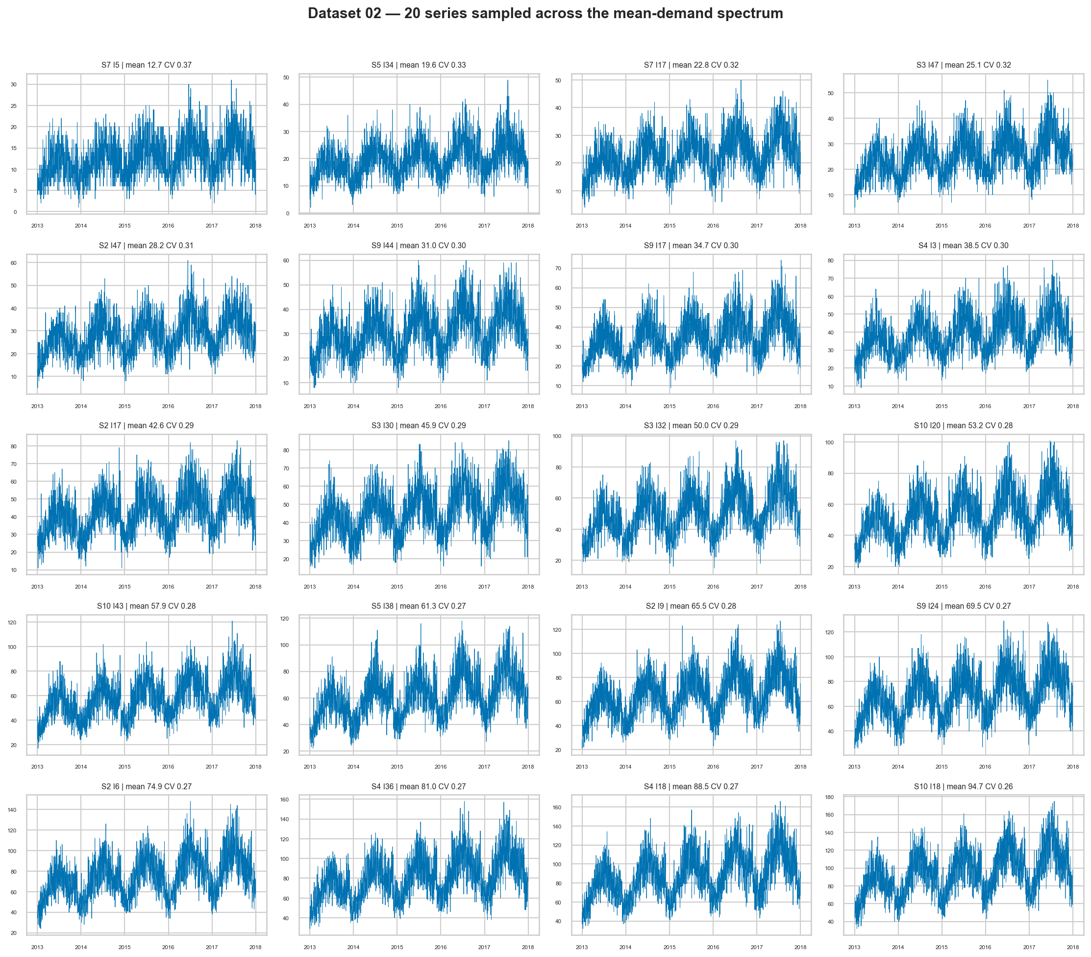
Store demand diversity: level and volatility vary widely even in a dense environment, so one fixed model cannot fit all. Source: notebook 03.

What the study establishes
Three things. First, a credible forecast leaderboard on both datasets with uncertainty properly quantified. Second, a decision-level leaderboard showing where forecasting skill converts into money and where it does not. Third, a robustness map telling the reader which conclusions survive contact with different lead times, service targets, and cost ratios — and which do not. The short version is the at-a-glance panel: on M5 the smartest forecaster is also the cheapest stocker and stays there; on Store demand it is not, and leadership depends on the policy.

Research Methodology

End-to-end research workflow
The study runs as a notebook ladder: a research map (00) fixes the question; environment control (01) freezes seeds and software; acquisition and audit notebooks (02a, 02b) verify both datasets; exploratory analysis (03) characterizes demand before any model is chosen; experimental design (04) locks the protocol; a teaching notebook (05a) establishes time-series vocabulary; then the model rungs execute in order — baselines (05b), exponential smoothing (06), Croston specialists (06c), ARIMA/SARIMA (07), LSTM (08). A post-hoc hardening pass corrected nine classes of issues (leap-day calendar gap, LSTM validation leakage, subset-comparability, metric methodology, shared policy) and froze the evidence; see section 2.14. Every notebook maps to report sections in the traceability matrix (traceability/notebook_traceability.csv).

Data acquisition and audit
M5 source files (sales_train_evaluation.csv, calendar.csv) were audited for dimensions (30,490 item–store series, day columns d_1 onward with a verified d-index alignment), and the Store file (train.csv) was verified as a complete panel: every store–item–date combination present, no duplicates, a single zero-sales entry. Both datasets were reindexed onto one common calendar so that cross-dataset comparison never confounds “model effect” with “different history lengths.”

Temporal experimental protocol
1 is the frozen design. Time-based splits only — no shuffling, ever. Training covers 2013-01-01 to 2015-10-31 (1,034 days); validation 2015-11-01 to 2016-02-29 (121 days, leap day included after the hardening correction); testing 2016-03-01 to 2016-05-22 (83 days). Forecasts span $h=28$ days from each of 8 weekly rolling origins under an expanding window: every model sees strictly the history before each origin, asserted in code. All selection (windows, smoothing weights, ARIMA orders, Croston alphas, LSTM stopping) uses validation data only; the test window is touched once for final scoring. Global seed 42 governs all stochastic steps.
Frozen experimental protocol (source: 05_experiments/config.json).
Element | Frozen value
Common window | 2013-01-01 to 2016-05-22 (1,238 days)
Train / validation / test | 1,034 / 121 / 83 days (validation includes 2016-02-29)
Horizon $h$ | 28 days, 8 weekly rolling origins, expanding window
M5 sample | 500 series, stratified by archetype $×$ department
Store sample | All 500 series (complete panel)
Evaluation population | $500×8×28=112,000$ forecasts per model–dataset
Seed | 42 everywhere

Series selection
Store demand uses all 500 series — no sampling needed. M5 contributes a stratified sample of 500 (recorded in 05_experiments/m5_series_selection.json) covering all demand archetypes and departments, because random sampling could miss rare but important demand shapes and full-catalog deep learning was computationally prohibitive. 4 documents representativeness.
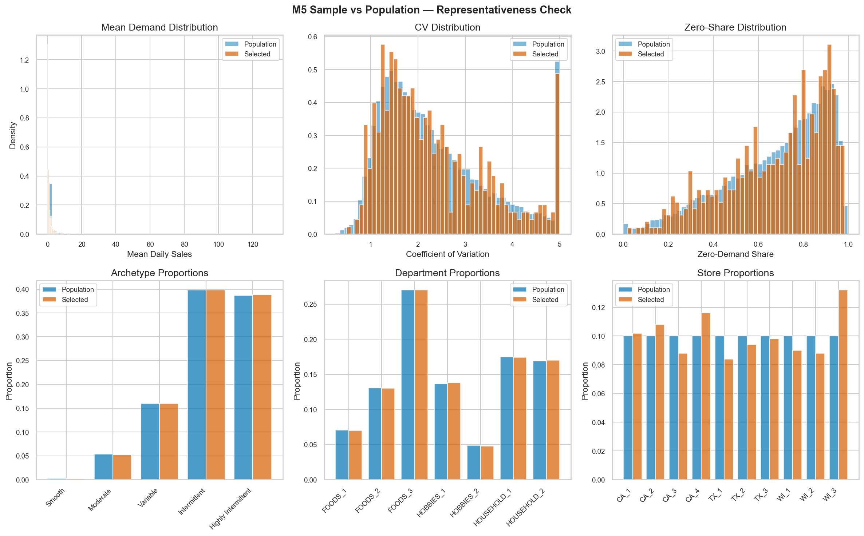
M5 500-series stratified selection: coverage across archetypes and departments. Source: notebook 04.

Demand characterization and archetypes
Following the Syntetos–Boylan tradition (Syntetos and Boylan 2005), intermittency is characterized per series by average demand interval (ADI) and squared coefficient of variation (CV$​^{2}$), yielding quadrants labeled here as Smooth, Intermittent, Erratic/Variable, and Lumpy/Highly Intermittent, plus a Moderate band. Volume terciles add a second axis. The resulting M5 archetype counts are 194 highly intermittent, 199 intermittent, 26 moderate, 80 variable, and 1 smooth — the last being anecdotal by construction (section 7.6).
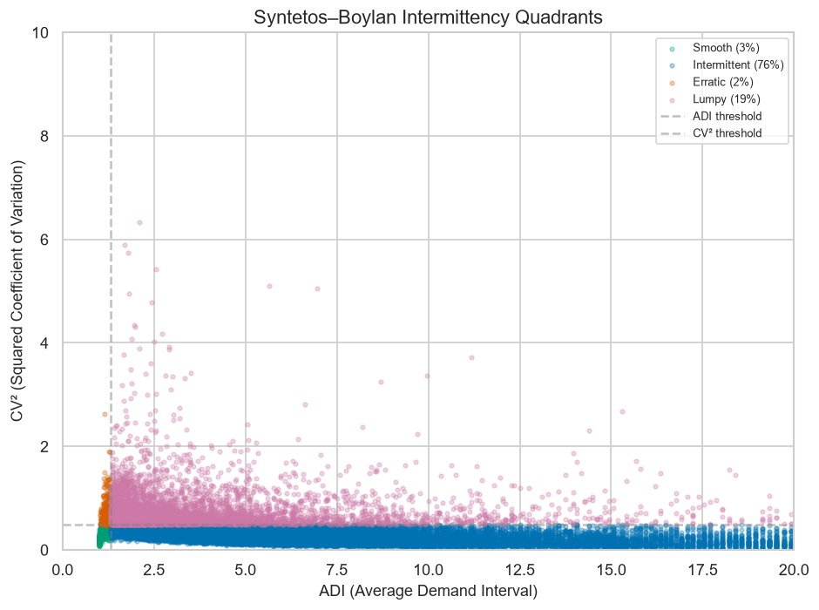
Intermittency quadrants (ADI vs. CV$​^{2}$): the map that motivates both the archetype analysis and the Croston rung. Source: notebook 03.

Model-ladder design
Models ascend in complexity while the evaluation stays fixed: baselines (Naive, Seasonal Naive, Moving Average) set the “beat this to matter” bar; SES, DES (Holt), and additive TES add memory for level, trend, and seasonality; ARIMA adds autocorrelation modeling and SARIMA seasonal autocorrelation; the Croston family specializes in intermittent demand; the global LSTM learns nonlinear patterns across all series of a dataset. Complexity is the independent variable; value is what is measured. 6 sketches the ladder.
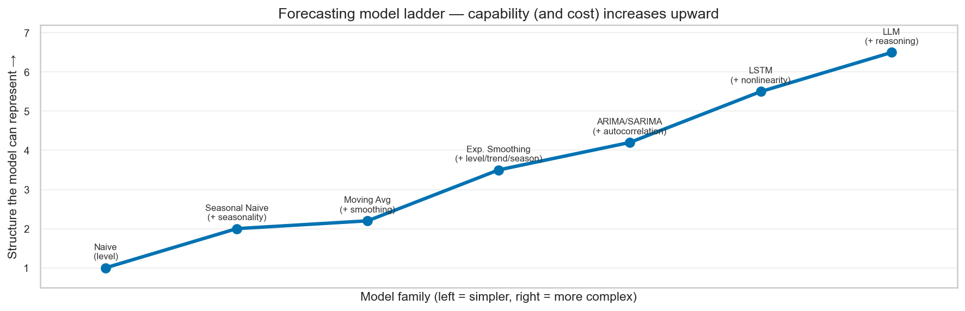
The model ladder: complexity rises rung by rung; whether value rises with it is the empirical question (it does not, monotonically). Teaching figure from notebook 05a.

Forecasting models
Naive repeats the last observed day; Seasonal Naive repeats the last seven observed days (an early implementation that peeked beyond the seasonal window was caught and corrected to repeat only observed values); Moving Average uses validation-selected global windows (M5: 14 days; Store: 7 days). SES (level, $α=0.1$), DES (level $+$ trend, $0.2/0.2$), and additive TES (level $+$ trend $+$ weekly season, $0.3/0.3/0.3$) use transparent implementations with validation-grid selection. ARIMA(1,1,0) runs on both datasets with a sparse-data pre-check (series with $>85\%$ zeros fall back to Naive rather than fitting noise). SARIMA(1,1,0)(0,1,1)$​_{7}$ runs Store-only: seasonal differencing on mostly-zero series is methodologically dubious, and the Croston family already covers the M5 specialty. Croston/SBA/TSB (validation alphas 0.1 / 0.5 / 0.1–0.3) run M5-only, since a flat intermittent-demand forecast has no premise on dense data. The LSTM is one global network per dataset (28-day lookback, per-series history-only scaling, chronological per-series validation), so it learns cross-series patterns rather than memorizing individual items. Full configurations live in appendix C.

Forecast evaluation metrics
Headline accuracy is mean absolute error (MAE); the primary scale-free metric is MASE with seasonal period $m=7$ (weekly retail rhythm, figure 7), whose denominator is the in-sample one-step seasonal-naive error on training data only — validation and test never enter it. RMSE, RMSSE, WAPE, and sMAPE are reported alongside; no metric is cherry-picked. Two disciplined choices matter. First, denominators that hit zero (constant training history) stay honest NaNs instead of epsilon-guarded fakes (zero occurred nowhere: $n_{\text{NaN}}=0$ everywhere). Second, archetype-level WAPE and sMAPE are pooled ratios over each cell, because averaging per-series ratios lets one near-zero-demand series explode the mean (an intermediate computation hit $∼2×{10}^{9}$ before the fix); model-level WAPE columns remain per-series means and were verified consistent across files. sMAPE is reported with its known zero-demand distortions documented, not hidden. Definitions are formalized in appendix A.
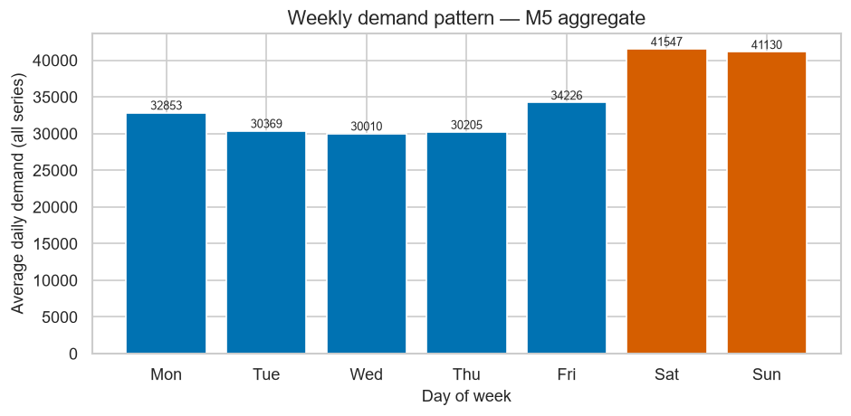
Weekly seasonality in retail demand: the business-week rhythm that justifies seasonal period $m=7$ in MASE/RMSSE, Seasonal Naive, and SARIMA. Source: notebook 03.
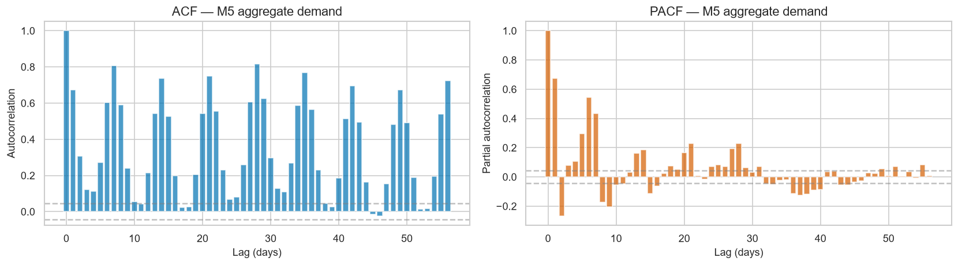
Autocorrelation structure: demand remembers its recent past, which is the premise ARIMA-style models exploit. Source: notebook 03.

Statistical comparison
Ninety-one paired comparisons (55 M5 $+$ 36 Store) combine the Wilcoxon signed-rank test (normal approximation) with the Diebold–Mariano test (Diebold and Mariano 1995), Holm correction (Holm 1979) for multiplicity, 500-replication bootstrap confidence intervals (Efron and Tibshirani 1993), Cohen’s paired $d_{z}$, and the Wilcoxon rank-biserial $r$. With 112,000 paired errors, nearly everything is “significant” — which is exactly why every $p$-value travels with an effect size. Methodology detail is in appendix B.

Inventory policy
All forecasts drive one shared ordering engine (11_src/inventory_policy.py), identical for every model by construction: a daily-review order-up-to (base-stock) policy with lost sales. Per series–origin instance, safety stock is $z$ times the forecast-error standard deviation (floored) times $\sqrt{L}$; the order-up-to level is the sum of the next $L$ forecasts plus safety stock; unmet demand is lost at penalty $P$ per unit; end-of-day stock accrues holding cost $H$ per unit. The default ranking policy is $L=7$, 95% service target ($z≈1.645$), $H=1$, $P=5$. Costs decompose into holding $+$ stockout, with service level, average inventory, and reorder counts as diagnostics. 9 shows how forecasts become orders.
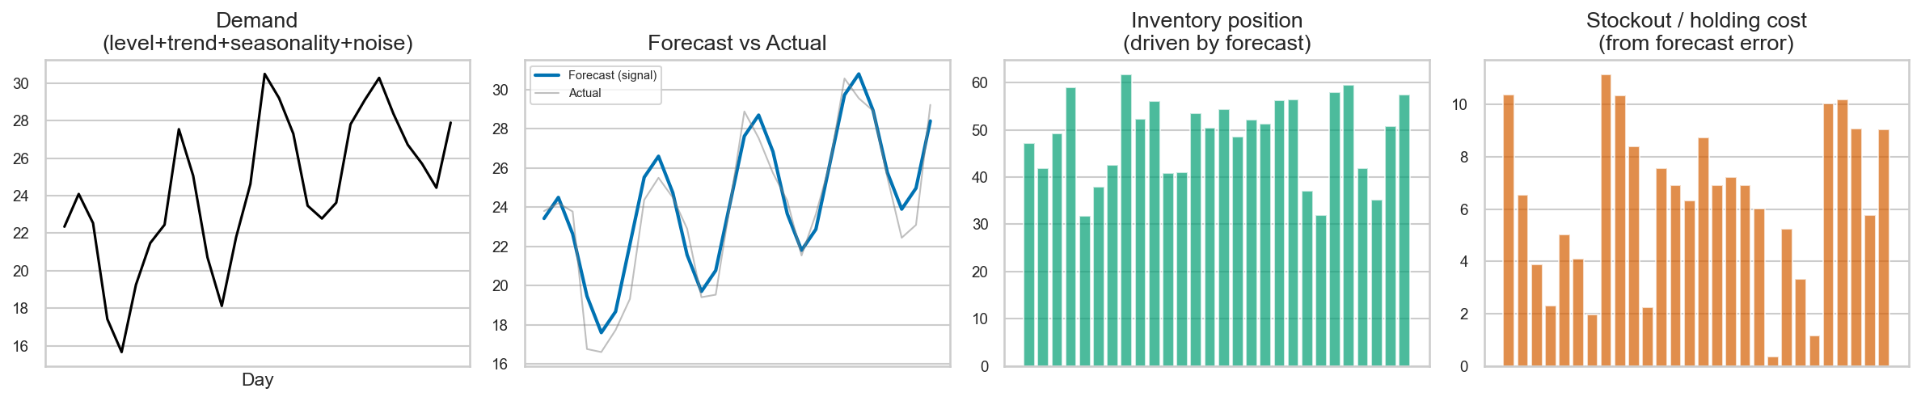
From forecast to shelf: forecasts feed safety stock and order-up-to levels; the policy — not the error metric — decides what an error costs. Teaching figure from notebook 05a.

Robustness and sensitivity analysis
Headline rankings use the default policy, but trust requires more: a 27-policy grid ($L∈\{3,7,14\}×$ service $∈\{90\%,95\%,99\%\}×P∈\{3,5,10\}$, $H=1$) replays every model–dataset through 540 costing runs. A model first across nearly all policies is robust; one whose crown moves with the policy is fragile. Per-archetype M5 costing adds the demand-structure dimension.

Convergence and feasibility
Every ARIMA/SARIMA fit is logged per series–origin (convergence_details_*.csv) with a scope column separating the exploratory 100-series SARIMA subset from the primary full-500 run. A 16-fit feasibility probe (0.62 s/fit) preceded the 4,000-fit full-500 SARIMA run (2,382 s, 4,000/4,000 successful). Zero-failure convergence on dense data is itself a finding when contrasted with the sparse-data fallback rate.

Validation and reproducibility
An independent validator re-checks row counts (112,000 per model–dataset), duplicate keys (zero), origin coverage (1–8), horizon length (28 everywhere), test-window containment, forecast finiteness/non-negativity, and cross-family actuals identity (max spread 0.0): 0 FAIL (06_results/validation_report.json). Seeds (42), manifests, run logs, and a pre-hardening backup make every step replayable; provenance is inventoried in appendix I.

Research hardening and final evidence freeze
Before reporting, the evidence passed a hardening audit that corrected the calendar (leap day 2016-02-29 assigned to validation: 1,034/121/83), revalidated the LSTM on chronological per-series splits, fixed a Seasonal Naive lookahead, unified all models onto one inventory module, corrected MASE grouping and Wilcoxon effect sizes, pooled archetype WAPE/sMAPE, replaced the SARIMA subset with the full-500 run as the primary result, and repaired identifiers. Pre-hardening originals are preserved untouched in 06_results/_pre_hardening_backup/ and never used as report sources. The freeze (commits 53c8343 through edb42ad) generated the number sheet, figure/table audits, and claim traceability programmatically — no headline number in this report was typed by hand. Hardening is reported to explain why the evidence can be trusted, not as a debugging diary.

Models Used
Each rung below states what the method does in one breath, why it earned a place, how it was actually run here, and what job it does on the ladder. Textbook derivations are omitted; implementation truth is in appendix C.

Naive
Does: tomorrow equals today. Why: the irreducible baseline — any method that cannot beat “repeat yesterday” adds no value. Implementation: last observed value carried forward 28 days; history strictly before each origin. Role: reference floor. It is a weak floor (M5 MAE 1.18; Store 16.29) but, remarkably, wins 6 of 27 Store inventory policies — a first hint that accuracy and cost diverge.

Seasonal Naive
Does: tomorrow equals the same weekday last week. Why: retail demand has a weekly heartbeat (figure 7); this is the cheapest way to use it. Implementation: repeats only the last seven observed values (a lookahead bug reaching past the seasonal window was found and fixed during hardening). Role: seasonal reference line run in every phase. It is Store’s third-cheapest inventory driver (2,128.14) despite middling accuracy — weekly rhythm, it turns out, stocks shelves well.

Moving Average
Does: forecasts the average of the last $w$ days — a low-pass filter on noisy demand. Why: the classic practitioner workhorse: no parameters to break, no trends to chase. Implementation: global window chosen on validation (M5: $w=14$; Store: $w=7$; per-series counts favored 28 on M5 and 7 on Store, but the global rule won on validation MAE). Role: the simple method the fancy ones must justify themselves against. It nearly tops M5 forecasting (MASE 1.346 vs. LSTM 1.316) and wins Store inventory (2,084.49).

Simple Exponential Smoothing
Does: tracks a slowly moving level, weighting recent days more ($α=0.1$ selected on validation). Why: the minimal model with memory — level without trend or seasonality (Hyndman and Athanasopoulos 2018). Implementation: transparent SES, grid-searched $α$. Role: smoothing-rung anchor. SES is the quiet overachiever: second-cheapest on M5 inventory (159.31), second-cheapest on Store (2,113.82), and winner of 2 M5 sensitivity policies at short lead with high stockout penalty.

Double Exponential Smoothing
Does: SES plus a trend component ($α=β=0.2$). Why: to test whether explicit trend modeling helps. Implementation: Holt’s method, grid-searched. Role: cautionary tale. DES over-stocks badly (average inventory 8.41 on M5, 76.07 on Store) and lands mid-pack or worse on cost — trend extrapolation on noisy retail data buys inventory, not accuracy. It nonetheless wins 5 Store sensitivity policies, which says more about Store fragility than DES quality.

Triple Exponential Smoothing
Does: DES plus a weekly seasonal component (additive Holt–Winters, $0.3/0.3/0.3$). Why: the full classical toolkit in one model. Implementation: transparent additive form. Role: the negative finding. TES is worst almost everywhere: M5 MASE 2.60 and cost 346.68; Store MASE 2.11 and cost 3,419.88; worst in every archetype. Complexity without discipline is just expensive noise.

ARIMA
Does: models tomorrow as a linear mix of recent values and recent shocks after differencing to stationarity (Box and Jenkins 1970; Hyndman and Athanasopoulos 2018). Why: the statistical view of autocorrelation that smoothing cannot express. Implementation: fixed ARIMA(1,1,0) after a validation sanity check (per-series search rejected as overfitting-prone and over-budget); series with $>85\%$ zeros skip fitting and fall back to Naive. Role: linear-memory representative. Mid-pack accuracy (M5 MASE 1.51; Store 1.45) with a striking fallback asymmetry: 22.65% on sparse M5 vs. 0% on dense Store.

SARIMA
Does: ARIMA plus seasonal autoregression and moving averages. Why: to test whether explicit weekly autocorrelation beats SES-style seasonality on dense data. Implementation: SARIMA(1,1,0)(0,1,1)$​_{7}$, Store-only, full 500 series $×$ 8 origins (4,000 fits, 4,000 successes, 2,382 s). An earlier 100-series subset exists but is exploratory-only and never the headline. Role: seasonal-statistical challenger. Store MASE 1.055 — second-best forecaster — yet fifth-cheapest on cost (2,282.31): exhibit B of the forecast–decision gap.

LSTM
Does: a recurrent network with gating that learns nonlinear, long-range temporal patterns across all series jointly (Hochreiter and Schmidhuber 1997). Why: the neural rung: can shared structure beat per-series statistics? Implementation: one global model per dataset, 28-day lookback, history-only per-series scaling, chronological per-series validation (rebuilt during hardening to remove overlapping-window leakage), seed 42. Role: the complexity thesis. It wins forecasting on both datasets and M5 inventory, but loses Store inventory — the most important single-model story in the report (section 4.12).
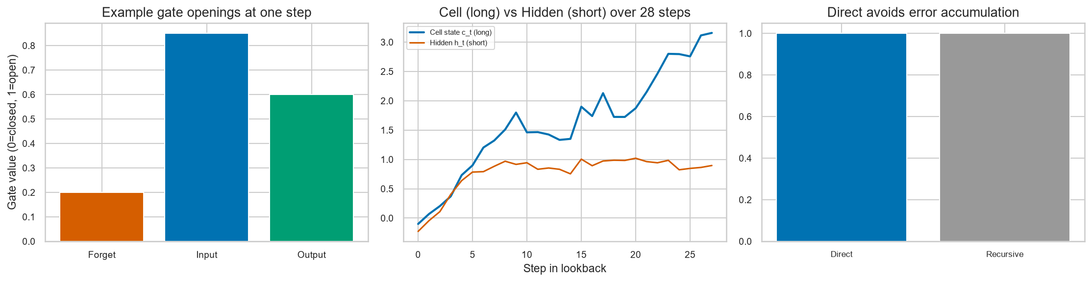
The LSTM cell: gates decide what to remember, forget, and output, letting the network carry useful signal across weeks of noisy demand. Teaching figure from notebook 08.

Croston
Does: splits intermittent demand into two hidden sequences — demand size when it occurs, and interval between occurrences — smoothing each separately (Croston 1972). Why: general models assume every day carries signal; on sparse data most days carry none, and Croston refuses to fit noise to zeros. Implementation: M5-only, $α=0.1$ validation-selected, flat 28-day rate forecast. Role: intermittency specialist baseline. Respectable accuracy (MAE 1.08) and the best service level on M5 (93.9%), but out-stocked on cost (174.81) by its own corrected siblings.

SBA
Does: Croston with the Syntetos–Boylan debiasing factor (Syntetos and Boylan 2005): multiplies the rate by $(1−α/2)$ to correct Croston’s over-forecast bias. Why: the standard bias-corrected intermittent-demand method. Implementation: M5-only, $α=0.5$. Role: best cost performer of the family (160.66) — a small algebraic correction worth real money.

TSB
Does: replaces Croston’s interval smoothing with direct probability-of-demand updating, reacting faster when demand patterns shift (Teunter et al. 2011). Why: the modern intermittent-demand alternative. Implementation: M5-only, $(α,β)=(0.1,0.3)$. Role: best accuracy of the family (MAE 1.010, MASE 1.369) but second on cost (165.13): within one family, the accuracy–cost ranking already flips.

Model-ladder comparison
2 compresses the ladder to one page: twelve methods, five rungs, two datasets with deliberate scope exceptions (SARIMA Store-only, Croston family M5-only). The pattern to carry into section 4: the ladder predicts complexity, not value.
Model taxonomy: purpose, scope, and rung. Full configurations in appendix C.
Model | Rung | Scope | Job on the ladder
Naive | Baseline | Both | Reference floor
Seasonal Naive | Baseline | Both | Weekly-rhythm reference
Moving Average | Baseline | Both | Practitioner workhorse
SES | Smoothing | Both | Level memory
DES | Smoothing | Both | Trend test (fails expensively)
TES | Smoothing | Both | Full classical kit (worst)
ARIMA(1,1,0) | Statistical | Both | Linear memory
SARIMA(1,1,0)(0,1,1)$​_{7}$ | Statistical | Store only | Seasonal challenge
LSTM (global) | Neural | Both | Complexity thesis
Croston | Intermittent | M5 only | Sparse-data specialist
SBA | Intermittent | M5 only | Debiased specialist
TSB | Intermittent | M5 only | Adaptive specialist

Key Findings and Results

Overall forecasting results
11 tells the whole forecasting story in one panel. On M5, a tight lead cluster — LSTM (1.316), Moving Average (1.346), SES (1.351), TSB (1.369) — separates from ARIMA (1.505), the Naive family ($≈$1.53), and the smoothing failures DES (1.987) and TES (2.599). On Store demand the spread is wider and more decisive: LSTM (0.978) stands alone below 1.0, followed by SARIMA-full500 (1.055), Seasonal Naive (1.183), and Moving Average (1.191), with Naive (1.971) and TES (2.111) far behind. Two remarks before the detail: MASE below 1.0 means beating a seasonal-naive-on-training benchmark, which only Store LSTM achieves; and the M5 lead cluster is so tight that statistical machinery is needed to rank inside it honestly (section 4.5).
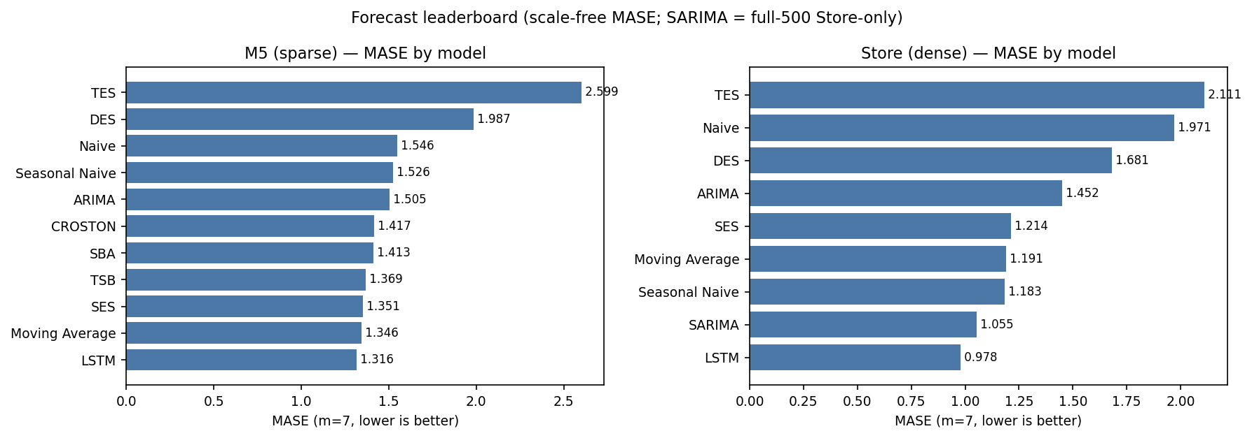
Forecast leaderboard (MASE, $m=7$, lower is better). M5: tight LSTM / MA / SES / TSB cluster. Store: LSTM alone sub-1.0, SARIMA-full500 second. Deterministic rebuild from final files (F-NEW-01).

M5 forecasting results
3 is the M5 board. LSTM leads on both MAE (0.989) and MASE (1.316); Moving Average (0.9997 / 1.346) and SES (0.998 / 1.351) are within a whisker, and TSB (1.010 / 1.369) completes the lead pack. SBA and Croston sit just behind; ARIMA (1.132 / 1.505) trails the pack without disgrace; the Naive pair ($≈$1.19) anchors the middle; DES (1.514) and TES (1.922) fail outright. Note the RMSE column’s warning: SES’s RMSE (2.00) exceeds Croston’s (2.11)? No — read carefully: SES 2.00 vs. Croston 2.11 vs. LSTM 1.95 vs. Moving Average 1.30. Moving Average owns the best RMSE by far, because averaging suppresses the large errors RMSE punishes quadratically — yet it loses MAE/MASE to LSTM. Different losses already crown different champions before inventory enters the picture. sMAPE ($≈$117–161%) confirms that percentage errors on near-zero demand are huge for everyone; WAPE (per-series mean) ranks LSTM (0.77) first, matching the MAE story.
M5 forecast leaderboard ($n=112,000$ per model). Bold: column best.
Model | MAE | RMSE | MASE | RMSSE | WAPE | sMAPE (%)
LSTM | 0.99 | 1.95 | 1.32 | 0.85 | 0.77 | 144.2
Moving Average | 1.00 | 1.30 | 1.35 | 0.86 | 1.31 | 143.5
SES | 1.00 | 2.00 | 1.35 | 0.86 | 0.78 | 145.1
TSB | 1.01 | 2.01 | 1.37 | 0.88 | 0.79 | 146.3
SBA | 1.07 | 2.12 | 1.41 | 0.89 | 0.83 | 148.1
Croston | 1.08 | 2.11 | 1.42 | 0.87 | 0.85 | 143.9
ARIMA | 1.13 | 2.32 | 1.51 | 1.05 | 0.88 | 139.0
Naive | 1.18 | 1.60 | 1.55 | 1.12 | 1.43 | 160.9
Seasonal Naive | 1.19 | 1.67 | 1.53 | 1.14 | 1.45 | 152.7
DES | 1.51 | 3.43 | 1.99 | 1.33 | 1.18 | 117.8
TES | 1.92 | 4.39 | 2.60 | 1.85 | 1.50 | 116.0
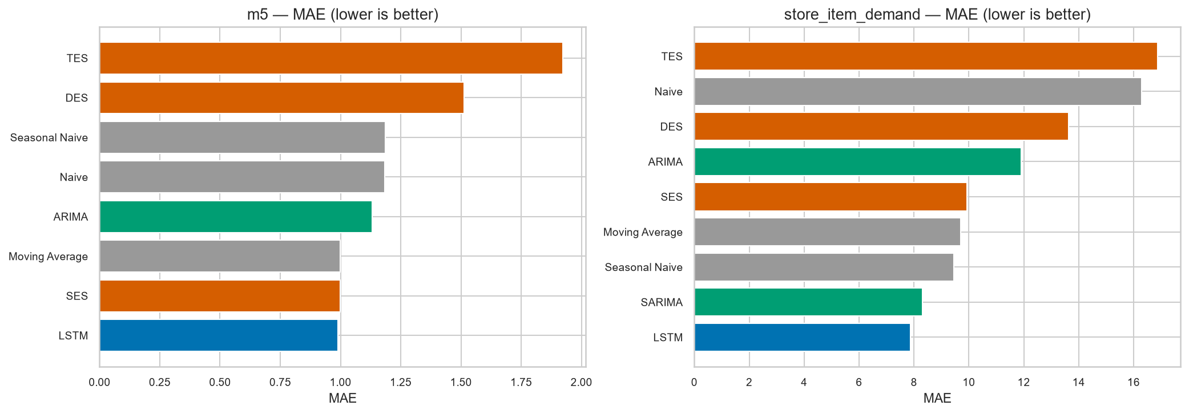
Full-ladder MAE comparison including LSTM (hardened run). The M5 cluster at $≈$1.0 and Store’s LSTM-led spread are both visible here; exact boards are tables 3 and 4. Source: notebook 08.
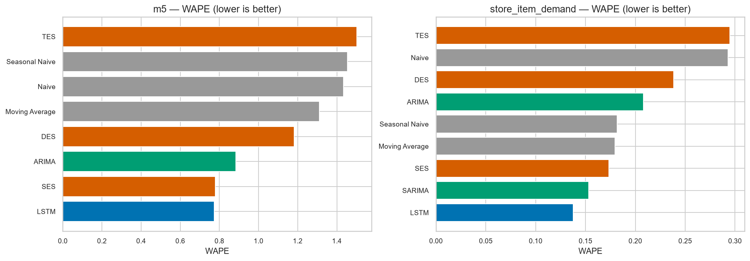
Full-ladder WAPE comparison. Note Store WAPE values are an order of magnitude smaller (dense demand inflates the denominator) — cross-dataset WAPE levels are not comparable; ranks are. Source: notebook 08.

Store forecasting results
4 is the Store board, and it is less ambiguous. LSTM wins every column that matters (MAE 7.87, MASE 0.978, RMSSE 0.971, WAPE 0.138); SARIMA-full500 is a clear second (8.45 / 1.055 / 1.040 / 0.148); Seasonal Naive (9.45) and Moving Average (9.71) form the next tier; SES (9.92) follows; ARIMA (11.90), DES (13.63), Naive (16.29), TES (16.87) trail. Two points deserve emphasis. First, seasonal structure pays on Store demand: SARIMA’s seasonal moving-average term cuts MAE from ARIMA’s 11.90 to 8.45, and even the humble Seasonal Naive beats SES. Second, the full500 SARIMA (MAE 8.45, MASE 1.055) differs modestly from the exploratory 100-series subset (8.31 / $≈$1.069): a population shift, documented, not hidden — and a reminder that subset results must never headline.
Store forecast leaderboard ($n=112,000$ per model; SARIMA full500). Bold: column best.
Model | MAE | RMSE | MASE | RMSSE | WAPE | sMAPE (%)
LSTM | 7.87 | 10.42 | 0.98 | 0.97 | 0.14 | 15.3
SARIMA | 8.45 | 11.09 | 1.05 | 1.04 | 0.15 | 16.9
Seasonal Naive | 9.45 | 11.64 | 1.18 | 1.17 | 0.18 | 19.2
Moving Average | 9.71 | 12.08 | 1.19 | 1.18 | 0.18 | 18.3
SES | 9.92 | 13.41 | 1.21 | 1.21 | 0.17 | 18.6
ARIMA | 11.90 | 15.98 | 1.45 | 1.43 | 0.21 | 23.0
DES | 13.63 | 18.44 | 1.68 | 1.67 | 0.24 | 25.4
Naive | 16.29 | 18.95 | 1.97 | 1.87 | 0.29 | 33.2
TES | 16.87 | 23.39 | 2.11 | 2.16 | 0.29 | 33.7
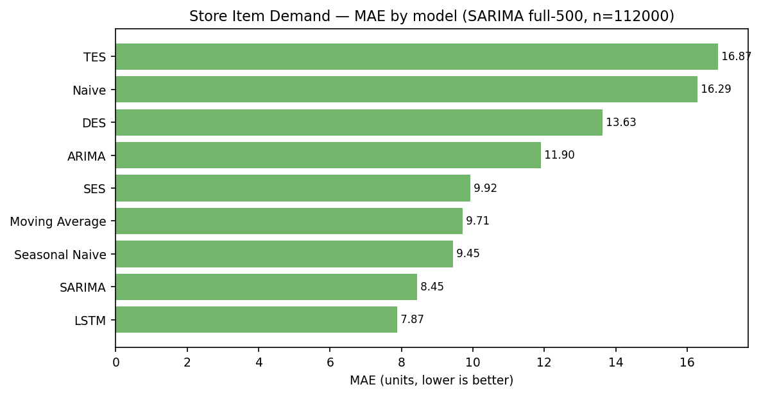
Store MAE with full-population SARIMA (8.45, $n=112,000$). This replaces the stale subset-based panels. Deterministic rebuild (F-NEW-02).

Statistical significance vs. practical significance
With 112,000 paired errors per comparison, a microscope finds everything significant. 5 therefore reports effect sizes alongside $p$-values, and the lesson is taught by two rows. M5 LSTM vs. TSB: $d_{z}≈−0.031$, Holm-adjusted $p≈2×{10}^{−10}$ — astronomically significant, practically tiny: the models differ by two hundredths of an MAE unit. Store LSTM vs. Moving Average: $d_{z}≈−0.29$, $p≈0$ — significant and material, nearly two MAE units apart. Same “significant” label, tenfold difference in meaning. A $p$-value answers “are they different?”; only $d_{z}$, the rank-biserial $r$, and the bootstrap interval answer “should anyone care?” 10 formalizes the machinery; the full 91-pair table is appendix F.
Spotlight pairwise comparisons (paired-error $d$ = A minus B; negative favors A).
Dataset | A vs. B | $d_{z}$​ | Holm $p$ | $r$​ | 95% CI
M5 | LSTM vs. TSB | $−0.031$​ | $2.0×{10}^{−10}$​ | $−0.020$​ | $[−0.024,−0.017]$​
M5 | LSTM vs. MA | $−0.015$​ | $1.8×{10}^{−3}$​ | $−0.010$​ | $[−0.014,−0.007]$​
M5 | LSTM vs. SES | $−0.014$​ | $5.1×{10}^{−4}$​ | $−0.011$​ | $[−0.013,−0.005]$​
M5 | MA vs. SES | $+0.006$​ | $1.7×{10}^{−12}$​ | $−0.022$​ | $[0.000,0.003]$​
Store | LSTM vs. MA | $−0.295$​ | $≈$0 | $−0.282$​ | $[−1.868,−1.800]$​
Store | LSTM vs. SARIMA | $−0.118$​ | $≈$0 | $−0.128$​ | $[−0.599,−0.548]$​
Store | LSTM vs. SES | $−0.336$​ | $≈$0 | $−0.311$​ | $[−2.085,−2.014]$​
*Wilcoxon significant but Diebold–Mariano $p=0.056$ (raw) / $0.113$ (Holm): the two tests disagree on MA vs. SES — correctly, the pair is declared indistinguishable in practice.

Pairwise statistical comparisons
Across all 91 pairs, three patterns stand out. First, M5’s lead cluster is genuinely ordered (LSTM $>$ MA $≈$ SES $>$ TSB, all pairwise significant) but the gaps are operationally negligible — the entire cluster spans 0.05 MASE. Second, Store gaps are an order of magnitude larger and every LSTM pairing is both significant and material. Third, the MA–SES pair on M5 is the honest null of the study: Wilcoxon says significant, Diebold–Mariano says not ($p=0.113$ Holm), the interval straddles zero — two excellent simple methods with nothing between them. That disagreement is a feature: it shows the machinery can say “too close to call” even at $n=112,000$.

Inventory evaluation framework
Recall the shared engine from section 2.10: every forecast drives the same daily-review order-up-to policy ($L=7$, 95% target, $H=1$, $P=5$), lost sales, cost $=$ holding $+$ stockout. Rankings below are total cost under that policy; service level, average inventory, and reorder frequency diagnose how each cost was earned. Sensitivity to the policy itself is not a footnote — it is sections 4.16 and 4.17.

M5 inventory results
6 ranks M5 decision quality. LSTM wins (152.83), daylight ahead of Moving Average (158.83) and SES (159.31); SBA (160.66), TSB (165.13), and Croston (174.81) follow; Seasonal Naive (192.55), ARIMA (194.60), and Naive (200.75) form the expensive middle; DES (268.80) and TES (346.67) are in a different, worse league. The cost anatomy matters: SBA’s cheap holding (128.39) is eaten by stockouts (32.27); SES pairs the lowest stockout bill (21.00) with the second-best service level (93.6%); Croston buys the best service (93.9%) at middling cost. LSTM’s margin ($≈$6 over MA) is ten times its MAE margin — the policy amplifies small accuracy edges into real money when demand is sparse.
M5 inventory ranking under the shared policy (cost units; lower better). Bold: best.
Model | Total | Holding | Stockout | Service (%) | Avg. inv.
LSTM | 152.83 | 130.04 | 22.80 | 92.8 | 4.64
Moving Average | 158.83 | 136.30 | 22.52 | 93.0 | 4.87
SES | 159.31 | 138.32 | 21.00 | 93.6 | 4.94
SBA | 160.66 | 128.39 | 32.27 | 90.9 | 4.59
TSB | 165.13 | 143.54 | 21.59 | 93.2 | 5.13
Croston | 174.81 | 154.54 | 20.28 | 93.9 | 5.52
Seasonal Naive | 192.55 | 170.73 | 21.82 | 93.8 | 6.10
ARIMA | 194.60 | 162.62 | 31.98 | 89.6 | 5.81
Naive | 200.75 | 158.25 | 42.50 | 87.2 | 5.65
DES | 268.80 | 235.35 | 33.46 | 89.9 | 8.41
TES | 346.67 | 304.28 | 42.40 | 88.0 | 10.87

Store inventory results
7 ranks Store decision quality — and upends the forecast board. Moving Average wins (2,084.50); SES (2,113.83) and Seasonal Naive (2,128.15) complete a podium with no LSTM on it; LSTM (2,247.45) sits fourth, SARIMA (2,282.31) fifth, ARIMA (2,320.87) sixth; Naive (2,700.37), DES (2,779.64), TES (3,419.88) trail. The anatomy flips versus M5: Naive holds the least stock (28.38) but pays a catastrophic stockout bill (1,905.74) at 43.2% service; DES/TES drown in inventory (76.07 / 88.77) yet still pay mid-range stockouts — overstocking without protection. Moving Average’s virtue is balance: moderate stock (45.58), the lowest stockout frequency (10.72), and no extreme in either column. This ranking is policy-contingent — section 4.16 shows the crown moves — and must never be quoted without that caveat.
Store inventory ranking under the shared policy. Bold: best. Caution: fragile across policies (section 4.16).
Model | Total | Holding | Stockout | Service (%) | Avg. inv.
Moving Average | 2,084.50 | 1,276.10 | 808.40 | 61.7 | 45.58
SES | 2,113.83 | 1,155.60 | 958.24 | 56.1 | 41.27
Seasonal Naive | 2,128.15 | 1,281.05 | 847.10 | 62.0 | 45.75
LSTM | 2,247.45 | 1,157.70 | 1,089.76 | 53.1 | 41.35
SARIMA | 2,282.31 | 1,307.78 | 974.53 | 59.2 | 46.71
ARIMA | 2,320.87 | 1,076.48 | 1,244.40 | 52.4 | 38.45
Naive | 2,700.37 | 794.63 | 1,905.74 | 43.2 | 28.38
DES | 2,779.64 | 2,130.09 | 649.55 | 73.5 | 76.07
TES | 3,419.88 | 2,485.65 | 934.23 | 69.1 | 88.77
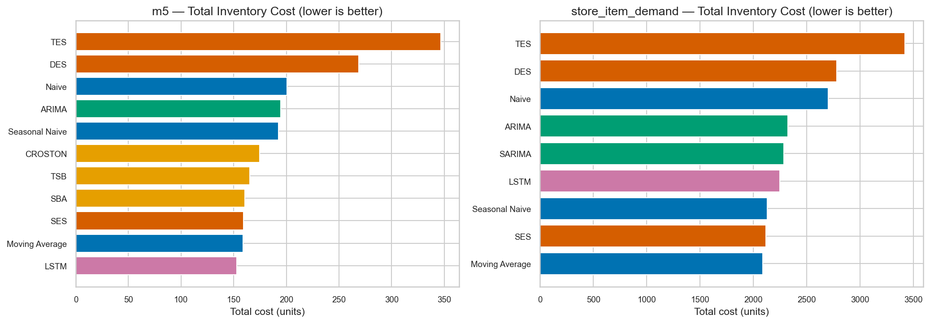
Total inventory cost by model and dataset under the shared policy. M5: LSTM leads. Store: Moving Average leads, LSTM fourth. Source: unified simulation (notebook inventory layer).
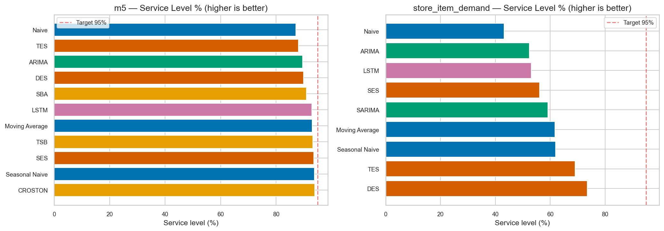
Service level by model: Croston buys M5’s best service (93.9%); Store service sits far lower for all models (43–74%), reflecting denser, higher-volume exposure. Same source as figure 15.
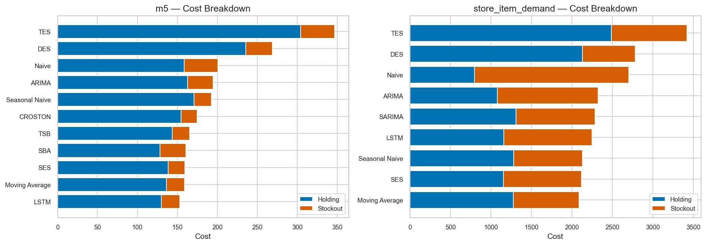
Holding vs. stockout composition. Naive’s Store bar is almost entirely stockout; DES/TES bars are holding-heavy everywhere — two different ways to waste money. Same source as figure 15.
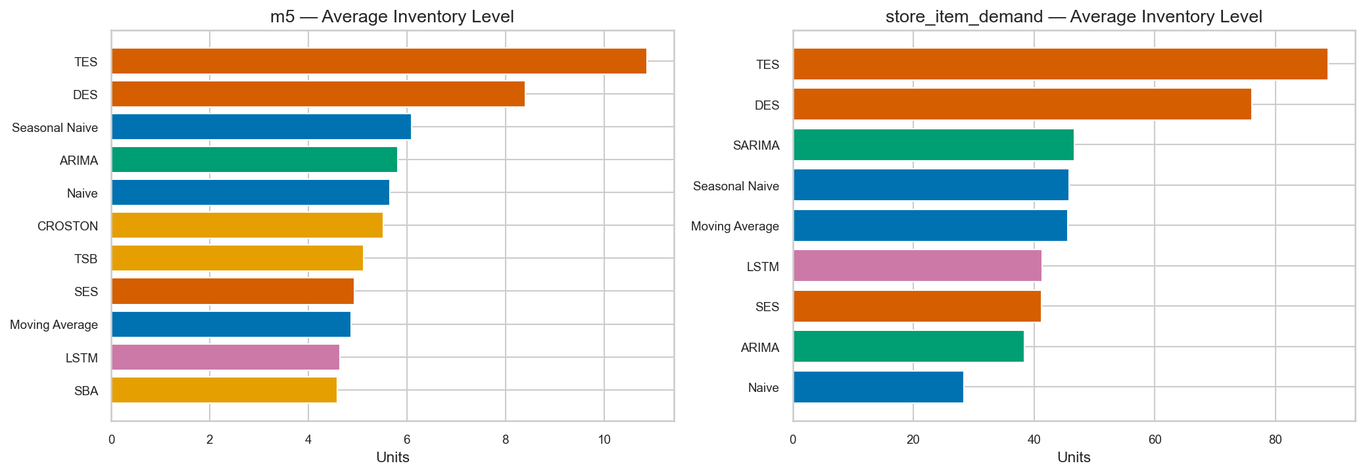
Average inventory and reorder frequency: DES/TES carry roughly double the stock of the leaders. Same source as figure 15.

Forecast accuracy vs. inventory decision quality
19 is the report’s center of gravity. Each point is a model: horizontal position is forecast error, vertical is inventory cost. On M5 the cloud slopes sensibly — better forecasts, cheaper shelves, LSTM at the good corner. On Store the relationship breaks: LSTM sits leftmost (best error) but mid-pack vertically, while Moving Average, SES, and Seasonal Naive sit to its right and below it. The mechanism is cost asymmetry: the policy charges under-prediction (lost sales at $P=5$) five times harder than over-prediction (holding at $H=1$), and safety stock scales with each model’s own error volatility. A slightly biased-toward-averaging forecaster that rarely under-shoots can out-stock a sharper but occasionally short one. Accuracy is a symmetric ruler; the shelf is not symmetric.
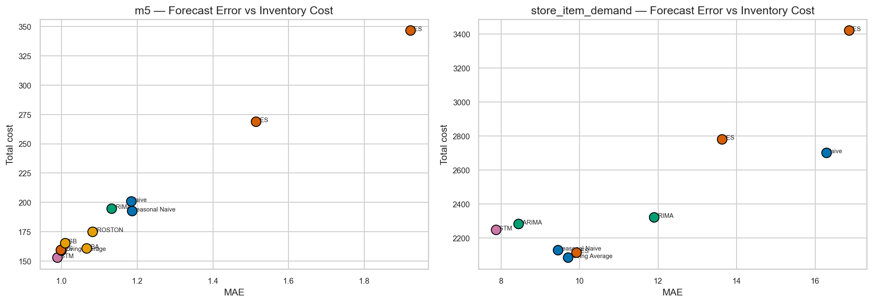
Forecast error vs. inventory cost per model. M5: aligned (better forecasts, cheaper shelves). Store: broken (LSTM leftmost but mid-cost). Same source as figure 15.

Croston-family findings
The specialists justify their rung. On M5, TSB is the family’s best forecaster (MAE 1.010, MASE 1.369 — fourth overall), SBA second (1.066), Croston third (1.082): adaptivity beats bias-correction beats the original on accuracy. On cost, the order reverses its head: SBA (160.66) $<$ TSB (165.13) $<$ Croston (174.81). SBA’s debiasing trims exactly the over-forecast that holding cost punishes, while TSB’s responsiveness costs a little extra stock. Two lessons: even inside one family, accuracy rank $≠$ cost rank; and the family as a whole validates the design choice — on intermittent demand, models that refuse to fit zeros belong in the comparison.
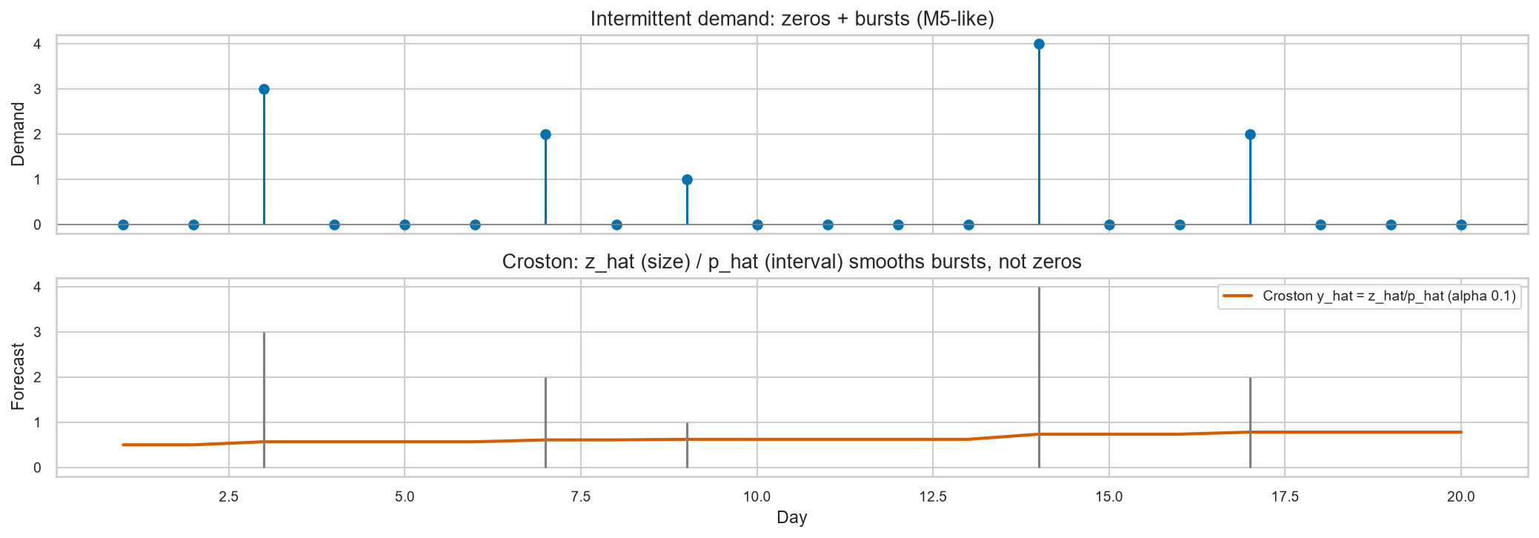
Croston intuition: split sparse demand into how much when it happens and how long between happenings, smooth each separately. Teaching figure from notebook 06c.
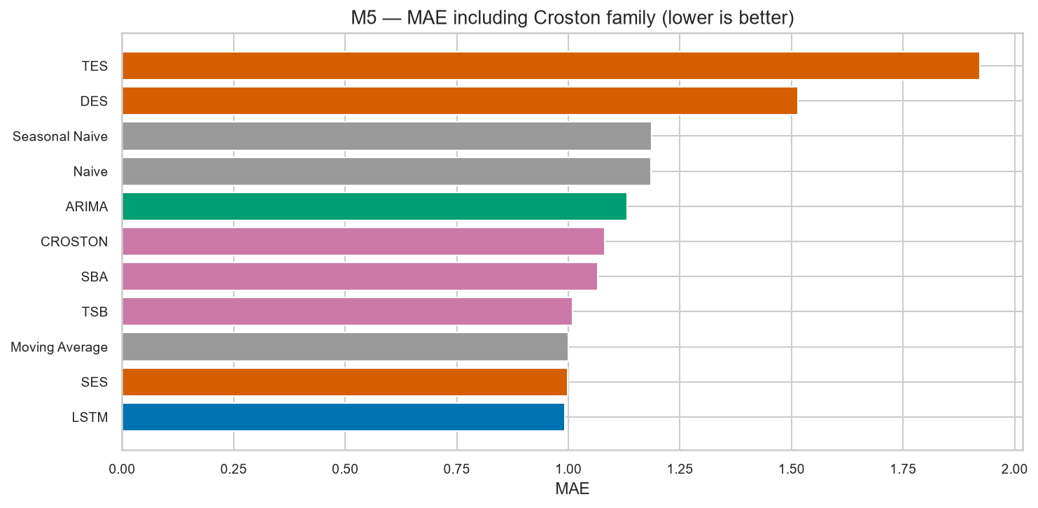
M5 MAE with the Croston family: TSB leads the family at 1.010. Source: notebook 06c.

Demand-archetype findings
[fig:arch-mae,fig:arch-wape] break M5 accuracy by demand shape (pooled WAPE/sMAPE; per-series ratios would let one near-zero series dominate). LSTM wins Highly Intermittent (MAE 0.416) and Intermittent (0.989) outright. In Variable demand the top three — SES (1.799), Moving Average (1.804), LSTM (1.806) — sit within 0.007 of each other: a genuine three-way tie, honestly reported as such. SES takes Moderate (2.634). TES is worst in every archetype, including the smooth ones its trend-seasonality machinery should favor. The Smooth column (single series; LSTM nominally best at forecast MAE 2.358) is anecdotal and carries no conclusion — it is shown for completeness, not evidence. Inventory-by-archetype (figure 25) splits the crown: LSTM is cheapest in Highly Intermittent (64.52) and Intermittent (147.94), Moving Average takes Variable (285.93), and SBA takes Moderate (383.59) — the intermittent-demand specialist winning exactly where intermittency bites least smoothly. Sparse structure rewards the learner; but no single method owns every demand shape, which is itself a finding.
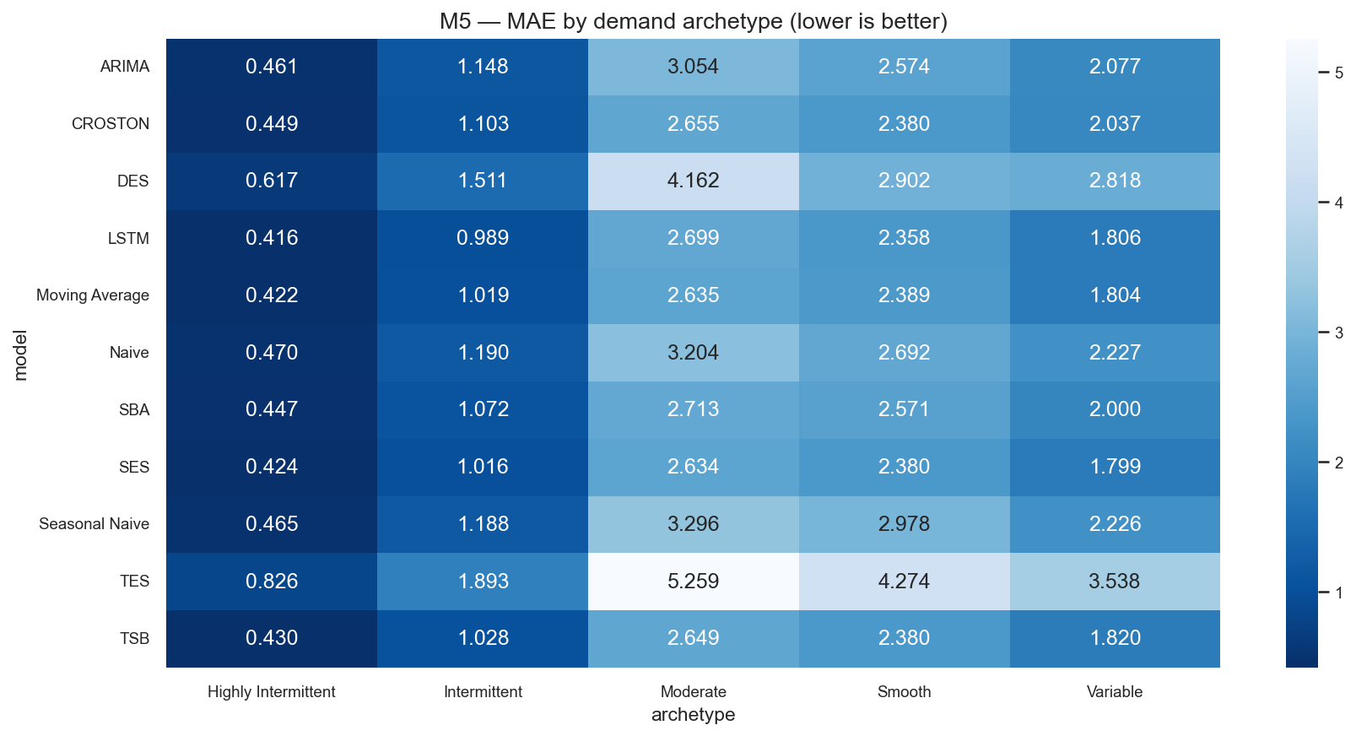
M5 MAE by archetype: LSTM leads sparse shapes; Variable is a three-way tie; TES trails everywhere. Pooled-metric figure (notebook archetype layer).
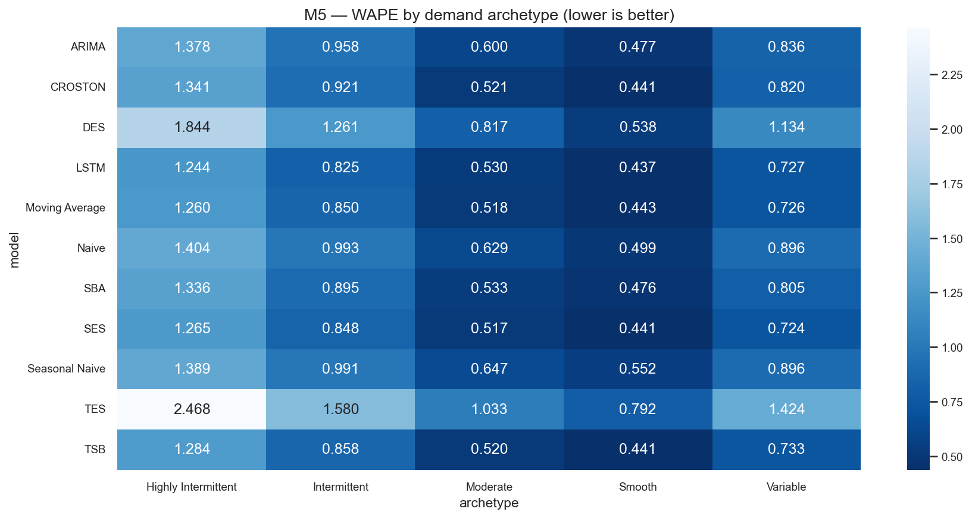
M5 pooled WAPE by archetype: the ratio-of-sums construction keeps near-zero series from exploding the mean. Same source as figure 22.
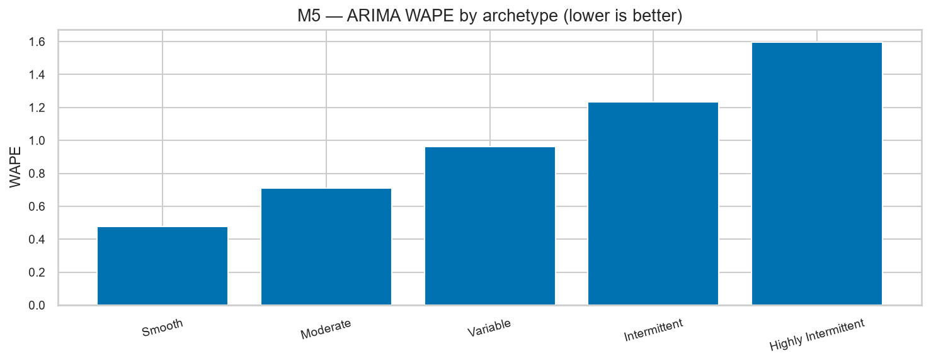
ARIMA error by M5 archetype: degradation concentrates where demand is sparsest — the visual companion to the 22.65% fallback rate. Source: notebook 07.
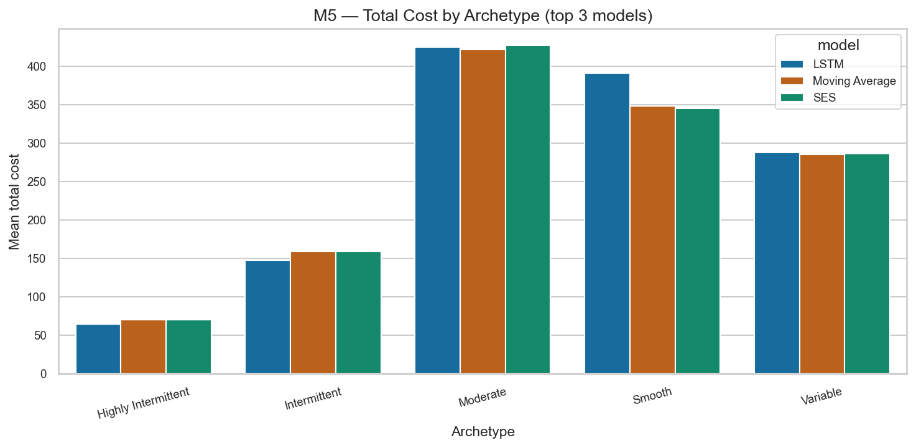
M5 inventory cost by archetype: LSTM cheapest on sparse shapes; Moving Average takes Variable, SBA takes Moderate. Same source as figure 15.

LSTM findings
The neural rung half-validates its thesis. As a forecaster the global LSTM is untouchable: best MAE and MASE on both datasets, best archetype MAE on sparse shapes, sub-1.0 MASE on Store (the only model to beat the training benchmark). As an inventory driver it splits: best on M5 (152.83, robust at 25/27) but fourth on Store (2,247.45), where its sharper forecasts carry an under-prediction profile the $P/H=5$ cost ratio punishes. The hardening note matters here: the LSTM was revalidated on chronological per-series splits after overlapping-window leakage was found in the first validation design, so these numbers reflect genuine generalization, not validation peeking. Bottom line for practitioners: buy the LSTM for forecast quality with confidence; for shelf decisions, check your cost ratio first.

ARIMA findings
ARIMA is the fragile linear middle. On dense Store data it fits cleanly (4,000/4,000, zero fallbacks) yet finishes sixth on both boards (MASE 1.452; cost 2,320.87) — linear memory adds little where weekly structure dominates. On sparse M5 data, 906 of 4,000 fits (22.65%) trip the $>85\%$-zero pre-check and defer to Naive, concentrated in Highly Intermittent series (figure 24); crucially, there are zero optimizer failures — every non-skipped fit converges. The pre-check is a designed guardrail, not a crash log, and its asymmetry (22.65% vs. 0%) is itself a measurement of how demand structure dictates statistical feasibility.

SARIMA full-population findings
The seasonal challenger delivers. All 4,000 Store fits succeed with zero fallbacks in 2,382 s ($≈$0.6 s/fit): seasonal differencing at $m=7$ is feasible at full population, not just on the exploratory 100-series subset (MAE 8.31) that preceded it. Final full500 accuracy (MAE 8.45, MASE 1.055, RMSSE 1.040) shifts slightly from the subset — a population effect, logged openly. Decision quality (2,282.31, fifth) lags accuracy (second): strong weekly tracking still under-protects against stockouts at $P/H=5$. SARIMA was never run on M5, deliberately: seasonal differencing of mostly-zero series is methodologically unsound, and the Croston rung already covers that territory.

Model complexity findings
H3 in monotone form is rejected. The most complex classical models are the worst performers (TES last everywhere; DES an overstocking liability), the mid-complexity linear model sits mid-pack, and only the neural model converts complexity into accuracy — and even then into inventory value on just one of two datasets. Meanwhile the simplest rung (Moving Average, SES) wins or near-wins three of the four boards. Complexity buys capability (LSTM’s cross-series learning is real), not value: value is decided by the interaction of capability with demand structure and cost asymmetry.

Robustness across inventory policies
8 with figures 26 and 27 is the trust map. M5: LSTM first in 25 of 27 policies — robust. Its only defeats, both to SES, sit in one corner: short lead time ($L=3$) with high stockout penalty ($P=10$), where SES’s conservative level-tracking wastes less on emergency cover. Store: fragile — Moving Average 9, SES 7, Naive 6, DES 5. No model reaches even half the grid; the “winner” is a property of the policy, not the model. This asymmetry is the report’s second major device after the forecast–decision gap: bank M5-LSTM; rent Store-MA.
Robustness verdict: policy wins across the 27-policy grid. M5 robust; Store fragile.
Dataset | Wins (of 27) | Verdict
M5 | LSTM 25, SES 2 (both at $L=3$, $P=10$) | Robust
Store | MA 9, SES 7, Naive 6, DES 5 | Fragile / policy-sensitive
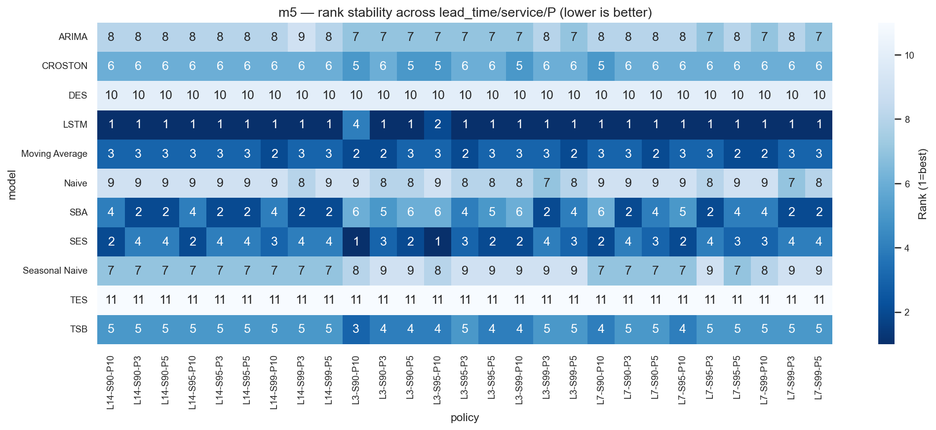
M5 rank heatmap across 27 policies: an unbroken LSTM band with two SES cells in the short-lead/high-penalty corner. Source: sensitivity layer.
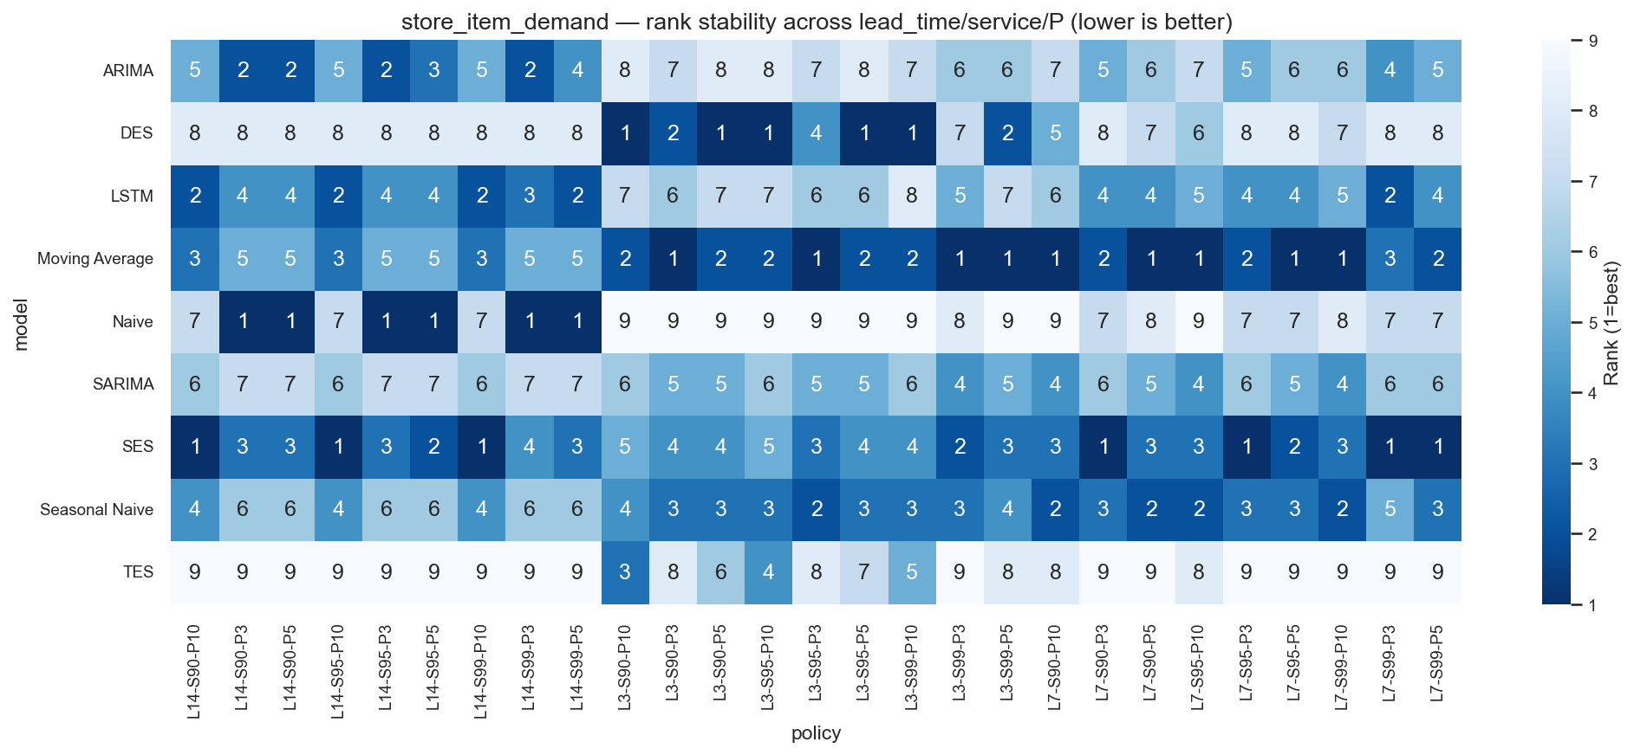
Store rank heatmap: leadership fragments across four models as the policy moves. Same source as figure 26.
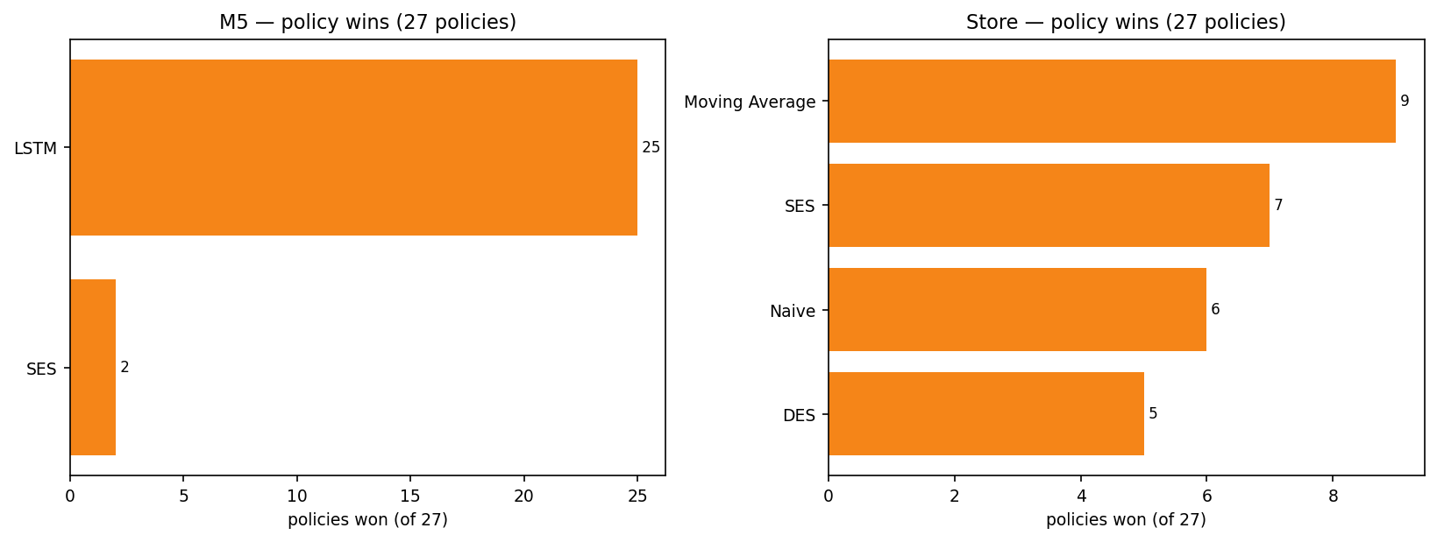
Winner shares across the 27-policy grid: M5 concentration vs. Store fragmentation. Deterministic rebuild (F-NEW-03).

Sensitivity analysis
The grid’s interior tells managers when leadership changes. Longer lead times amplify safety-stock differences (volatility-driven models suffer); higher $P/H$ punishes under-predictors (Naive collapses everywhere except short-lead Store corners where its leanness pays); higher service targets reward conservative levels (SES gains).
Per-archetype M5 costing (55 rows, sensitivity_by_archetype_m5.csv) confirms the structure story: sparse archetypes magnify every policy effect.
Full matrices are appendix G.

Convergence and feasibility
9 accounts for every fit. M5 ARIMA: 3,094 fits, 906 pre-check skips (22.65%), 0 optimizer failures. Store ARIMA: 4,000/4,000. SARIMA subset (exploratory): 800/800. SARIMA full500 (primary): 4,000/4,000 in 2,382 s. The feasibility gradient — dense fits always, sparse fits sometimes — is a result about the world, not about the software.
Convergence accounting. Pre-check skips are by-design guards, not failures.
Scope | Model | Attempted | Failed | Naive fallback | Fallback %
M5 full500 | ARIMA | 4,000 | 0 | 906 | 22.65
Store full500 | ARIMA | 4,000 | 0 | 0 | 0.00
Store subset (explor.) | SARIMA | 800 | 0 | 0 | 0.00
Store full500 (primary) | SARIMA | 4,000 | 0 | 0 | 0.00

Negative and surprising findings
Stated plainly, because nulls are findings: (1) TES is worst on all four boards and every archetype. (2) DES buys double inventory for worse service than SES. (3) Naive — the dumbest method — wins 6 Store policies. (4) Seasonal Naive is Store’s inventory bronze medalist. (5) The LSTM loses Store inventory to a moving average. (6) An intermediate WAPE computation exploded to $∼2×{10}^{9}$ on near-zero-test-demand series before pooling fixed it — a live demonstration of why metric construction needs the same skepticism as modeling. (7) MA vs. SES on M5 is statistically indistinguishable in practice despite $n=112,000$.

Consolidated findings and hypothesis verdicts
H1 (accuracy differs): confirmed — 91 paired tests, nearly all significant with Holm control. H2 (accuracy moves inventory): confirmed with the central qualification — it moves inventory, but not monotonically and not always in the same direction (Store paradox). H3 (monotone sophistication): rejected — TES/DES/ARIMA lose to simpler methods; only LSTM complexity pays, and only partially. H4 (cross-dataset consistency): rejected in its strong form — forecasting leadership transfers (LSTM both), decision leadership does not (LSTM vs. MA), and robustness transfers not at all (robust vs. fragile). The qualified verdict is the contribution: what transfers (forecast skill) and what does not (decision superiority, policy-stability) are now mapped.

Discussion

Forecast accuracy is not decision quality
The executive summary of this entire report is one asymmetry. Accuracy metrics are symmetric, per-unit, and policy-free; inventory costs are asymmetric, thresholded, and policy-defined. Safety stock transforms error volatility into money; the order-up-to rule transforms error bias into money; the $P/H$ ratio decides the exchange rate. Any evaluation that stops at the forecast has measured the ingredient, not the dish.

Why LSTM wins forecasting but not always inventory
The global LSTM learns shapes no per-series linear model can: zero-inflated regimes, cross-item weekly patterns, nonlinear rebounds. That buys the best point forecasts on both datasets. But inventory does not buy point forecasts; it buys a distribution summary (error volatility for safety stock) plus a level (the next-$L$ sum). On dense Store demand, the LSTM’s sharpness comes with occasional confident under-predictions — cheap under MAE, ruinous at $P=5$. The moving average, by construction, rarely under-shoots violently. Precision without caution is a fast car with weak brakes: brilliant on the track (error metrics), expensive in traffic (asymmetric costs).

Why simple models remain competitive
Moving Average and SES do two things right. First, averaging is the optimal response to noise-dominated demand: most daily variation is unpredictable, and the mean of recent days is the minimum-variance guess. Second, their errors are symmetric and stable, which is exactly what safety-stock formulas assume. Simplicity aligns with the policy’s assumptions; sophistication violates them profitably only when the demand signal is strong enough to repay the violation — true on sparse M5, false on dense Store.

Demand structure and model suitability
Intermittency decides which machinery is legitimate. Where zeros dominate, refuse-to-fit-zeros methods (Croston family, Naive-fallback ARIMA) and cross-series learners (LSTM) win; linear autoregression starves. Where demand is dense and weekly, seasonal structure (SARIMA, Seasonal Naive) pays and trend machinery (DES/TES) overfits noise into inventory. The archetype tables are the suitability map; the Store–M5 contrast is its validation.

Inventory policy as the effective loss function
A useful reframe: the choice of $(L,z,P/H)$ is the choice of loss function, and forecasters are implicitly optimized for the wrong one (symmetric error). The sensitivity grid makes this visible: move $P$ from 3 to 10 and the optimal forecaster changes. Practitioners should therefore select models conditional on their policy, and researchers reporting accuracy-only leaderboards should attach a warning label.

Statistical significance vs. practical importance
At $n=112,000$, significance is nearly free and therefore nearly meaningless alone. The M5 LSTM–TSB pair ($p≈2×{10}^{−10}$, $d_{z}=−0.031$) would headline a naive report as “highly significant superiority”; the honest headline is “indistinguishable for any business purpose.” Effect sizes, intervals, and the MA–SES disagreement between tests are the report’s immune system against $p$-value theater.

Complexity vs. value
Capability and value parted ways. The ladder’s complexity order (Naive $<$ MA $<$ SES $<$ DES $<$ TES $<$ ARIMA $<$ SARIMA $<$ LSTM) predicts neither the accuracy order nor the cost order. The only complexity that paid was the neural kind, and only in accuracy everywhere and cost in one world. Budget accordingly: a moving average costs nothing to run and nearly wins; an LSTM costs real engineering and wins sometimes.

Robust vs. fragile conclusions
Robustness is a property of the conclusion under policy variation, not of the model. M5-LSTM is robust (25/27, losses confined to one explicable corner). Store-MA is fragile (9/27) — and so is every Store alternative. Fragile does not mean wrong: under the stated default policy MA genuinely wins. It means conditional: change the lead time or cost ratio and re-run the comparison before spending money.

What can and cannot be generalized
Transferable: the forecast–decision gap mechanism, the significance-vs-size discipline, the sensitivity-as-verdict method, LSTM forecast superiority on both structures, TES/DES failure modes. Not transferable: the specific winner of any board (policy- and structure-contingent), anything about the Smooth archetype ($n=1$), anything about LLMs (unexecuted), anything beyond $h=28$ or univariate demand. The contribution is a map with marked hazards, not a universal champion.

Learning, Contribution and Practical Implications

Empirical contribution
The study demonstrates the forecast–decision gap in both directions inside one controlled design: alignment on intermittent M5 demand, divergence on dense Store demand, with the paradoxical Store podium (MA $>$ SES $>$ SNaive $>$ LSTM) as its sharpest exhibit. It also maps exactly where sophistication pays (LSTM accuracy everywhere; LSTM cost on sparse demand) and where it bills without benefit (TES/DES; ARIMA on dense demand).

Methodological contribution
Three reusable instruments: (1) a shared-policy evaluation harness that makes cross-model inventory comparison fair by construction — one module, every model, no per-model tuning; (2) a leakage-safe rolling protocol (history strictly before origin, validation-only selection, honest-NaN scale-free metrics with pooled archetype ratios); (3) sensitivity-as-verdict: headline rankings are published with their 27-policy stability record, separating bankable conclusions from conditional ones.

Analytical contribution
Ninety-one Holm-corrected paired comparisons with effect sizes and bootstrap intervals, reported with the explicit doctrine that $p$-values never travel without $d_{z}$. The MA–SES “honest null” shows the machinery can exonerate as well as convict.

Inventory-management implications
For intermittent catalogs: invest in learned or specialist forecasting (LSTM, TSB/SBA) and expect the forecast win to reach the shelf. For dense, fast-moving catalogs: pilot simple averaging methods against the neural option under your own cost ratio before committing engineering budget; the cheapest stocker may already be in production. In both worlds, distrust any vendor leaderboard that stops at accuracy.

Model-selection implications
Select conditional on three answers: What is my demand structure (sparse or dense)? What is my cost asymmetry ($P/H$)? What is my lead time? The report’s tables answer the rest: sparse + any reasonable policy $→$ LSTM; dense + default policy $→$ Moving Average with SES as backup; dense + short-lead/high-penalty $→$ re-run, leadership is fluid.

Reproducibility contribution
The frozen package (number sheet, audits, traceability, validation log with 0 FAIL, pre-hardening backup, seeds, manifests) means any number in this report resolves to a source file in one lookup. Reproducibility here is not a claim but an address book (appendix I).

Research-hardening lessons
The most expensive errors were methodological, not algorithmic: an unassigned leap day, overlapping validation windows, a subset presented at full weight, a mean-of-ratios that exploded to ${10}^{9}$. Each was caught by an audit that assumed nothing — row counts, date containment, denominator discipline, population labels. The lesson for any analytics team: validate the experiment with the same paranoia you apply to the model, because the experiment is what you actually conclude from.

Limitations and Future Research

Dataset scope
Two retail environments, however contrasted, are still two. Both are brick-and-mortar-style daily demand; neither covers e-commerce spikes, perishables with expiry, promotions-driven regimes, or supply-side censoring beyond the lost-sales assumption.

Series selection
M5 results describe the stratified 500, not the 30,490-series catalog. Stratification protects archetype coverage but cannot guarantee catalog-level point estimates; scaling the full ladder to the catalog is compute-bound (SARIMA alone cost 2,382 s for 500 series).

Forecast horizon
All conclusions are conditional on $h=28$. Shorter horizons favor naive and averaging methods; longer ones may favor trend/seasonal machinery. The robustness grid varies policy, not horizon.

Inventory-policy scope
One policy family (daily-review order-up-to, lost sales, no capacity, no minimum order quantities, no perishability, stationary costs) carries all decision conclusions. Backordering regimes, batch constraints, or stochastic lead times could reorder the boards — which is precisely why the sensitivity discipline, not any single ranking, is the transferable asset.

Feature scope
Univariate demand only: no prices, promotions, SNAP/calendar events, or cross-series covariates. The LSTM’s advantage could widen with features; the classical methods’ standing could improve with regressors. Both are open questions, not assumptions.

Archetype limitations
The Smooth archetype contains exactly one series ($n=1$). Nothing in this report generalizes from it, and any Smooth figure is shown for completeness only.

SARIMA scope
SARIMA is Store-only by design; no claim is made about seasonal autoregression on intermittent demand. The 100-series subset is exploratory history, never the headline.

Computational considerations
Per-fit costs ($≈$0.03 s ARIMA, $≈$0.6 s SARIMA, plus LSTM training) bound full-catalog scaling. Per-series ARIMA order search was rejected on this ground; future work with larger budgets could revisit it.

LLM experiment — future work only
The research program’s final rung — local LLM forecasting (controlled vs. context-enhanced prompting, Ollama backend, leak-guarded prompt builder in 11_src/llm_experiment_design.md) — is designed but deliberately unexecuted, held behind a frozen benchmark so the benchmark could not be tuned against it. No LLM result exists; none is presented, implied, or charted anywhere in this report. Executing that phase against the frozen evidence base is the natural next step.

Proposed future extensions
In priority order: (1) execute the LLM phase; (2) add price/promotion/calendar covariates; (3) widen the policy family (backorders, MOQs, perishability); (4) vary the horizon (7/56 days); (5) scale M5 toward the full catalog for the cheap rungs; (6) test additional retail environments beyond the two studied.

Conclusion

Answer to the research question
Effectiveness does not march in step with sophistication. Moving from traditional methods to neural forecasting reliably improves forecast accuracy — the LSTM tops both datasets — but improves inventory outcomes only conditionally: decisively on sparse intermittent demand, not at all on dense demand under the default cost structure. The journey up the model ladder buys capability everywhere and value somewhere.

Main evidence
M5: LSTM best forecaster (MASE 1.316) and cheapest stocker (152.83), first in 25 of 27 policies — robust. Store: LSTM best forecaster (MASE 0.978) but fourth-cheapest stocker (2,247.45) behind Moving Average (2,084.49), SES, and Seasonal Naive — fragile (9/7/6/5 policy split). Ninety-one paired tests separate the significant from the important (M5 LSTM–TSB: $p≈2×{10}^{−10}$ yet $d_{z}=−0.031$; Store LSTM–MA: $d_{z}=−0.29$). H1 confirmed, H2 confirmed-with-qualification, H3 rejected in monotone form, H4 rejected in strong form.

Practical takeaway
If your shelves look like M5 — sparse, intermittent — invest in the learner; the forecast win reaches the cash register and survives policy changes. If your shelves look like Store demand — dense, smooth — run a moving average against anything expensive under your own cost ratio before you buy complexity; and whatever wins, re-check it when lead times or penalties move. In all cases, demand an inventory-level evaluation before trusting an accuracy leaderboard.

Final research conclusion
Forecasting skill and decision value are related but distinct quantities, joined by demand structure and cost asymmetry. This study measured both, mapped where they align and where they break, stress-tested the map across 27 policies, and froze every number for audit. The shelf, not the scoreboard, is where forecasting earns its keep — and now there is a reproducible record of exactly when the smartest predictor is, and is not, the cheapest stocker.

Metric Definitions
Let $y_{t}$ be actual demand, ${\hat{y}}_{t}$ the forecast, $n$ the test size. MAE $=n^{−1}∑|y_{t}−{\hat{y}}_{t}|$. With seasonal period $m=7$ and training-only seasonal-naive denominator $Q=(T−m)^{−1}\sum_{t=m+1}^{T}{|}y_{t}−y_{t−m}|$ over the frozen train window, MASE $=(n^{−1}∑|y_{t}−{\hat{y}}_{t}|)/Q$ (Hyndman and Koehler 2006). RMSSE replaces absolute errors with squared ones under the root. WAPE (model level) is the mean of per-series ratios $∑|y−\hat{y}|/∑|y|$; WAPE (archetype level) is the pooled ratio cell​|y−y|/cell​|y|, adopted after a mean-of-ratios computation exploded to $∼2×{10}^{9}$ on near-zero-test-demand series. sMAPE $=100 n^{−1}∑2|y−\hat{y}|/(|y|+|\hat{y}|)$, reported with its zero-demand distortions documented. Zero denominators stay honest NaNs ($n_{\text{NaN}}=0$ everywhere); no epsilon guards.

Statistical Methodology
For each model pair, paired errors $d_{i}=|e_{i}^{A}|−|e_{i}^{B}|$ ($n=112,000$): Wilcoxon signed-rank (normal approximation) and Diebold–Mariano (Diebold and Mariano 1995) tests, Holm step-down correction (Holm 1979) across all 91 pairs, 500-replication bootstrap percentile CIs for mean $d$, Cohen paired $d_{z}=\overset{‾}{d}/s_{d}$, and Wilcoxon rank-biserial $r$. “A better” in the raw file means $\overset{‾}{d}<0$; the report’s verdicts additionally require material $|d_{z}|$ and interval support. The MA–SES M5 disagreement (Wilcoxon significant, DM Holm $p=0.113$) is the worked example of restraint.

Model Configurations and Hyperparameters
Moving Average global windows: M5 $w=14$ (validation MAE 0.9206 vs. 0.9236 for $w=7$, 0.9282 for $w=28$), Store $w=7$ (7.4057 vs. 7.5113/7.9132); seed 42. SES $α=0.1$; DES $(α,β)=(0.2,0.2)$; additive TES $(0.3,0.3,0.3)$; identical grids both datasets (model_parameters.json, execution_metadata.json). ARIMA(1,1,0) both datasets with $>85\%$-zero $→$ Naive pre-check. SARIMA(1,1,0)(0,1,1)$​_{7}$ Store-only, full500 (run_log_full500.json: 4,000 fits, 2,382 s, seed 42). Croston $α=0.1$, SBA $α=0.5$, TSB $(0.1,0.3)$ (validation_selection.json); validation window 2015-11-01..2016-02-29 (121 d) throughout. LSTM: global per dataset, lookback 28, history-only per-series scaling, chronological last-$k$-window validation, seed 42 (notebook 08). Inventory: shared module, POLICY_DEFAULT $L=7$, 95%, $H=1$, $P=5$, $σ$ floor 0.1; sensitivity grid $L∈\{3,7,14\}×$ service $\{0.90,0.95,0.99\}×P∈\{3,5,10\}$.

Frozen Experimental Protocol
Machine truth: 05_experiments/config.json (v1.0, 2026-08-28; validation end corrected 2016-02-28 $→$ 2016-02-29 by recorded decision 2026-09-03). Common window 2013-01-01..2016-05-22 (1,238 d); train 2013-01-01..2015-10-31 (1,034); validation 2015-11-01..2016-02-29 (121); test 2016-03-01..2016-05-22 (83). Horizon 28, origin spacing 7, 8 origins (2016-03-01 through 2016-04-19), expanding window, history strictly before origin.
M5: 500 stratified series (m5_series_selection.json); Store: all 500. Forecast metrics MAE/RMSE/sMAPE/WAPE/MASE/RMSSE; inventory metrics holding/shortage/total cost, service level, average inventory, reorder count.
Governance: 00_project/decisions.md (519 lines), 00_project/research_readiness_checklist.md (all PASS).

Validation and Quality Gates
The independent validator (11_src/validate_results.py) enforces 44 gates: per-family row counts (112,000), zero duplicate keys, origins 1–8, horizon 28 everywhere, test-window containment, finite non-negative forecasts, cross-family actuals identity (spread 0.0), metric presence with zero unexpected NaNs, and SARIMA-full500 presence (112,000 rows). Result: 44 PASS, 0 FAIL (06_results/validation_report.json). Gate log:
Validation gates (part 1).
Gate | Status | Detail
sarima full500 present | PASS | 112000 rows
baselines row counts | PASS | ((’store_item_demand’, ’Seasonal Naive’):
baselines no dup keys | PASS | dups=0
baselines origins 1 to 8 | PASS | [np.int64(1), np.int64(2), np.int64(3), np.i
baselines h28 everywhere | PASS | min=28 max=28
baselines dates in test window | PASS
baselines forecasts finite nonneg | PASS
exponential smoothing row counts | PASS | ((’store_item_demand’, ’TES’): 112000, (’m
exponential smoothing no dup keys | PASS | dups=0
exponential smoothing origins 1 to 8 | PASS | [np.int64(1), np.int64(2), np.int64(3), np.i
exponential smoothing h28 everywhere | PASS | min=28 max=28
exponential smoothing dates in test window | PASS
exponential smoothing forecasts finite nonneg | PASS
arima row counts | PASS | ((’store_item_demand’, ’ARIMA’): 112000, (
arima no dup keys | PASS | dups=0
arima origins 1 to 8 | PASS | [np.int64(1), np.int64(2), np.int64(3), np.i
arima h28 everywhere | PASS | min=28 max=28
arima dates in test window | PASS
arima forecasts finite nonneg | PASS
lstm row counts | PASS | ((’store_item_demand’, ’LSTM’): 112000, (’
lstm no dup keys | PASS | dups=0
lstm origins 1 to 8 | PASS | [np.int64(1), np.int64(2), np.int64(3), np.i

Validation gates (part 2).
Gate | Status | Detail
lstm h28 everywhere | PASS | min=28 max=28
lstm dates in test window | PASS
lstm forecasts finite nonneg | PASS
croston row counts | PASS | ((’m5’, ’SBA’): 112000, (’m5’, ’CROSTON’): 1
croston no dup keys | PASS | dups=0
croston origins 1 to 8 | PASS | [np.int64(1), np.int64(2), np.int64(3), np.i
croston h28 everywhere | PASS | min=28 max=28
croston dates in test window | PASS
croston forecasts finite nonneg | PASS
cross family actuals identical | PASS | max spread=0.000000
baselines metrics have MASE RMSSE | PASS | [’dataset’, ’model’, ’MAE’, ’RMSE’, ’sMAPE’,
baselines metrics no unexpected NaN | PASS | Empty DataFrame Columns: [dataset, model] In
exponential smoothing metrics have MASE RMSSE | PASS | [’dataset’, ’model’, ’MAE’, ’RMSE’, ’sMAPE’,
exponential smoothing metrics no unexpected NaN | PASS | Empty DataFrame Columns: [dataset, model] In
arima metrics have MASE RMSSE | PASS | [’dataset’, ’model’, ’n’, ’MAE’, ’RMSE’, ’sM
arima metrics no unexpected NaN | PASS | Empty DataFrame Columns: [dataset, model] In
lstm metrics have MASE RMSSE | PASS | [’dataset’, ’model’, ’MAE’, ’RMSE’, ’sMAPE’,
lstm metrics no unexpected NaN | PASS | Empty DataFrame Columns: [dataset, model] In
croston metrics have MASE RMSSE | PASS | [’dataset’, ’model’, ’MAE’, ’RMSE’, ’sMAPE’,
croston metrics no unexpected NaN | PASS | Empty DataFrame Columns: [dataset, model] In
inventory covers all models | PASS | missing=set() extra=set()
inventory costs finite | PASS

Complete Pairwise Statistical Results
All 91 paired comparisons (55 M5 $+$ 36 Store) with Holm-adjusted Wilcoxon $p$, paired $d_{z}$, and rank-biserial $r$. Generated from 06_results/statistical_tests/pairwise_tests.csv; bootstrap CIs in the source file. Negative mean-$d$ favors A.
Pairwise results: M5 (part 1 of 2).
Dataset | Pair (A vs. B) | Mean $d$ | $d_{z}$​ | Holm $p$ | $r$​
M5 | ARIMA vs. CROSTON | 0.0503 | 0.036 | 5.48e-20 | -0.028
M5 | ARIMA vs. DES | -0.3815 | -0.187 | 0.00e+00 | -0.281
M5 | ARIMA vs. LSTM | 0.1433 | 0.119 | 3.56e-87 | -0.060
M5 | ARIMA vs. Moving Average | 0.1327 | 0.115 | 9.36e-223 | -0.102
M5 | ARIMA vs. Naive | -0.0520 | -0.073 | 2.59e-130 | -0.100
M5 | ARIMA vs. SBA | 0.0659 | 0.057 | 4.44e-28 | -0.033
M5 | ARIMA vs. SES | 0.1342 | 0.125 | 3.82e-127 | -0.072
M5 | ARIMA vs. Seasonal Naive | -0.0542 | -0.034 | 1.50e-12 | -0.027
M5 | ARIMA vs. TES | -0.7898 | -0.273 | 0.00e+00 | -0.427
M5 | ARIMA vs. TSB | 0.1227 | 0.123 | 1.43e-72 | -0.054
M5 | CROSTON vs. DES | -0.4318 | -0.170 | 0.00e+00 | -0.191
M5 | CROSTON vs. LSTM | 0.0929 | 0.099 | 4.20e-227 | -0.096
M5 | CROSTON vs. Moving Average | 0.0824 | 0.093 | 2.25e-118 | -0.070
M5 | CROSTON vs. Naive | -0.1023 | -0.062 | 2.57e-38 | -0.039
M5 | CROSTON vs. SBA | 0.0156 | 0.020 | 2.37e-63 | -0.051
M5 | CROSTON vs. SES | 0.0839 | 0.101 | 1.27e-126 | -0.072
M5 | CROSTON vs. Seasonal Naive | -0.1045 | -0.062 | 8.77e-32 | -0.036
M5 | CROSTON vs. TES | -0.8401 | -0.239 | 0.00e+00 | -0.258
M5 | CROSTON vs. TSB | 0.0724 | 0.078 | 1.49e-16 | -0.025
M5 | DES vs. LSTM | 0.5248 | 0.213 | 0.00e+00 | -0.228
M5 | DES vs. Moving Average | 0.5142 | 0.213 | 0.00e+00 | -0.272
M5 | DES vs. Naive | 0.3296 | 0.148 | 0.00e+00 | -0.217
M5 | DES vs. SBA | 0.4475 | 0.187 | 0.00e+00 | -0.216
M5 | DES vs. SES | 0.5157 | 0.217 | 0.00e+00 | -0.257
M5 | DES vs. Seasonal Naive | 0.3273 | 0.134 | 0.00e+00 | -0.185
M5 | DES vs. TES | -0.4083 | -0.187 | 0.00e+00 | -0.259
M5 | DES vs. TSB | 0.5042 | 0.216 | 0.00e+00 | -0.276
M5 | LSTM vs. Moving Average | -0.0105 | -0.015 | 1.78e-03 | -0.010

Pairwise results: M5 (part 2 of 2).
Dataset | Pair (A vs. B) | Mean $d$ | $d_{z}$​ | Holm $p$ | $r$​
M5 | LSTM vs. Naive | -0.1952 | -0.136 | 9.82e-127 | -0.072
M5 | LSTM vs. SBA | -0.0773 | -0.085 | 1.69e-86 | -0.059
M5 | LSTM vs. SES | -0.0090 | -0.014 | 5.11e-04 | -0.011
M5 | LSTM vs. Seasonal Naive | -0.1975 | -0.133 | 3.68e-124 | -0.071
M5 | LSTM vs. TES | -0.9331 | -0.274 | 0.00e+00 | -0.298
M5 | LSTM vs. TSB | -0.0206 | -0.031 | 2.02e-10 | -0.020
M5 | Moving Average vs. Naive | -0.1847 | -0.129 | 8.28e-272 | -0.114
M5 | Moving Average vs. SBA | -0.0668 | -0.073 | 4.20e-75 | -0.055
M5 | Moving Average vs. SES | 0.0015 | 0.006 | 1.75e-12 | -0.022
M5 | Moving Average vs. Seasonal Naive | -0.1869 | -0.129 | 6.33e-257 | -0.111
M5 | Moving Average vs. TES | -0.9225 | -0.270 | 0.00e+00 | -0.331
M5 | Moving Average vs. TSB | -0.0100 | -0.025 | 2.34e-43 | -0.042
M5 | Naive vs. SBA | 0.1179 | 0.085 | 3.49e-54 | -0.047
M5 | Naive vs. SES | 0.1862 | 0.136 | 2.74e-113 | -0.068
M5 | Naive vs. Seasonal Naive | -0.0022 | -0.001 | 4.78e-01 | -0.003
M5 | Naive vs. TES | -0.7378 | -0.248 | 0.00e+00 | -0.410
M5 | Naive vs. TSB | 0.1746 | 0.132 | 8.08e-55 | -0.047
M5 | SBA vs. SES | 0.0683 | 0.078 | 4.78e-63 | -0.051
M5 | SBA vs. Seasonal Naive | -0.1202 | -0.076 | 5.89e-25 | -0.031
M5 | SBA vs. TES | -0.8558 | -0.254 | 0.00e+00 | -0.281
M5 | SBA vs. TSB | 0.0567 | 0.061 | 6.24e-23 | -0.030
M5 | SES vs. Seasonal Naive | -0.1884 | -0.131 | 4.33e-92 | -0.061
M5 | SES vs. TES | -0.9240 | -0.274 | 0.00e+00 | -0.312
M5 | SES vs. TSB | -0.0115 | -0.041 | 5.08e-30 | -0.035
M5 | Seasonal Naive vs. TES | -0.7356 | -0.224 | 0.00e+00 | -0.334
M5 | Seasonal Naive vs. TSB | 0.1769 | 0.124 | 4.13e-42 | -0.041
M5 | TES vs. TSB | 0.9125 | 0.274 | 0.00e+00 | -0.330

Pairwise results: Store (36 pairs).
Dataset | Pair (A vs. B) | Mean $d$ | $d_{z}$​ | Holm $p$ | $r$​
Store | ARIMA vs. DES | -1.7311 | -0.138 | 4.34e-176 | -0.085
Store | ARIMA vs. LSTM | 4.0264 | 0.536 | 0.00e+00 | -0.483
Store | ARIMA vs. Moving Average | 2.1920 | 0.389 | 0.00e+00 | -0.372
Store | ARIMA vs. Naive | -4.3916 | -0.759 | 0.00e+00 | -0.629
Store | ARIMA vs. SARIMA | 3.4532 | 0.489 | 0.00e+00 | -0.443
Store | ARIMA vs. SES | 1.9780 | 0.411 | 0.00e+00 | -0.385
Store | ARIMA vs. Seasonal Naive | 2.4484 | 0.256 | 0.00e+00 | -0.224
Store | ARIMA vs. TES | -4.9689 | -0.299 | 0.00e+00 | -0.261
Store | DES vs. LSTM | 5.7575 | 0.477 | 0.00e+00 | -0.444
Store | DES vs. Moving Average | 3.9231 | 0.366 | 0.00e+00 | -0.353
Store | DES vs. Naive | -2.6605 | -0.172 | 0.00e+00 | -0.228
Store | DES vs. SARIMA | 5.1843 | 0.463 | 0.00e+00 | -0.429
Store | DES vs. SES | 3.7091 | 0.311 | 0.00e+00 | -0.294
Store | DES vs. Seasonal Naive | 4.1795 | 0.338 | 0.00e+00 | -0.300
Store | DES vs. TES | -3.2378 | -0.254 | 0.00e+00 | -0.234
Store | LSTM vs. Moving Average | -1.8345 | -0.295 | 0.00e+00 | -0.282
Store | LSTM vs. Naive | -8.4180 | -0.831 | 0.00e+00 | -0.694
Store | LSTM vs. SARIMA | -0.5732 | -0.118 | 0.00e+00 | -0.128
Store | LSTM vs. SES | -2.0484 | -0.336 | 0.00e+00 | -0.311
Store | LSTM vs. Seasonal Naive | -1.5781 | -0.251 | 0.00e+00 | -0.248
Store | LSTM vs. TES | -8.9953 | -0.567 | 0.00e+00 | -0.542
Store | Moving Average vs. Naive | -6.5836 | -0.684 | 0.00e+00 | -0.589
Store | Moving Average vs. SARIMA | 1.2612 | 0.184 | 0.00e+00 | -0.170
Store | Moving Average vs. SES | -0.2139 | -0.082 | 5.22e-198 | -0.090
Store | Moving Average vs. Seasonal Naive | 0.2564 | 0.031 | 9.82e-12 | -0.020
Store | Moving Average vs. TES | -7.1608 | -0.442 | 0.00e+00 | -0.415
Store | Naive vs. SARIMA | 7.8448 | 0.757 | 0.00e+00 | -0.644
Store | Naive vs. SES | 6.3696 | 0.751 | 0.00e+00 | -0.629
Store | Naive vs. Seasonal Naive | 6.8400 | 0.581 | 0.00e+00 | -0.581
Store | Naive vs. TES | -0.5773 | -0.031 | 2.25e-19 | -0.027
Store | SARIMA vs. SES | -1.4752 | -0.206 | 0.00e+00 | -0.183
Store | SARIMA vs. Seasonal Naive | -1.0048 | -0.148 | 0.00e+00 | -0.141
Store | SARIMA vs. TES | -8.4221 | -0.567 | 0.00e+00 | -0.550
Store | SES vs. Seasonal Naive | 0.4703 | 0.056 | 2.59e-32 | -0.036
Store | SES vs. TES | -6.9469 | -0.421 | 0.00e+00 | -0.394
Store | Seasonal Naive vs. TES | -7.4172 | -0.464 | 0.00e+00 | -0.430

Robustness and Sensitivity Matrices
Winner per policy cell ($H=1$ throughout). M5: LSTM everywhere except two SES cells at short lead/high penalty. Store: short leads $→$ Moving Average/DES; mid leads $→$ SES/Moving Average; long leads $→$ Naive/SES; LSTM wins no Store cell — the fragility verdict in tabular form. Full 540-row costs: 06_results/sensitivity/sensitivity_grid.csv.
Policy winners: M5 (27 cells).
Dataset | $L$​ | Service | $P$​ | Winner
M5 | 3 | 0.90 | 3 | LSTM
M5 | 3 | 0.90 | 5 | LSTM
M5 | 3 | 0.90 | 10 | SES
M5 | 3 | 0.95 | 3 | LSTM
M5 | 3 | 0.95 | 5 | LSTM
M5 | 3 | 0.95 | 10 | SES
M5 | 3 | 0.99 | 3 | LSTM
M5 | 3 | 0.99 | 5 | LSTM
M5 | 3 | 0.99 | 10 | LSTM
M5 | 7 | 0.90 | 3 | LSTM
M5 | 7 | 0.90 | 5 | LSTM
M5 | 7 | 0.90 | 10 | LSTM
M5 | 7 | 0.95 | 3 | LSTM
M5 | 7 | 0.95 | 5 | LSTM
M5 | 7 | 0.95 | 10 | LSTM
M5 | 7 | 0.99 | 3 | LSTM
M5 | 7 | 0.99 | 5 | LSTM
M5 | 7 | 0.99 | 10 | LSTM
M5 | 14 | 0.90 | 3 | LSTM
M5 | 14 | 0.90 | 5 | LSTM
M5 | 14 | 0.90 | 10 | LSTM
M5 | 14 | 0.95 | 3 | LSTM
M5 | 14 | 0.95 | 5 | LSTM
M5 | 14 | 0.95 | 10 | LSTM
M5 | 14 | 0.99 | 3 | LSTM
M5 | 14 | 0.99 | 5 | LSTM
M5 | 14 | 0.99 | 10 | LSTM

Policy winners: Store (27 cells).
Dataset | $L$​ | Service | $P$​ | Winner
Store | 3 | 0.90 | 3 | Moving Average
Store | 3 | 0.90 | 5 | DES
Store | 3 | 0.90 | 10 | DES
Store | 3 | 0.95 | 3 | Moving Average
Store | 3 | 0.95 | 5 | DES
Store | 3 | 0.95 | 10 | DES
Store | 3 | 0.99 | 3 | Moving Average
Store | 3 | 0.99 | 5 | Moving Average
Store | 3 | 0.99 | 10 | DES
Store | 7 | 0.90 | 3 | SES
Store | 7 | 0.90 | 5 | Moving Average
Store | 7 | 0.90 | 10 | Moving Average
Store | 7 | 0.95 | 3 | SES
Store | 7 | 0.95 | 5 | Moving Average
Store | 7 | 0.95 | 10 | Moving Average
Store | 7 | 0.99 | 3 | SES
Store | 7 | 0.99 | 5 | SES
Store | 7 | 0.99 | 10 | Moving Average
Store | 14 | 0.90 | 3 | Naive
Store | 14 | 0.90 | 5 | Naive
Store | 14 | 0.90 | 10 | SES
Store | 14 | 0.95 | 3 | Naive
Store | 14 | 0.95 | 5 | Naive
Store | 14 | 0.95 | 10 | SES
Store | 14 | 0.99 | 3 | Naive
Store | 14 | 0.99 | 5 | Naive
Store | 14 | 0.99 | 10 | SES

Convergence Details
Per-fit logs: convergence_details_all.csv (ARIMA both datasets), convergence_details_full500.csv (4,000 SARIMA fits, all fit_ok), run_log_full500.json (seed 42, 2,382 s, 0 skips, 0 failures), sarima_feasibility.json (16-fit probe, 0.62 s/fit mean). M5 ARIMA’s 906 pre-check fallbacks concentrate in Highly Intermittent series per the per-fit archetype field. Scope column (subset100_exploratory vs. full500_primary) separates the exploratory subset from the primary run everywhere.

Reproducibility and Provenance
Repository root: AI-INVENTORY-OPTIMIZATION, branches main. Evidence-freeze commits: 53c8343 (final results), 7da7c45 (generators), edb42ad (tracked asset package). Seeds: 42 in config, notebooks, torch/numpy, SARIMA scripts, validator sampling. Manifests: smoothing execution metadata (121 d), Croston validation selection (121 d $+$ seed), SARIMA run log, feasibility probe, validation report (0 FAIL), pre-hardening backup manifest. Pre-hardening originals: 06_results/_pre_hardening_backup/ (10 metric files $+$ subset-based forecasts) — historical, never report sources. Stale/self-excluded: 06_results/inventory/phase1_*.csv (legacy names), 12_notebooks_pdf/ (pre-rerun export), subset-SARIMA Store figure panels. Report inputs: 09_reports/final/ (README, number sheet, audits, traceability, staged figures, rebuild generators 11_src/build_number_sheet.py, 11_src/rebuild_report_figures.py, 11_src/build_figure_audit.py, 11_src/gen_appendix_tables.py).

Notebook Index
00 research map (framing); 01 environment/reproducibility; 02a M5 acquisition/audit; 02b Store acquisition/audit; 03 EDA (M5 deep dive); 04 series selection/experimental design (frozen numbers); 05a time-series components (teaching); 05b baselines (re-executed 2026-09-03 15:35); 06 smoothing (15:36–37); 06c Croston (15:42); 07 ARIMA/SARIMA (15:55 $+$ full500 script 22:49); 08 LSTM (hardened rerun 18:00). Full purpose/figure/table/section mapping: traceability/notebook_traceability.csv.

Figure Index
Main text FIG-01..FIG-28 in narrative order: intermittency quadrants, weekly seasonality, ACF/PACF, M5/Store representative series, Store diversity, M5 representativeness, model ladder, inventory connection, combined MASE board, full-ladder MAE, full-ladder WAPE, Croston MAE, archetype MAE, archetype WAPE, ARIMA-by-archetype, M5 cost-by-archetype, Store MAE (full500), Croston intuition, LSTM cell, total cost, service level, cost split, inventory levels, forecast-vs-inventory scatter, M5 rank heatmap, Store rank heatmap, winner-share. Full 97-figure audit with classes, placement, and captions: data/figure_audit.csv. Rejected: the three subset-SARIMA Store panels. Teaching figures beyond the four main-text selections are appendix-only or omitted.

Supplementary Tables
Table audit (T-01..T-09 $+$ appendix tables with exact sources): data/table_audit.csv. Number sheet (188 rows, programmatic): data/final_number_sheet.csv. Claim-to-source matrix (14 claims): traceability/claim_traceability.csv. Key lookup values: M5 MASE board LSTM 1.316 / MA 1.346 / SES 1.351 / TSB 1.369; Store MASE LSTM 0.978 / SARIMA-full500 1.055 / SNaive 1.183; M5 costs LSTM 152.83 through TES 346.68; Store costs MA 2,084.49 through TES 3,419.88; policy wins M5 LSTM 25/SES 2, Store MA 9/SES 7/Naive 6/DES 5; convergence M5 ARIMA 22.65% pre-check, Store 0%, SARIMA-full500 4,000/4,000.
Box, George E. P., and Gwilym M. Jenkins. 1970. Time Series Analysis: Forecasting and Control. Holden-Day.
Croston, J. D. 1972. “Forecasting and Stock Control for Intermittent Demands.” Operational Research Quarterly 23 (3): 289–303.
Diebold, Francis X., and Roberto S. Mariano. 1995. “Comparing Predictive Accuracy.” Journal of Business & Economic Statistics 13 (3): 253–63.
Efron, Bradley, and Robert J. Tibshirani. 1993. An Introduction to the Bootstrap. Chapman & Hall.
Hochreiter, Sepp, and Jürgen Schmidhuber. 1997. “Long Short-Term Memory.” Neural Computation 9 (8): 1735–80.
Holm, Sture. 1979. “A Simple Sequentially Rejective Multiple Test Procedure.” Scandinavian Journal of Statistics 6 (2): 65–70.
Hyndman, Rob J., and George Athanasopoulos. 2018. Forecasting: Principles and Practice. 2nd ed. OTexts.
Hyndman, Rob J., and Anne B. Koehler. 2006. “Another Look at Measures of Forecast Accuracy.” International Journal of Forecasting 22 (4): 679–88.
Makridakis, Spyros, Evangelos Spiliotis, and Vassilios Assimakopoulos. 2022. “The M5 Competition: Background, Organization, and Implementation.” In International Journal of Forecasting, No. 4, vol. 38.
Syntetos, Aris A., and John E. Boylan. 2005. “The Accuracy of Intermittent Demand Estimates.” International Journal of Forecasting 21 (2): 303–14.
Teunter, Ruud H., Aris A. Syntetos, and M. Zied Babai. 2011. “Intermittent Demand: Linking Forecasting to Inventory Obsolescence.” European Journal of Operational Research 214 (3): 606–15.

