Pericope ERM: A Resilience-First, Three-Tier Architecture for Full-Lifecycle Enterprise Risk Management
Abstract
Most mid-size organizations still run risk management out of spreadsheets, shared drives, and e-mail approval chains. These tools are cheap and familiar, but they give nobody a single source of truth, they never tie a control’s effectiveness to the residual risk it is supposed to reduce, and they leave no real record of who approved what and when. Regulatory frameworks such as the Sarbanes-Oxley Act, ISO 31000, and the COSO Enterprise Risk Management framework expect exactly the kind of traceable, continuously monitored governance that manual tooling cannot deliver at scale, and commercial Governance, Risk and Compliance (GRC) suites meet that bar only at a licensing and implementation cost that puts them out of reach for smaller risk teams. This paper presents Pericope ERM, a full-stack platform that digitizes the entire risk lifecycle (identification, inherent and residual assessment, control mapping, appetite and response selection, key risk indicator (KRI) monitoring, maker-checker approval, and immutable audit logging) on top of a single Oracle Autonomous Database schema exposed through Oracle REST Data Services (ORDS). The system is built around three cooperating tiers rather than one monolithic backend: a Node.js backend-for-frontend (BFF) absorbs Oracle/ORDS outages through bounded timeouts, an in-memory shadow store, and boundary-level validation, while the Next.js/React client keeps a local, offline-tolerant CRUD store running for nine of the platform’s newer governance modules. The scoring model is deliberately dual-natured: a five-point Likelihood x Impact matrix drives the qualitative heatmap, and the same inputs feed a monetary Single Loss Expectancy (SLE) estimate. Rather than gloss over it, we document a real production defect-remediation exercise that closed five separate failure classes, including silent write timeouts, unattributed audit entries, and free-text junk input, and we compare Pericope ERM structurally against spreadsheet-based and legacy commercial GRC tooling across seven governance-relevant dimensions. The paper closes with an honest account of where the platform still falls short: an unfinished migration to a layered Clean Architecture backend, a single-band residual-risk heuristic that does not yet weight control effectiveness, and a scoring model that is deterministic rather than probabilistic, along with the roadmap for fixing each of them.
Srivatsan B  1AT23CG104  Dept of Computer Science and Engineering  Atria Institute of Technology  Bengaluru, India  srivatsan359@gmail.com | Veena S  Assistant Professor, Dept of Computer Science and Engineering  Atria Institute of Technology  Bengaluru, India  veena_cse@atria.edu.in | Raja Vishnu  1AT23CG080  Dept of Computer Science and Engineering  Atria Institute of Technology  Bengaluru, India  rajavishnuuu36911@gmail.com
Rithvik R  1AT23CG084  Dept of Computer Science and Engineering  Atria Institute of Technology  Bengaluru, India  rithvikravindranath@gmail.com | Niranthar M Javagal  1AT23CG071  Dept of Computer Science and Engineering  Atria Institute of Technology  Bengaluru, India  nmjavagal@gmail.com

Introduction
Any organization past a certain size is sitting on a portfolio of operational, financial, compliance, and strategic risks that need to be identified, scored, treated, and revisited on some kind of cycle. What has actually changed over the last two decades is how seriously regulators expect that cycle to be documented. The Sarbanes-Oxley Act requires public companies to attest to the design and operating effectiveness of their internal controls over financial reporting [3]. ISO 31000 lays out an internationally recognized process for identifying, analyzing, evaluating, and treating risk [1], and the COSO Enterprise Risk Management framework pushes further still, tying risk appetite explicitly to strategy and performance [2]. None of these frameworks tell an organization which software to run; all three simply expect evidence, who assessed a given risk, when, against what criteria, who signed off on the response, and what happened afterward. Producing that evidence reliably out of a spreadsheet turns out to be genuinely hard.
And yet a large share of risk and control self-assessment (RCSA) work still happens exactly that way: in Excel workbooks passed around over e-mail or SharePoint, with approvals tracked as whatever happens to survive in someone’s inbox. It is cheap, and everybody already knows how to use it, which is precisely why it persists despite three structural problems that motivate this paper. There is no single source of truth across risk owners. There is no enforced link between a control’s effectiveness and the residual risk it is supposed to be reducing. And there is no tamper-evident record of who changed what. Commercial GRC suites such as RSA Archer, ServiceNow GRC, and MetricStream do solve these problems, but only as large, modular, multi-month implementations licensed per user and per module. That cost structure puts them out of reach for the risk function of a smaller organization, or for any team that just wants to run RCSA digitally without first negotiating an enterprise software contract.
Pericope ERM, the system this paper describes, is our answer to that gap: a full-stack web application that digitizes the complete enterprise risk lifecycle behind a single Oracle-hosted schema. It is built resilience-first, on the assumption that upstream failures will happen and that the system should degrade gracefully rather than block a risk owner from doing their job. It is worth being upfront about what kind of paper this is. Pericope ERM is not a research prototype evaluated against a benchmark dataset; it is a production-oriented platform, and its actual engineering record, including a documented set of defects found and fixed during hardening, serves as the primary evidence here, much the way a systems paper would report on a deployed pipeline rather than a simulation.
Five contributions come out of this work. It describes a three-tier, resilience-first architecture for a compliance-sensitive web application layered over a REST-exposed enterprise database. It formalizes the platform’s dual qualitative and quantitative risk-scoring model. It documents the production defect-remediation and database-hardening work that shaped the current implementation. It offers a structural comparison against spreadsheet-based and commercial GRC alternatives. And it lays out, honestly, where the platform still falls short, together with a prioritized roadmap for closing those gaps.

Problem Statement
Digitizing enterprise risk management is not hard because any single step is technically difficult. It is hard because the steps have to stay linked to each other over months of real organizational activity, and the whole chain has to stay auditable the entire time. Three concrete problems with the conventional, spreadsheet-centric approach motivate this work.
- Fragmented, Non-Auditable Risk Registers: A risk recorded in one workbook, assessed in another, and approved over e-mail has no single, queryable source of truth anywhere. Ask an auditor’s question, who approved accepting this risk, and when, and the answer has to be reconstructed from inbox search rather than retrieved from a system of record.
- Static, Disconnected Qualitative and Quantitative Risk Views: Likelihood x Impact heatmaps are usually built once, by hand, from a snapshot of the register. When a new control is added, or an existing one’s effectiveness changes, the residual position on the heatmap is rarely recomputed, so the visual risk map quietly drifts out of sync with what is actually protecting the organization.
- Absent Segregation of Duties and Governance Traceability: SOX and ISO 31000 both expect risk acceptance, mitigation sign-off, and policy changes to pass through an independent reviewer before they take effect. A shared spreadsheet has no concept of a pending-approval state, no maker/checker distinction, and no immutable before-and-after record of a change, all of which end up being manufactured after the fact whenever an audit happens.
All three problems point toward the same kind of system: one that keeps identification, assessment, control mapping, response, and monitoring inside a single linked data model, computes qualitative and quantitative risk views off the same underlying score so the two cannot drift apart, and enforces an approval workflow with an immutable audit trail, all while staying affordable and fast enough for a team that cannot justify a multi-module commercial GRC license.

Related Work

Commercial GRC Platforms
Enterprise suites such as RSA Archer, ServiceNow GRC, and MetricStream offer mature, configurable modules across risk, policy, audit, and vendor management, usually backed by dedicated workflow engines and reporting layers. On paper, these platforms solve the traceability and segregation-of-duties problem comprehensively. In practice, they solve it through large, professional-services-heavy implementations, licensed per module and per named user, with rollout timelines that tend to run into months rather than weeks. The same configurability that makes them powerful also makes them expensive: getting a suite to actually reflect an organization’s specific risk taxonomy usually takes a fair amount of paid customization first.

Spreadsheet and Point-Solution Risk Management
What most small and mid-size organizations reach for instead is the spreadsheet-based risk register, sometimes propped up with point solutions for a single domain: an incident tracker here, a policy-approval SharePoint list there, a vendor questionnaire tool somewhere else. It is inexpensive and needs no implementation project, which is exactly why it is so common, but it reproduces all three deficiencies from Section II and scales badly the moment more than a handful of risk owners need to collaborate on the same register.

Quantitative and Actuarial Risk Modeling
A separate strand of work treats risk quantification as a statistical estimation problem, rather than a scoring exercise. The Factor Analysis of Information Risk (FAIR) model, standardized by the Open Group as the Risk Analysis (O-RA) standard, breaks loss exposure down into loss event frequency and probable loss magnitude, then propagates uncertainty through Monte Carlo simulation instead of collapsing everything into a deterministic Likelihood x Impact product [5]. What comes out is a probability distribution over financial loss rather than a single ordinal score, and that distribution is genuinely more informative, but only if someone can supply calibrated input distributions, and most risk owners are simply not trained to produce them. NIST SP 800-30 sits somewhere in between, offering a structured, semi-quantitative assessment methodology for information systems that stays closer to the familiar Likelihood x Impact tradition [4].

Cloud-Native and Low-Code GRC Tooling
Closer to the approach taken here, a newer generation of cloud-native and low-code GRC products gives up some of the legacy suites’ configurability in exchange for faster time-to-value and lower operating cost. These products are typically built as REST-backed single-page applications sitting over a managed cloud database rather than an on-premises workflow engine.

Summary and Positioning
Table I lines these categories up against four dimensions relevant to this paper: whether the approach covers the full risk lifecycle in one linked model, whether it produces a quantitative loss estimate alongside the qualitative score, whether it produces an automated audit trail, and whether it keeps working when a backend dependency is degraded or unavailable.
Table I. Summary of Related Approach Categories
Category | Lifecycle | Quant. | Audit Trail | Offline-Tolerant
Spreadsheet / e-mail ERM | Partial | Partial | No | Full
Commercial GRC suite | Full | Partial | Full | No
Actuarial / FAIR-style tools | No | Full | No | N/A
Cloud-native / low-code GRC | Full | Partial | Partial | Partial
Pericope ERM (this work) | Full | Partial | Full | Full
Pericope ERM’s row in Table I reflects a deliberate trade-off. It matches commercial suites on lifecycle coverage and audit traceability while staying a single-schema, single-deployment system, and it adds an offline-tolerant client layer that none of the other categories really bother to document. Where it does not yet match FAIR-style tooling is quantitative rigor, a gap Section XI comes back to.

System Architecture and Data Model

Three-Tier Resilient Architecture
Pericope ERM runs as three cooperating tiers, shown in Fig. 1. At the bottom sits an Oracle Autonomous Database holding the actual system of record, split into a PER_* schema for the core RCSA entities and an ERM_* schema for KRI/KPI monitoring (Table II). Nothing talks to this database directly; every call passes through a RESTful boundary, Oracle REST Data Services (ORDS) [10], in the sense Fielding originally formalized for network-based architectures [7].
Between the browser and ORDS sits a Node.js Express backend-for-frontend (BFF). This pattern gives each client its own tailored server-side layer instead of forcing it to consume a generic API [8]. The BFF authenticates to ORDS with an OAuth2 client-credentials grant, wraps every upstream call in a bounded 8-second timeout, applies input validation at the boundary, rate-limits and compresses traffic, and mirrors every successful create or update into an in-memory shadow store keyed by table name. On the client side, the Next.js/React application [11] talks to the BFF through TanStack Query [12], which caches GET responses for five minutes by default, and separately keeps a typed, localStorage-backed CRUD store running for nine of the platform’s newer governance modules: KRI configuration, control library, risk appetite, workflow, vendor risk, incidents, business continuity planning, scenario analysis, and heatmaps. Those modules keep working even when the BFF itself goes down.
What this buys is a system that fails in two independent, bounded steps rather than one large one. If ORDS times out, the BFF answers from its shadow store instead of leaving the request hanging. If the BFF itself becomes unreachable, the affected client modules keep operating against their local store and reconcile once connectivity returns. Every request that changes state, no matter which tier actually handled it, still has to carry actor attribution (Section IV-C), which is why the audit trail in Section VIII stays complete regardless of which of these three states the system happens to be in.
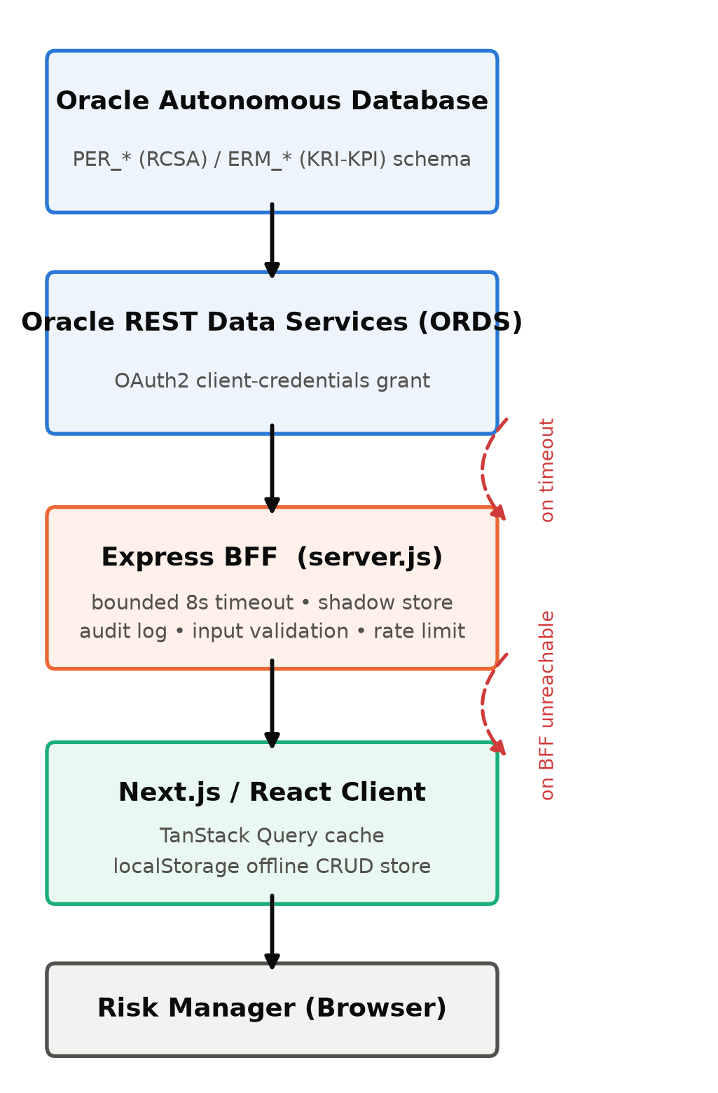
Three-tier resilient architecture.

Data Model
The production schema currently spans 14 core Oracle entities, listed in Table II. Anything prefixed PER_ belongs to the original RCSA core: identify, assess, control, respond. Anything prefixed ERM_ came later, added to support continuous KRI/KPI monitoring and audit logging. Within either prefix, an MST_ infix marks slowly-changing reference data (categories, business processes, control types, KRI/KPI definitions), while a TRN_ infix marks transactional data tied to a specific assessment cycle.
Table II. Core Oracle Entities (prefix convention explained above)
Prefix | Entity (suffix) | Domain
per_trn | identify_risk | RCSA core
per_trn | inherent_risk_assessment | RCSA core
per_trn | control_implementation | RCSA core
per_trn | mitigation_plans | RCSA core
per_trn | risk_monitoring | RCSA core
per_mst | risk_category | RCSA core
per_mst | business_process | RCSA core
per_mst | control_type | RCSA core
erm_mst | kri_definition | KRI/KPI monitoring
erm_mst | kpi_definition | KRI/KPI monitoring
erm_trn | kri_readings | KRI/KPI monitoring
erm_trn | kpi_actuals | KRI/KPI monitoring
erm_trn | assessment_cycle | KRI/KPI monitoring
erm_trn | audit_log | Governance

Identity, Attribution, and Session Handling
Every mutating client request carries X-User-Id, X-User-Name, and X-User-Role headers, populated from the authenticated session and passed through unchanged to the audit-log writer. This closes a gap that is easy to miss in a naive REST proxy: without per-request attribution, every write looks like it came from a generic service account, and an audit trail showing that a risk was accepted but not by whom fails the evidentiary bar that SOX and ISO 31000 both set (Section II-3).

Risk Quantification Model
Pericope ERM scores every risk on two axes at once, so a single assessment produces both a heatmap position and a monetary exposure estimate. Nobody has to keep two disconnected views in sync by hand.
Qualitative composite score. Likelihood $L$ and Impact $I$ are each selected from a five-point ordinal scale (1 = Rare/Insignificant through 5 = Almost Certain/Severe), and the composite score is their product:
$$S=L×I, L,I∈\{1,2,3,4,5\} \text{(1)}$$
$S$ ranges from 1 to 25 and positions the risk on the 5x5 heatmap in Fig. 2, which also classifies $S$ into four qualitative bands (Low, Medium, High, Critical) used consistently across the inherent, residual, and monitoring views.
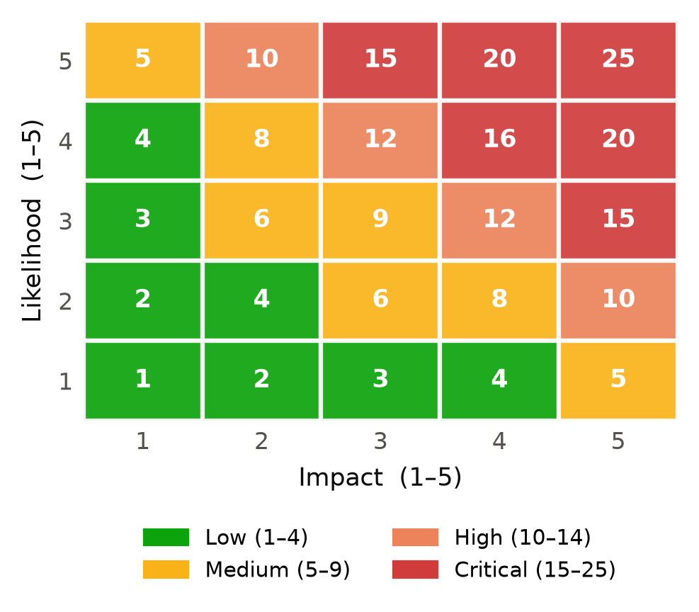
Composite score and qualitative bands.
Quantitative exposure. In parallel, the platform computes a Single Loss Expectancy (SLE) estimate directly from the same qualitative inputs, so every risk gets a first-order monetary figure without the assessor having to separately estimate a dollar value:
$$SLE=L×I×10,000 \text{(USD)} \text{(2)}$$
This is a deliberately simple linear proxy, not a calibrated loss-distribution model, and Section XI discusses what it would take to replace it with an actuarial estimate.
Residual adjustment. When one or more controls are mapped to a risk, the platform’s heatmap module currently applies a single-band step-down heuristic on each axis to derive the residual position:
$$L_{\text{res}}=max(1, L−1), I_{\text{res}}=max(1, I−1) \text{(3)}$$
This adjustment holds regardless of the mapped control’s recorded design-effectiveness percentage. That is a known simplification, not a final design choice; Section XI proposes replacing Eq. (3) with a continuous, effectiveness-weighted reduction once the platform has collected enough control-effectiveness history to calibrate one.
Risk response taxonomy. Once a residual position is established, the risk owner selects a treatment strategy from the ISO 31000-aligned taxonomy in Table III [1].
Table III. Risk Response Taxonomy
Strategy | Definition
Mitigate | Reduce likelihood or impact through additional or strengthened controls
Accept | Formally acknowledge and retain the risk within stated appetite, with sign-off
Avoid | Eliminate the risk by discontinuing the underlying activity
Transfer | Shift the financial consequence via insurance, contract, or outsourcing

System Workflow
A risk moves through the pipeline described in Procedure 1, from initial identification to closed-loop monitoring, and every transition along the way is subject to the attribution and audit requirements described in Section IV-C.
Procedure 1: RCSA-to-Monitoring Pipeline
- Identify: an analyst records a candidate risk against a business process and risk category (per_trn_identify_risk).
- Inherent Assessment: qualitative Likelihood/Impact are selected; $S$ and SLE are computed via Eq. (1)-(2) and the risk is plotted on the inherent heatmap.
- Control Mapping: existing or planned controls are linked via per_trn_control_implementation, each carrying a design-effectiveness percentage.
- Residual Assessment: Eq. (3) discounts the inherent position to a residual position, replotted on the residual heatmap.
- Response Selection: the owner selects a strategy from Table III and records a mitigation plan.
- Governance Approval: the change is routed through the maker-checker workflow module, and every approver’s decision (Approved / Rejected / Pending) is appended to the approval chain before the change takes effect.
- Monitoring: once approved, the risk enters continuous monitoring against configured KRI/ KPI thresholds (erm_trn_kri_readings, erm_trn_kpi_actuals), and action plans are tracked to closure.
- Audit: every state transition in steps 1-7 is appended, with actor identity and a before-and-after snapshot, to the audit trail, independent of which architectural tier ultimately serviced the write.

Functional Module Inventory
The platform currently comprises 25 routed application areas built across 42 page-level React components, roughly 23,000 lines of TypeScript/TSX in total, and Fig. 3 groups them into five functional domains. The core RCSA pipeline, identification through response, accounts for 16 components on its own, the largest single group. Monitoring and KRI functionality (KRI configuration, the KRI matrix, KRI intelligence, action-plan and actions-hierarchy monitoring, heatmaps) makes up nine more. Governance and appetite (risk appetite, appetite framework, the maker-checker workflow, audit trail, policy management) accounts for six, matched by a separate set of extended GRC domains that were added after the initial RCSA core: control library, incident management, business continuity planning, vendor/third-party risk, scenario analysis, and asset library. The remaining five components form the administrative layer: dashboard, reports, settings, user management, and authentication.
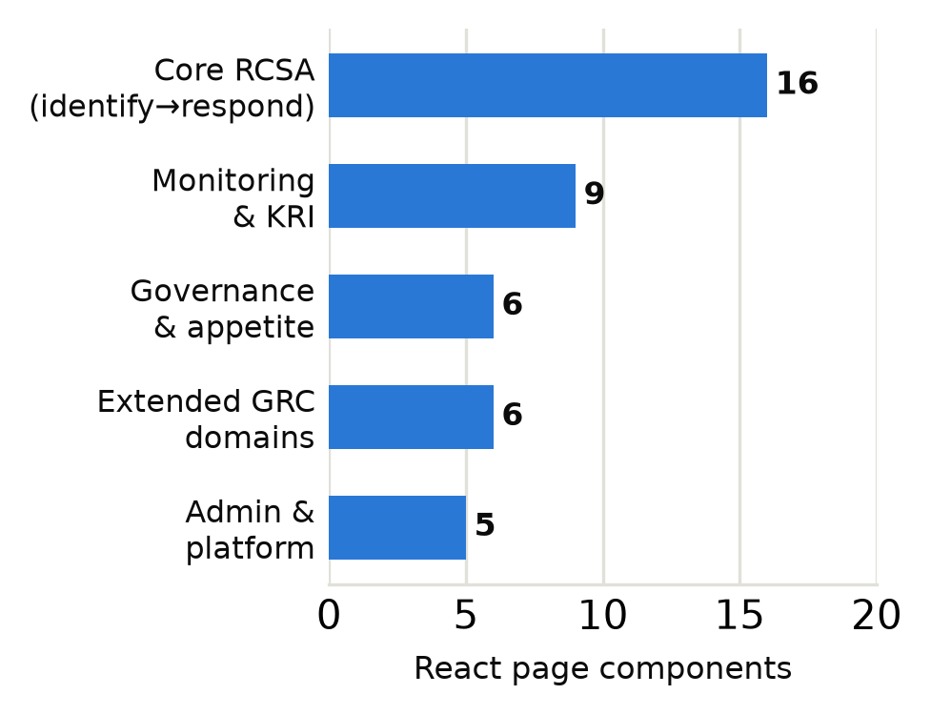
Module distribution across five domains.

Resilience and Data-Quality Engineering

Backend-for-Frontend Fault Tolerance
The Express BFF (Section IV-A) is written so that no single request can hang forever. Every upstream ORDS call sits inside an 8-second timeout, and every successful mutation is mirrored into an in-memory shadow store, so a later read against the same table still returns a deterministic result even if ORDS happens to be unreachable at that exact moment. None of this is a novel idea by itself; bounding failure with an explicit timeout instead of an indefinite hang, and falling back to something degraded but defined instead of an opaque error, reflects fairly standard production-resilience practice for any system that depends on an external, occasionally slow upstream [6], [9]. What matters here is that the platform applies it consistently, rather than assuming ORDS will always answer promptly.

Documented Defect Remediation
A production QA pass against the platform turned up five defect classes, all now closed and summarized in Table IV. This table is included specifically because it is real evidence of engineering maturity, not a claimed benchmark. Each row is an actual fix sitting in the current codebase today, still referenced there by the same defect identifiers used internally during hardening.
Table IV. Documented Defect Remediation
ID | Symptom | Remediation
REC-01 | Create/Update requests hung indefinitely when ORDS stalled | Bounded 8s timeout + shadow-store fallback + explicit error response
REC-04 | Report endpoints occasionally bound to empty result sets | Guaranteed non-empty data binding at the report-query layer
REC-07 | Audit entries were attributed to a generic “System” actor | Per-request X-User-* headers propagated to every mutating call
REC-10 | Free-text fields accepted keyboard-mash/junk input | Consonant-run and vowel-ratio heuristic rejects low-entropy strings
SEC-01/06 | Missing boundary validation risked malformed upstream writes | Schema-level required-field and type validation before every write

Database-Level Hardening
A separate problem showed up at the database tier itself: an invalid PL/SQL trigger (Oracle error ORA-04098) that blocked every INSERT/UPDATE against the PER_TRN_* tables. The fix was an idempotent SQL remediation script that diagnoses invalid objects and compile errors, recompiles them, and runs eight data-quality checks (DQ-01 through DQ-08) to clean up corrupt or orphaned rows without touching anything that is provably valid. Because the script is idempotent, it can be re-run safely whenever a new data-quality issue turns up, instead of requiring a bespoke fix every time.

Comparative Analysis: Pericope ERM vs. Conventional Approaches
Table V sets Pericope ERM against the two dominant conventional approaches across seven governance-relevant dimensions, listed in the table itself rather than repeated here. Scoring follows the convention from Section III: None counts 0, Partial 1, and Full 2, giving a maximum of 14 across the seven rows.
Table V. Structural Feature Comparison
Dimension | Spreadsheet ERM | Legacy GRC Suite | Pericope ERM
Full lifecycle coverage | Partial | Full | Full
Quantitative + qualitative scoring | Partial | Full | Full
Automated, immutable audit trail | None | Full | Full
Maker-checker segregation of duties | None | Full | Full
Real-time KRI/KPI monitoring | None | Partial | Partial
Offline / degraded-connectivity resilience | Full | None | Full
Low total cost of ownership | Full | None | Partial
Aggregate score (max 14) | 6 | 9 | 12
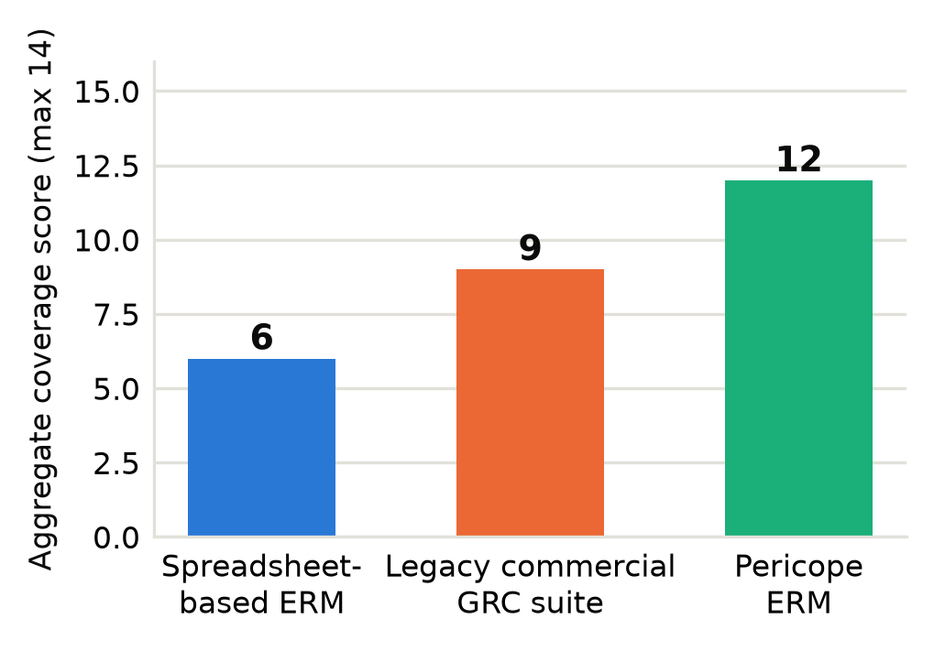
Aggregate structural coverage score.
Fig. 4 makes the trade-off visible. Spreadsheet-based ERM scores well only on cost and offline resilience, and it is no coincidence that those are exactly the two dimensions that require no backend at all, while legacy GRC suites go the other way, dominating on governance depth at the expense of resilience and price. Pericope ERM’s score lands between the two: it matches commercial-suite governance rigor while keeping the availability characteristics of a local tool, though its real-time-monitoring maturity is still only partial, as Section XI acknowledges. This scoring exercise is a qualitative structural comparison, not a throughput or cost benchmark run against production infrastructure. It is meant to communicate scope, nothing more, and it complements rather than replaces the kind of formal load or user study described as future work in Section XII.

Applications
Nothing in the architecture or the data model ties either one to the RCSA workflow that has served as the running example so far. SOX / ICFR compliance is the closest fit, since the identify-assess-control-respond pipeline and its audit trail carry over untouched as evidence for internal-control-over-financial-reporting testing. Vendor risk asks even less: point the scoring model at a vendor register instead of an internal process register and it works as-is, because Section V never assumes the risk under assessment belongs to the organization’s own operations.
Two further cases lean on the monitoring layer rather than the scoring one. Recovery-time objectives in business continuity planning can be tracked against configured thresholds exactly the way KRIs are tracked elsewhere, and IT or cyber risk registers drop onto the control-library and control-implementation entities with little friction, neither having been built around one particular control catalog. For internal audit the payoff is more immediate still, the audit trail from Section VIII being most of the way to usable evidence already. Scenario and stress-testing work is the outlier here: it borrows the Likelihood x Impact and SLE machinery of Section V wholesale, but aims it at positions nobody has observed yet.

Discussion and Limitations
The problems from Section II do get addressed here, but a fair account of the platform cannot stop at that and has to say plainly where it still comes up short.
Start with the residual-risk heuristic in Eq. (3), probably the largest simplification anywhere in the current design. It applies a single-band step-down rather than a continuous function of a mapped control’s recorded design-effectiveness percentage, so two controls of very different quality currently produce exactly the same residual reduction. That outcome is clearly wrong in the general case, which is exactly why it sits first on the roadmap in Section XII.
The risk-quantification model in Eq. (1)-(2) has a related weakness: it is a deterministic linear proxy, not a calibrated probabilistic estimate. Unlike the FAIR-based tooling discussed in Section III, it does not propagate uncertainty anywhere, so it cannot express a confidence interval on the SLE figure it produces.
There is an architectural loose end worth mentioning too. The backend currently exists as two parallel implementations: the production Oracle/ORDS-backed BFF described in Section IV, and a separate, in-progress Clean Architecture skeleton (controller, service, repository, and validator layers) meant to eventually replace it. Maintaining two backend code paths at once carries real overhead, and closing that gap is one of the roadmap items in Section XII.
The offline-tolerant client store from Section IV-A trades availability for eventual consistency, and that trade is not free either. A risk owner editing a record while the BFF is unreachable can, in principle, drift away from a concurrent server-side edit, and reconciliation is not yet conflict-aware.
Real-time KRI/KPI monitoring, despite the name, is presently poll-based rather than event-driven (Table V), so threshold breaches do not surface with the latency a genuinely real-time claim would require.
Finally, everything reported here is a structural, code-grounded account of the system’s architecture and engineering record. It is not a formal load test, a penetration test, or a user study, and all three remain necessary before any production-readiness claim about the platform can be considered fully validated.

Future Scope
Future work breaks down into six priorities, roughly in the order we would tackle them. First, and structurally the most important, is finishing the migration to the Clean Architecture backend touched on in Section XI and extending it to support multi-tenant schema isolation. Second, tied directly to the largest limitation in Section XI, is replacing the deterministic SLE proxy (Eq. (2)) and the single-band residual heuristic (Eq. (3)) with an effectiveness-weighted, Monte Carlo-based quantitative model in the spirit of FAIR [5]. Third is an automated regression and end-to-end test suite gating deployment, which does not exist in any form today. Fourth is moving KRI/KPI monitoring off polling and onto a WebSocket- or event-driven push model, closing the real-time gap flagged in Table V. Fifth is adding conflict-aware reconciliation to the offline client store from Section IV-A. Sixth, and a prerequisite before any production compliance claim is made about this platform, is commissioning formal load and penetration testing, together with a user study involving practicing risk managers rather than only the people who built it.

Conclusion
This paper set out to describe Pericope ERM, a full-stack enterprise risk management platform that digitizes the complete RCSA lifecycle behind a single Oracle-hosted schema, closing the fragmentation, traceability, and segregation-of-duties gaps that persist in spreadsheet-based risk management (Section II) without the licensing and implementation cost of a legacy commercial GRC suite. We described a three-tier, resilience-first architecture that degrades gracefully across two independent failure boundaries (Section IV), formalized the platform’s dual qualitative and quantitative risk-scoring model (Section V), and, somewhat unusually for a paper of this kind, documented a real production defect-remediation and database-hardening exercise as evidence of engineering maturity (Section VIII) rather than leaning on a simulated benchmark. A structural comparison (Section IX) placed the platform between spreadsheet-based and commercial GRC approaches on governance depth, resilience, and cost. The limitations catalogued in Section XI, namely a simplified residual-risk heuristic, a deterministic rather than probabilistic loss model, and an unfinished backend migration, are not an afterthought. They are the actual roadmap (Section XII) toward a more rigorous, event-driven, multi-tenant successor.

Acknowledgment
The authors thank the Department of Computer Science and Engineering, Atria Institute of Technology, for the guidance and computational resources that made this work possible.

References
[1] International Organization for Standardization, “ISO 31000:2018 Risk Management — Guidelines,” ISO, Geneva, Switzerland, 2018.
[2] Committee of Sponsoring Organizations of the Treadway Commission (COSO), “Enterprise Risk Management — Integrating with Strategy and Performance,” COSO, 2017.
[3] Sarbanes-Oxley Act of 2002, Pub. L. No. 107-204, 116 Stat. 745, U.S. Congress, 2002.
[4] National Institute of Standards and Technology, “Guide for Conducting Risk Assessments,” NIST Special Publication 800-30 Rev. 1, Gaithersburg, MD, 2012.
[5] The Open Group, “Risk Analysis (O-RA), an Open Group Standard,” based on the Factor Analysis of Information Risk (FAIR) model, The Open Group, 2021.
[6] M. Nygard, Release It!: Design and Deploy Production-Ready Software, 2nd ed. Raleigh, NC: Pragmatic Bookshelf, 2018.
[7] R. T. Fielding, “Architectural Styles and the Design of Network-based Software Architectures,” Ph.D. dissertation, Univ. of California, Irvine, 2000.
[8] M. Fowler, Patterns of Enterprise Application Architecture. Boston, MA: Addison-Wesley, 2002.
[9] S. Newman, Building Microservices, 2nd ed. Sebastopol, CA: O’Reilly Media, 2021.
[10] Oracle Corporation, “Oracle REST Data Services Documentation,” Oracle Help Center, 2024. [Online]. Available: https://docs.oracle.com/en/database/oracle/oracle-rest-data-services/
[11] Vercel Inc., “Next.js Documentation,” 2024. [Online]. Available: https://nextjs.org/docs
[12] TanStack, “TanStack Query Documentation,” 2024. [Online]. Available: https://tanstack.com/query
[13] Committee of Sponsoring Organizations of the Treadway Commission (COSO), “Internal Control — Integrated Framework,” COSO, 2013.

