GitHub Repo Summarizer – Documentation

GitHub Repo Summarizer is a browser extension with a lightweight Python backend that analyzes GitHub repositories and generates AI-powered summaries and an optional project overview. It also visualizes the repository tree with a clean, responsive UI.

# Features

* AI-Powered Summaries of GitHub repositories
* Project Overview document generation
* Beautiful, interactive Tree Visualization
* History and Favorites management
* Dark/Light theme with responsive design

# Installation

## For Users

1. Download the extension files
2. Open Chrome/Edge and go to chrome://extensions/
3. Enable Developer mode
4. Click Load unpacked and select the extension folder
5. Pin the extension to your toolbar

## For Developers

1. Clone the repository
2. Install Python dependencies: pip install -r requirements.txt
3. Run the backend server for local testing: python src/backend.py
4. Load the extension in your browser (Load unpacked)

# Usage

1. Navigate to a GitHub repository page
2. Click the extension icon
3. Click Analyze Repository
4. Wait for analysis to complete and view the summary and tree

# Architecture

* Frontend (Extension): popup.html, popup.js, content.js, styles.css, tree-overlay.*
* Backend (Python FastAPI/Serverless): receives repo info, fetches README/structure, calls LLM (Groq)
* Data Flow: Content script extracts minimal repo info -> Backend retrieves README/tree -> LLM generates summary and paper -> Extension UI displays results

# Configuration

* API_KEY (required): Groq API key for LLM calls (serverless backend).
* GITHUB_TOKEN (optional): Increases GitHub API rate limits when fetching README and tree.

# API Overview

The deployed backend accepts POST requests with repository metadata and returns a summary and a project overview. The local development backend in src/backend.py proxies to the deployed API.

# Screenshots

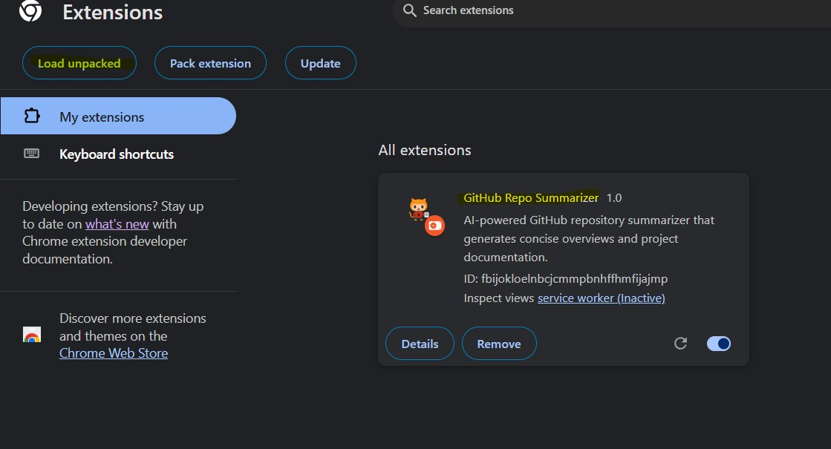

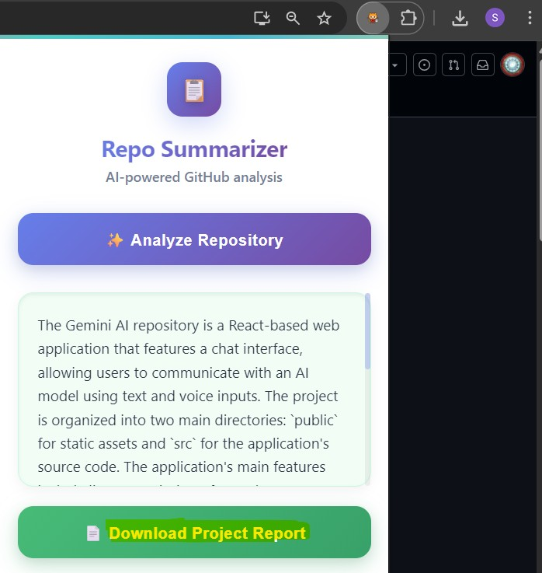

# License

MIT License