GitHub Repo Summarizer – Documentation
GitHub Repo Summarizer is a browser extension with a lightweight Python backend that analyzes GitHub repositories and generates AI-powered summaries and an optional project overview. It also visualizes the repository tree with a clean, responsive UI.

Features
- AI-Powered Summaries of GitHub repositories
- Project Overview document generation
- Beautiful, interactive Tree Visualization
- History and Favorites management
- Dark/Light theme with responsive design

Installation

For Users
- Download the extension files
- Open Chrome/Edge and go to chrome://extensions/
- Enable Developer mode
- Click Load unpacked and select the extension folder
- Pin the extension to your toolbar

For Developers
- Clone the repository
- Install Python dependencies: pip install -r requirements.txt
- Run the backend server for local testing: python src/backend.py
- Load the extension in your browser (Load unpacked)

Usage
- Navigate to a GitHub repository page
- Click the extension icon
- Click Analyze Repository
- Wait for analysis to complete and view the summary and tree

Architecture
- Frontend (Extension): popup.html, popup.js, content.js, styles.css, tree-overlay.*
- Backend (Python FastAPI/Serverless): receives repo info, fetches README/structure, calls LLM (Groq)
- Data Flow: Content script extracts minimal repo info -> Backend retrieves README/tree -> LLM generates summary and paper -> Extension UI displays results

Configuration
- API_KEY (required): Groq API key for LLM calls (serverless backend).
- GITHUB_TOKEN (optional): Increases GitHub API rate limits when fetching README and tree.

API Overview
The deployed backend accepts POST requests with repository metadata and returns a summary and a project overview. The local development backend in src/backend.py proxies to the deployed API.

Screenshots
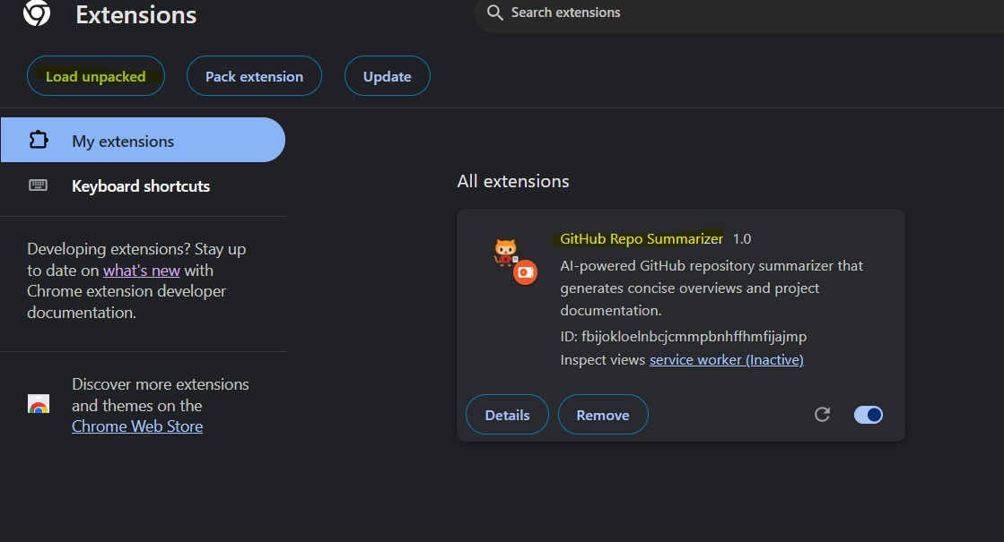
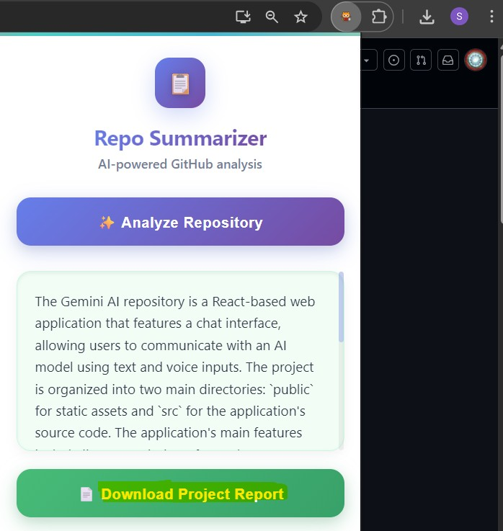

License
MIT License

