E-R DIAGRAM OF CUSTOMER DATABASE :
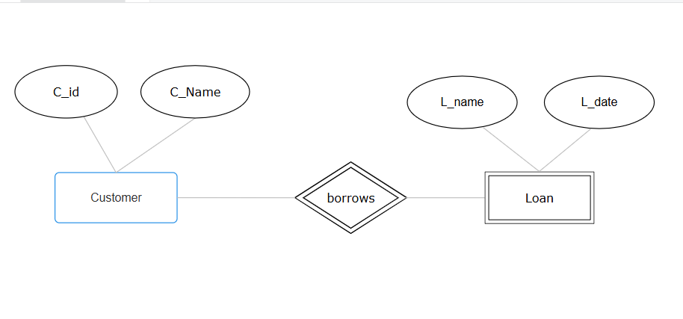

E-R DIAGRAM OF LIBRARY MANAGEMENT DATABASE :

