E- R DIAGRAM OF STUDENT MANAGEMENT DATABASE :
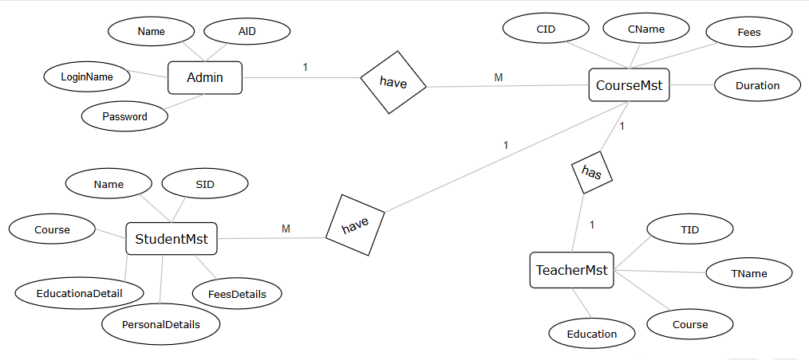

E- R DIAGRAM OF HOSPITAL MANAGEMENT DATABASE :

