**DIGITAL BADGES**

**Objective:**

* To design a page to upload badge details
* After uploading, list all the badges in a separate page
* Check if a student is eligible for a badge

**Technology used:**

* Python 3.7/Flask
* SQLite3

**Deployment of code:**

**Pre requisites:**

* Install flask if not already installed
* Install sqlite3 if not already installed
* Copy all the required files including .html,.py,.css
* Ensure all environment variables are set to run flask and sqlite3

**Github repository path:**

**https://github.com/srividyas88/BADGE/upload**

After installing flask,sqlite3, run hello.py.

Run the app in localhost:5050

**Application workflow:**

* Two main categories on badge:
* Upload badge details:
  + Enter name of the badge, description, upload an image of the badge and list of comma separated email ids of students.
  + Badge name and eligible student list are mandatory fields.
  + While clicking on save, “badge” source is called from the flask app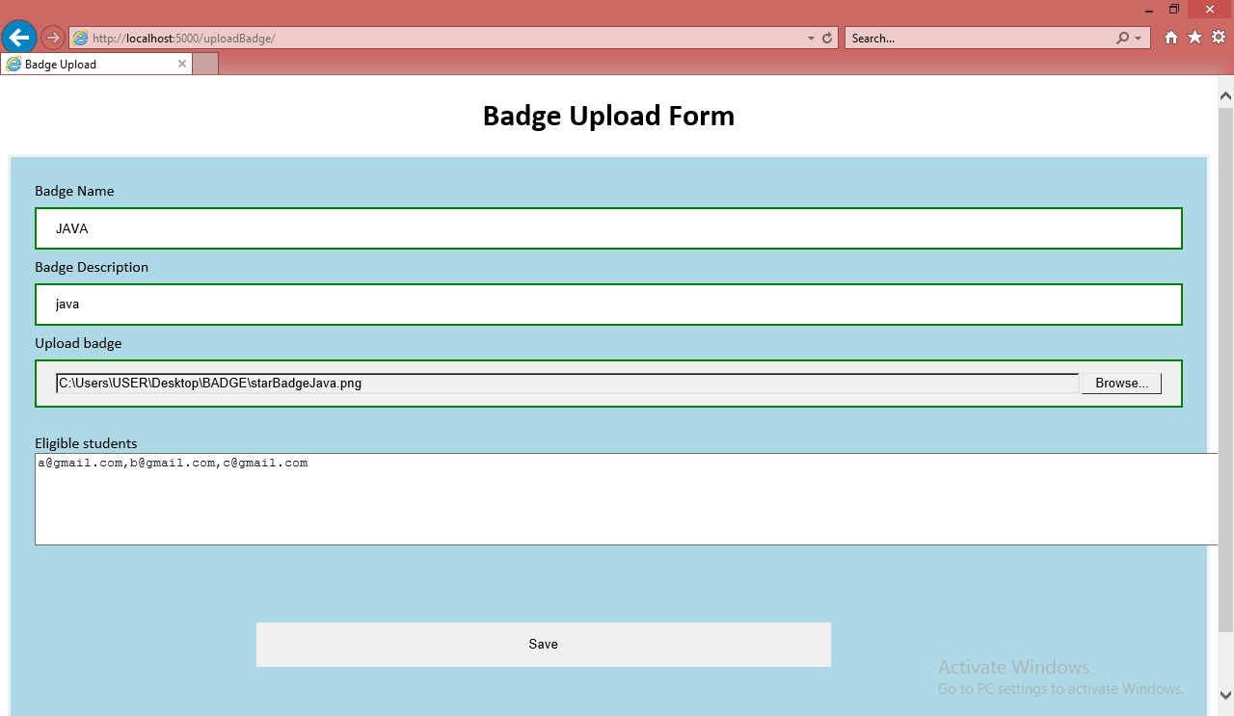

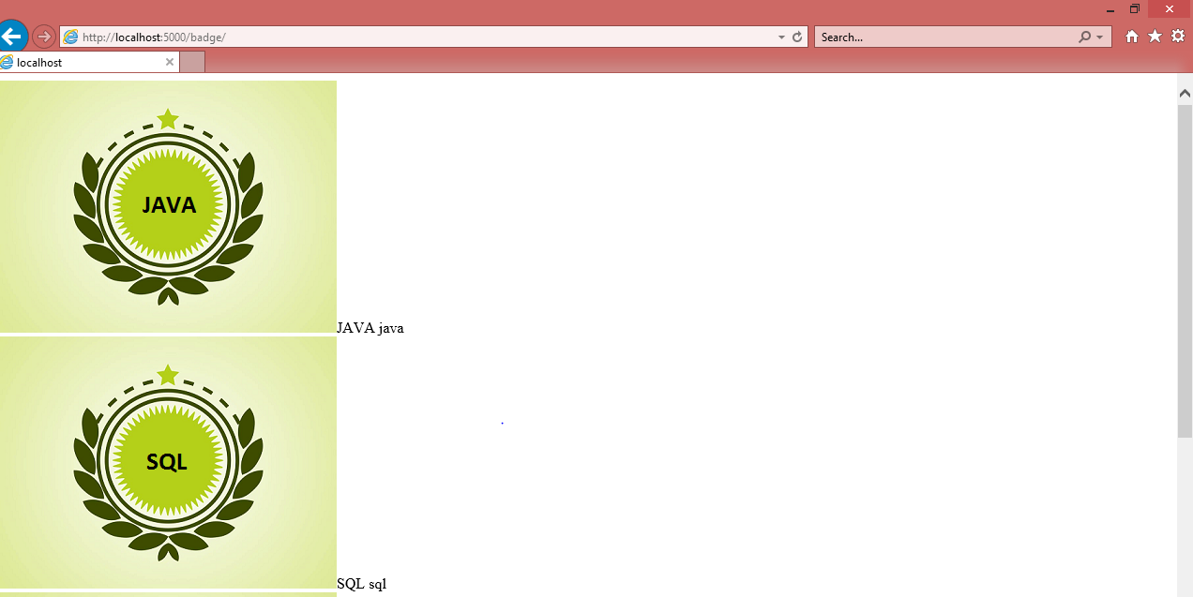

* At the backend, details are saved in BADGE table with name as primary key.
* If an existing badge is added in the frontend, only the students email id is updated in the table as the badge name is unique.

Check if a student is eligible for badge:

* At the front end, Enter badge name and student email id. Click on check.
* 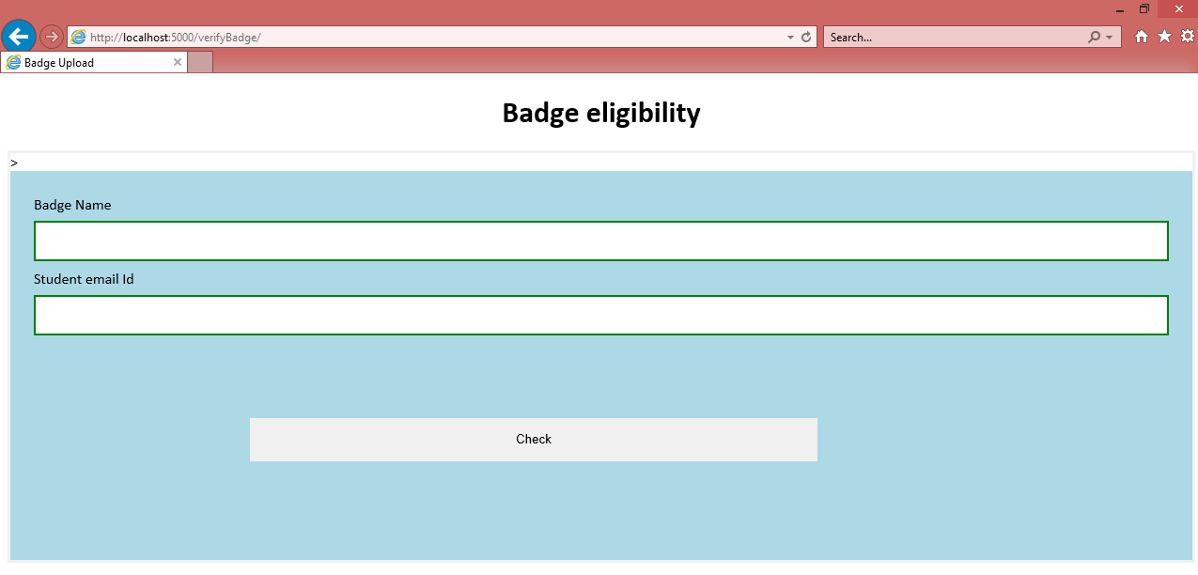
* At the backend, the email id is checked in the table associated with the badge.



* If the row exists, the message “student is eligible for badge” is displayed.
* If not, the message “student is not eligible for badge” is displayed.