**Public transportation optimization - Phase2**

Public transportation optimization refers to the process of improving the efficiency, reliability, and effectiveness of public transportation systems. This optimization can encompass various aspects, including route planning, scheduling, resource allocation, and passenger experience

**DESIGN**

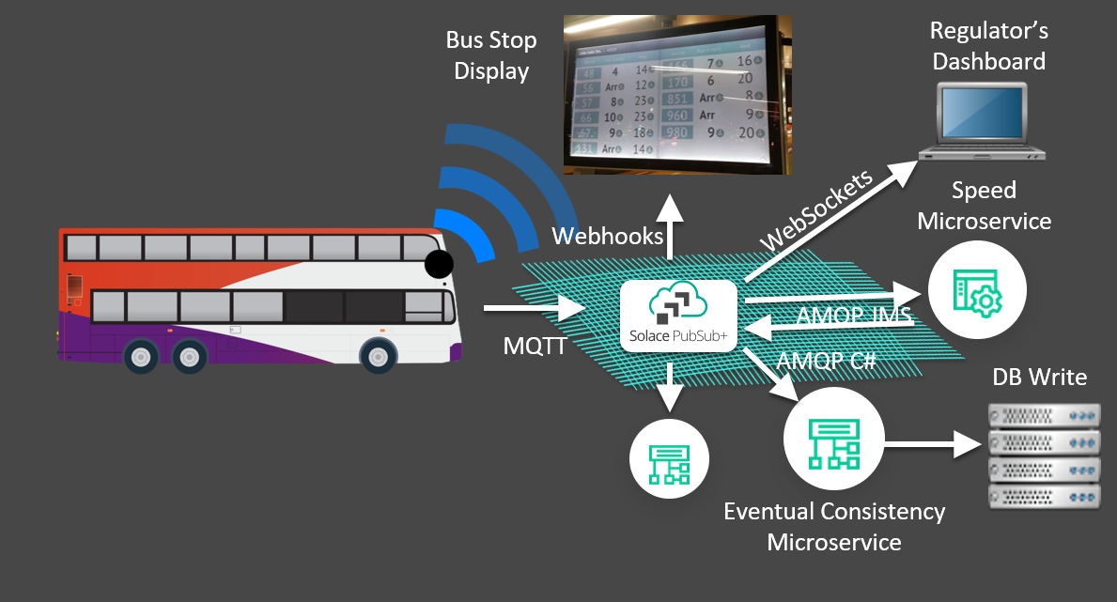

With more and more Internet of Things (IOT) devices entering the market daily, it’s getting easier and easier to capture interesting data from the sensors and control systems involved with running a modern city. Low Energy Bluetooth (LEB) devices, GPS, near-field communication, mobile apps, streaming apps — data comes from everywhere today, and cities are generating data at a rapidly increasing rate. **cities** use this data to enhance the quality of life for their citizens, and there’s no better example than when you apply a “smart city” mindset to public transportation systems.

By optimizing your public transport systems you can help citizens get where they’re going more quickly by reducing congestion on roadways and intelligently allocating and routing buses to areas with more travelers. That means locals, visitors and workers spend less time in transit and more time enjoying your city, successfully completing errands or getting to and from work.

Finally, smarter transportation can reduce environmental impact. The **EPA has found** that investing in public transport and other types of transportation can lower greenhouse gas emissions. Considering that in 2017 the transportation sector represented the largest source of emissions from fossil fuel combustion, this is a significant win.

**Problems**

Public transportation optimization problems are complex challenges that involve finding efficient ways to manage and improve public transportation systems in urban areas. These problems often arise due to increasing urbanization, traffic congestion, environmental concerns, and the need for more sustainable transportation options. Innovative solutions are essential to address these challenges effectively.

**Innovative solutions**

1. **Route Optimization:**
   * ***Problem*: Designing efficient routes to minimize travel time and congestion.**
   * ***Solution*: Implementing dynamic routing algorithms that adjust routes in real-time based on traffic conditions and demand. Using data analytics and machine learning to predict congestion and optimize routes.**
2. **Fleet Management:**
   * ***Problem*: Efficiently managing the allocation of vehicles and drivers.**
   * ***Solution*: Developing smart scheduling and dispatch systems that optimize vehicle and driver assignments based on real-time demand. Implementing predictive maintenance to reduce vehicle downtime.**
3. **Pricing and Fare Optimization:**
   * ***Problem*: Setting fare prices to balance affordability with revenue generation.**
   * ***Solution*: Implementing demand-based pricing models that adjust fares based on time of day, demand, and occupancy. Introducing contactless payment options to streamline the fare collection process.**
4. **Last-Mile Connectivity:**
   * ***Problem*: Addressing the challenge of connecting passengers to and from transportation hubs.**
   * ***Solution*: Integrating various transportation modes (buses, subways, bikes, scooters) and offering real-time information on connections. Promoting micro-mobility options for short-distance travel.**
5. **Environmental Sustainability:**
   * ***Problem*: Reducing the carbon footprint of public transportation.**
   * ***Solution*: Transitioning to electric or hybrid vehicles, implementing green infrastructure (e.g., electric bus charging stations), and promoting public transportation as an eco-friendly alternative to private vehicles.**
6. **Passenger Experience and Accessibility:**
   * ***Problem*: Ensuring a positive experience for all passengers, including those with disabilities.**
   * ***Solution*: Designing accessible stations and vehicles, providing real-time information for passengers, and offering mobile apps for ticketing and navigation. Implementing features like wheelchair ramps and priority seating.**
7. **Data Integration and Analysis:**
   * ***Problem*: Making sense of vast amounts of data to inform decision-making.**
   * ***Solution*: Utilizing advanced data analytics and machine learning algorithms to predict demand patterns, optimize routes, and improve maintenance scheduling. Creating open data platforms for developers to build innovative transportation apps.**
8. **Public-Private Partnerships (PPP):**
   * ***Problem*: Securing funding and expertise for large-scale transportation projects.**
   * ***Solution*: Partnering with private companies for investments, technology deployment, and operation. Implementing revenue-sharing models to encourage private sector involvement.**
9. **Microtransit and On-Demand Services:**
   * ***Problem*: Addressing transportation gaps in underserved areas.**
   * ***Solution*: Introducing on-demand microtransit services that use small vehicles or ride-sharing platforms to provide flexible and cost-effective transportation options in areas with lower demand.**

**10. User Engagement and Marketing:**

* + ***Problem*: Encouraging more people to use public transportation.**
  + ***Solution*: Implementing marketing campaigns that highlight the benefits of public transportation, offering incentives like discounts or loyalty programs, and actively engaging with the community to gather feedback and make improvements.**

**Innovative solutions to public transportation optimization problems often involve the integration of technology,**

**Steps taken by me**

* Utilization of the device is manageable
* Found the problem and take proper action
* Upgrade the time zones as per the work aspects
* Wide the range and reach ability
* Done the device when that is in any situation
* Design of the device is aspect to whether conditions
* Transportation of the vehicles and pedastrians should be convinsoble
* Identification of error is rectified
* Error monitoring system is maintained
* Sustainable gain was reproduced