**PSG COLLEGE OF TECHNOLOGY, COIMBATORE – 641 004**

**DEPARTMENT OF COMPUTER APPLICATIONS**

**20MX28 ENTERPRISE APPLICATION DEVELOPMENT**

**2020-2021 MCA First Year Semester 2**

**I. Team Detail**

|  |  |  |  |
| --- | --- | --- | --- |
| **Team No.** | **Roll No.** | **Name of the student** | **Name of the Faculty Guide** |
| 12 | 20mx107 | Chandeesh S | Dr. Bhuvaneswari A |
| 20mx221 | Srivijayram N B |

**II. Title of the Application**

|  |
| --- |
| A Two-way Communication Bus Architecture for the e-Health System |

**III. Abstract**

|  |
| --- |
| The electronic Healthcare (e-Health) system is a message-based architecture that allows the user to access Electronic Health Records (EHR) in a secured manner with privacy. This system acts as a middleware between the Point of Service [POS] and the users. In this project, a communication system is built that uses HL7 version 3 protocol to transfer the patient’s electronic health records to the POS [Point of Service] and vice versa. Every electronic communication needs a protocol to communicate. Similarly clinical records need a proper protocol to be communicated in a secure manner. HL7 is a protocol or standard for transferring clinical records. It allows the user to update their health records in a database. This database assists in retrieving the history of the patient that helps the doctor in better diagnosis and provides appropriate treatment. In this pandemic situation, this system can be very much useful for the patients in need and receive necessary treatment on time. |

**IV. Objectives of the Proposed Application**

|  |
| --- |
| * “Consult doctors virtually” – is the main motive of our application. Aged-patients or patients who are self-quarantined could not visit doctors in-person. This application will be very much useful to those users. * Many medical crimes are happening recently by misusing the medical records of a person. So this system is intended to keep them safe by using HL7 protocols. * This proposed application is been developed inorder to give atmost care and treatment to the patients. * In this pandemic risks, patients can communicate to the doctors through online privately and securely by the developed application. Patients history will not be misused at any cause. |

**V. Scope / Use**

|  |
| --- |
| * Many patients may lose their paper-based medical records. But here it is automated in online, which are secured enough. Doctors can view the records and give required treatment needed. |

**VI. Software Technology to be used (Specific Framework etc.)**

|  |
| --- |
| FRONT END **SOFTWARE** : PyCharm  **SCRIPTING LANGUAGES** : HTML , JAVASCRIPT, CSS  **WEB APPLICATION FRAMEWORKS** : React JS BACK END **FRAMEWORK :** Django  **DATABASE** : MySQL  **SOFTWARE**  : phpMyAdmin  **SERVER**  : WAMP SERVER |

**VII. Functional Requirements of the Application**

|  |
| --- |
| * Generate Medical document * Secure transmission of Electronic Health Records * Implementation of standard HL7 protocol * Maintain privacy and security of patient health record |

**VIII. Non-Functional Requirements of the Application**

|  |
| --- |
| * **Reliability**   The ability of the system to behave consistently in a user-acceptable manner when operating within the environment for which the system was intended.   * **Availability**   24 X 7 availability. The system should be available at all times, meaning the user can access it using a web browser, only restricted by the down time of the server on which the system runs.   * **User friendly**   System should be easily used by the user.   * **Performance**   Performance of the system should be faster without loading delay.   * **Security**   As HL7 protocol is used, security is very much expected to reach the main objective of the application.   * **Privacy**   The privacy of the data/records of the patients is maintained   * **Interoperability**   Interoperability is a characteristic of a product or system, whose interfaces are completely understood, to work with other products or systems |

**IX. Flow diagram of the Application ( CAD/ Flow chart kind of simple diagram to illustrate the functional flow of your application)**

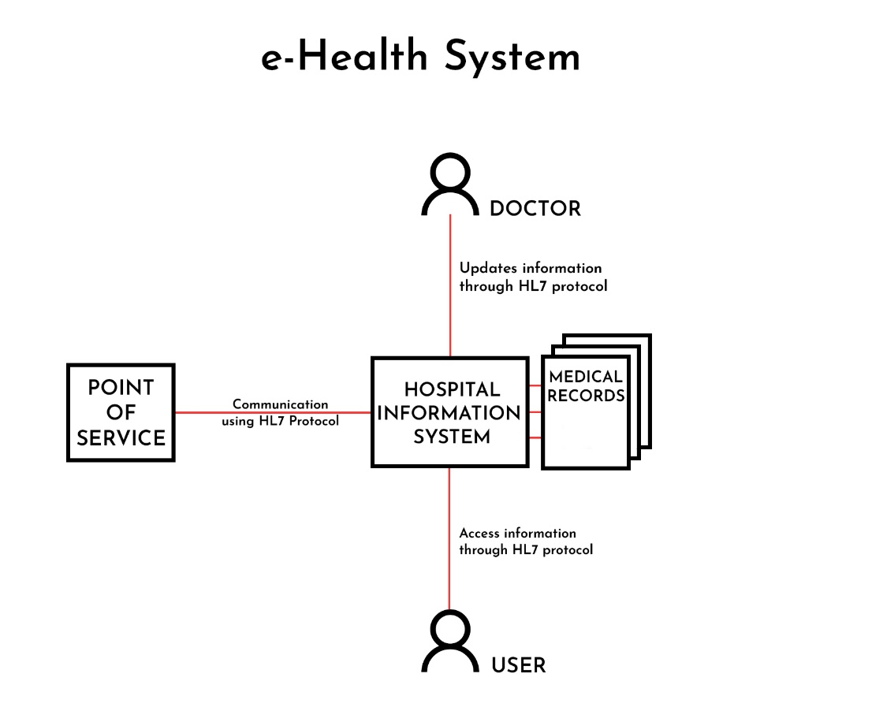

**X. Complete interface/prototype of the Application (use Storyboarding method / Wireframe tools to do this….)**

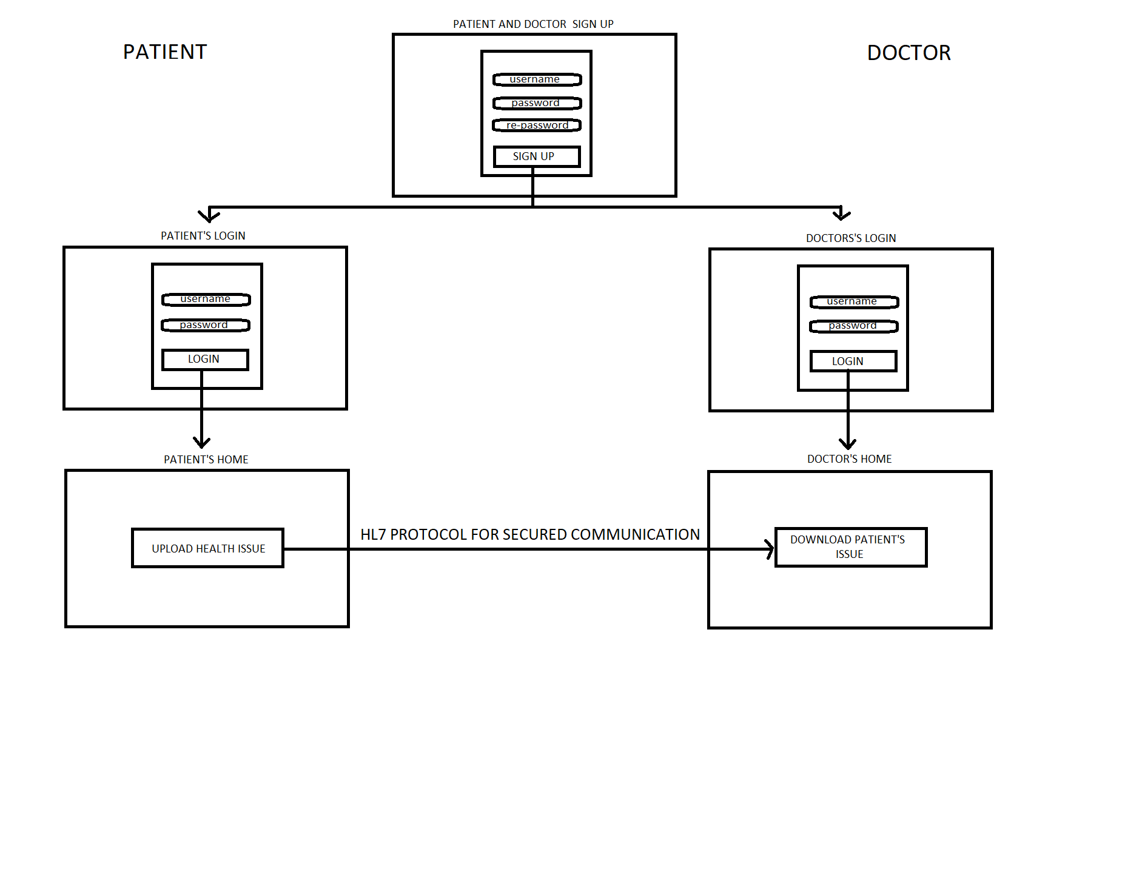

**X1. Database Schema of the application:**

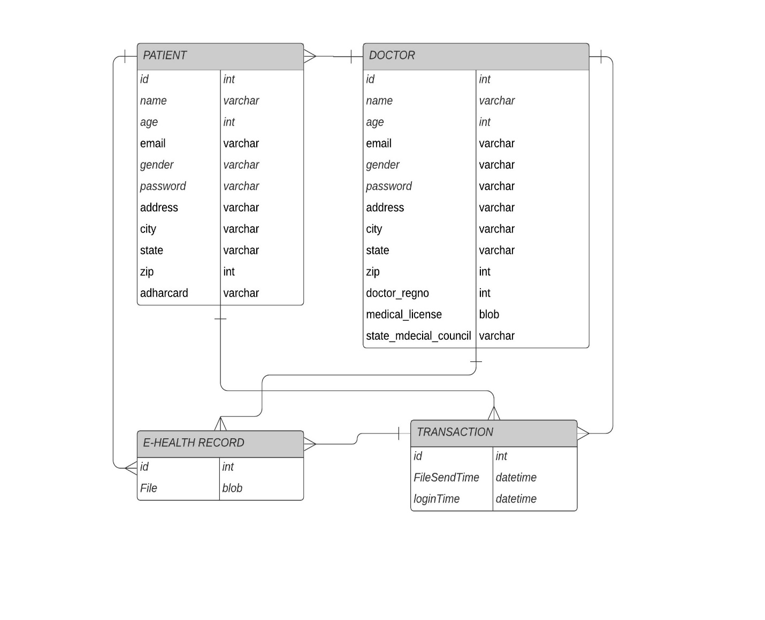

**XII: Use Case Diagram for the application:**

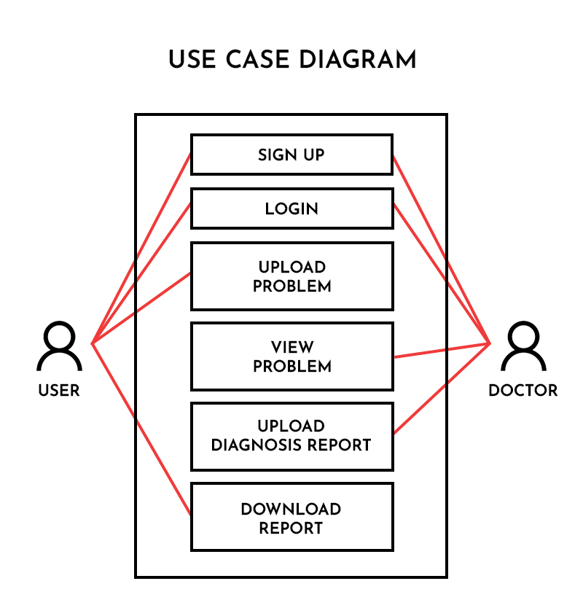

**XIII: Other specifications/diagrams related to your work:**

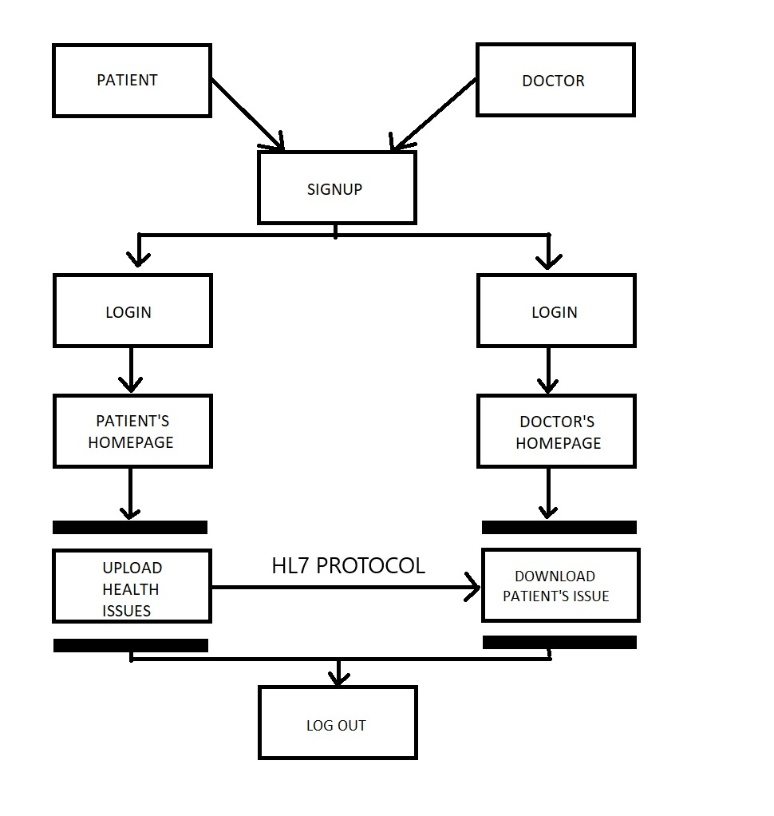

**XIV: Timeline of Activities planned/completed**

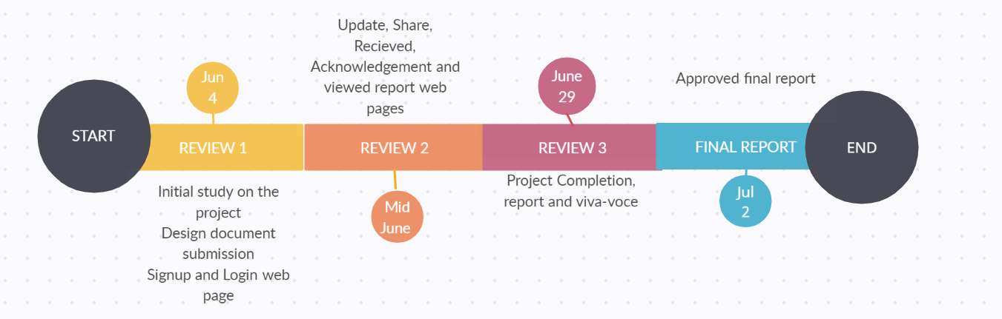

 **Signature of the students Signature of the Guide**

**Name 1: Chandeesh S Name:** Dr. Bhuvaneswari A

**Name 2: Sri Vijay Ram N B**