**NITTE MEENAKSHI INSTITUTE OF TECHNOLOGY**

(AN AUTONOMOUS INSTITUTION, AFFILIATED TO VISVESVARAYA TECHNOLOGICAL UNIVERSITY, BELGAUM, APPROVED BY AICTE & GOVT.OF KARNATAKA



**PHP MINI PROJECT**

on

**Agricultural Produce Market Committee**

*Submitted in partial fulfilment of the requirement for Web Technology lab*

Submitted by:

|  |  |
| --- | --- |
| **SIDDANAGOUDA** | **1NT17CS183** |

**SRI VINAY 1NT17CS188**

UNDER THE GUIDANCE OF:

Mr.Nagaraj

Ms.Impana



**Department of Computer Science and Engineering**

2019-20

**ACKNOWLEDGEMENT**

The satisfaction and euphoria that accompany the successful completion of any task would be incomplete without the mention of the people who made it possible, whose constant guidance and encouragement crowned our effort with success. I express my sincere gratitude to our Principal **Dr. H. C. Nagaraj**, Nitte Meenakshi Institute of Technology for providing facilities.

We wish to thank our HOD**, Dr. Thippeswamy M.N** for the excellent environment created to further educational growth in our college. We also thank him for the invaluable guidance provided which has helped in the creation of a better project.

I hereby like to thank our guides **Ms. Poornima M S** and **Mrs. Jagdevi N Kalshetty**, Department of Computer Science & Engineering on his periodic inspection, time to time evaluation of the project and help to bring the project to the present form.

**ABSTRACT**

The purpose of the “APMC” project is that we are going to link the farmers and whole sellers using the database management software. Here the “APMC” is managed by the admin who gives a platform for both the farmers and sellers to interact with each other efficiently. The main problem in the present world is that there is no online database to store information permanently for the market transactions. So we are going to create a dynamic online website which solves the transaction problem. Here we are collecting information about the produced goods , requirement by sellers and is will be managed by the admin efficiently. The outcome of this project is that the farmer will be obtaining the maximum profit for his products and the seller can buy the products at minimal cost.

**TABLE OF CONTENTS**

|  |  |  |
| --- | --- | --- |
| **SL NO** | **CONTENTS** | **PAGE NO** |
| 1 | INTRODUCTION | 6-17 |
| 2 | REQUIREMENT | 18 |
| 3 | IMPLEMENTATION | 19-22 |
| 4 | SNAPSHOTS | 23-26 |
| 5 | CONCLUSION | 27 |
| 6 | BIBLIOGRAPHY | 28 |
| 7 | SIGNATURE OF THE TEAM MEMBERS | 29 |

**INTRODUCTION**

The main aim of our “APMC” project is to provide a platform for the communication of both farmers and whole sellers and help them for marketing goods efficiently. Here the APMC ADMIN is the head of the total database management software who decides the deal between and farmers and whole sellers. With this system the government will be able to track the transactions and levy appropriate taxes for all the goods hence reducing black market economy. This project consists of following attributes.

* Farmer name
* Farmer product
* Farmer product’s size
* Farmer id
* Seller name
* Seller id
* Seller buying cost
* Admin login

This project aims at maintaining all the information pertaining farmer details,seller details and the previous transactions help them manage in a better way. Aim is to provide transparency in this field, make the process of marketing very easy.

**Software & Tools Used**

**1. PHP:-**

PHP is now officially known as “**PHP: Hypertext Preprocessor**”. It is a server-side scripting language usually written in an HTML context. Unlike an ordinary HTML page, a PHP script is not sent directly to a client by the server; instead, it is parsed by the PHP binary or module, which is server-side installed. HTML elements in the script are left alone, but PHP code is interpreted and executed. PHP code in a script can query databases, create images, read and write files, talk to remote servers – the possibilities is endless. The output from PHP code is combined with the HTML in the script and the result sent to the user’s web-browser, therefore it can never tell the user whether the web-server uses PHP or not, because the entire browser sees is HTML.

PHP’s support for Apache and MySQL further increases its popularity. Apache is now the most-used web-server in the world, and PHP can be compiled as an Apache module. MySQL is a powerful free SQL database, and PHP provides a comprehensive set of functions for working with it. The combination of Apache, MySQL and PHP is all but unbeatable.

That doesn’t mean that PHP cannot work in other environments or with other tools. In fact, PHP supports an extensive list of databases and web-servers. While in the mid-1990s it was ok to build sites, even relatively large sites, with hundreds of individual hard-coded HTML pages, today’s webmasters are making the most of the power of databases to manage their content more effectively and to personalize their sites according to individual user preferences.

**Reasons for using PHP**

There are some indisputable great reasons to work with PHP. As an open source product, PHP is well supported by a talented production team and a committed user community. Furthermore, PHP can be run on all the major operating systems with most servers.

**a)** **Learning PHP is easy**Basic is easy any interpreted language should be easy to learn. Since you are isolated from the system (no pointers to use, no memory to allocate). The other advantage that all modern interpreted languages share is good associative array constructs.

**b)** **Its Performance**

While we can build an application that serves millions of pages a day on a server, when we really look at the performance of the language it sucks. We are still orders of magnitude from real performance. Not only that, but since PHP is designed around a single process model our ability to share data structures or connection pool resources is left to native code libraries.

**The low cost**

There are many languages which are available at very less cost. There are some languages which are available at very less cost like below:

* PHP
* C
* C++ etc

**d) It’s Open Source, We can modify it**

We can modify it if you need a hole in your head! Technically the point is that it’s an open source project and they release patches often. You’re point is that the community is actively working out the bugs. So, what any active language is doing this...

Unfortunately C, C++ and Perl have all “died” at this point and will pretty much remain static at their current functionality.

**Its Portability**

C is portable; it’s just the OS bits that aren’t. A lot PHP isn’t portable to Windows since people don’t use the OS abstractions to avoid some problems.

**It has interfaces to a large variety of database systems**

PHP supports a large variety of the database.

**Support available**

Online Support is available for using PHP.

**e)PHP Syntax**

You cannot view the PHP source code by selecting “View source” in the browser – you will only see the output from the PHP file, which is plain HTML. This is because the scripts are executed on the server before the result is sent back to the browser.

**Basic PHP Syntax**

A PHP scripting block always starts with **<?php** and ends with **?>**. A PHP scripting block can be placed anywhere in the document. On servers with shorthand support enabled you can start a scripting block with <? And end with ?>. However, for maximum compatibility, we recommend that you use the standard form (<?php) rather than the shorthand form.

A PHP file normally contains HTML tags, just like an HTML file, and some PHP scripting code.

**2 .HTML**

**HTML** or **Hyper Text Markup Language** is the standard markup language used to create web pages.

HTML was created in 1991 by Tim Berners-Lee at CERN in Switzerland. It was designed to allow scientists to display and share their research.

HTML is written in the form of HTML elements consisting of *tags* enclosed in angle brackets(like <html>). HTML tags most commonly come in pairs like <h1> and </h1>, although some tags represent *empty elements* and so are unpaired, for example <img>. The first tag in a pair is the *start tag*, and the second tag is the *end tag* (they are also called *opening tags* and *closing tags*).

The purpose of a web browser is to read HTML documents and compose them into visible or audible web pages. The browser does not display the HTML tags, but uses the tags to interpret the content of the page. HTML describes the structure of a website semantically along with cues for presentation, making it a markup language rather than a programming language.

HTML elements form the building blocks of all websites. HTML allows images and objects to be embedded and can be used to create interactive forms. It provides a means to create structured documents by denoting structural semantics for text such as headings, paragraphs, lists, links, quotes and other items. It can embed scripts written in languages such as Java Script which affect the behavior of HTML web pages.

HTML is descriptive markup language. Library of various markup languages is defined in various browsers.

**a) HTML Images - The <img> Tag and the Src Attribute**

In HTML, images are defined with the <img> tag.

The <img> tag is empty, which means that it contains attributes only, and has no closing tag.

To display an image on a page, you need to use the src attribute. Src stands for "source". The value of the src attribute is the URL of the image you want to display.

**Syntax for defining an image:**

<imgsrc="*url*" alt="*some_text*">

**b) HTML FORMS**

HTML forms are used to pass data to a server.

|  |
| --- |
| The <form> tag is used to create an HTML form:  <form> . *input elements* . </form> |

An HTML form can contain input elements like text fields, checkboxes, radio-buttons, submit buttons and more. A form can also contain select lists, textarea, fieldset, legend, and label elements.

**c)** **Image tag (<img>) :**

To add an image to an HTML document, we just need to include an <IMG> tag with a

reference to the desired image. The <IMG> tag is an empty element i.e. it doesn’t require a

closing tag and we can use it to include from small icons to large images.

**Syntax: <imgsrc=”URL” alt=”alternative text”>**

**d) HTML Lists :**

|  |  |
| --- | --- |
| An ordered list:   * The first list item * The second list item * The third list item | An unordered list:   * List item * List item * List item |

**HTML 5**

HTML5 will be the new standard for HTML. The previous version of HTML, HTML 4.01,

came in 1999. The web has changed a lot since then. HTML5 is still a work in progress.

However, the major browsers support many of the new HTML5 elements and APIs.

HTML5 is cooperation between the World Wide Web Consortium (W3C) and the Web

Hypertext Application Technology Working Group (WHATWG).

WHATWG was working with web forms and applications, and W3C was working with

XHTML 2.0. In 2006, they decided to cooperate and create a new version of HTML.

Some rules for HTML5 were established:

a) New features should be based on HTML, CSS, DOM, and JavaScript

b) Reduce the need for external plug-ins (like Flash)

c) Better error handling

d) More markup to replace scripting

e) HTML5 should be device independent

f) The development process should be visible to the public

**CSS**

**CSS tutorial** or CSS 3 tutorial provides basic and advanced concepts of CSS technology. Our CSS tutorial is developed for beginners and professionals. The major points of CSS are given below:

* CSS stands for Cascading Style Sheet.
* CSS is used to design HTML tags.
* CSS is a widely used language on the web.
* HTML, CSS and JavaScript are used for web designing. It helps the web designers to apply style on HTML tags.

**Cascading Style Sheets** (**CSS**) is a style sheet language used for describing the look and formatting of a document written in a markup language. While most often used to style web pages and user interfaces written in HTML and XHTML, the language can be applied to any kind of XML document, including plain XML, SVG and XUL. CSS is a cornerstone specification of the web and almost all web pages use CSS style sheets to describe their presentation.

CSS is designed primarily to enable the separation of document content from document presentation, including elements such as the layout, colors, and fonts. This separation can improve content accessibility, provide more flexibility and control in the specification of presentation characteristics, enable multiple pages to share formatting, and reduce complexity and repetition in the structural content (such as by allowing for table less web design).

CSS can also allow the same markup page to be presented in different styles for different rendering methods, such as on-screen, in print, by voice (when read out by a speech-based browser or screen reader) and on Braille-based, tactile devices. It can also be used to allow the web page to display differently depending on the screen size or device on which it is being viewed. While the author of a document typically links that document to a CSS file, readers can use a different style sheet, perhaps one on their own computer, to override the one the author has specified.

With plain HTML you define the colors and sizes of text and tables throughout your pages. If

you want to change a certain element you will therefore have to work your way through the

document and change it. With CSS you define the colors and sizes in "styles". Then as you

write your documents you refer to the styles. Therefore: if you change a certain style it will

change the look of your entire site. Another big advantage is that CSS offers much more

detailed attributes than plain HTML for defining the look and feel of your site.

**MySQL’s Logical Architecture**

The topmost layer contains the services that aren’t unique to MySQL. They’re services most network-based client/server tools or servers need: connection handling, authentication, security, and so forth.

.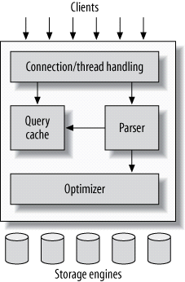

The third layer contains the storage engines. They are responsible for storing and retrieving all data stored “in” MySQL. Like the various filesystems available for GNU/Linux, each storage engine has its own benefits and drawbacks. The server communicates with them through the *storage engine API*. This interface hides differences between storage engines and makes them largely transparent at the query layer. The API contains a couple of dozen low-level functions that perform operations such as “begin a transaction” or “fetch the row that has this primary key.” The storage engines don’t parse SQL[[4](https://www.safaribooksonline.com/library/view/high-performance-mysql/9781449332471/ch01.html)] or communicate with each other; they simply respond to requests from the server.

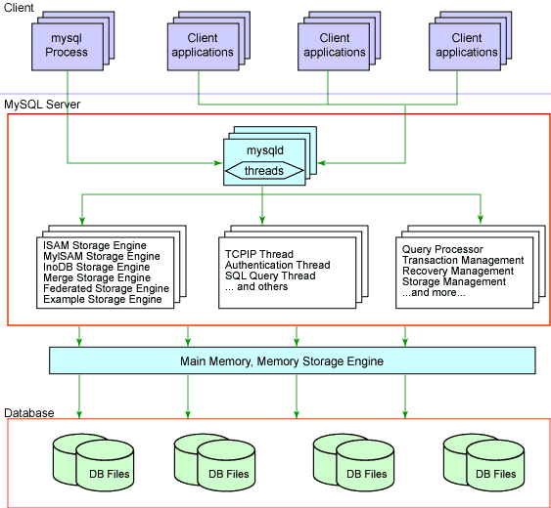

**5.2 Softwares and tools used:**

**5.2.1 My Sql:**

**Introduction:**

The database has become an integral part of almost every human's life. Without it, many things we do would become very tedious, perhaps impossible tasks. Banks, universities, and libraries are three examples of organizations that depend heavily on some sort of database system. On the Internet, search engines, online shopping, and even the website naming convention would be impossible without the use of a database. A database that is implemented and interfaced on a computer is often termed a database server.  
 One of the fastest SQL (Structured Query Language) database servers currently on the market is the MySQL server, developed by T.c.X. DataKonsultAB. MySQL, available for download at [www.mysql.com](http://www.mysql.com/), offers the database programmer with an array of options and

**These capabilities range across a number of topics, including the following:**

a) Ability to handle an unlimited number of simultaneous users.

b) Capacity to handle 50,000,000+ records.

c) Very fast command execution, perhaps the fastest to be found on the market.

d)Easy and efficient user privilege system.

However, perhaps the most interesting characteristic of all is the fact that it's free. That's right, T.c.X offers MySQL as a free product to the general public.

**Reasons to Use MySQL**

**a) Scalability and Flexibility**

The MySQL database server provides the ultimate in scalability, sporting the capacity to handle deeply embedded applications with a footprint of only 1MB to running massive data warehouses holding terabytes of information. Platform flexibility is a stalwart feature of MySQL with all flavors of Linux, UNIX, and Windows being supported.

**b) High Performance**

A unique storage-engine architecture allows database professionals to configure the MySQL database server specifically for particular applications, with the end result being amazing performance results.

**C) High Availability**

Rock-solid reliability and constant availability are hallmarks of MySQL, with customers relying on MySQL to guarantee around-the-clock uptime. MySQL offers a variety of high-availability options from high-speed master/slave replication configurations, to specialized Cluster servers offering instant failover, to third party vendors offering unique high-availability solutions for the MySQL database server.

**d) Robust Transactional Support**

MySQL offers one of the most powerful transactional database engines on the market. Features include complete ACID (atomic, consistent, isolated, durable) transaction support, unlimited row-level locking, distributed transaction capability, and multi-version transaction support where readers never block writers and vice-versa.

**e) Web and Data Warehouse Strengths**

MySQL is the de-facto standard for high-traffic web sites because of its high-performance query engine, tremendously fast data inserts capability, and strong support for specialized web functions like fast full text searches.

**f) Strong Data Protection**

Because guarding the data assets of corporations is the number one job of database professionals, MySQL offers exceptional security features that ensure absolute data protection. In terms of database authentication, MySQL provides powerful mechanisms for ensuring only authorized users have entry to the database server, with the ability to block users down to the client machine level being possible.

**g) Management Ease**

MySQL offers exceptional quick-start capability with the average time from software download to installation completion being less than fifteen minutes. This rule holds true whether the platform is Microsoft Windows, Linux, Macintosh, or UNIX.

**PHP Main Features of MySQL**

* Tested with a broad range of different compilers.
* Works on many different platforms.
* The MySQL Server design is multi-layered with independent modules.
* Fully multi-threaded using kernel threads. It can easily use multiple CPUs if they are available.
* Provides transactional and non-transactional storage engines.
* Uses very fast B-tree disk tables with index compression.
* Relatively easy to add other storage engines. This is useful if you want to provide an SQL interface for an in-house database.
* A very fast thread-based memory allocation system.
* Very fast joins using an optimized one-sweep multi-join.
* In-memory hash tables, which are used as temporary tables.
* SQL functions are implemented using a highly optimized class library and should be as fast as possible. Usually there is no memory allocation at all after query initialization.
* The server is available as a separate program for use in a client/server networked environment.

**REQUIRMENTS**

Processor : Intel Core Duo 2.0 GHz or more

RAM : 1 GB or More

Harddisk : 80GB or more

Monitor : 15” CRT, or LCD monitor

Keyboard : Normal or Multimedia

Mouse : Compatible mouse

Front End : Visual Basic 2005 Express edition

With Sql Server Compact Edition

Microsoft SDK 2.0

Or Visual Basic 2008 Express edition

With Sql Server Compact Edition

Microsoft SDK 3.0

Back End : MS Sql Server

Operation System : Windows 10 with server pack

**IMPLEMENTATION**

This phase is initiated after the system has been tested and accepted by the user. In this phase, the system is installed to support the intended business functions. System performance is compared to performance objectives established during the planning phase. Implementation includes user notification, user training, installation of hardware, installation of software onto production computers, and integration of the system into daily work processes.

This phase continues until the system is operating in production in accordance with the defined user requirements.

**E-R Diagrams**

**INTRODUCTION ER DIAGRAM**

The entity-relationship data model is based on a perception of a real world that consists of a collection of basic objects called entities and of relationships among these objects. An entity is an “object” in the real world that is distinguishable from other objects. **For e.g.** each customer is an entity and rooms can be considered to be entities. Entities are described by a set of attributes. **For e.g.** the attributes Room no. and Room type describes a particular Room in a hotel. The set of all entities of the same type and the set of all relationships of the same type are termed as an entity set and relationship set respectively.

The logical structure of a database can be expressed graphically by an E- R diagram consists of the following major components:

**Entity**

An entity is an “object” in the real world that is distinguishable from all other objects. An entity set is a set of entities of the same type that share the same attributes.

**Weak Entity**

An entity set that may not have sufficient attributes to form a primary key is termed as a weak entity set.

**Attribute**

Attributes are descriptive properties possessed by each member of an entity set.

**Key attribute**

A key attribute is the unique, distinguishing characteristic of the entity. For example, Guest ID might be the guest’s key attribute.

**Multivalued attribute**

In an instance where an attribute has a set of values for a specific entity is called multivalued attribute.

**Derived attribute**

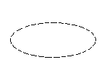In these attributes the value can be derived from the values of other related attributes.

**Relationships**

A relationships an association among several entities.

**Relationship**

**For e.g.,** we can define a relationship that associates customer Jon with Room 142.This relationship specifies that Jon is a customer with Room No.142.

**Recursive Relationship**

In some cases, entities can be self-linked. For example, Employees can supervise other employees in a hotel.

**While using E-R diagrams, we can follow certain guidelines, which are as follows:**

* Unnecessary attributes should not be introduced.
* Entities should be merged with common attributes.
* A complex entity should be simplified by decomposing a complex attribute into sub attributes.
* We should generalize or specialize wherever possible and appropriate. Generalization is the result of taking the union of several lower entity sets to produce higher- level entity set. 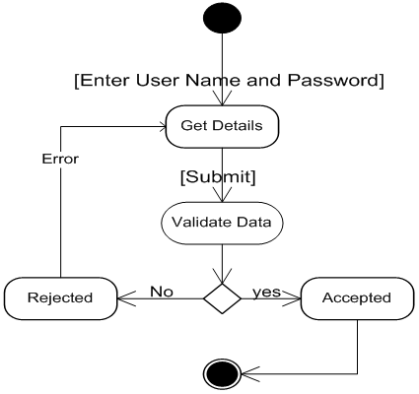

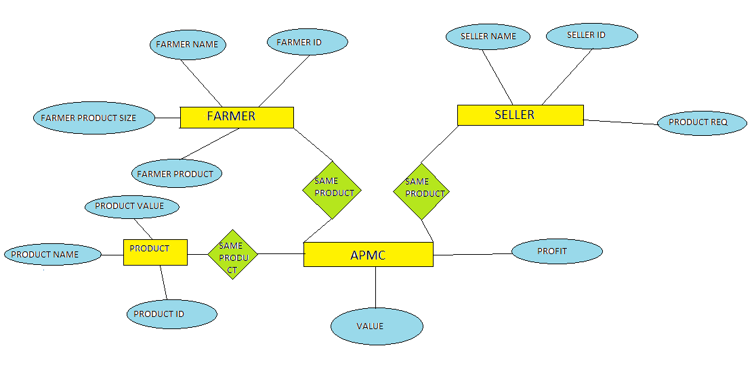

**SNAPSHOTS**



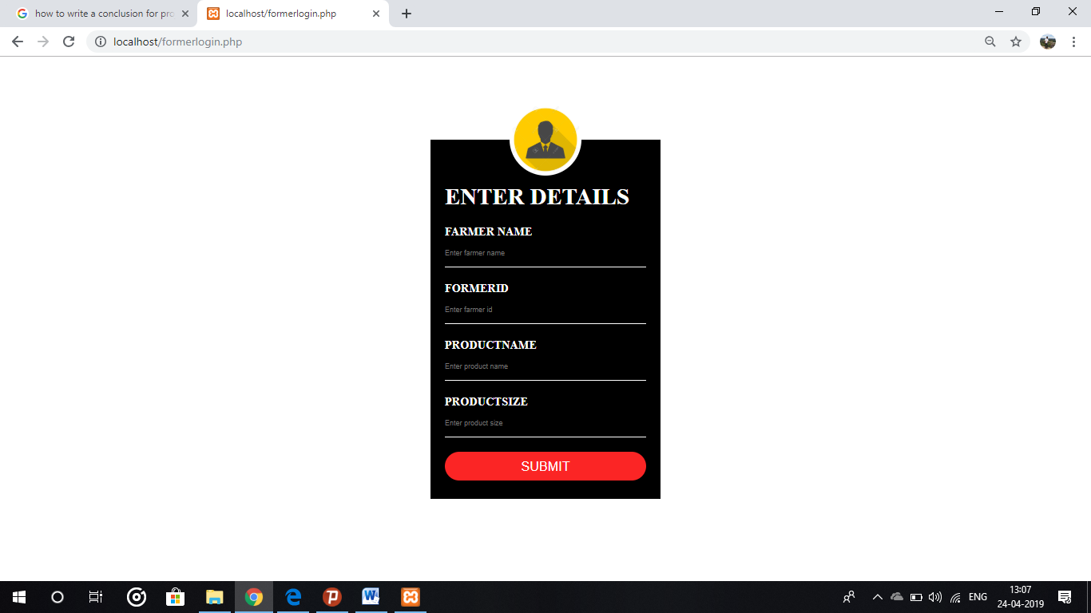

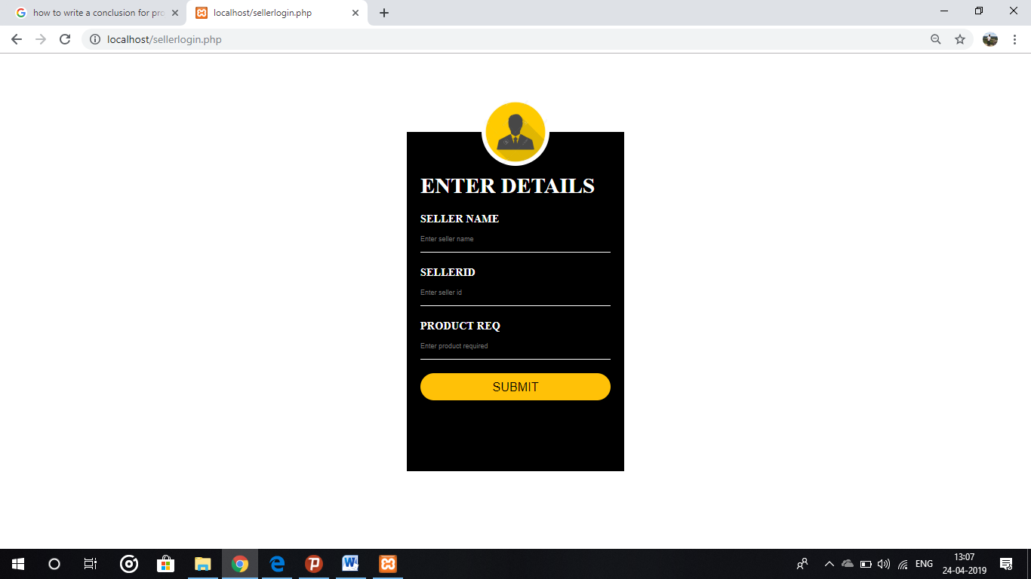

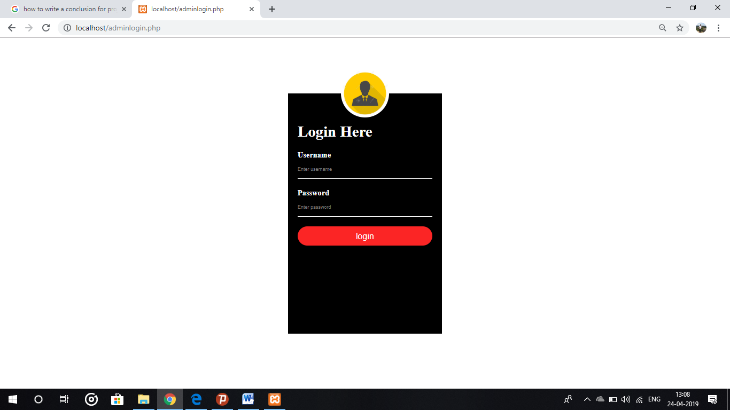



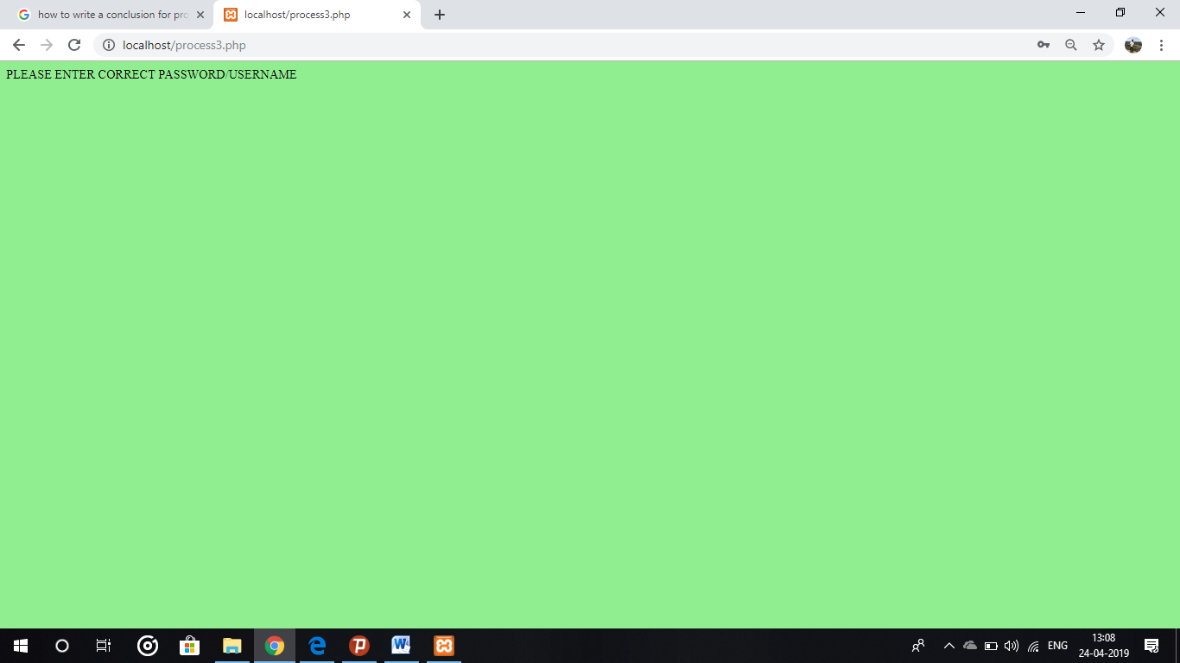



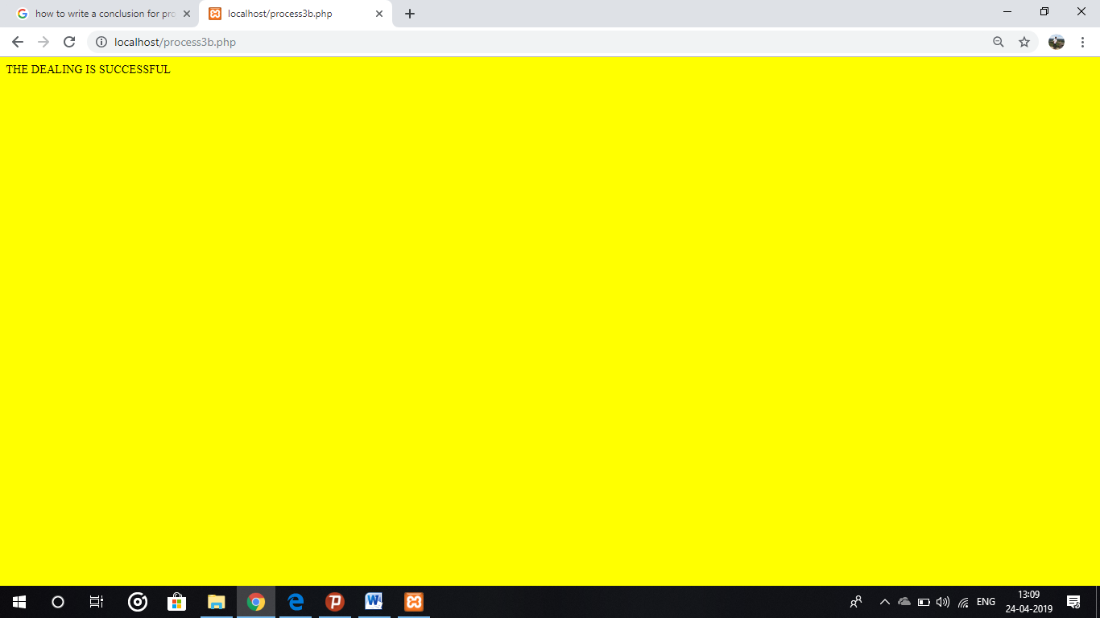

**CONCLUSIONS**

One important future scope is availability the platform as is provided online for all the people who wish to participate in marketing.While using this type of process wastage of agricultural products can be minimized drastically and the total management cost will increase at drastic rate.

With the theoretical inclination of our syllabus it becomes very essential to take the atmost advantage of any opportunity of gaining practical experience that comes along. The building blocks of this Major Project “AGRICULTURE PRODUCT MANAGEMENT COMMITTEE” was one of these opportunities. It gave us the requisite practical knowledge to supplement the already taught theoretical concepts thus making us more competent as a computer engineer. The project from a personal point of view also helped us in understanding the following aspects of project development:

* The planning that goes into implementing a project.
* The importance of proper planning and an organized methodology.
* The key element of team spirit and co-ordination in a successful project.

The project also provided us the opportunity of interacting with our teachers and to gain from their best experience.

**Bibliography**

**1.PHP Manual** [**www.php.net/**](http://www.php.net/)

2.[**https://www.google.com**](https://www.google.com/)

3.[http://www.w3schools.com](http://www.w3schools.com/)

4.http://www.phpmyadmin.org

**SIGNATURE OF THE TEAM MEMBERS**

|  |  |
| --- | --- |
| **SRI VINAY B N** | **1NT17CS188** |

**SIDDANAGOUDA B B 1NT17CS183**