Install hive

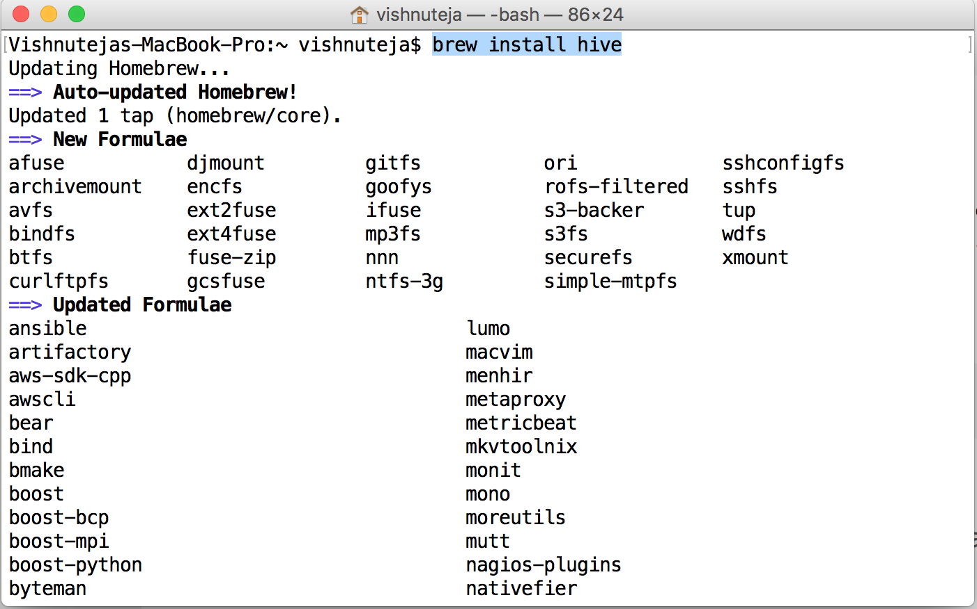

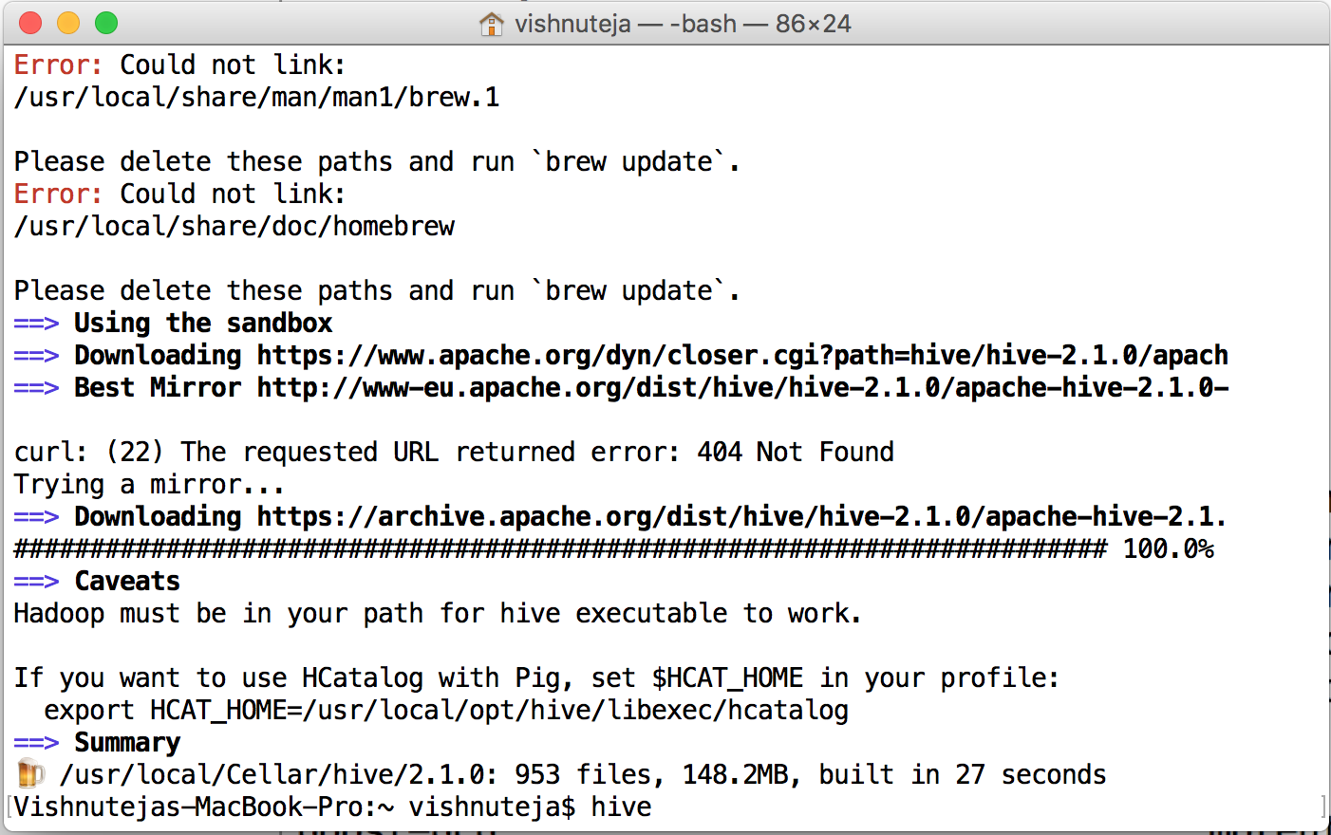

Add HIVE path

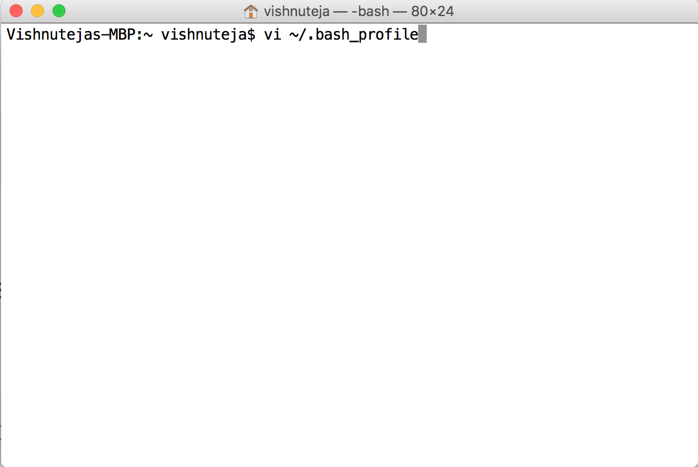

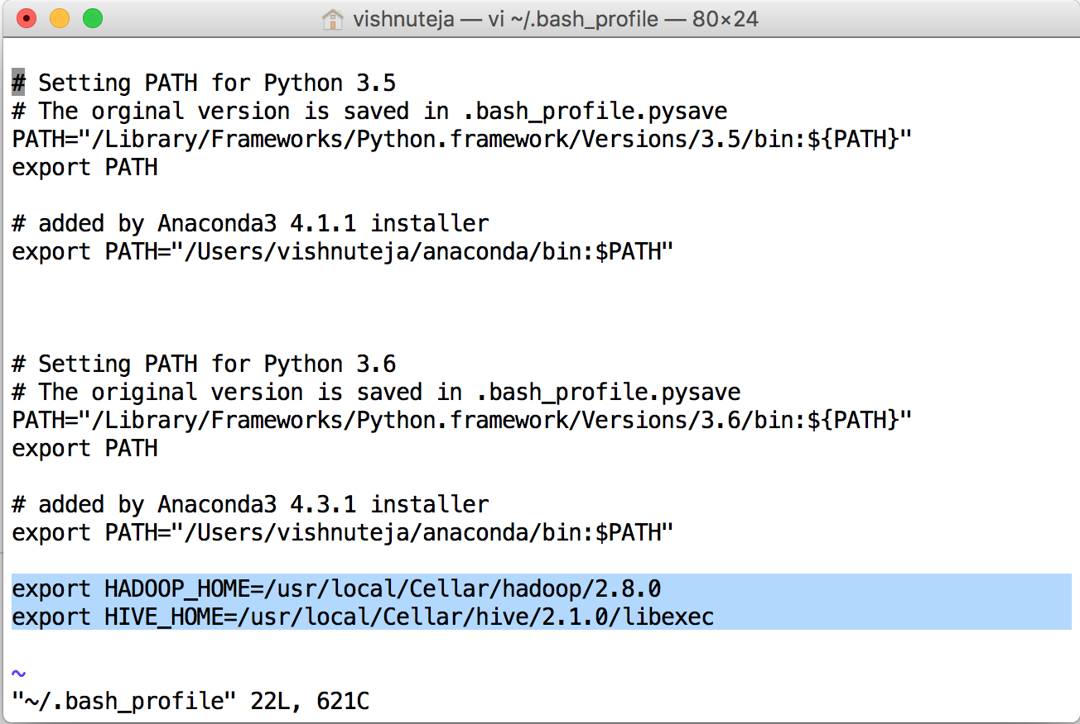

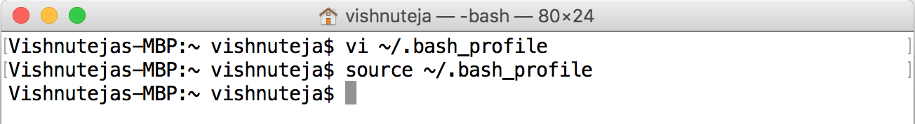

CREATE USER 'hiveuser'@'localhost' IDENTIFIED BY 'password';

GRANT ALL PRIVILEGES ON \*.\* TO 'hiveuser'@'localhost' WITH GRANT OPTION;

CREATE USER 'hiveuser'@'%' IDENTIFIED BY 'password';

GRANT ALL PRIVILEGES ON \*.\* TO 'hiveuser'@'%' WITH GRANT OPTION;

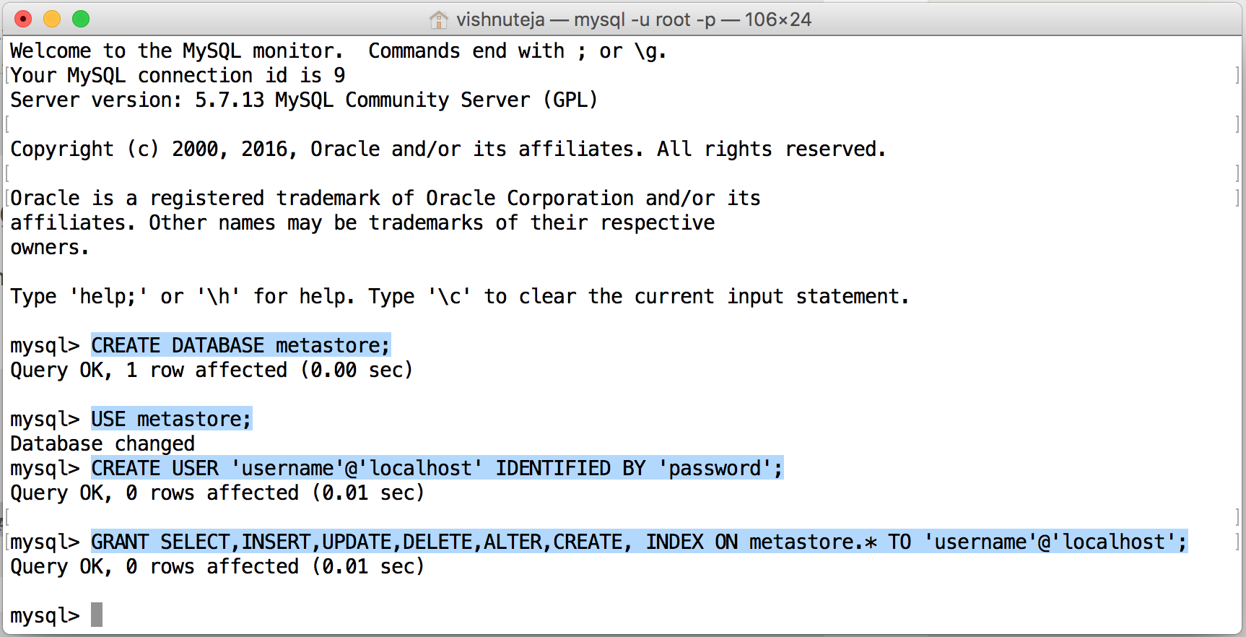

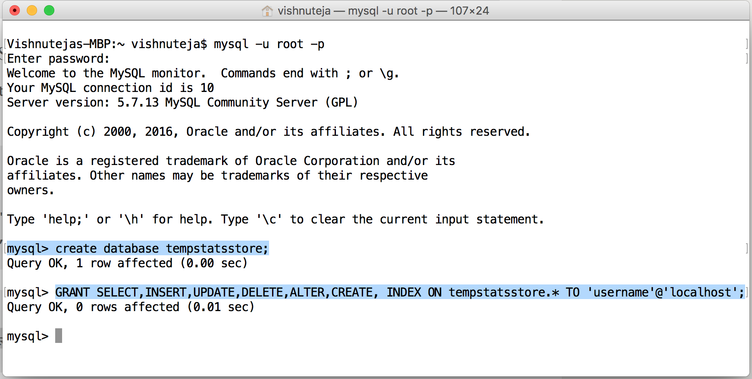

Download MySQL connector.

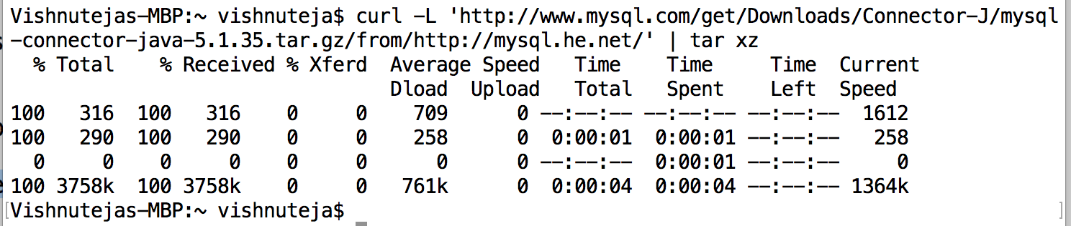

Edit hive-site.xml to configure MySQL metastore and user.

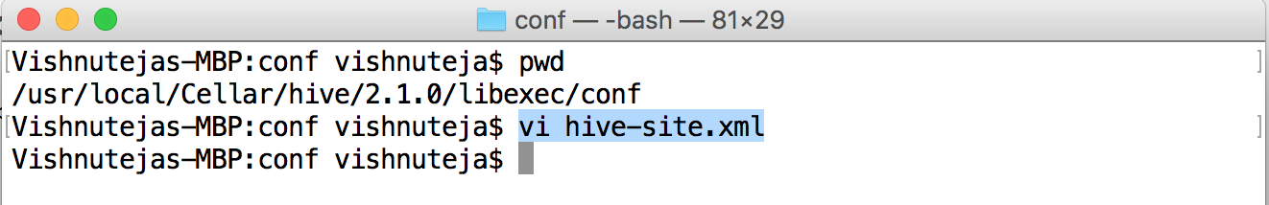

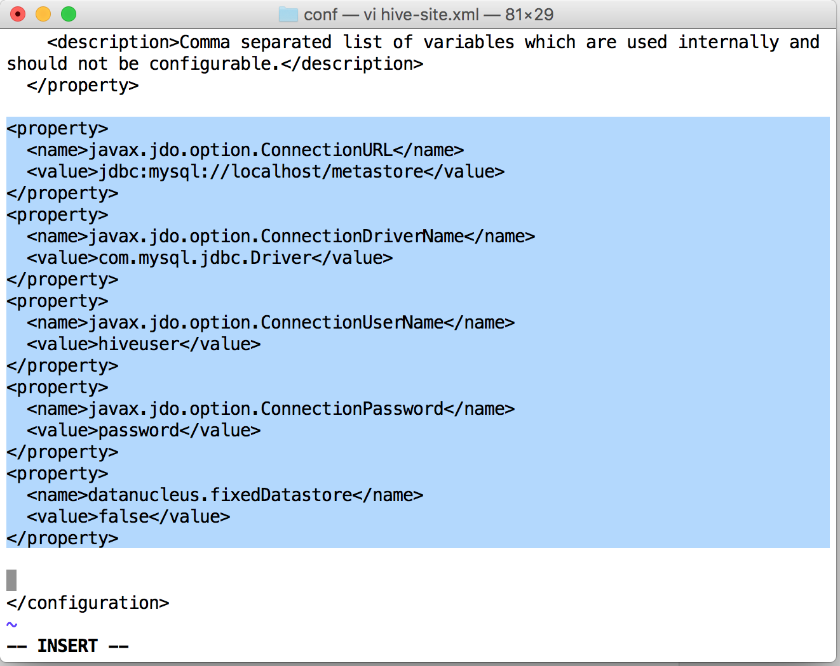

Run Hive

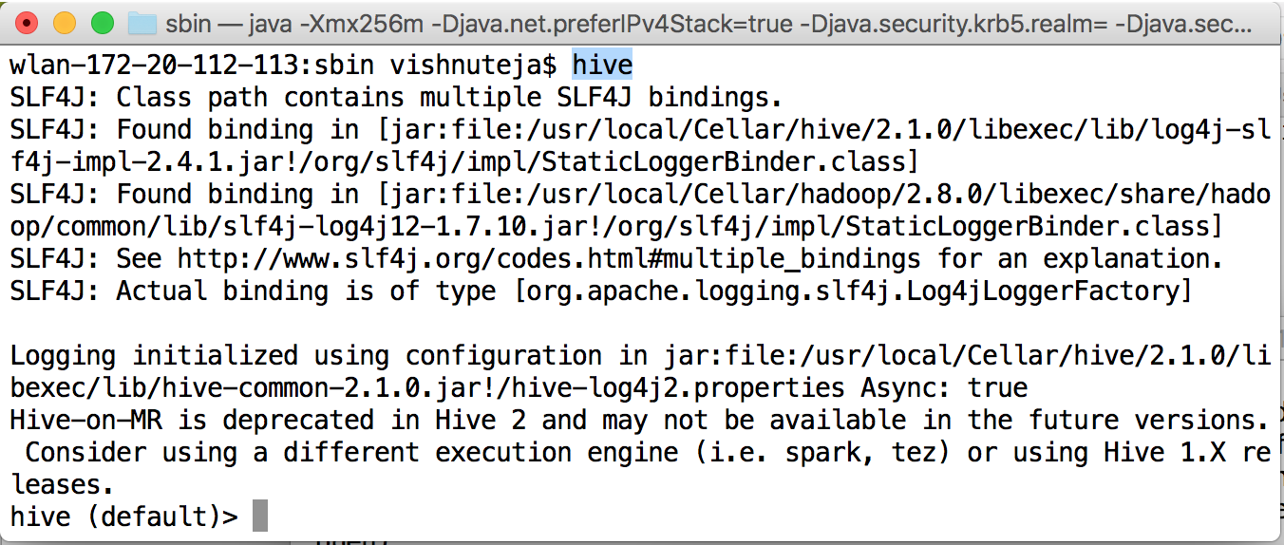

1. Tables

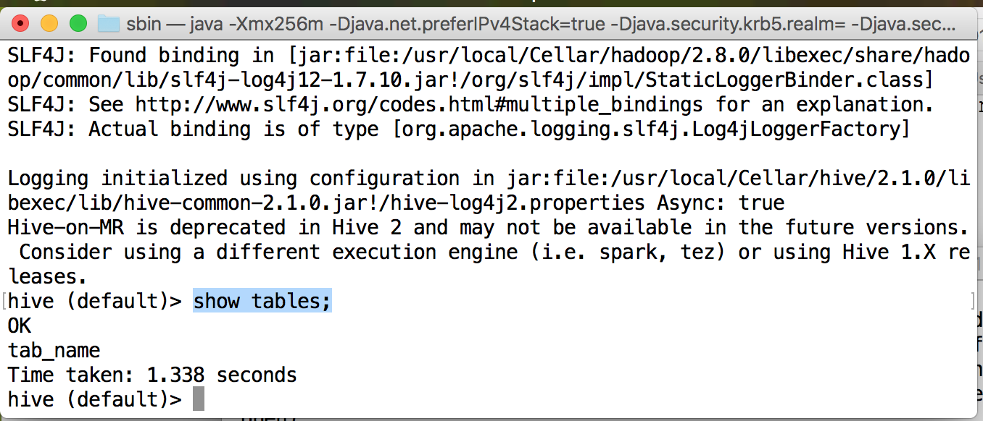

1. Move CSV file from local file system to HDFS

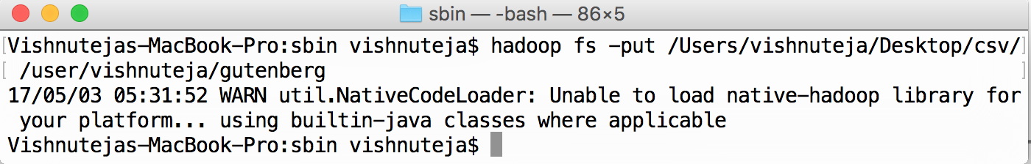

create table structure from CSV

