1. Identify the system configuration whether it is 32 bit or 64 bit

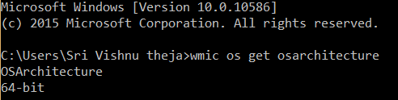

1. Download Mongo DB server

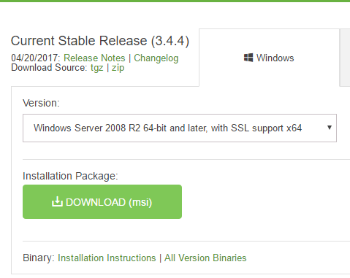

1. Set the environmental variable for MongoDB to run from command prompt.



1. To put the data from MongoDB, creating a folder /data/db

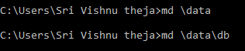

1. Running MongoDB server and MongoDB client

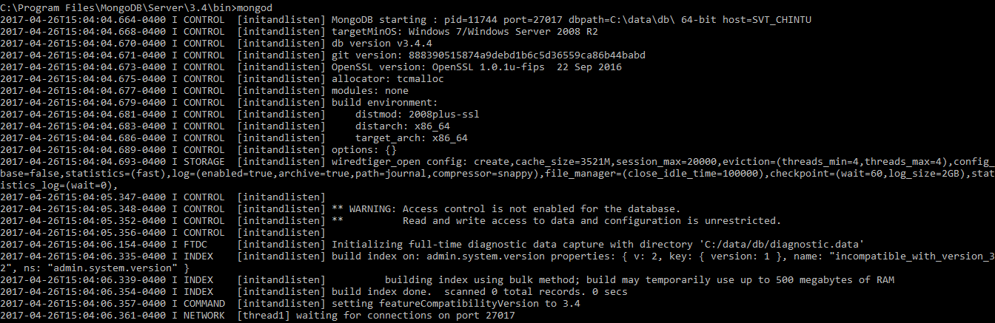

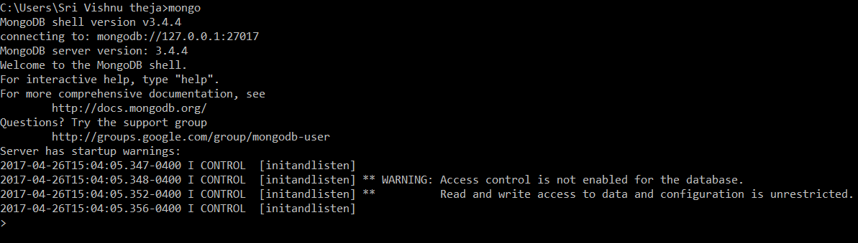

1. Creating a collection in MongoDB

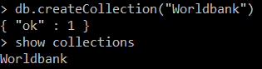

1. Importing json file into Collection

Dataset downloaded from <http://jsonstudio.com/resources/>



1. Reading the json file using find ()

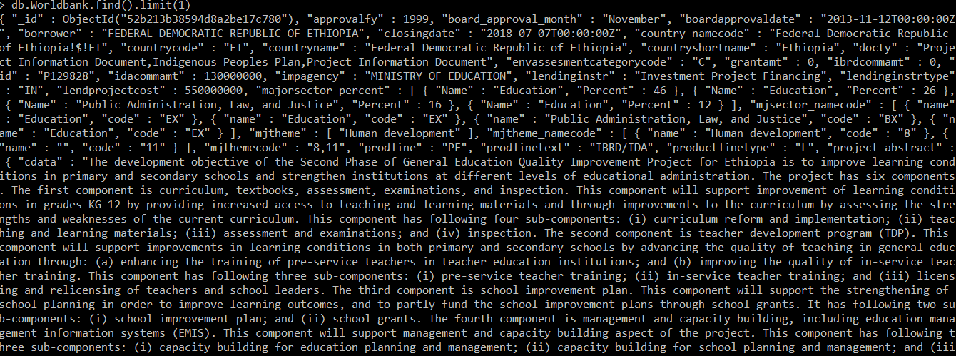

1. Using Pretty() to get structured format of the output

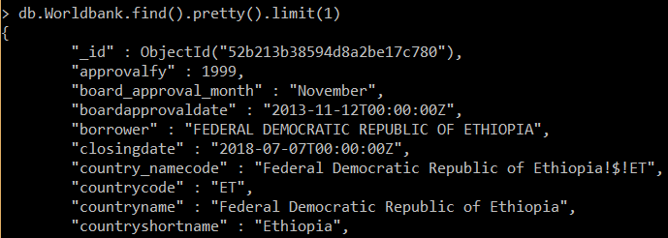

1. Inserting a record into the document

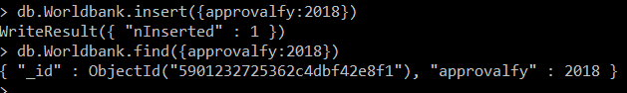

1. Updating a record into the document



1. Read the record from the document

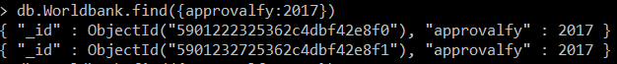

1. Deleting multiple records from the document



1. Shutting down server

