LAB 1: REQUIREMENTS ENGINEERING & UML USE-CASE MODELLING
Problem Statement #41 — OpenAPI Mock Server Generator
Problem Context: A developer productivity tool that ingests OpenAPI 3.0 YAML/JSON specifications, creates dynamic mock REST endpoints with schema validation, and simulates configurable response latency. Target stakeholders/actors: API Developer and QA Engineer.

1. Requirements Table
Functional Requirements — exactly 5 (FR-001 to FR-005)
ID | Type | Description | Priority | Acceptance Criteria | Rationale
FR-001 | Functional | The system shall parse OpenAPI 3.0 YAML/JSON schema definitions. | High | A valid OpenAPI 3.0 specification is parsed successfully; invalid syntax is rejected. | Parsing is necessary before endpoints and schemas can be used.
FR-002 | Functional | The system shall generate dynamic HTTP mock endpoints from the parsed OpenAPI specification. | High | Each valid endpoint path and HTTP method can be accessed as a mock endpoint. | Dynamic endpoint generation is the core purpose of the tool.
FR-003 | Functional | The system shall generate randomized JSON payloads that comply with the schemas defined in the OpenAPI specification. | High | Mock responses contain the correct schema-defined structure and data types. | Provides realistic schema-compliant API responses for development and testing.
FR-004 | Functional | The system shall allow users to configure simulated response latency for mock endpoints. | Medium | The configured latency is applied to mock responses within the required tolerance. | Allows users to simulate different network/API response conditions.
FR-005 | Functional | The system shall validate mock API requests and responses against the relevant OpenAPI schemas. | High | Valid requests/responses pass schema validation and invalid ones are identified. | Supports API contract testing and QA validation.

Non-Functional Requirements — exactly 2 (NFR-001 & NFR-002)
ID | Type | Description | Priority | Acceptance Criteria | Rationale
NFR-001 | Performance | The mock server engine must sustain 1,000 mock API requests per second with user-configured simulated latency accurate within ±10 ms. | High | Benchmarking tests confirm the target throughput and latency under simulated peak load. | Directly addresses the performance requirement specified in the problem statement.
NFR-002 | Security | The mock server shall reject malformed or invalid API requests without exposing sensitive server information. | High | Security testing confirms invalid requests are rejected and implementation details are not leaked. | Supports safe operation of the mock server during development and QA testing.

2. UML Use-Case Diagram
The diagram models both required actors, the primary use cases, and includes both «include» and «extend» relationships.
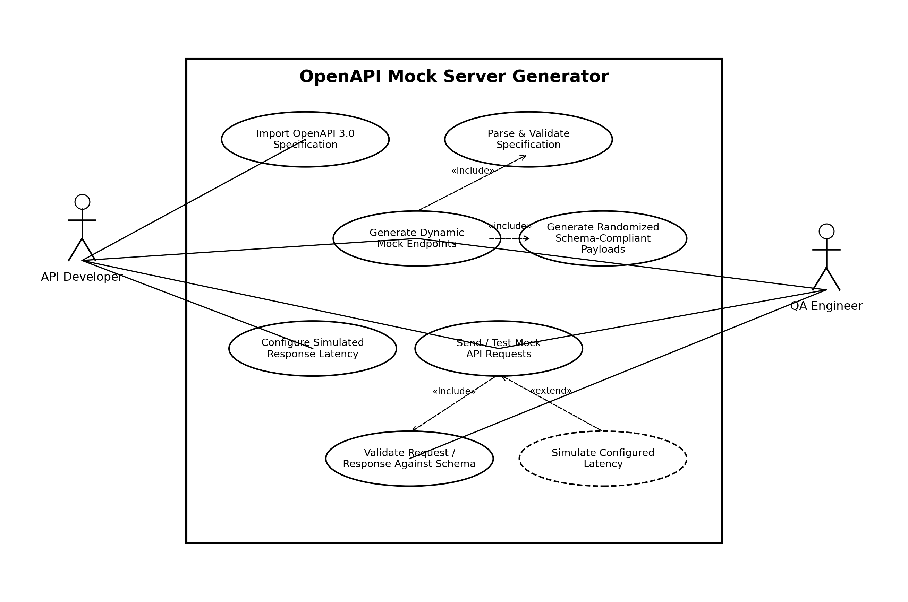

3. Use-Case Flow Specification
Core Use Case: Generate Dynamic Mock Endpoints
Primary Actors: API Developer, QA Engineer

Preconditions
- The OpenAPI Mock Server Generator is available and running.
- The user has an OpenAPI 3.0 YAML/JSON specification.
- The specification is accessible to the system.

Postconditions
- The OpenAPI specification has been successfully parsed and validated.
- Dynamic mock HTTP endpoints corresponding to the specification are generated.
- Schema-compliant randomized JSON responses can be returned by the generated endpoints.

Main Success Scenario
- The user imports an OpenAPI 3.0 YAML/JSON specification.
- The system parses the specification.
- The system validates the OpenAPI schema definitions and endpoint information.
- The system identifies the API paths, HTTP methods, request/response schemas, and related definitions.
- The system generates dynamic mock HTTP endpoints.
- The system generates randomized JSON payloads that comply with the defined schemas.
- The user sends a request to a generated mock endpoint.
- The system validates the request/response against the relevant schema.
- The system applies the configured simulated response latency, when configured.
- The system returns the schema-compliant mock response to the user.

Alternate Flow
- The user imports an OpenAPI 3.0 specification.
- The system attempts to parse and validate the specification.
- The system detects invalid syntax, an invalid endpoint definition, or an invalid schema.
- The system rejects the invalid specification and reports the validation/parsing error.
- The system does not generate the affected mock endpoints.
- The user corrects the specification and imports it again.
- The system reprocesses the corrected specification and continues with the Main Success Scenario.

Source basis: Problem Statement #41 supplied in the course PDF. The deliverables require exactly five functional requirements, two non-functional requirements, a UML use-case diagram with at least one «include» and one «extend» relationship, and a one-page use-case flow specification containing preconditions, postconditions, a main success scenario, and one alternate flow.

