Software Requirements Specification (SRS)
Project: Shared Whiteboard - Real-Time Collaborative Whiteboard
Version: 1.0
Team: 11
Authors : Dr. Rati D Joshi
Sriviswaja M – PES1UG24AM288
Samhitha Kanth – PES1UG24AM245
Shloka Reddy – PES1UG24AM262
Sushir C – PES1UG24AM297

Section: E
Date: 10-10-2026
Status: Draft

Revision history
Version | Date | Author | Change summary | Approval
1.0 | 10-10-2026 | Sriviswaja M | Initial draft of SRS with use-case diagrams

Approvals
Role | Name | Signature / Email | Date
Course Coordinator

Table of Contents
1. Introduction
2. Overall description
3. External interfaces
4. System features (detailed)
5. Non-functional requirements (detailed)
6. Quality attributes & Acceptance tests
7. UML Use-Case Diagram
8. Requirements Traceability Matrix (RTM)

1. Introduction
1.1 Purpose
This document is the Software Requirements Specification (SRS) for the Shared Whiteboard system, a web application in which multiple users draw, write and edit on a shared whiteboard at the same time, with changes synchronised in real time and a basic version history. It defines functional and non-functional requirements, security objectives and requirements, interfaces and verification criteria. It is the basis for the Software Architecture and Design Specification (SAD) and the Software Test Plan (STP).
1.2 Scope
Covers creating and joining boards through a shared link, drawing / text / editing tools, real-time synchronisation between up to 20 concurrent participants on a board, version history (automatic and manual snapshots, preview and restore) and board persistence. Excludes user accounts and authentication, role-based permissions, native mobile apps, audio/video chat, and import/export of files (possible future work).
1.3 Audience
Developers, QA engineers, course instructors and evaluators, and the project team.
1.4 Definitions
List of acronyms and terms:
- Board: a shared whiteboard canvas identified by a unique link.
- Participant: any person who has joined a board; all participants have equal permissions.
- Object: an item on the board (stroke, shape or text box).
- Operation: a single change to the board (add, update or delete an object).
- Snapshot / Version: a saved copy of the full board state at a point in time.
- LWW: last-write-wins, the conflict policy where the later write to an object replaces the earlier one.
- WebSocket / WSS: persistent two-way browser-server connection (WSS = over TLS).
- SRS, SAD, STP, RTM: Software Requirements Specification, Software Architecture and Design Specification, Software Test Plan, Requirements Traceability Matrix.
- UI, API, TLS, XSS, FR, NFR, SR: user interface, application programming interface, Transport Layer Security, cross-site scripting, functional / non-functional / security requirement.

2. Overall description
2.1 Product perspective
Shared Whiteboard is a self-contained client-server web system. The client is a browser application with a drawing canvas. The server hosts a real-time synchronisation service (WebSocket), a REST API for boards and versions, and a database for boards and snapshots. It has no external system integrations.
2.2 Major product functions (detailed)
- Create and join boards via a shareable link (no account needed)
- Draw, write and edit: pen, shapes, text, eraser, select / move / resize / delete, undo / redo
- Real-time synchronisation of all changes between participants, with remote cursors
- Conflict handling for simultaneous edits (last-write-wins per object)
- Automatic reconnection and resynchronisation after network drops
- Basic version history: automatic and named snapshots, preview, restore
- Board persistence

2.3 User roles and characteristics (expanded)
- Participant: any person with a board link, from students to teams, with basic web skills. All participants are equal: any participant can edit any object and restore any version. Identified only by a display name.
- System Timer: internal scheduler that triggers automatic snapshots (secondary actor).

2.4 Operating environment
Client: latest two versions of Chrome, Firefox, Edge and Safari on desktop or tablet, with mouse, touch or stylus input. Server: cloud-hosted virtual machine or container with a database. Network: broadband with round-trip time under 100 ms for the stated performance targets.
2.5 Constraints
Browser-only (no installation); WebSocket support required; no user accounts; last-write-wins conflict policy; maximum 20 concurrent participants per board; development within the course timeline using the team GitHub workflow (protected main branch, pull requests, CI). Assumption: participants have a stable internet connection most of the time.

3. External interface requirements
3.1 User interfaces
A single-page web UI with a central canvas and a toolbar (pen, shapes, text, eraser, select), colour and thickness controls, undo / redo buttons, a participants panel and a version-history panel. Controls are keyboard-reachable with sufficient colour contrast, and the layout adapts to tablet-sized screens.
3.2 Hardware interfaces
- No special hardware. Input via mouse, touch screen or stylus (browser pointer events).

3.3 Software interfaces
- WebSocket API (JSON messages) for join, add / update / delete object, cursor movement, presence and resynchronisation events.
- REST API for boards and versions, for example: POST /boards, GET /boards/{id}, GET /boards/{id}/versions, POST /boards/{id}/versions, POST /boards/{id}/versions/{versionId}/restore.
- Database interface for boards, objects, operations and snapshots.
- Exact message formats and endpoints are defined in the SAD.

3.4 Communications
- HTTPS and WSS with TLS 1.2 or higher.
- Heartbeat every 30 seconds to detect dead connections.
- Automatic reconnect with exponential backoff; the client resumes from its last-seen operation number.

4. System features (detailed)
Each requirement below includes acceptance criteria and a reference test case. IDs follow WB-F-###.

4.1 Board and Session Management
Description: Create boards, join them through a link and see who is present.
Req ID | Requirement (shall...) | Type | Priority | Source / Stakeholder | Acceptance criteria / Test case ref | Comments / Dependencies
WB-F-001 | The system shall let a user create a new board and return a unique shareable link. | Functional | High | Participant | AC-WB-F-001: Creating a board returns a link; opening it in a second browser shows the same empty board. Test: TC-Board-01 | Board Service; WB-SR-002
WB-F-002 | The system shall let a user join a board via its link by entering a display name, without creating an account. | Functional | High | Participant | AC-WB-F-002: A valid link and a display name (1-30 chars) joins the board; an empty name is rejected. Test: TC-Board-02 | Session Service
WB-F-003 | The system shall show the list of currently active participants and update it when users join or leave. | Functional | Medium | Participant | AC-WB-F-003: A joining or leaving user appears or disappears on all clients within 2 s. Test: TC-Board-03 | Presence tracking
WB-F-004 | The system shall limit a board to 20 concurrent participants and show a "board full" message to additional users. | Functional | Medium | Operations | AC-WB-F-004: The 21st join attempt is refused with a message; existing users are unaffected. Test: TC-Board-04 | Enforced server-side (WB-SR-006)

4.2 Drawing and Editing
Description: Tools to create and modify objects (strokes, shapes and text). All participants have equal editing rights.
Req ID | Requirement (shall...) | Type | Priority | Source / Stakeholder | Acceptance criteria / Test case ref | Comments / Dependencies
WB-F-010 | The system shall support freehand pen drawing with selectable colour and thickness. | Functional | High | Participant | AC-WB-F-010: A stroke drawn with the chosen colour and thickness renders with those properties. Test: TC-Draw-01 | Canvas UI
WB-F-011 | The system shall support drawing rectangle, ellipse and line shapes. | Functional | High | Participant | AC-WB-F-011: Each shape can be drawn by dragging and renders correctly. Test: TC-Draw-02 | Canvas UI
WB-F-012 | The system shall support adding text boxes and editing their text. | Functional | High | Participant | AC-WB-F-012: Text appears at the clicked position; double-clicking lets the user change it. Test: TC-Draw-03 | Text is escaped (WB-SR-003)
WB-F-013 | The system shall let any participant select, move, resize and delete any object on the board. | Functional | High | Participant | AC-WB-F-013: A selected object can be moved, resized and deleted, and the change appears on other clients. Test: TC-Draw-04 | All users equal; no object ownership
WB-F-014 | The system shall provide an eraser tool that removes objects it passes over. | Functional | Medium | Participant | AC-WB-F-014: Objects touched by the eraser path are removed for all participants. Test: TC-Draw-05 | Canvas UI
WB-F-015 | The system shall support undo and redo of a participant's own actions. | Functional | Medium | Participant | AC-WB-F-015: Undo reverts only that participant's last action, not other users' actions; redo reapplies it. Test: TC-Draw-06 | Interacts with WB-F-022

4.3 Real-Time Collaboration
Description: Propagate changes to all participants quickly and keep every client consistent, including during concurrent edits and network drops.
Req ID | Requirement (shall...) | Type | Priority | Source / Stakeholder | Acceptance criteria / Test case ref | Comments / Dependencies
WB-F-020 | The system shall broadcast every change to all other participants of the board in real time. | Functional | High | Participant | AC-WB-F-020: A change made by user A is visible to user B within 300 ms (95% of operations). Test: TC-Sync-01 | Sync Gateway; WB-NF-001
WB-F-021 | The system shall show each participant's cursor with their display name. | Functional | Low | Participant | AC-WB-F-021: A remote cursor with a name label follows the other user and disappears when they leave. Test: TC-Sync-02 | Presence updates
WB-F-022 | When two participants edit the same object concurrently, the system shall resolve the conflict by last-write-wins so that all clients converge on the same state. | Functional | High | Product / Instructor | AC-WB-F-022: Two users modify one object at once; after edits stop, all clients show the same final state (the later server-ordered write wins). Test: TC-Sync-03 | Server assigns ordering
WB-F-023 | After a network interruption, the client shall reconnect and resynchronise to the latest board state automatically. | Functional | High | Participant | AC-WB-F-023: After a 30 s disconnect the client reconnects without a page reload and shows the current board. Test: TC-Sync-04 | Resume from last-seen op number

4.4 Version History
Description: Basic history through snapshots (automatic and named), with preview and non-destructive restore. Restores never delete existing versions.
Req ID | Requirement (shall...) | Type | Priority | Source / Stakeholder | Acceptance criteria / Test case ref | Comments / Dependencies
WB-F-030 | The system shall automatically save a snapshot every 100 operations or after 5 minutes of activity, whichever comes first. | Functional | High | Product / Instructor | AC-WB-F-030: After 100 operations a new snapshot appears in the history; an idle board creates none. Test: TC-Ver-01 | Operation counter and System Timer
WB-F-031 | The system shall let a participant save a named snapshot manually. | Functional | Medium | Participant | AC-WB-F-031: Saving with a name adds a version carrying that name and the saver's display name. Test: TC-Ver-02 | Version Service
WB-F-032 | The system shall list the 50 most recent versions of a board with timestamp, author and name, newest first. | Functional | High | Participant | AC-WB-F-032: The list shows the required fields in order; the 51st version pushes out the oldest. Test: TC-Ver-03 | Retention limit of 50
WB-F-033 | The system shall let a participant preview any version in read-only mode. | Functional | Medium | Participant | AC-WB-F-033: Preview shows the board as at that version with editing disabled; leaving preview returns to the live board. Test: TC-Ver-04 | Does not affect other users
WB-F-034 | Restoring a version shall create a new version (without deleting later versions) and notify all participants. | Functional | High | Product / Instructor | AC-WB-F-034: After restore, the board equals the chosen version, earlier versions remain listed, a "restored from" entry exists and every participant sees a notification. Test: TC-Ver-05 | WB-SR-005

4.5 Persistence
Description: Boards survive after all participants leave.
Req ID | Requirement (shall...) | Type | Priority | Source / Stakeholder | Acceptance criteria / Test case ref | Comments / Dependencies
WB-F-040 | The system shall persist boards so that reopening the link later shows the latest board state. | Functional | High | Participant | AC-WB-F-040: After all users leave and the link is reopened later, the latest content is shown. Test: TC-Persist-01 | Database

5. Non-functional requirements (detailed)
NFRs below are measurable and tied to the test plan. IDs follow WB-NF-###.
Req ID | Requirement | Category | Priority | Acceptance criteria / Measurement
WB-NF-001 | A change shall appear on other participants' screens within 300 ms for 95% of operations with 20 users on a board under normal network conditions (RTT < 100 ms). | Performance | High | 95th percentile latency <= 300 ms in the load test. Test: TC-Perf-01
WB-NF-002 | A single board shall support 20 concurrent participants without violating WB-NF-001. | Scalability | High | 20 simulated users draw simultaneously; latency target met, no errors. Test: TC-Perf-02
WB-NF-003 | The service shall be available 99% of the time per month, excluding planned maintenance. | Reliability | Medium | Uptime report shows >= 99% per month. Test: TC-Ops-01
WB-NF-004 | After concurrent edits stop, all clients shall hold an identical board state within 2 seconds. | Consistency | High | State hashes of all test clients match within 2 s. Test: TC-Sync-05
WB-NF-005 | The application shall work on the latest two versions of Chrome, Firefox, Edge and Safari. | Compatibility | Medium | Smoke test suite passes on every listed browser. Test: TC-Compat-01
WB-NF-006 | The canvas shall render at 30 frames per second or better with 1,000 objects on the board. | Performance | Medium | Measured frame rate >= 30 fps with 1,000 objects. Test: TC-Perf-03

5.1. Security

5.1.1 Security Objectives
- SO-1 Confidentiality: only people who hold a board's link can view or edit that board.
- SO-2 Integrity: board content and version history cannot be tampered with or silently lost.
- SO-3 Availability: one misbehaving or malicious client must not degrade the board for others.

5.1.2 Security Requirements
Req ID | Requirement (shall...) | Type | Priority | Acceptance criteria / Test case ref
WB-SR-001 | All network connections (HTTP and WebSocket) shall use TLS 1.2 or higher (HTTPS/WSS). | Security | High | Plain HTTP/WS is refused or redirected; TLS version verified with a scanner. Test: TC-Sec-01
WB-SR-002 | Board identifiers shall be unguessable random tokens of at least 128 bits generated by a cryptographically secure generator. | Security | High | Generated IDs meet length/entropy check; sequential guessing finds no board. Test: TC-Sec-02
WB-SR-003 | The server shall validate every incoming message (schema and size limit) and user-entered text shall be escaped on output to prevent XSS. | Security | High | Malformed or oversized messages are rejected; "<script>" typed in a text box displays as plain text. Test: TC-Sec-03
WB-SR-004 | The server shall rate-limit each connection (default 60 messages per second) and throttle or disconnect violators. | Security | Medium | A client flooding messages is throttled; other users' latency stays within WB-NF-001. Test: TC-Sec-04
WB-SR-005 | Version history shall be append-only: no operation deletes existing snapshots, and every restore shall be logged with who, when and which version. | Security | High | Restore leaves all earlier snapshots intact; audit entry present for each restore. Test: TC-Sec-05
WB-SR-006 | The server shall verify board membership and the participant limit on every WebSocket message, not only at connection time. | Security | High | Messages from unknown connections or for other boards are rejected; 21st connection refused. Test: TC-Sec-06

6. Quality attributes & Acceptance tests
- Exit criteria for acceptance: all high-priority functional requirements implemented and verified, no critical NFR or security failures, and the RTM shows all test cases passed.
- Key quality attributes: real-time performance, consistency across clients, reliability, security, browser compatibility.
- Acceptance test suites: Board & Session, Drawing & Editing, Real-time Sync, Version History, Persistence, Performance, Security, Compatibility.

7. System models and diagrams

7.1 UML Use-Case diagram
UC-1 covers everyday collaboration on a board. Drawing and editing both include synchronising the change to all participants.
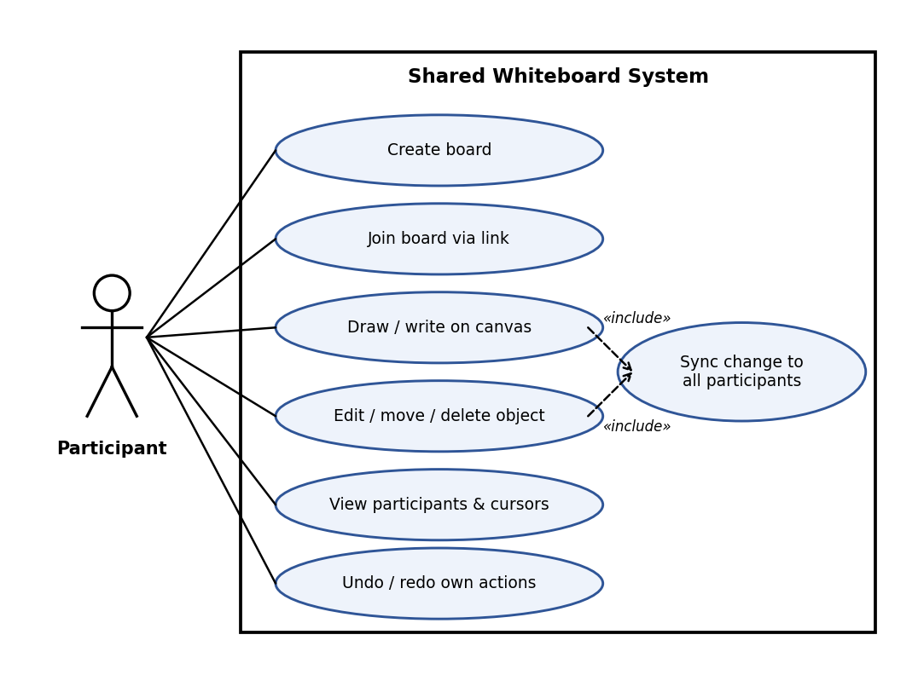
Figure 1: UC-1 Collaborate on a board
UC-2 covers version history. Restoring a version includes notifying all participants; the System Timer triggers automatic snapshots.
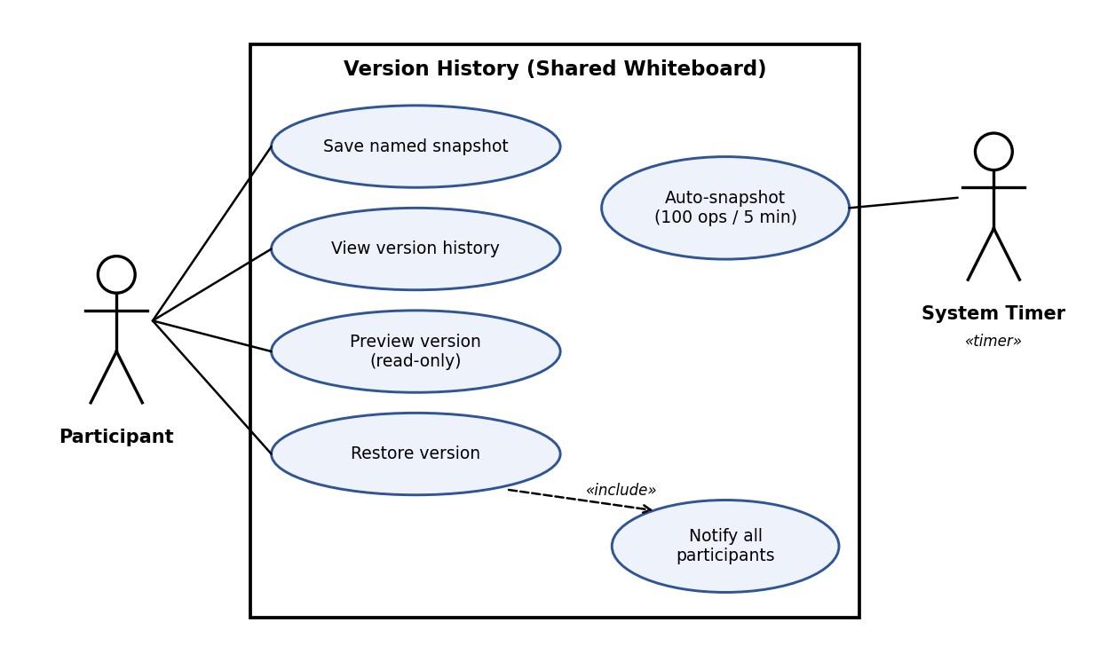
Figure 2: UC-2 Manage version history

8. Requirements Traceability Matrix (RTM)
Req ID | Requirement short | Section ref / Design Spec | Module | Test case(s) | Status (N/P/A) | Comments
WB-F-001 | Create board | 4.1 / DS-Board-01 | BoardService | TC-Board-01 | N
WB-F-002 | Join via link | 4.1 / DS-Session-01 | SessionService | TC-Board-02 | N
WB-F-003 | Active participants | 4.1 / DS-Session-02 | SessionService / CanvasUI | TC-Board-03 | N
WB-F-004 | 20-user limit | 4.1 / DS-Session-03 | SessionService | TC-Board-04 | N
WB-F-010 | Pen tool | 4.2 / DS-Canvas-01 | CanvasUI | TC-Draw-01 | N
WB-F-011 | Shapes | 4.2 / DS-Canvas-02 | CanvasUI | TC-Draw-02 | N
WB-F-012 | Text boxes | 4.2 / DS-Canvas-03 | CanvasUI | TC-Draw-03 | N
WB-F-013 | Select/move/resize/delete | 4.2 / DS-Canvas-04 | CanvasUI | TC-Draw-04 | N
WB-F-014 | Eraser | 4.2 / DS-Canvas-05 | CanvasUI | TC-Draw-05 | N
WB-F-015 | Undo / redo | 4.2 / DS-Canvas-06 | CanvasUI | TC-Draw-06 | N
WB-F-020 | Real-time broadcast | 4.3 / DS-Sync-01 | SyncGateway | TC-Sync-01 | N
WB-F-021 | Remote cursors | 4.3 / DS-Sync-02 | SyncGateway / CanvasUI | TC-Sync-02 | N
WB-F-022 | Conflict resolution (LWW) | 4.3 / DS-Sync-03 | SyncGateway / BoardService | TC-Sync-03 | N
WB-F-023 | Reconnect and resync | 4.3 / DS-Sync-04 | SyncGateway / CanvasUI | TC-Sync-04 | N
WB-F-030 | Auto-snapshot | 4.4 / DS-Ver-01 | VersionService | TC-Ver-01 | N
WB-F-031 | Named snapshot | 4.4 / DS-Ver-02 | VersionService | TC-Ver-02 | N
WB-F-032 | Version list | 4.4 / DS-Ver-03 | VersionService / CanvasUI | TC-Ver-03 | N
WB-F-033 | Preview version | 4.4 / DS-Ver-04 | VersionService / CanvasUI | TC-Ver-04 | N
WB-F-034 | Restore version | 4.4 / DS-Ver-05 | VersionService / SyncGateway | TC-Ver-05 | N
WB-F-040 | Board persistence | 4.5 / DS-Persist-01 | BoardService / Database | TC-Persist-01 | N
WB-NF-001 | Sync latency <= 300 ms | 5 / DS-Perf-01 | SyncGateway / CanvasUI | TC-Perf-01 | N
WB-NF-002 | 20 users per board | 5 / DS-Perf-02 | SyncGateway | TC-Perf-02 | N
WB-NF-003 | 99% availability | 5 / DS-Rel-01 | Deployment | TC-Ops-01 | N
WB-NF-004 | Convergence within 2 s | 5 / DS-Sync-03 | SyncGateway / BoardService | TC-Sync-05 | N
WB-NF-005 | Browser compatibility | 5 / DS-Compat-01 | CanvasUI | TC-Compat-01 | N
WB-NF-006 | 30 fps rendering | 5 / DS-Perf-03 | CanvasUI | TC-Perf-03 | N
WB-SR-001 | TLS 1.2+ | 5.1 / DS-Sec-01 | SyncGateway / Deployment | TC-Sec-01 | N
WB-SR-002 | Unguessable board IDs | 5.1 / DS-Sec-02 | BoardService | TC-Sec-02 | N
WB-SR-003 | Input validation / XSS | 5.1 / DS-Sec-03 | SyncGateway / CanvasUI | TC-Sec-03 | N
WB-SR-004 | Rate limiting | 5.1 / DS-Sec-04 | SyncGateway | TC-Sec-04 | N
WB-SR-005 | Append-only history | 5.1 / DS-Sec-05 | VersionService | TC-Sec-05 | N
WB-SR-006 | Per-message membership check | 5.1 / DS-Sec-06 | SessionService / SyncGateway | TC-Sec-06 | N
Status: N = Not started, P = Partial, A = Achieved. Design spec IDs (DS-...) and module names are provisional and will be aligned with the SAD.

