Software Architecture Document (SAD)
Project: Shared Whiteboard - Real-Time Collaborative Whiteboard
Version: 1.0
Team: 11
Authors: Sriviswaja M - PES1UG24AM288
Samhitha Kanth - PES1UG24AM245
Shloka Reddy - PES1UG24AM262
Sushir C - PES1UG24AM297
Section: E
Date: 10-10-2026
Status: Draft

Revision history
Version | Date | Author | Change summary | Approval
1.0 | 10-10-2026 | Sriviswaja M | Initial architecture draft

Approvals
Role | Name | Signature / Email | Date
Instructor | Dr. Rati D Joshi
Team Lead

Table of Contents
1. Introduction
2. Architectural Drivers
3. Architecture Overview
4. Architectural Views
5. Interface Design
6. Cross-Cutting Concerns
7. Technology Stack
8. Architecture Decision Log
9. Development Workflow, Repository and CI
10. Traceability and Testing Alignment
11. Risks and Open Issues

1. Introduction

1.1 Purpose
This document describes the architecture of the Shared Whiteboard system, a real-time collaborative whiteboard: the major structural elements, how they interact, the key design decisions and the reasons behind them. It is the bridge between the SRS (what the system must do) and the implementation and test plan (how it is built and verified).

1.2 Scope
Covers the web client, the real-time collaboration service, the REST API, the persistence layer, deployment and the team's development pipeline. Excludes user accounts and authentication, role-based permissions, native mobile apps, audio / video chat, and file import / export.

1.3 Audience
Developers, QA engineers, instructors / evaluators and anyone maintaining or extending the system.

1.4 Definitions, acronyms and abbreviations
Term | Meaning
AD | Architecture Decision (an entry in the decision log, Section 8)
API / REST | Application Programming Interface / Representational State Transfer (HTTP + JSON)
CI/CD | Continuous Integration / Continuous Delivery
CRDT | Conflict-free Replicated Data Type, a merge approach considered and not chosen
LWW | Last-write-wins: the later write to an object replaces the earlier one
OT | Operational Transformation, an alternative merge approach considered and not chosen
Operation (op) | One change to a board: add, update or delete an object
PR | Pull Request
RTM / SRS / STP | Requirements Traceability Matrix / Software Requirements Specification / Software Test Plan
Seq | Sequence number the server gives each operation on a board; defines the one global order
Snapshot / Version | A saved copy of the full board state at a point in time
STRIDE | Threat model: Spoofing, Tampering, Repudiation, Information disclosure, Denial of service, Elevation of privilege
Tombstone | Marker that an object was deleted; the record is kept so a late update cannot bring it back
TLS / WSS / WS | Transport Layer Security / WebSocket over TLS / WebSocket
XSS | Cross-site scripting

1.5 References
- Shared Whiteboard SRS v1.0 (requirement IDs WB-F-###, WB-NF-###, WB-SR-###)
- Shared Whiteboard Software Test Plan (STP) v1.0 (to be written)
- ISO/IEC/IEEE 42010 (architecture description)
- RFC 6455 (The WebSocket Protocol); RFC 8446 (TLS 1.3)
- OWASP Top 10 and OWASP ASVS
- FastAPI, Pydantic and SQLAlchemy documentation; HTML Living Standard (Canvas 2D, Pointer Events)

2. Architectural Drivers
These are taken from the SRS. Architecture exists to satisfy them, so every later decision traces back here.

2.1 Key functional requirements
SRS ID | Requirement (summary) | Architectural impact
WB-F-001 | Create a board and receive a unique shareable link | REST API + Board Service; unguessable board ID (6.2)
WB-F-002 | Join a board via the link with a display name, no account | Session Service; the link is the access token, so no auth module (AD-07)
WB-F-003 | Show the active participants | Presence kept in memory by Session Service; presence events (5.2)
WB-F-004 | At most 20 participants per board | Cap enforced server-side in Session Service on every join
WB-F-010 | Freehand pen with colour and thickness | Canvas rendering layer; stroke element model (4.2)
WB-F-011 | Rectangle, ellipse and line shapes | Canvas rendering layer; shape element types (4.2)
WB-F-012 | Text boxes that can be edited | Text element type; text is drawn on the canvas, never inserted as HTML (XSS)
WB-F-013 | Select, move, resize and delete any object | Update and delete operations; all users equal, no ownership checks
WB-F-014 | Eraser tool | Client-side hit testing; one delete operation per erased object
WB-F-015 | Undo / redo of a participant's own actions | Per-client undo stacks of inverse operations, sent as normal operations
WB-F-020 | Broadcast every change to all other participants in real time | Sync Gateway fan-out per board room over WebSocket (AD-01)
WB-F-021 | Remote cursors with display names | Throttled cursor messages relayed to the room, never stored
WB-F-022 | Concurrent edits resolved by last-write-wins; all clients converge | Server-assigned sequence numbers, LWW per object, tombstones (AD-02, 6.1)
WB-F-023 | Automatic reconnect and resync | Client operation queue, resume from lastSeq, operation log with full-state fallback
WB-F-030 | Auto-snapshot every 100 operations or 5 minutes of activity | Operation counter and System Timer in Version Service (6.6)
WB-F-031 | Manual named snapshot | REST endpoint on Version Service
WB-F-032 | List the 50 most recent versions with timestamp and author | Versions table and retention limit; REST list endpoint
WB-F-033 | Preview a version read-only | REST fetch of a snapshot; client preview mode that never sends operations
WB-F-034 | Restore creates a new version and notifies everyone | Restore = new version + reset operation + board:reset event (AD-06)
WB-F-040 | Boards persist and can be reopened | Database holds current objects and an append-only operation log; rooms load on demand

2.2 Quality attributes (non-functional drivers)
SRS ID | Attribute | Target | Architectural tactic
WB-NF-001 | Latency | Change visible to others within 300 ms (p95, 20 users) | WebSocket, small delta operations, in-memory rooms, throttled cursor events
WB-NF-002 | Scalability | 20 concurrent users per board without breaking NF-001 | One independent room per board; async I/O; pub/sub scale-out path (11)
WB-NF-003 | Availability | 99% per month | Health endpoint, automatic restart, client reconnect, rooms rebuilt from the database
WB-NF-004 | Consistency | Identical state on all clients within 2 s after edits stop | One server-side order per board, LWW rules, tombstones
WB-NF-005 | Compatibility | Latest two versions of Chrome, Firefox, Edge, Safari | Only standard Web APIs (Canvas 2D, Pointer Events, WebSocket); no framework lock-in
WB-NF-006 | Rendering | >= 30 fps with 1,000 objects | requestAnimationFrame batching, layered canvases, redraw only changed regions
WB-SR-001 | Security: transport | TLS 1.2+ on all connections | HTTPS / WSS only at the proxy; plain HTTP redirected
WB-SR-002 | Security: access | Board IDs of at least 128 random bits | Cryptographically secure token generator; no board listing
WB-SR-003 | Security: input | Validate every message; no XSS | Pydantic schemas, size limits, text drawn on canvas only
WB-SR-004 | Security: abuse | 60 messages per second per connection | Token bucket rate limiter in Sync Gateway
WB-SR-005 | Security: integrity | Append-only version history | Restore creates a new version; audit log
WB-SR-006 | Security: membership | Membership and 20-user cap checked on every message | Session Service is_member() before each operation

2.3 Constraints
- Technical: browser only (latest two versions of Chrome, Firefox, Edge, Safari); WebSocket support required; Python backend; no user accounts and no roles; maximum 20 participants per board; last-write-wins conflict policy.
- Organisational: course deadline, team of four, free-tier hosting.
- Process: all work follows the GitHub workflow in Section 9.

2.4 Assumptions
- Users have a stable internet connection most of the time (round-trip time under 100 ms).
- A single server instance is enough for the demo load (a few dozen boards at once).
- A board holds up to about 1,000 objects (matches WB-NF-006).
- Everyone who has a board link is trusted to edit it; display names are labels, not identities.

3. Architecture Overview

3.1 Architectural style
Client-server with an event-driven real-time layer. Browsers talk to one central server over WebSocket (live editing) and REST (creating boards, working with versions). Inside the server the style is a layered modular monolith: a gateway layer, a service layer and a persistence layer. Each board runs as an independent in-memory "room", so boards never affect each other.
Alternatives rejected:
- Peer-to-peer (WebRTC): cannot easily enforce the participant limit, keep history or protect against bad clients.
- Microservices: too much deployment and network overhead for 20 users per board and a team of four.
- HTTP polling / SSE: polling cannot meet 300 ms efficiently; SSE is one-way.
- CRDT / OT: per-object last-write-wins already satisfies the SRS at much lower complexity.
Details are in the decision log (Section 8).

3.2 System context
Figure 1 shows the system as a single box with its users and external systems.
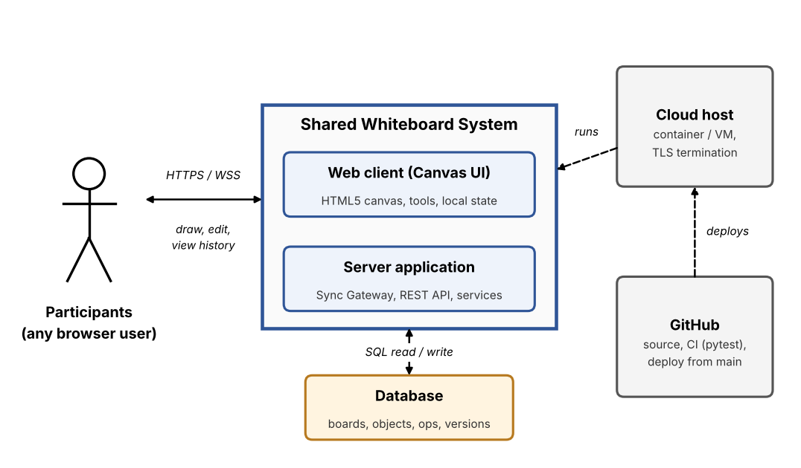
Figure 1: System context diagram
Actor / External system | Type | Interaction
Participant | User | Draws, writes, edits, views other participants, previews and restores versions. All participants have the same rights.
System Timer | Internal (secondary actor) | Triggers automatic snapshots after 5 minutes of activity.
Cloud host | External | Runs the container or VM and terminates TLS (HTTPS / WSS).
GitHub / GitHub Actions | External | Holds the repository, runs CI on every PR and deploys main.
Database | Data store | Stores boards, objects, the operation log, versions and the audit log.
The template's "Board owner" and "Identity provider" do not exist here: the SRS has no accounts, roles or login (decision AD-07).

3.3 Logical architecture (layers and components)
Figure 2 shows the components and their dependencies. The gateway layer talks to clients, the service layer holds the logic and the persistence layer stores data.
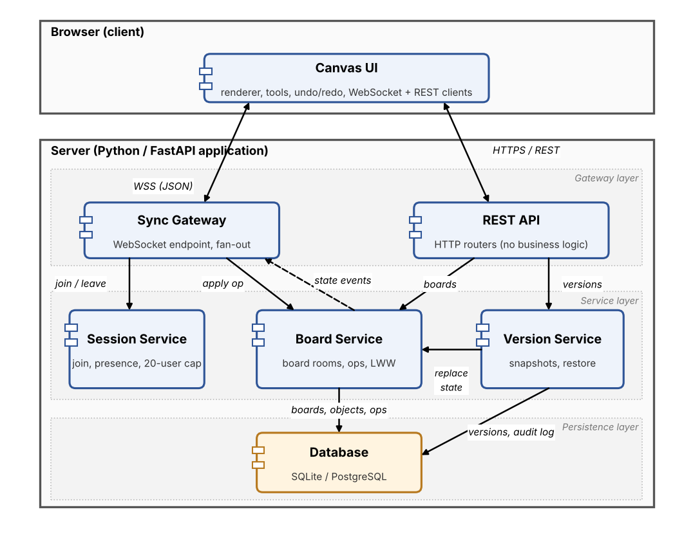
Figure 2: Component diagram
Component | Responsibility | Technology
Web client (Canvas UI) | Canvas rendering, tools, local state, undo/redo stacks, optimistic apply, presence and cursors, version panel, connection banner. | HTML5 Canvas 2D, vanilla JavaScript (ES modules), Pointer Events
Real-time gateway (Sync Gateway) | Manages WebSocket connections and one room per board; checks membership, schema and rate limit on every message; broadcasts accepted operations; handles resume after reconnect. | FastAPI / Starlette WebSocket on Uvicorn
Sync engine (Board Service) | Owns board state in memory; gives every operation a sequence number; applies LWW and tombstone rules; persists each operation; serves ops_since() and replace_state(). | Python asyncio, SQLAlchemy
Session Service | Join and leave, display-name validation, clientId assignment, 20-participant cap, in-memory presence list. | Python
Version Service | Automatic and named snapshots, version list, preview data, restore as a new version, audit log, retention of the 50 most recent. | Python, SQLAlchemy
REST API | Thin HTTP adapter for boards and versions; request validation and error mapping only. | FastAPI, Pydantic
Persistence layer (Database) | Boards, current objects, append-only operation log, version snapshots, audit log. | SQLite (dev/test), PostgreSQL optional, via SQLAlchemy
Cache / pub-sub | Not used in v1.0: live state lives in memory in a single server process. A pub/sub layer (for example Redis) is the scale-out path (Section 11). | None
Auth module | Not used: access is by board link and there are no accounts (SRS 1.2). Protections are listed in 6.2. | None

4. Architectural Views

4.1 Runtime (process) view
How the components collaborate at runtime for the main scenarios. Scenarios 1 to 3 are the ones listed in the template; scenario 4 covers version restore, which is a headline requirement.

4.1.1 Scenario 1: join a board
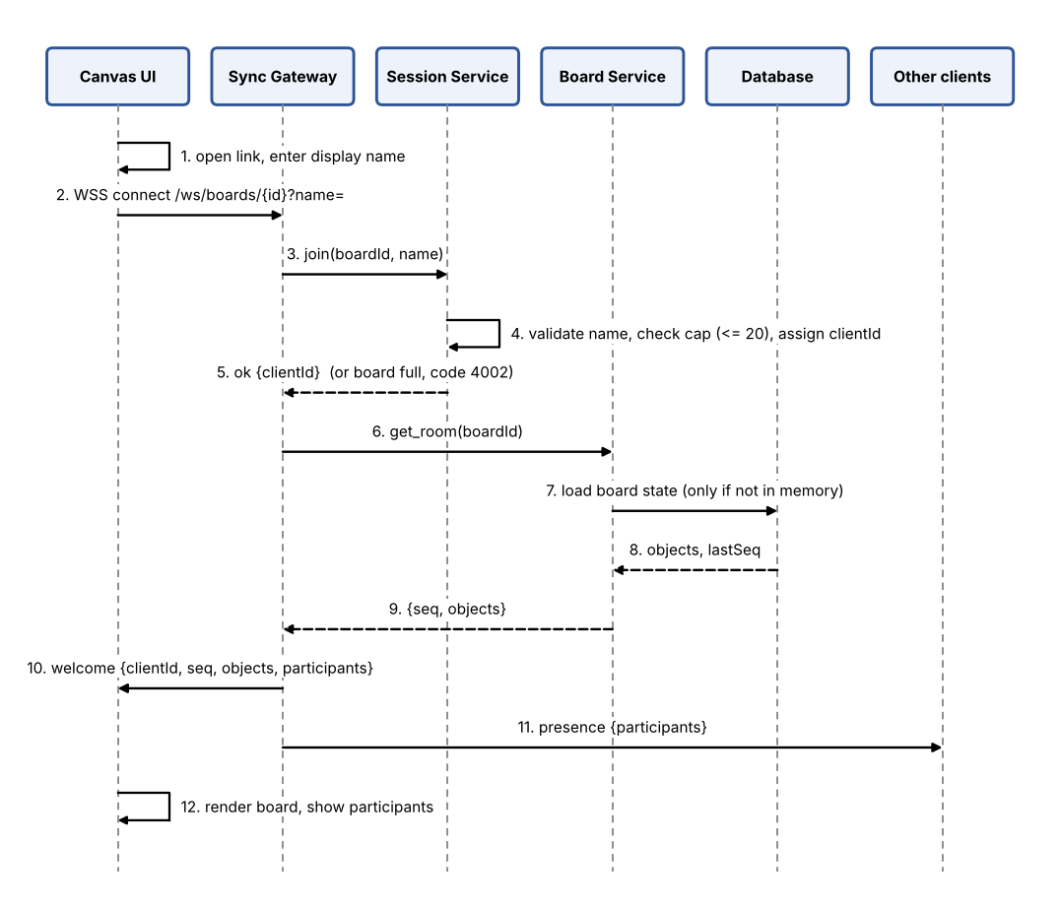
Figure 3: Join a board (WB-F-002, 003, 004)
1. The participant opens the board link; the client loads and asks for a display name (1 to 30 characters).
2. Canvas UI opens a WSS connection to /ws/boards/{boardId}?name=<displayName>.
3. Sync Gateway asks Session Service to admit the client.
4. Session Service validates the name, checks the board has fewer than 20 participants and assigns a clientId.
5. Session Service answers ok; otherwise Sync Gateway closes the connection with code 4002 (board full) or 4001 (board not found).
6. Sync Gateway asks Board Service for the board room.
7. If the board is not in memory, Board Service loads it from the database.
8. The database returns the objects and the last sequence number.
9. Board Service returns the state to Sync Gateway.
10. Sync Gateway sends welcome with the full state and participant list to the new client.
11. Sync Gateway sends an updated presence list to the other clients.
12. Canvas UI renders the board and the participant list.

4.1.2 Scenario 2: draw / edit an element
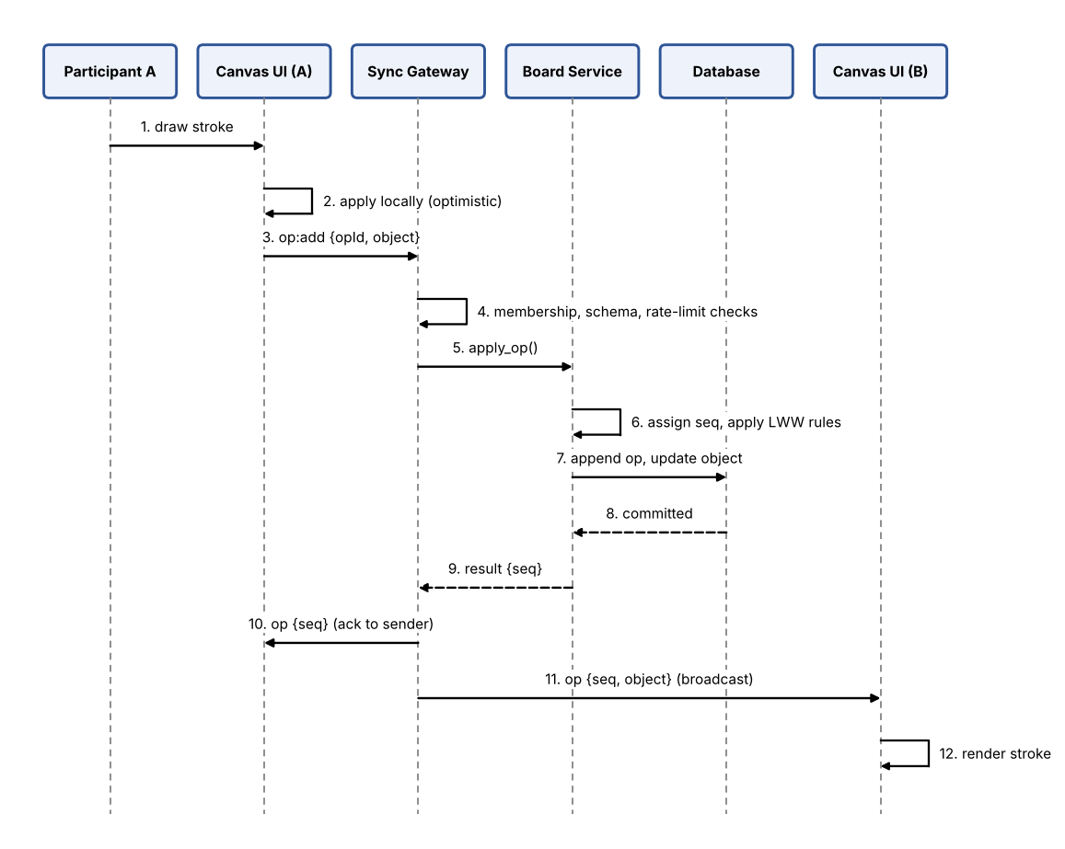
Figure 4: Draw a stroke and sync it (WB-F-010, 020, 022)
1. Participant A draws a stroke.
2. Canvas UI (A) draws it immediately so the user sees no delay (optimistic apply).
3. Canvas UI sends op:add with a client-generated opId and the stroke object.
4. Sync Gateway checks membership, message schema and rate limit (WB-SR-003, 004, 006); on failure it replies with an error and stops.
5. Sync Gateway passes the operation to Board Service.
6. Board Service assigns the next seq and applies the LWW and tombstone rules.
7. Board Service appends the operation to the log and updates the object in the database.
8. The database confirms the commit.
9. Board Service returns the result with its seq.
10. Sync Gateway acknowledges to the sender with the same operation and its seq.
11. Sync Gateway broadcasts the operation to all other participants of the board.
12. Canvas UI (B) renders the stroke.

4.1.3 Scenario 3: reconnect after network loss
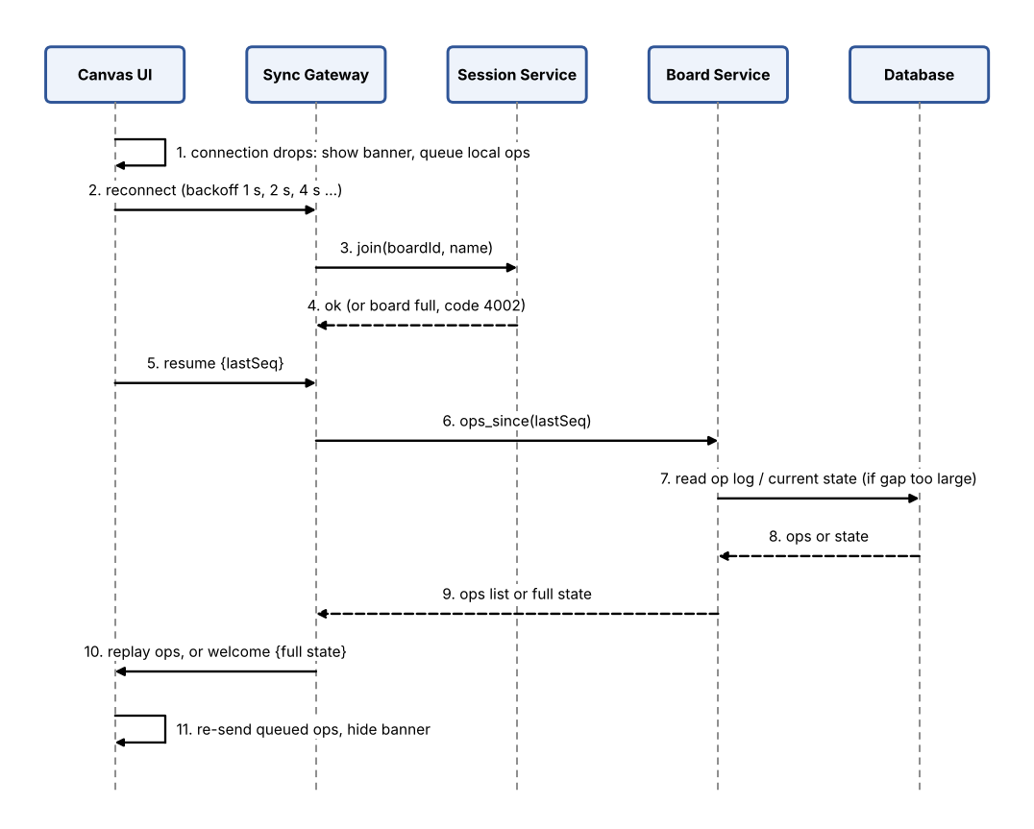
Figure 5: Reconnect and resync (WB-F-023, WB-NF-004)
1. The connection drops; Canvas UI shows a "Reconnecting..." banner and queues local operations.
2. The client reconnects with exponential backoff (1 s, 2 s, 4 s, up to 30 s).
3. Sync Gateway asks Session Service to admit the client again (the 20-user cap applies here too).
4. Session Service confirms, or refuses with code 4002 if the board is full.
5. The client sends resume with the last seq it applied.
6. Sync Gateway asks Board Service for operations after lastSeq.
7. If the in-memory buffer does not cover the gap, Board Service reads the log or current state from the database.
8. The database returns the operations or state.
9. Board Service returns them to Sync Gateway.
10. Sync Gateway replays the missing operations, or sends welcome with the full state.
11. The client re-sends its queued operations (duplicates are ignored through opId) and hides the banner.

4.1.4 Scenario 4: preview and restore a version
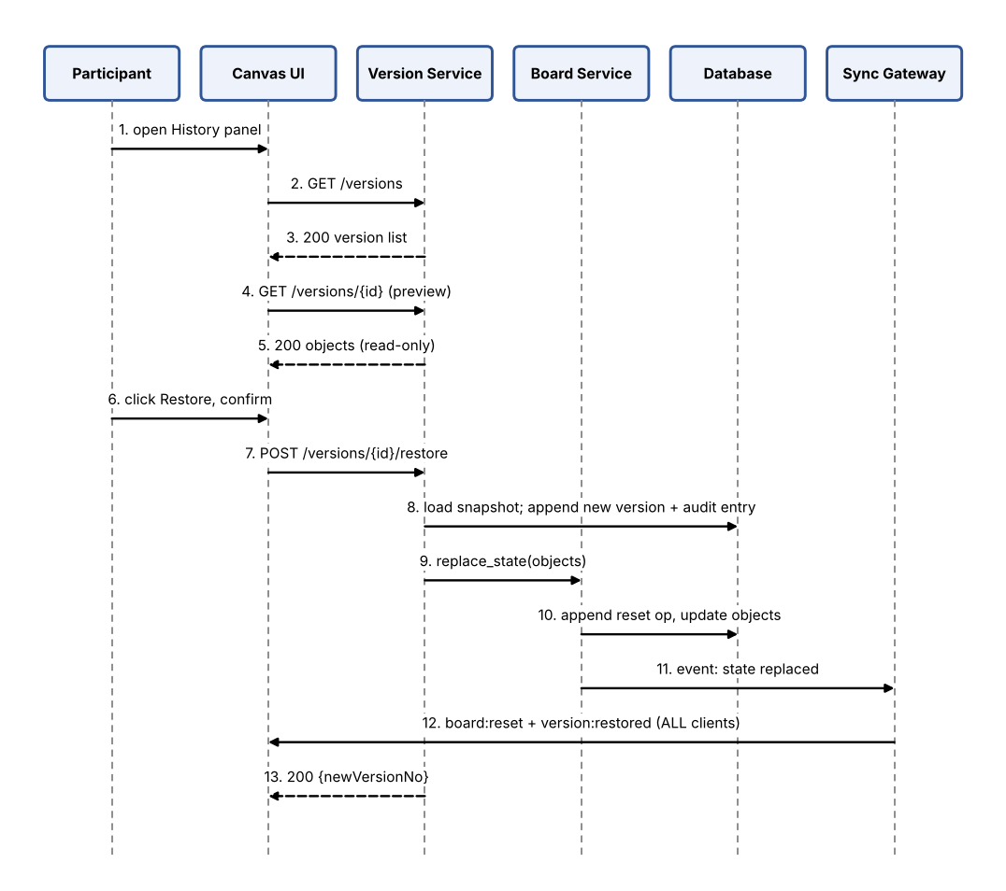
Figure 6: Restore a version (WB-F-032 to 034, WB-SR-005)
1. The participant opens the History panel.
2. Canvas UI requests the version list.
3. Version Service returns the 50 most recent versions with timestamp, author and name.
4. The participant selects a version; Canvas UI requests its content.
5. Version Service returns the objects; Canvas UI shows them read-only with a "Previewing" banner.
6. The participant clicks Restore and confirms in a dialog.
7. Canvas UI sends POST restore.
8. Version Service loads the snapshot and appends a new version "restored from vN" plus an audit entry (nothing is deleted).
9. Version Service asks Board Service to replace the live state.
10. Board Service appends a reset operation and updates the objects.
11. Board Service emits a state-replaced event to Sync Gateway.
12. Sync Gateway sends board:reset and version:restored to all clients, who re-render and show a notification.
13. Version Service returns the new version number to the requester.

4.2 Data view
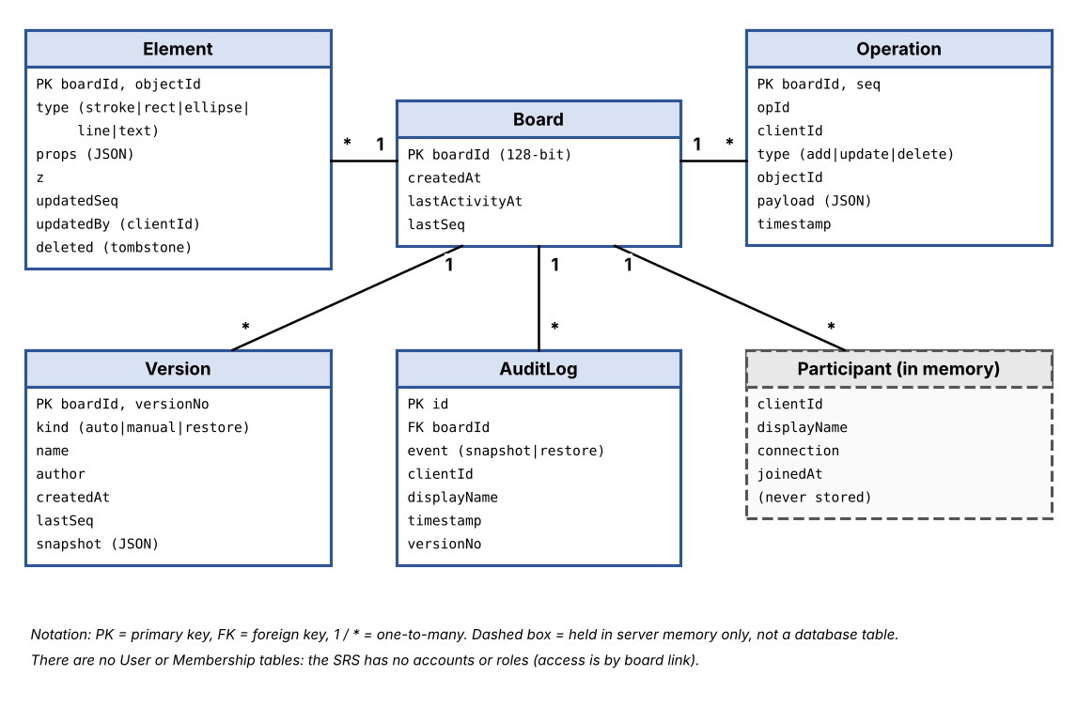
Figure 7: Entity-relationship diagram
Entity | Key attributes | Notes
Board | boardId (128-bit random token), createdAt, lastActivityAt, lastSeq | One row per board. The boardId is the access secret. A board has many elements, operations, versions and audit entries.
Element | boardId + objectId, type, props, z, updatedSeq, updatedBy, deleted | Current state of the board. deleted = tombstone (soft delete) so a late update cannot revive an object.
Operation | boardId + seq, opId, clientId, type, objectId, payload, timestamp | Append-only operation log; used for resync after reconnect and for history.
Version | boardId + versionNo, kind, name, author, createdAt, lastSeq, snapshot | Full snapshot of all non-deleted objects. kind = auto, manual or restore. Only the 50 most recent are listed.
AuditLog | id, boardId, event, clientId, displayName, timestamp, versionNo | Who saved a named snapshot or restored a version, and when (WB-SR-005).
Participant (memory only) | clientId, displayName, connection, joinedAt | Held by Session Service while connected; never written to the database.

Element properties by type:
Element type | props
stroke | points [[x, y], ...], colour, width
rect / ellipse | x, y, width, height, stroke colour, fill colour (optional), stroke width
line | x1, y1, x2, y2, colour, width
text | x, y, text, font size, colour
An operation has: opId (client-generated, used for acknowledgement and duplicate detection), seq (assigned by the server, increasing per board), clientId, type (add, update, delete), objectId and payload.

4.3 Deployment view
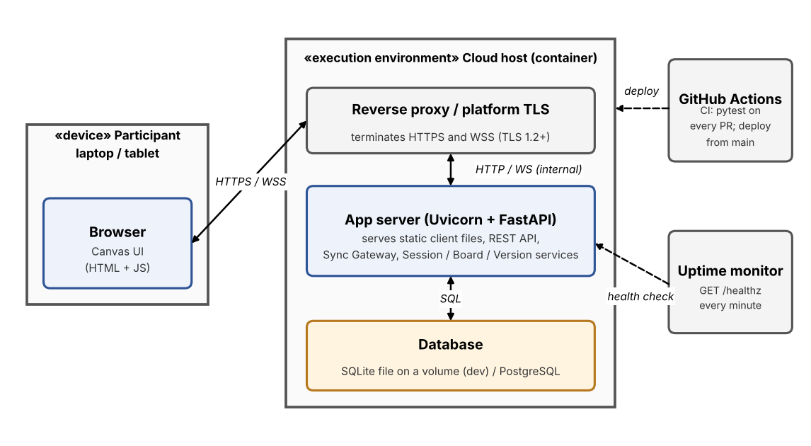
Figure 8: Deployment diagram
Environment | Purpose | Hosting
Local | Developer machines | uvicorn with a SQLite file; open two browser windows to test collaboration.
CI | Automated build and tests on every PR | GitHub Actions (ubuntu-latest runner, Python 3.11, pytest).
Staging / Production | Demo and release | One container on a free-tier host (Render / Railway) or a small cloud VM; HTTPS provided by the platform; SQLite on a persistent volume or managed PostgreSQL.

4.4 Code / module structure
Repository layout (https://github.com/sriviswaja/shared-whiteboard):
- /src/client : front-end source (HTML, canvas rendering, tools, WebSocket and REST clients)
- /src/server : back-end source, split into api/ (REST routers), gateway/ (WebSocket), services/ (session, board, version) and db/ (models, repository)
- /tests : unit, integration and end-to-end tests (pytest, Playwright), plus load scripts (k6)
- /docs : SRS, SAD, test plan, diagrams
- /.github/workflows : CI pipeline definitions (ci.yml)

5. Interface Design

5.1 REST API
The board ID in the URL is the access capability (decision AD-07), so the Auth column says "Board link" instead of a login. All endpoints use JSON over HTTPS.
Method | Endpoint | Purpose | Auth
POST | /api/boards | Create a board; returns boardId and link | None (rate-limited per IP)
GET | /api/boards/{boardId} | Board info: exists, participant count | Board link (boardId)
GET | /api/boards/{boardId}/versions | List the 50 most recent versions | Board link
POST | /api/boards/{boardId}/versions | Save a named snapshot | Board link
GET | /api/boards/{boardId}/versions/{versionNo} | Get a snapshot for read-only preview | Board link
POST | /api/boards/{boardId}/versions/{versionNo}/restore | Restore a version (creates a new version) | Board link
GET | /healthz | Health check for monitoring | None

Request, response and error details:
Endpoint | Request | Response | Errors
POST /api/boards | empty body | 201 {boardId, link} | 429 too many boards
GET /api/boards/{boardId} | path: boardId | 200 {boardId, createdAt, participantCount} | 404 board not found
GET .../versions | path: boardId | 200 {versions: [{versionNo, name, author, createdAt, kind}]}, newest first | 404 board not found
POST .../versions | {name, author} | 201 {versionNo, createdAt} | 400 invalid name; 404; 429
GET .../versions/{versionNo} | path: boardId, versionNo | 200 {versionNo, objects: [...]} | 404 board or version not found
POST .../versions/{versionNo}/restore | {author} | 200 {newVersionNo} | 404 board or version not found; 429
GET /healthz | none | 200 {status: "ok"} | 503 not ready

Standard error body for all REST errors:
{ "error": { "code": "BOARD_NOT_FOUND", "message": "Board not found" } }

5.2 Real-time (WebSocket) events
Connect to wss://<host>/ws/boards/{boardId}?name=<displayName>. Every message is a JSON object with a "type" field.
Event | Direction | Payload / behaviour
op:add | Client to server | {opId, object}. Add a stroke, shape or text object.
op:update | Client to server | {opId, objectId, changes}. Move, resize, recolour or edit text. Batched to at most one per object every 50 ms during a drag.
op:delete | Client to server | {opId, objectId}. Delete an object (becomes a tombstone).
cursor:move | Client to server | {x, y}. Not persisted; limited to about 20 per second.
resume | Client to server | {lastSeq}. Sent after reconnecting to catch up.
ping | Client to server | {}. Heartbeat every 30 s.
welcome | Server to client | {clientId, seq, objects, participants}. Sent after join, or when a full resync is needed.
op | Server to clients | {seq, clientId, opType, objectId, payload}. Validated operation with its authoritative seq, broadcast to the room. The sender receives it too as acknowledgement.
presence | Server to clients | {participants: [{clientId, name}]}. Sent when someone joins or leaves.
cursor | Server to clients | {clientId, name, x, y}. Another participant's pointer.
board:reset | Server to clients | {seq, objects, reason}. Replace the whole board (after a restore).
version:restored | Server to clients | {versionNo, by}. Notification that a restore happened.
error | Server to client | {code, message}. Rejected message or connection problem.

Example: adding a stroke, and the broadcast the other participants receive.
// client -> server
{ "type": "op:add", "opId": "c7f1...", "object": {
"id": "9a3e...", "type": "stroke", "z": 12,
"props": { "points": [[10,10],[12,14],[18,20]], "colour": "#d62828", "width": 3 } } }

// server -> all clients
{ "type": "op", "seq": 412, "clientId": "u7", "opType": "add",
"objectId": "9a3e...", "payload": { "type": "stroke", "z": 12, "props": { ... } } }

Error codes:
Code | Meaning | Used when
400 | Invalid input | REST body or parameter fails validation.
404 | Board or version not found | Unknown or malformed boardId / versionNo.
413 | Payload too large | Message or body above the size limit.
429 | Too many requests | Rate limit exceeded.
4001 (WS) | Board not found | WebSocket connect to an unknown board.
4002 (WS) | Board full | The 21st participant tries to join.
4003 (WS) | Invalid message | Schema validation failed; message dropped, connection kept.
4290 (WS) | Rate limit exceeded | Too many messages; client throttled, repeated abuse closes the connection.

5.3 User interface
Figure 9 is a wireframe of the main screen.
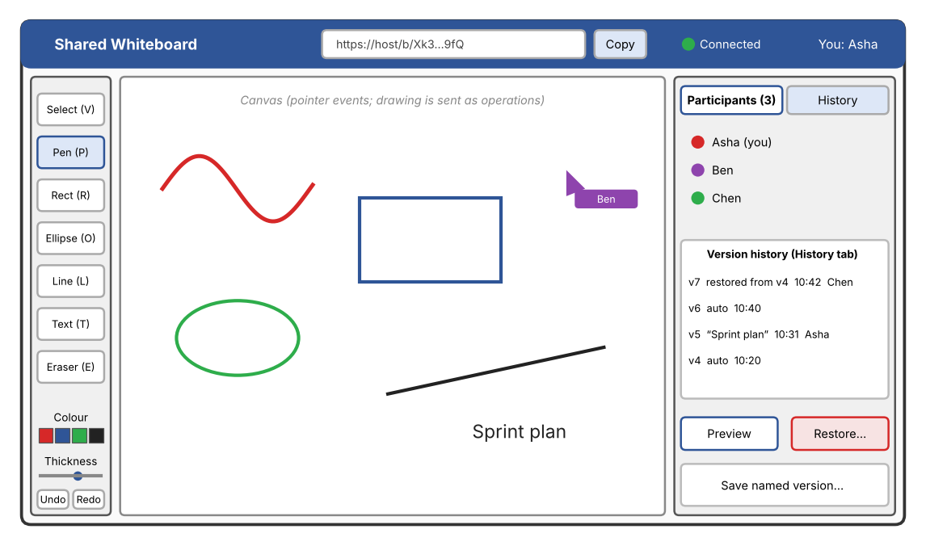
Figure 9: Wireframe of the board screen
- Layout: tool bar on the left (select, pen, rectangle, ellipse, line, text, eraser), colour, thickness and undo / redo controls below it, canvas in the centre, right panel with Participants and History tabs.
- Join screen: one field for the display name; a clear "board full" message.
- Collaboration indicators: each participant has a colour; remote cursors carry name labels; a status dot shows Connected or Reconnecting.
- Version history: list with timestamp, author and name. Preview shows a banner "Previewing v7 - Restore | Exit". Restore asks for confirmation: "This replaces the board for everyone. A new version is created and nothing is deleted."
- Shortcuts: V select, P pen, R rectangle, O ellipse, L line, T text, E eraser, Ctrl+Z / Ctrl+Y undo and redo.
- Accessibility and responsiveness: keyboard-reachable labelled controls, sufficient colour contrast, layout adapts to tablet-sized screens.

6. Cross-Cutting Concerns

6.1 Concurrency and consistency
- Ordering: each board room processes one operation at a time, so every operation gets a total order (seq).
- Optimistic apply: the client applies its own edit immediately and sends it; when the authoritative operation comes back with its seq, the client reconciles with the server order.
- Last-write-wins per object: an update changes only the properties it names; for the same property the later seq wins. An update to a deleted object is ignored (tombstone).
- Convergence: because every client applies the same operations in the same order, all clients reach the same state (WB-NF-004).
- Undo / redo: each client keeps its own stack of inverse operations, which are sent as normal operations. Undo therefore never reverts another user's work, and a later edit by someone else can override an undo.
- Offline and reconnect: the client queues operations while disconnected and resumes from lastSeq (see 4.1.3). Duplicates are ignored through opId.
Why not CRDT or OT: they merge edits inside one object (for example characters inside a text box), which the SRS does not require. Per-object LWW with a server order gives the same convergence with far less code (AD-02).

6.2 Security
- Authentication: none by design. Possession of the unguessable board link is the only access control (SRS objective SO-1). There are no accounts, tokens or sessions to steal.
- Authorisation: there are no roles. Membership and the 20-user cap are checked on every message, not only at connect time (WB-SR-006).
- Transport: TLS 1.2+ for HTTP and WebSocket (WB-SR-001).
- Input validation and rate limiting: every message is checked against a schema and a size limit, text is drawn on the canvas and never injected as HTML, and each connection is limited to 60 messages per second (WB-SR-003, 004).
- Secrets: kept in environment variables and never committed to the repository.
Threat model (STRIDE):
Threat | Scenario | Mitigation | SRS ref
Spoofing | Someone pretends to be another participant or guesses a board link. | clientId is assigned by the server per connection, so display names are labels, not identities. Board IDs are 128-bit random tokens and there is no board listing endpoint. | WB-SR-002, 006
Tampering | Forged or modified messages; editing history; traffic altered in transit. | Server validates every message and owns the ordering (seq). History is append-only. TLS on all connections. | WB-SR-001, 003, 005
Repudiation | A participant denies deleting content or restoring a version. | Operations carry clientId and display name. Restores and named snapshots are written to the audit log with a timestamp. | WB-SR-005
Information disclosure | Link leaks; traffic sniffed; logs reveal content. | TLS; unguessable IDs; logs never contain board content and only a shortened board ID; generic error messages. | WB-SR-001, 002
Denial of service | Message flood, mass connections, huge payloads. | Per-connection rate limit; message and payload size limits; 20-user cap; idle connection timeout; board-creation rate limit per IP. | WB-SR-004, 006
Elevation of privilege | A connection acts on a board it did not join, or calls internal operations. | There are no roles to escalate to. Membership and board are checked on every message. No admin endpoints are exposed. | WB-SR-006
Residual risk: anyone who obtains the link can edit and restore, so links must be shared carefully. Optional board passwords or expiring links are future work (Section 11).

6.3 Performance and scalability
- Cursor events are throttled to about 20 per second and are never stored.
- Update operations during a drag, resize or stroke are batched to at most one per object every 50 ms; the final state is always sent on pointer release.
- Rendering: requestAnimationFrame batching, a static layer for settled objects plus an active layer for the object being edited, and redraw of only the changed regions (WB-NF-006).
- Live board state is kept in memory; the database is used for persistence, not for reads on the hot path (WB-NF-001).
- Scaling: one process handles many boards because rooms are independent. Scaling out would add a pub/sub layer (Section 11). k6 load tests verify WB-NF-001 and WB-NF-002.

6.4 Reliability and error handling
- Reconnect with exponential backoff (1 s up to 30 s) and a visible "Reconnecting..." banner.
- Acknowledgement: the sender gets its own operation back with a seq; unacknowledged operations are re-sent after reconnect and de-duplicated by opId.
- Commit before broadcast: an operation is written to the log before other clients see it, so a crash never shows users something that was not saved (WB-F-040).
- Periodic snapshots (6.6) bound the cost of rebuilding a room after a restart.
- Graceful degradation: while disconnected the board stays visible; local edits are queued and shown as pending.
- Errors are standardised (5.1 and 5.2) and never expose internals; an invalid WebSocket message is dropped and reported while the connection stays open.

6.5 Logging and monitoring
- Structured JSON logs with timestamp, level, event, clientId and a shortened board ID. No board content, no full board IDs (the ID is the access secret).
- Audit events (named snapshot, restore) are also written to the audit_log table.
- GET /healthz for uptime checks and automatic restart (WB-NF-003).
- Metrics: active boards and connections, messages per second, p95 broadcast latency, error rate, reconnect count, snapshots created. Alerts: p95 latency above 300 ms, error rate above 2%, failing health check.

6.6 Version history design
- Automatic snapshot after 100 operations, or after 5 minutes if at least one operation happened since the last snapshot, whichever comes first (WB-F-030).
- Any participant can save a named snapshot (WB-F-031). The 50 most recent versions are listed (WB-F-032).
- Restore never deletes: the chosen snapshot becomes the live state and is recorded as a new version "restored from vN" with an audit entry; all clients receive board:reset and version:restored (WB-F-034, WB-SR-005).
- The only deletion path is a server-side retention job that stops listing versions beyond the 50 most recent. No user action can delete a snapshot.

7. Technology Stack
Layer | Choice | Rationale
Front end | HTML5 Canvas 2D, vanilla JavaScript (ES modules) | No framework needed for five tools; full control of rendering performance; Pointer Events cover mouse, touch and stylus; small download.
Back end | Python 3.11, FastAPI, Pydantic | Matches the team's skills and the pytest CI; async I/O; Pydantic validates every message (WB-SR-003); automatic OpenAPI docs.
Real-time | WebSocket (FastAPI / Starlette on Uvicorn), JSON messages | Two-way, low latency, runs in the same process as the REST API, so one deployment.
Database | SQLite (dev/test), PostgreSQL optional, via SQLAlchemy | Zero setup for tests and demos; switchable without code changes; transactions for commit-before-broadcast.
Testing | pytest (unit, integration), Playwright (multi-browser UI), k6 (load, native WebSocket support) | pytest is already in CI; Playwright can drive several browsers as several users; k6 checks the latency and 20-user targets.
CI/CD | GitHub Actions | Native to the team repository; the CI check is required before merging.
Transport security | HTTPS / WSS, TLS 1.2+ | Terminated by the hosting platform or reverse proxy (WB-SR-001).
Hosting | One container on a free-tier host or small VM | Low cost, simple deployment, health check and automatic restart.

8. Architecture Decision Log
Each significant decision is recorded once: what, why, and what was given up.
ID | Decision | Alternatives considered | Reason / trade-off | Status
AD-01 | Use WebSockets for real-time sync | HTTP polling, long polling, Server-Sent Events | Persistent two-way connection meets the 300 ms target with low overhead. Polling adds delay and load; SSE is one-way, so edits would still need separate requests. Cost: the server manages long-lived connections. | Accepted
AD-02 | Last-write-wins per object, ordered by a server-assigned sequence number; deletes are tombstones | OT, CRDT | Required by the SRS (WB-F-022) and far simpler to build and test. One server order makes all clients converge. Cost: two edits to the same object means one overwrites the other; version history is the safety net. | Accepted
AD-03 | Client-server with one central sync server | Peer-to-peer (WebRTC), microservices | One place to enforce the 20-user cap, security checks, persistence and history. P2P cannot easily enforce limits or keep history; microservices are too heavy for 20 users per board and a team of four. | Accepted
AD-04 | Modular monolith in Python (FastAPI), in-memory board rooms backed by the database | Node.js stack, Java / Spring Boot, separate services | Fits the team's skills and the existing pytest CI; WebSockets and REST in one process. Cost: live state sits in one process, so scaling out needs pub/sub (Section 11). | Accepted
AD-05 | SQL database through SQLAlchemy: SQLite for dev/test, PostgreSQL optional | MongoDB, Redis only, flat files | Relational model fits boards, ops and versions; SQLite needs no setup; the same code runs on PostgreSQL. Cost: SQLite allows one writer at a time, acceptable at this scale. | Accepted
AD-06 | Hybrid version history: append-only operation log plus periodic snapshots; restore creates a new version | Snapshots only, event-sourcing only, destructive rollback | Snapshots make preview and restore fast; the log makes resync possible; non-destructive restore means nobody loses work (WB-SR-005). | Accepted
AD-07 | Access by unguessable board link; no accounts, roles or JWT | Accounts with JWT and owner / editor / viewer roles | Required by the SRS (everyone equal, no accounts) and removes login friction. Cost: anyone who obtains the link can edit and restore, so users must share it carefully. | Accepted
AD-08 | Vanilla JavaScript with Canvas 2D for the client | React with a canvas library, SVG, Fabric.js / Konva | Fewer dependencies, direct control of rendering and event handling for the 30 fps target. Cost: more manual code for tools and hit testing. | Accepted

9. Development Workflow, Repository and CI
The team follows the workflow below. It is part of the architecture because it governs how every component is built, tested and integrated.

9.1 Repository and access
- One shared GitHub repository for the whole team: https://github.com/sriviswaja/shared-whiteboard
- All teammates are added as collaborators and clone the team repository directly (no forks).
- Contributions are balanced and meaningful across members (tracked in Section 9.4).

9.2 Branching and review rules
# | Rule
1 | The main branch is protected: no direct or unverified pushes.
2 | Every feature is developed in its own branch (e.g. feature/<short-name>).
3 | Every feature includes an appropriate test case.
4 | Run tests locally before pushing.
5 | Open a Pull Request and obtain at least one teammate's approval.
6 | Merge only after CI passes and the review is approved.
7 | After merging, everyone pulls the latest main.

9.3 Continuous integration
- Tool: GitHub Actions, triggered on every push to main and every Pull Request to main.
- Pipeline today: check out, set up Python 3.11, install pytest, run pytest. A lint step (ruff) and a build step are added with the first feature branch.
- Branch protection (ruleset "protect-main"): changes must come through a Pull Request with one approving review, the CI check "test" must pass, force pushes and deletion are blocked, and the bypass list is empty so it applies to the repository owner too.
Typical command sequence for a developer:
git clone https://github.com/sriviswaja/shared-whiteboard.git
git checkout -b feature/<name>
# write code and tests, run the test suite locally (pytest)
git add . && git commit -m "meaningful message"
git push -u origin feature/<name> # then open a Pull Request
# address review comments; merge once CI is green and the PR is approved
git checkout main && git pull

9.4 Team contributions
Proposed split of ownership; branches follow the feature/<name> rule and PR links are added as work is merged.
Member | Components / features owned | Branches / PRs
Sriviswaja M | Repository, CI and branch protection; documentation (SRS, SAD); Version Service | docs/srs-*, docs/sad-*, feature/version-service
Samhitha Kanth | Canvas UI: tools, rendering, undo / redo, version panel | feature/canvas-ui, feature/undo-redo
Shloka Reddy | Sync Gateway, Session Service and Board Service (real-time sync, conflict handling) | feature/sync-gateway, feature/board-service
Sushir C | REST API, database layer, test suites (pytest, Playwright, k6) and the test plan | feature/rest-api, feature/database, tests/*

10. Traceability and Testing Alignment
Every SRS requirement maps to at least one architectural element, a design section and a test case. The DS-... IDs are the design references used in the SRS traceability matrix.
SRS ID | Architectural element | Design section | Test case (STP)
WB-F-001 | REST API, Board Service | 5.1, 4.2; DS-Board-01 | TC-Board-01
WB-F-002 | Sync Gateway, Session Service | 4.1.1, 5.2; DS-Session-01 | TC-Board-02
WB-F-003 | Session Service, Canvas UI | 4.1.1, 5.2, 5.3; DS-Session-02 | TC-Board-03
WB-F-004 | Session Service | 4.1.1, 5.2; DS-Session-03 | TC-Board-04
WB-F-010 | Canvas UI | 4.2, 5.3; DS-Canvas-01 | TC-Draw-01
WB-F-011 | Canvas UI | 4.2, 5.3; DS-Canvas-02 | TC-Draw-02
WB-F-012 | Canvas UI | 4.2, 6.2; DS-Canvas-03 | TC-Draw-03
WB-F-013 | Canvas UI, Board Service | 4.1.2, 6.1; DS-Canvas-04 | TC-Draw-04
WB-F-014 | Canvas UI | 5.3, 6.1; DS-Canvas-05 | TC-Draw-05
WB-F-015 | Canvas UI | 6.1; DS-Canvas-06 | TC-Draw-06
WB-F-020 | Sync Gateway, Board Service | 4.1.2, 5.2, 6.1; DS-Sync-01 | TC-Sync-01
WB-F-021 | Sync Gateway, Canvas UI | 5.2, 6.3; DS-Sync-02 | TC-Sync-02
WB-F-022 | Board Service, Sync Gateway | 6.1; DS-Sync-03 | TC-Sync-03
WB-F-023 | Sync Gateway, Canvas UI | 4.1.3, 6.4; DS-Sync-04 | TC-Sync-04
WB-F-030 | Version Service | 6.6; DS-Ver-01 | TC-Ver-01
WB-F-031 | REST API, Version Service | 5.1, 6.6; DS-Ver-02 | TC-Ver-02
WB-F-032 | REST API, Version Service, Canvas UI | 5.1, 5.3, 6.6; DS-Ver-03 | TC-Ver-03
WB-F-033 | REST API, Version Service, Canvas UI | 4.1.4, 5.3; DS-Ver-04 | TC-Ver-04
WB-F-034 | Version Service, Board Service, Sync Gateway | 4.1.4, 6.6; DS-Ver-05 | TC-Ver-05
WB-F-040 | Board Service, Database | 4.2, 6.4; DS-Persist-01 | TC-Persist-01
WB-NF-001 | Sync Gateway, Canvas UI | 6.3; DS-Perf-01 | TC-Perf-01
WB-NF-002 | Sync Gateway | 6.3; DS-Perf-02 | TC-Perf-02
WB-NF-003 | Deployment, Sync Gateway | 4.3, 6.4, 6.5; DS-Rel-01 | TC-Ops-01
WB-NF-004 | Board Service, Sync Gateway | 6.1; DS-Sync-03 | TC-Sync-05
WB-NF-005 | Canvas UI | 7; DS-Compat-01 | TC-Compat-01
WB-NF-006 | Canvas UI | 6.3; DS-Perf-03 | TC-Perf-03
WB-SR-001 | Sync Gateway, Deployment | 4.3, 6.2; DS-Sec-01 | TC-Sec-01
WB-SR-002 | Board Service | 4.2, 6.2; DS-Sec-02 | TC-Sec-02
WB-SR-003 | Sync Gateway, Canvas UI | 6.2; DS-Sec-03 | TC-Sec-03
WB-SR-004 | Sync Gateway | 6.2; DS-Sec-04 | TC-Sec-04
WB-SR-005 | Version Service | 6.2, 6.6; DS-Sec-05 | TC-Sec-05
WB-SR-006 | Session Service, Sync Gateway | 6.2; DS-Sec-06 | TC-Sec-06

11. Risks and Open Issues
Risk / issue | Mitigation / next step
Latency rises above 300 ms with 20 active users (WB-NF-001, 002) | Keep live state in memory; throttle cursor events; batch updates; run k6 load tests early and track p95 latency.
Clients diverge after concurrent edits (WB-F-022) | One server-side order per board; tombstones; clients re-apply authoritative operations; convergence tests with many simulated clients.
Network drops lose edits (WB-F-023) | Client queues operations while offline; resume with lastSeq; opId makes re-sends harmless; full-state fallback.
A buggy or malicious client floods the server (WB-SR-003, 004, 006) | Rate limit per connection, size limits, schema validation, 20-user cap.
Server crash loses recent work (WB-F-040) | Commit each operation before broadcasting; automatic snapshots; automatic restart; rooms rebuilt from the database.
Last-write-wins overwrites a user's change unexpectedly (WB-F-022) | Per-object granularity keeps conflicts rare; version history and non-destructive restore as safety net; explain the behaviour in the UI help.
Single server is a single point of failure (WB-NF-003) | Health check with auto-restart on managed hosting; accept the 99% target; scaling out is future work.
Team is new to WebSockets and concurrency | Build a thin vertical slice first (create board, draw, sync in two browsers); small PRs; test with two browsers from day one.
Uneven contributions across the team | Assign owners per component (9.4); review PR history weekly; rotate reviewers.
Open issue: scaling beyond one server | Add a pub/sub layer (for example Redis) so rooms can span servers; route a board to one server or share state through pub/sub.
Open issue: concurrent edits to the same text box overwrite instead of merging characters | Accepted for v1.0; a CRDT for text is future work.
Open issue: cleanup of inactive boards is not specified | Decide a retention rule (for example delete boards inactive for 90 days) and add a scheduled job.

