**DOCUMENTATION ON PYTHON PROJECT**

**GUESS THE NUMBER**

Guess The Number is a type guessing game in which a random number is generated by computer and the person who plays has to guess the number in minimum number of attempts whoever guesses the number in most less attempts wins!

In my version of Guess The Number, the player gets 3 attempts to guess the number correctly and on 4th attempt player loses and the correct answer is shown on screen and whoever plays the game, their accuracy is also calculated which shows how accurate they are.

* After opening the Python Project folder open guessgame.py file.
* On opening the guessgame.py file a flash screen GUI will prompt giving some academic details about the project developer.



* This flashscreen shows a message box which informs the user that clicking on the photo will continue the game and will open a new GUI window ‘Welcome’ shown below

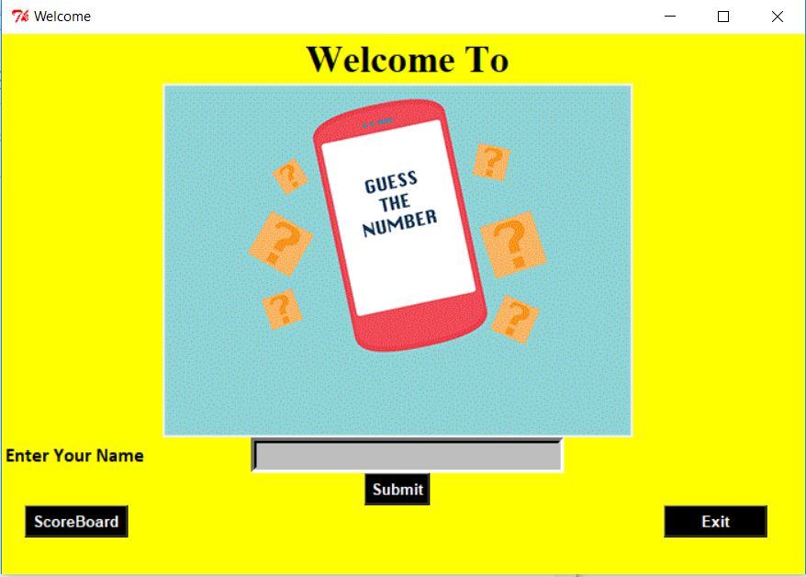

* In this window the user will provide their name and click on the Submit Button.
* A new GUI window ‘Game Starts’ will appear Welcoming the user with their name in which user will be asked to guess any number between 1 and 10 and has to enter it in the provided area and the click Guess Button.

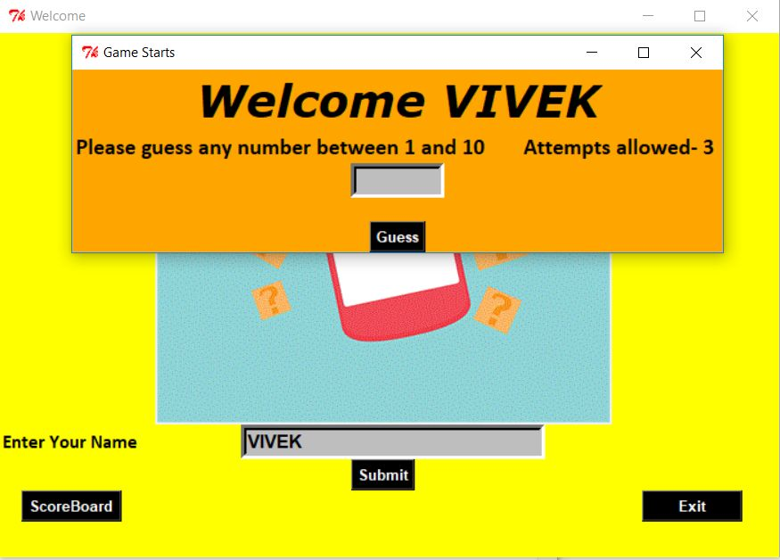

* Now the program will check whether the value entered by the user is equal to that of the number generated by the random function in the program.
* If the number entered is less than 1 and greater than 10 then a text will be printed below the Guess button showing ‘Enter Valid Value’.

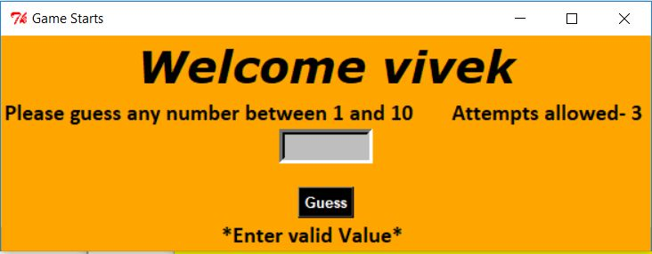

* This window also shows no. of attempts allowed to the user and also no. of attempts left on not guessing the number correctly.
* On entering a valid number and pressing the Guess Button , the text below guess button will change and will start showing ‘Your Guess is too Low Enter Again!’ and no. of attempts left if your entered value is less than the random number generated and ‘Your Guess is too High Enter Again’ and no. of attempts left if entered value is higher than the random number generated.

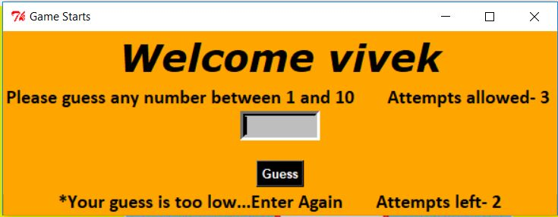

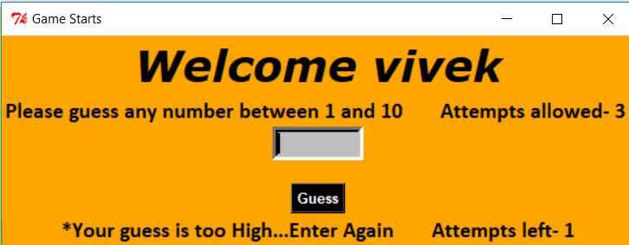

* But on guessing the random generated number correctly, a new GUI window ‘You Won!’ will open to greet you and to show Your Guess is Correct in ‘no. of attempts taken’ .

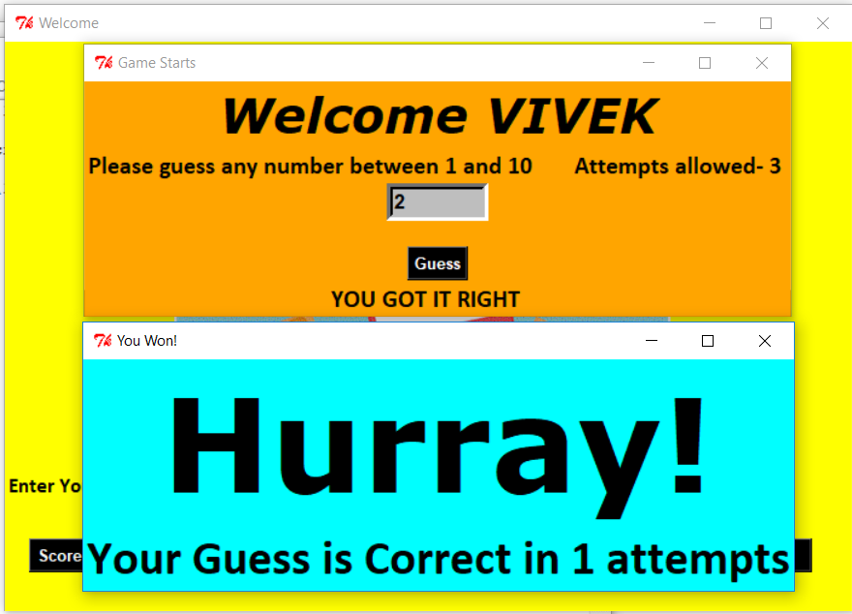

* But on not able to guess the number correctly and exhausting all of the 3 attempts provided, a new GUI window ‘Better Luck Next Time’ will open showing ‘You are out of Your all 3 Attempts’ and will show user the Correct Answer.

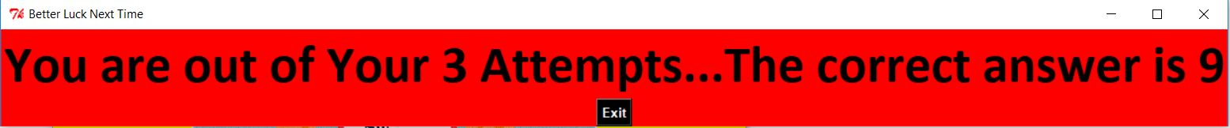

* Clicking on the Exit Button in above window provided will exit the ‘Better Luck Next Time’ GUI window.
* Now after playing the game and closing the windows that prompted. The user can now check their score by clicking on the Score Board Button which will again open a GUI window ‘Score Board’ showing the user their name, no. of attempts taken and accuracy.
* The score, no. of attempts taken, accuracy is stored in the database named ‘VIVEKDB.db’.
* The database consists of a table named ‘ggame’ and it consists of three columns, the first column shows name of player in scoreboard named ‘name’, second column shows no. of attempts taken by player named ‘score’ and third column shows accuracy of the player named ’accuracy’

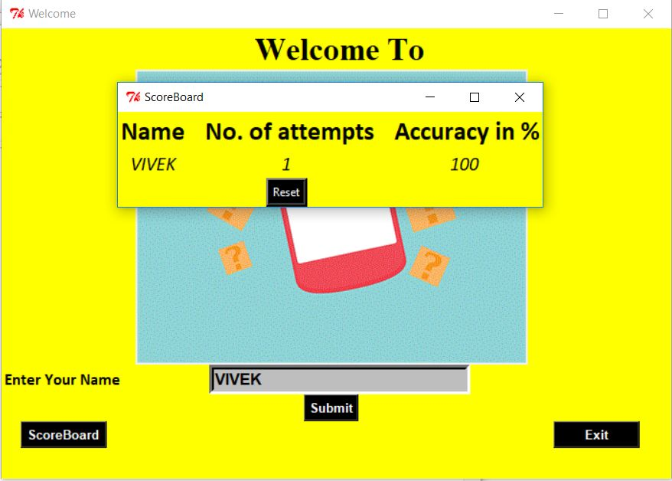

* Clicking on the Reset Button in above window provided will reset the score and exit the ‘Score Board’ GUI window.
* There is also a Exit Button on the ‘Welcome’ GUI window which on clicking will ask the user whether the user wants to Exit the window or not.

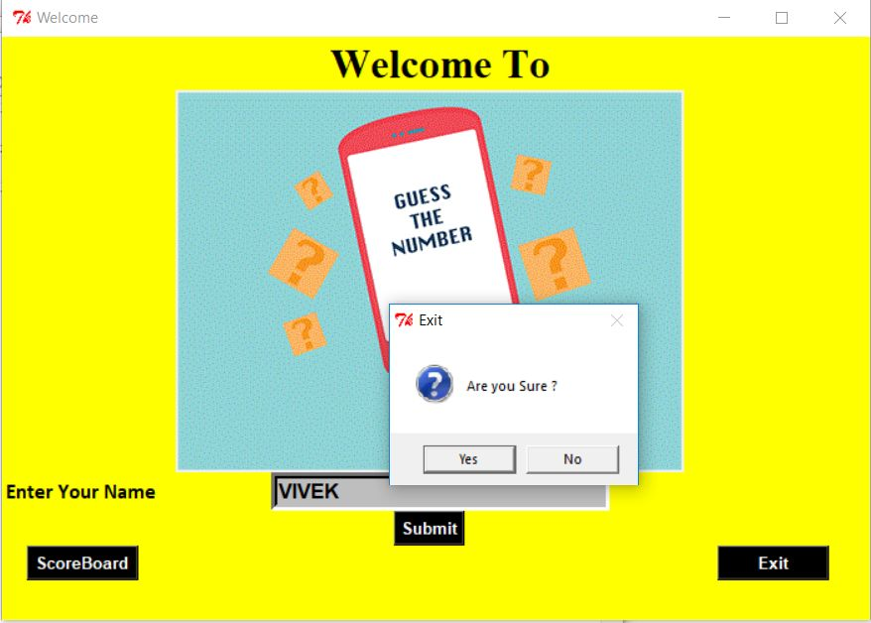

* If the user clicks on ‘Yes’ then the GUI window will close and will be as it is if user clicks on ‘No’.

________________________________________________________

* VIVEK SRIVASTAVA
* 171B155
* B5
* [vivekpopt2t@gmail.com](mailto:vivekpopt2t@gmail.com)
* 7379509676