CRIME RECORD MANAGEMENT SYSTEM

The user is required to run the index.py file in the directory , upon which
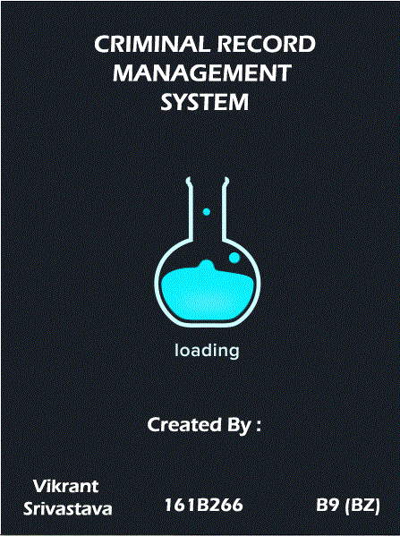
this splash screen appears that retains for 1500ms and then the login page of the projects loads
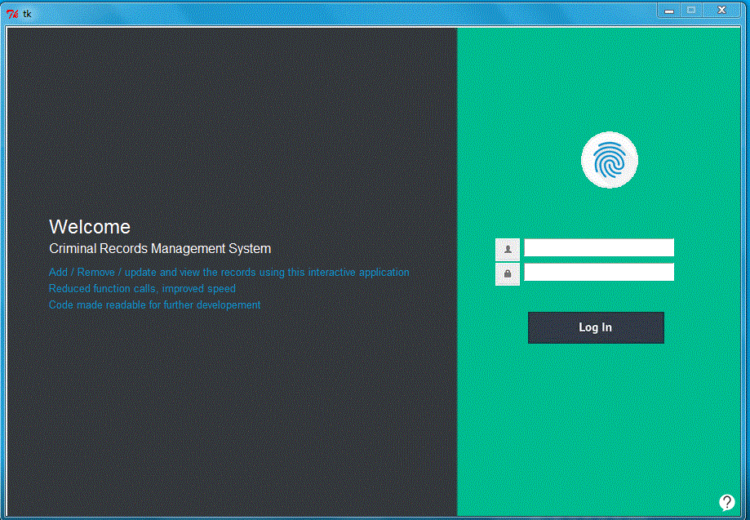

On this screen we have the basic image elements , two entry fileds Username and password followed by an icon denoting the username and password field , Only administrator has the rights to create an account therefore for now user can click the help button in the right bottom
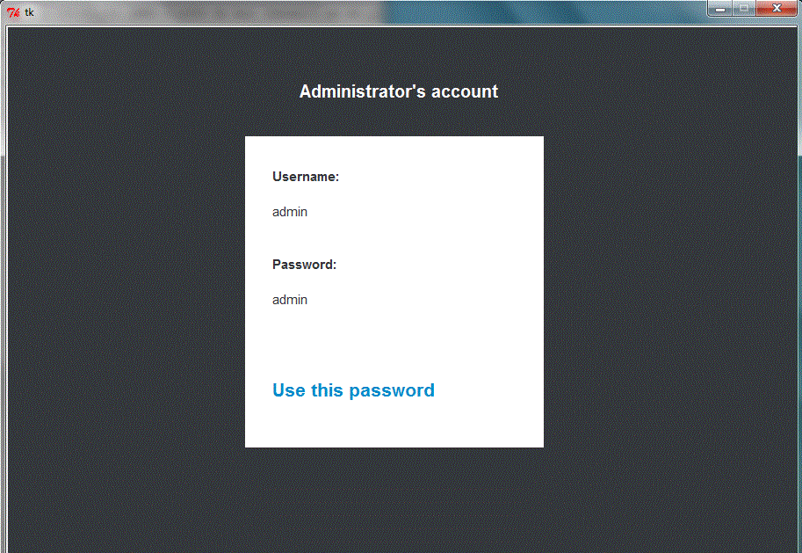
On clicking this help icon , the user will see a window demonstrating how to login with the administrator's username and password.

The username and the passwords are 'admin' and 'admin' (without quotes) that can be seen on the Help window.
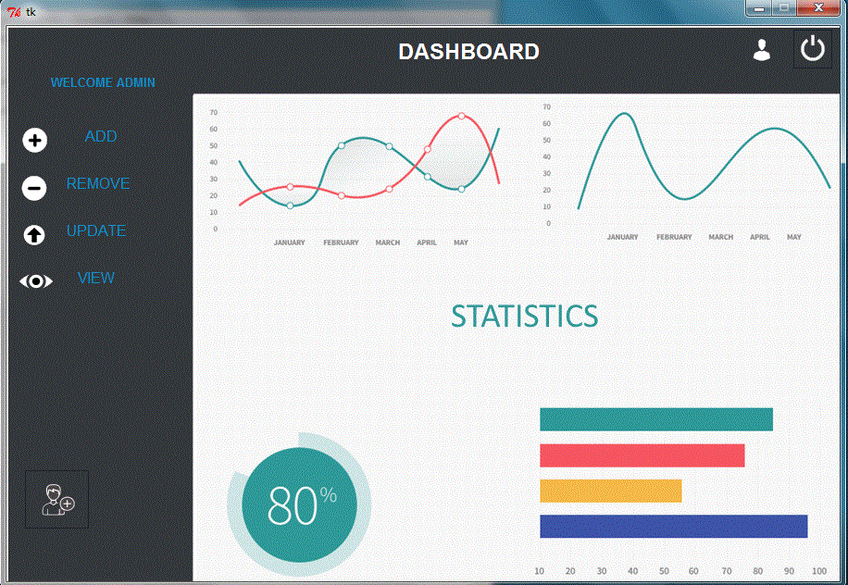
Now once the user logs in with the username and password , the user will be redirected to the dashboard

The dashboard has all the controls on the left side of the screen , as Add , remove , update and view record .

Add Button - To add a Criminal Record to the database
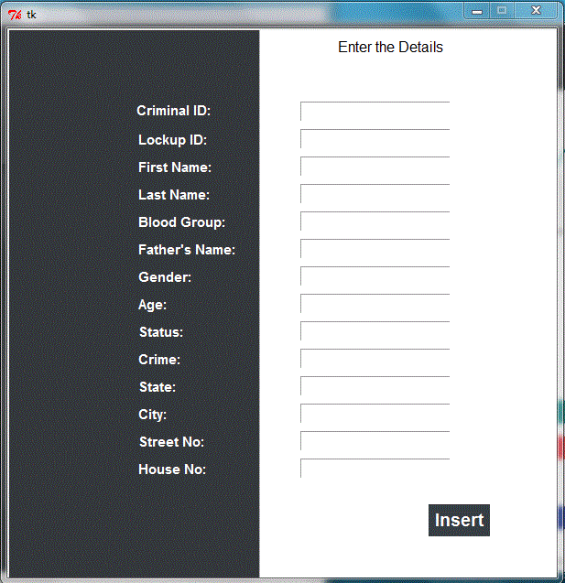
In this window we have entry field corresponding to our database columns and a button that inserts all the entries to the databse upon clicking


Remove Button – To remove a record from the database

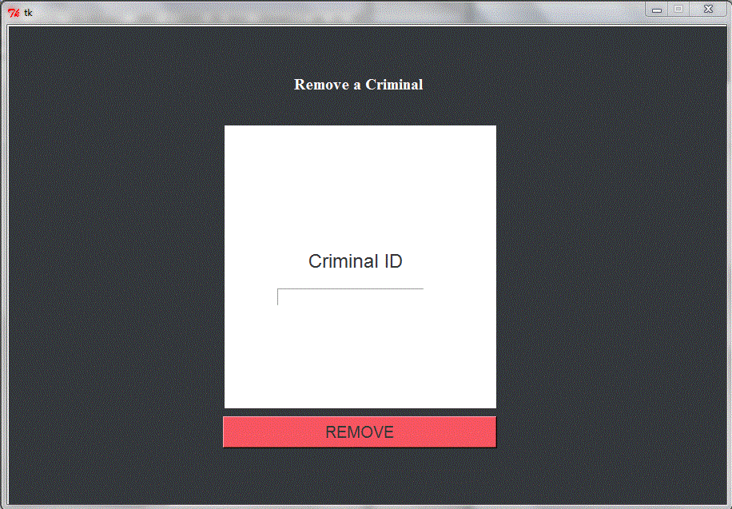
In this window we have an entry column to get the criminal_id of the criminal that is supposed to be removed from the database , and a button remove which on click removes
the record from the database corresponding to the given criminal_id and if errors are there then genrates a suitable message for the user using the tkMessageBox.

Update Button – To update the values for a criminal_id.

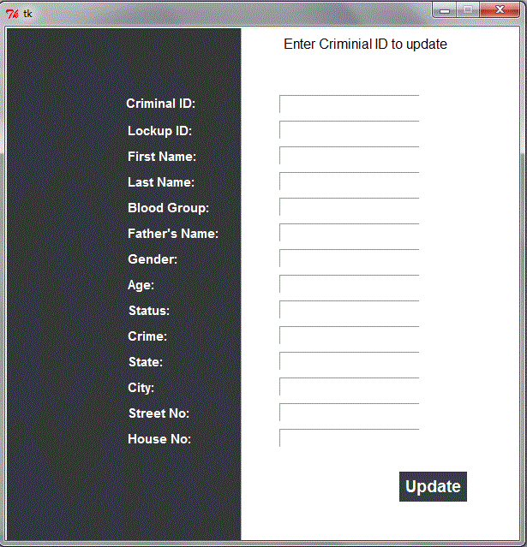
This has the simmilar user interface as the previous add menu , the labels and the button text guides the user how to operate the window.



View Button – To view a criminal record from the database

It has the simmilar UI to the update and the add menu , the user is required to enter the criminial id and press enter to get the entries populated .
( A record that is inserted in the database corresponds to the user id – 161B266)


Add User – To add a user that can log into the system.

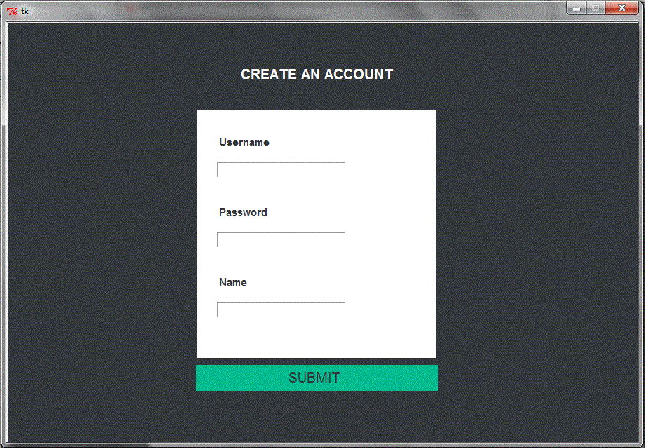
This window has Username, Password and a Name entry that needs to be filled by the administrator to create a new member for the system.
The window uses tkMessageBox and generates messages based on the enteries.


Close Button – To close the application

The user can click on the close ICON to terminate the application while in the dashboard

