SMARTBRIDGE EXTERNSHIP

Internet Of Things

*ASSIGNMENT 1*

**Question:** *In Wokwi, if the distance is less than 100cms for an ultrasonic sensor, glow a LED*

# Code:

## sketch.ino

#define ECHO_PIN 2

#define TRIG_PIN 3

void setup() { **Serial**.begin(9600); pinMode(LED_BUILTIN, OUTPUT); pinMode(TRIG_PIN, OUTPUT); pinMode(ECHO_PIN, INPUT);

}

float readDistanceCM() { digitalWrite(TRIG_PIN, LOW); delayMicroseconds(2); digitalWrite(TRIG_PIN, HIGH); delayMicroseconds(10); digitalWrite(TRIG_PIN, LOW);

int duration = pulseIn(ECHO_PIN, HIGH); return duration * 0.034 / 2;

}

void loop() {

float distance = readDistanceCM();

bool isNearby = distance < 100; digitalWrite(LED_BUILTIN, isNearby);

**Serial**.print("Measured distance: ");

**Serial**.println(readDistanceCM());

delay(100);

}

***diagram.json***

{

"version": 1,

"author": "JYOTI PRAKASH BEHURA 20BCE7355",

"editor": "wokwi", "parts": [

{ "type": "wokwi-arduino-uno", "id": "uno", "top": 299.62, "left": 89.42, "attrs": {} },

{

"type": "wokwi-resistor", "id": "r1",

"top": 210.34,

"left": 110.84,

"rotate": 90,

"attrs": { "value": "220" }

},

{

"type": "wokwi-led",

"id": "led",

"top": 141.49,

"left": 110.91,

"attrs": { "color": "red", "flip": "" }

},

{

"type": "wokwi-hc-sr04",

"id": "ultrasonic",

"top": 150.12,

"left": 250.7,

"attrs": { "distance": "180" }

}

],

"connections": [

[ "uno:GND.1", "ultrasonic:GND", "black", [ "v-8", "*", "v8" ] ], [ "uno:2", "ultrasonic:ECHO", "green", [] ],

[ "uno:3", "ultrasonic:TRIG", "purple", [ "*", "v4" ] ],

[ "uno:5V", "ultrasonic:VCC", "red", [ "v16", "h-96", "*", "v12" ] ], [ "uno:GND.1", "led:C", "black", [] ],

[ "r1:1", "led:A", "blue", [] ],

[ "uno:13", "r1:2", "blue", [] ]

],

"dependencies": {}

}

# Diagram:

Project Link: *https://wokwi.com/projects/365964169115280385*

**Outputs:**

## sketch.ino

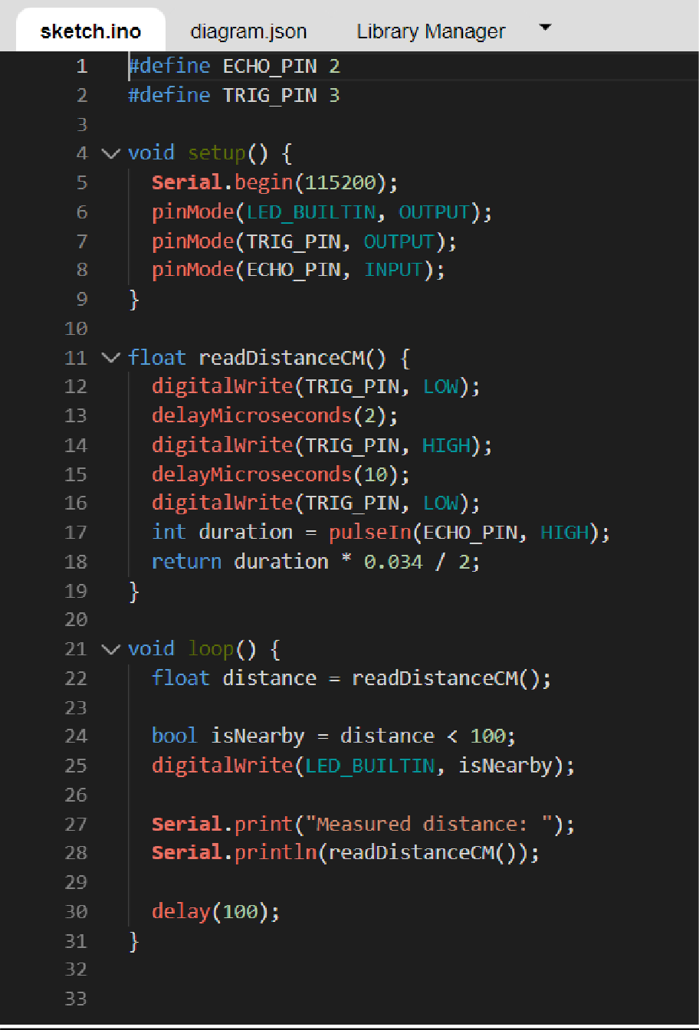

***Diagram.json:***

# Output:

## Distance more than 100cm

1. ***Distance equal to 100cm***

1. ***Distance less than 100cm***

