OUTPUT

**STUDENT DETAILS**

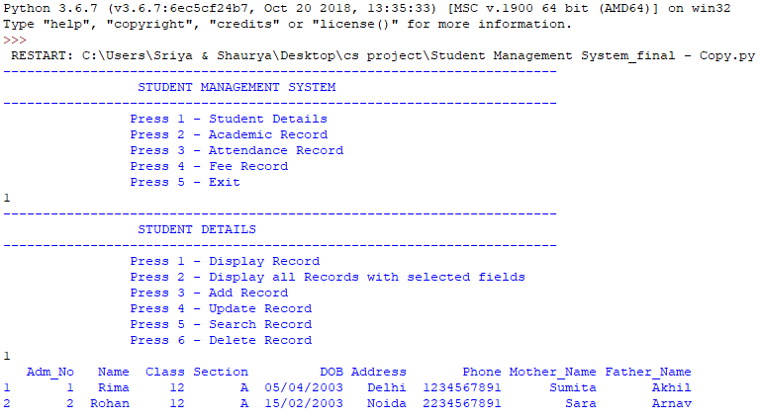

(i)Displaying Records



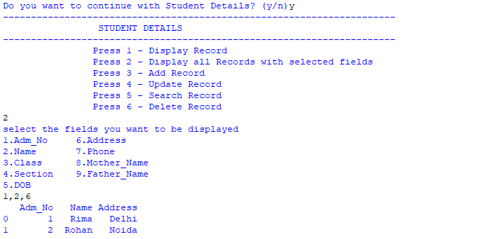

(ii)Adding Record

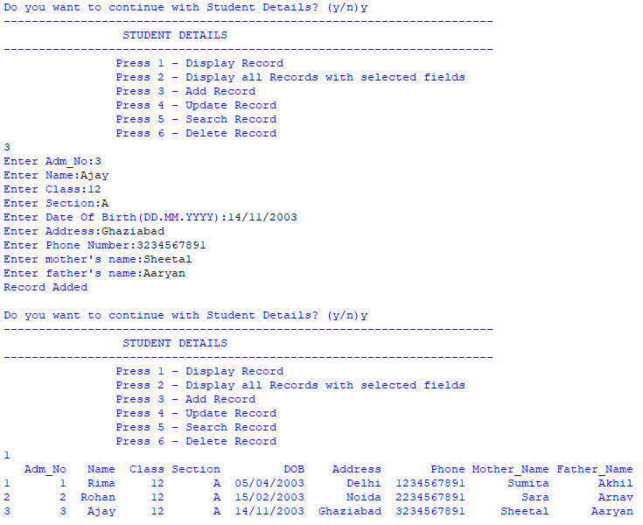

(iii)Updating Record

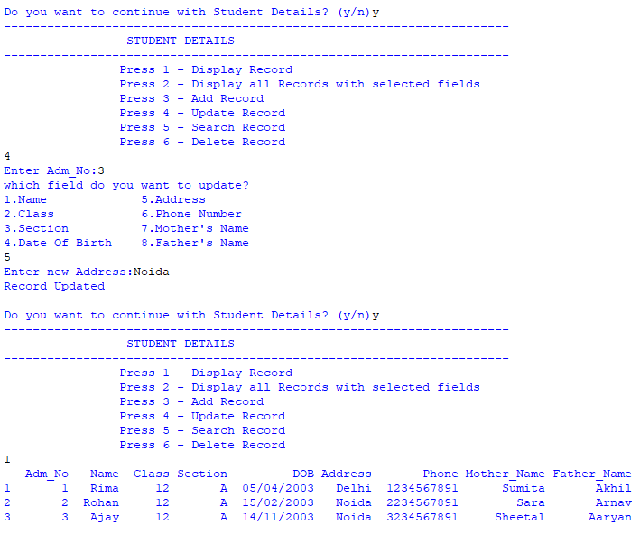



(iv)Searching Record

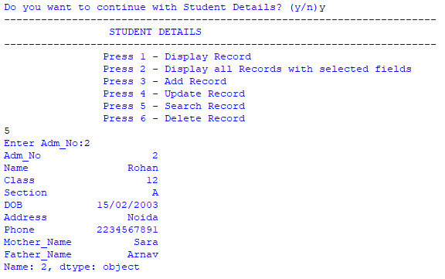

(v)Deleting Record

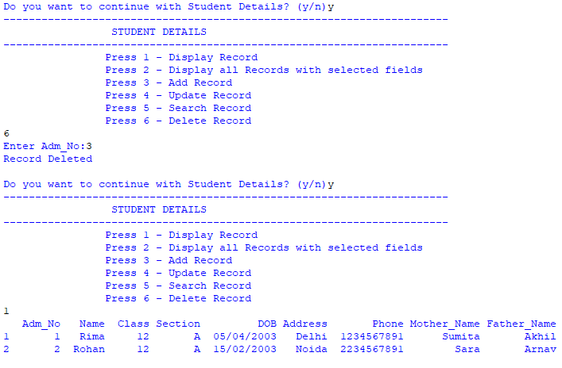



**ACADEMIC RECORD**

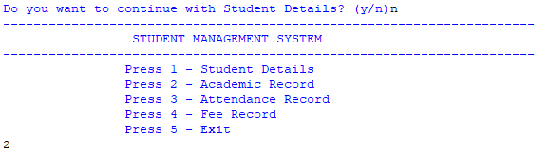

(i)Displaying Records

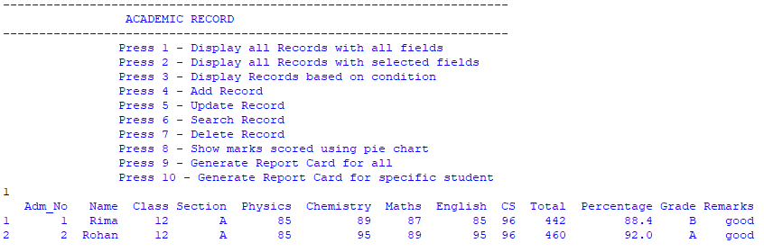

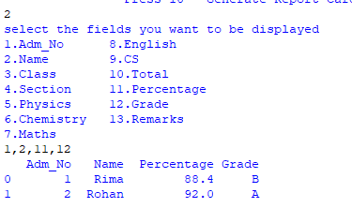

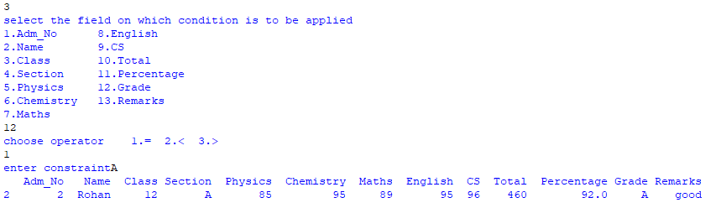

(ii)Adding Record

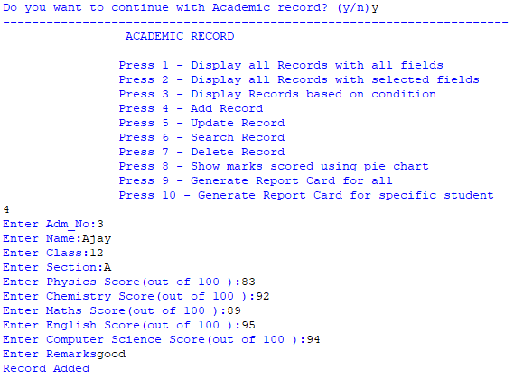

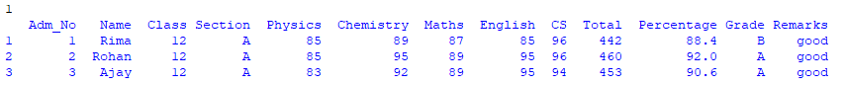

(iii)Updating Record

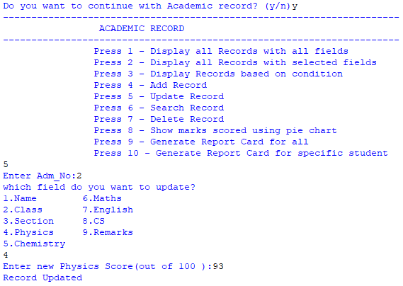

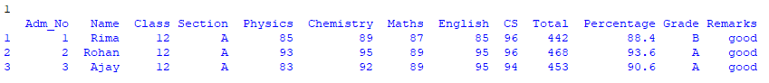

(iv)Searching Record

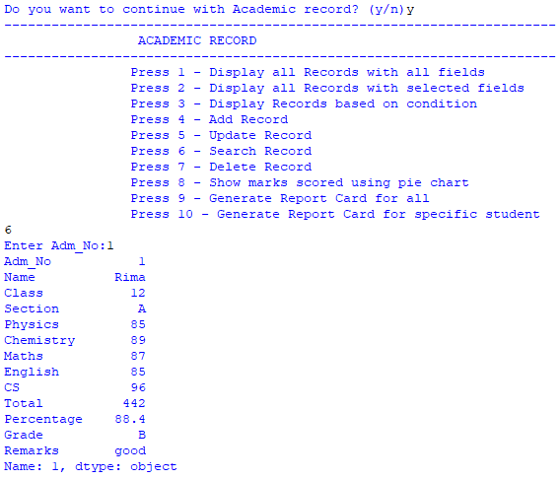



(v)Deleting Record

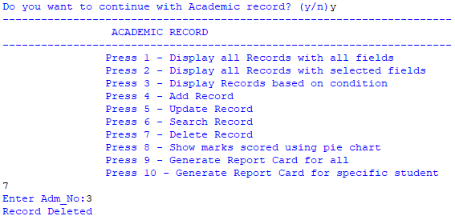



(vi)Report Card

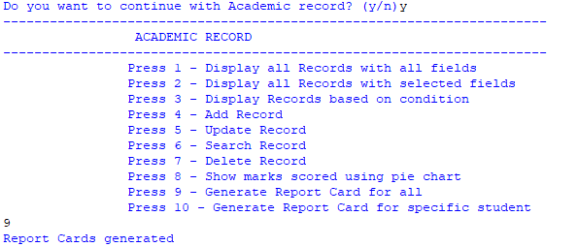



Report cards are saved by the name as admission number of the students in the form of text document.

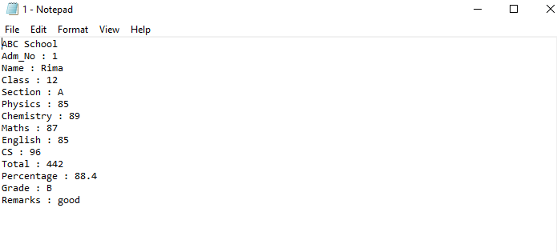 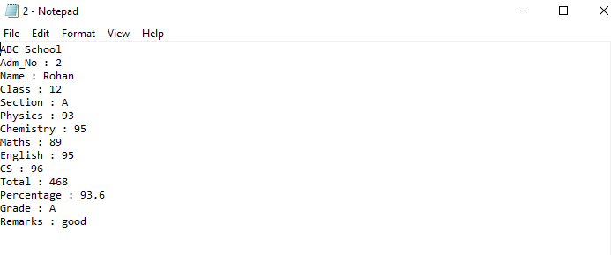

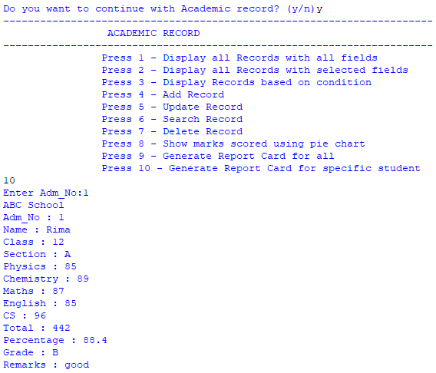

This option generates the report card of a specific student according to the user’s wish. It is also saved in the form of a text document.

(vii)Pie Chart

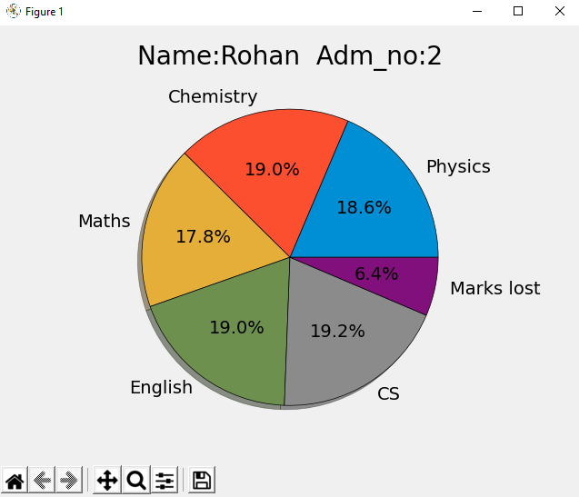

**ATTENDANCE RECORD**

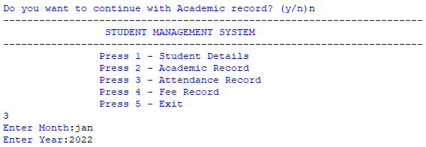

(i)Displaying Record

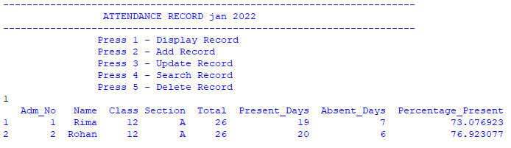

(ii)Adding Record

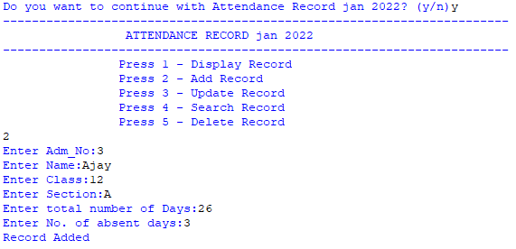

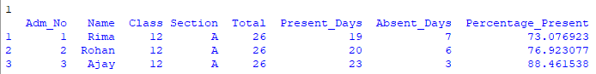

(iii)Updating Record

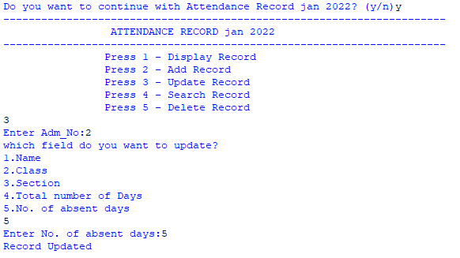

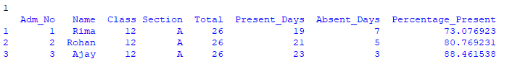

(iv)Searching Record

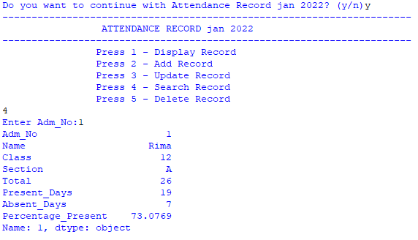

(v)Deleting Record

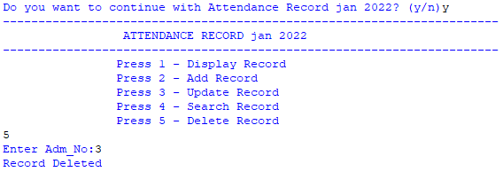

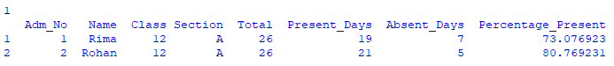

**FEE RECORD**

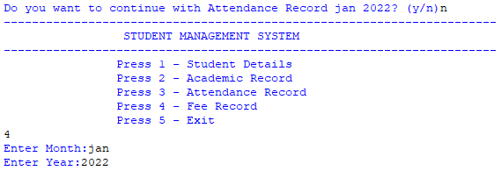

(i)Displaying Record

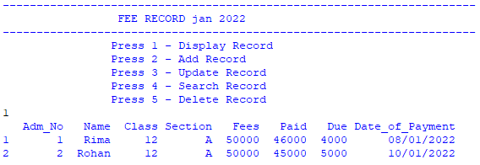

(ii)Adding Record

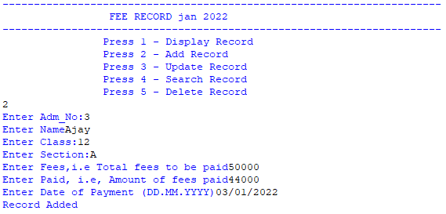

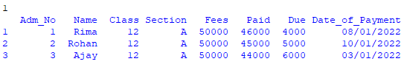

(iii)Updating Record

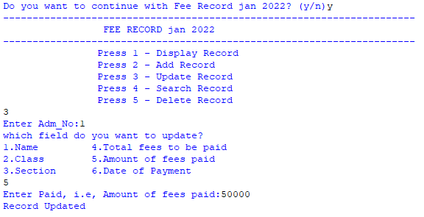

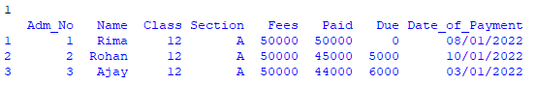

(iv)Searching Record

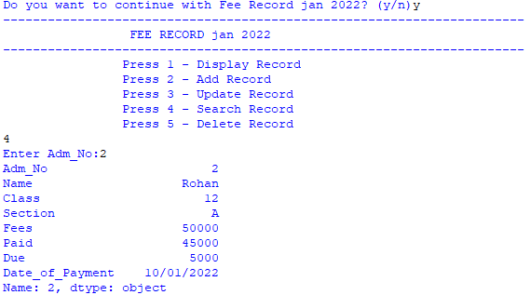

(v)Deleting Record

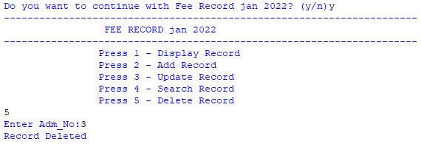

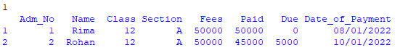

**EXITING THE PROGRAM**

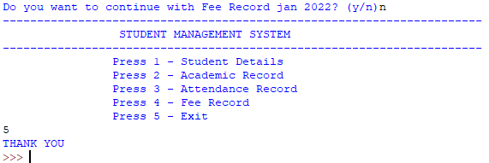

BIBLIOGRAPHY

* <https://www.geeksforgeeks.org/python-read-csv-using-pandas-read_csv/>
* <https://www.geeksforgeeks.org/saving-a-pandas-dataframe-as-a-csv/>
* <https://www.geeksforgeeks.org/python-pandas-dataframe-loc/>
* <https://www.geeksforgeeks.org/plot-a-pie-chart-in-python-using-matplotlib/>
* <https://www.geeksforgeeks.org/python-os-path-exists-method/>
* Sumita Arora Class 12