**WEEK - 1**

SKILL : Data Structures and Algorithms Mandatory Hands-on exercises

Exercise 2: E-commerce Platform Search Function

Code:

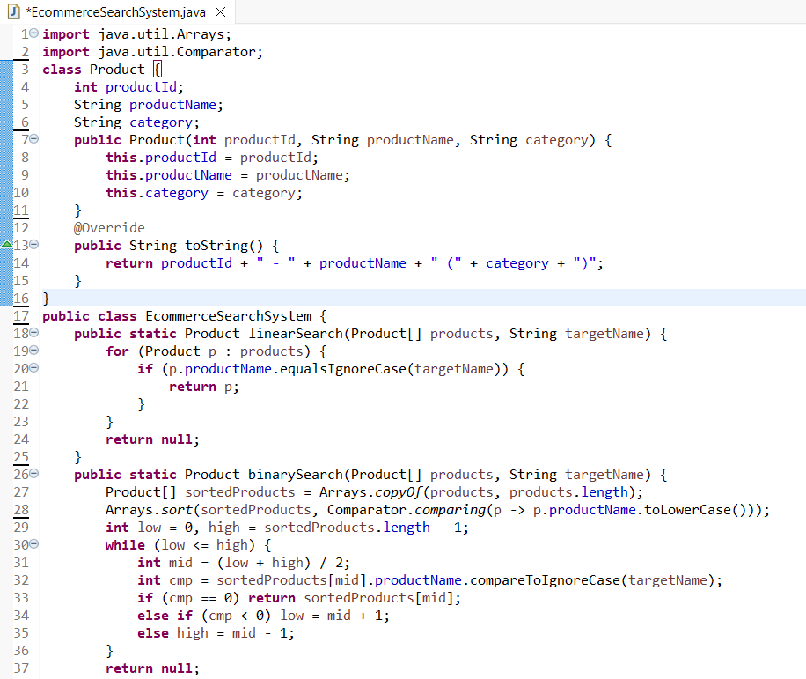

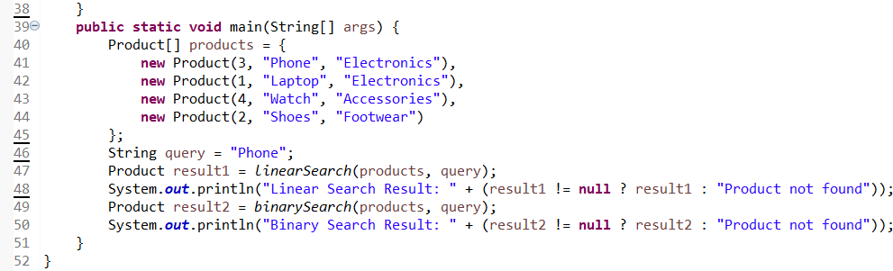

Output:

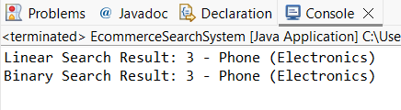

Time Complexities:

Linear Search : O(n)

Binary Search : O(log n) + O(n log n) [O(n log n) for sorting if needed]

**Therefore, for faster performance and larger data, binary search is suitable.**

Exercise 7: Financial Forecasting

Code:

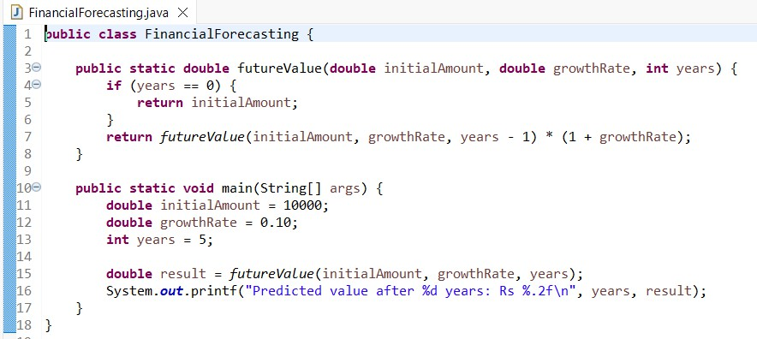

Output:

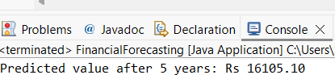

Time Complexity:

Since each call reduces years by 1, total calls = n (no. of years) . Hence, Time Complexity: O(n)

To optimize the solution, use iteration rather than recursion.