**WEEK - 1**

SKILL : Design Principles & Patterns Mandatory Hands-on exercises

Exercise 1: Implementing the Singleton Pattern

Code:

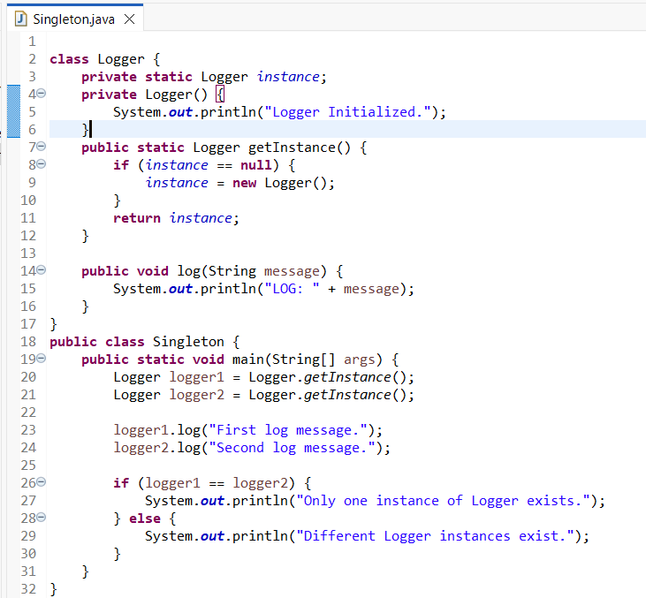

Output:

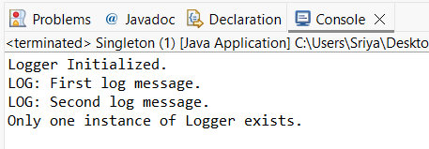

Exercise 2: Implementing the Factory Method Pattern

Code:

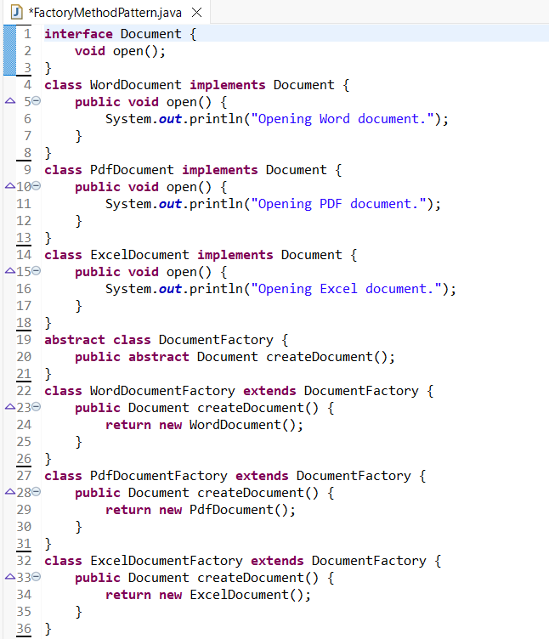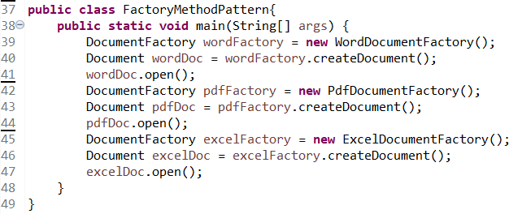

Output:

