**WEEK - 2**

SKILL : JUnit Basic Testing Exercise Mandatory Hands-on exercises

Complete Structure

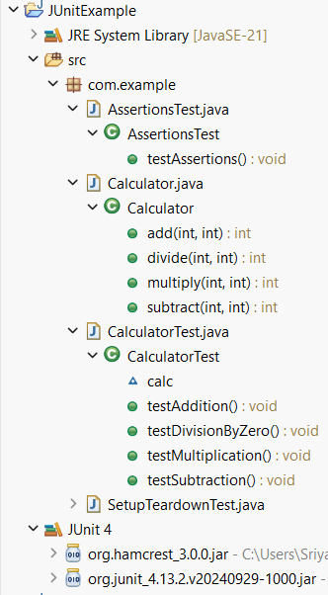

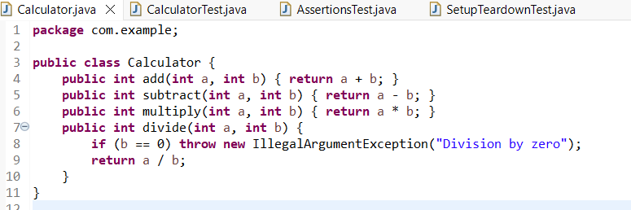Calculator.java – Class to be Tested

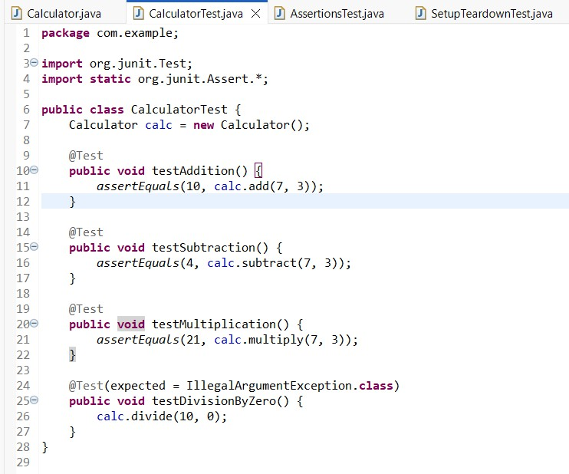CalculatorTest.java – Writing Basic JUnit Tests

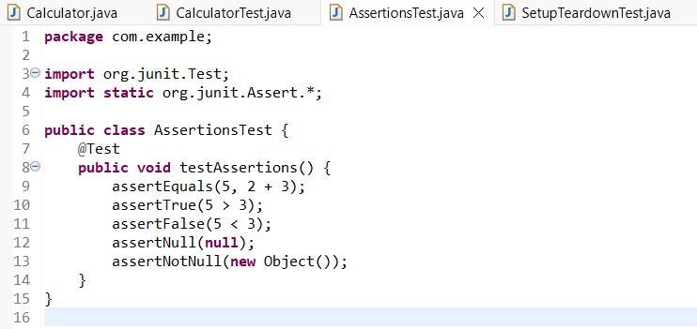AssertionsTest.java – Demonstrating JUnit Assertions

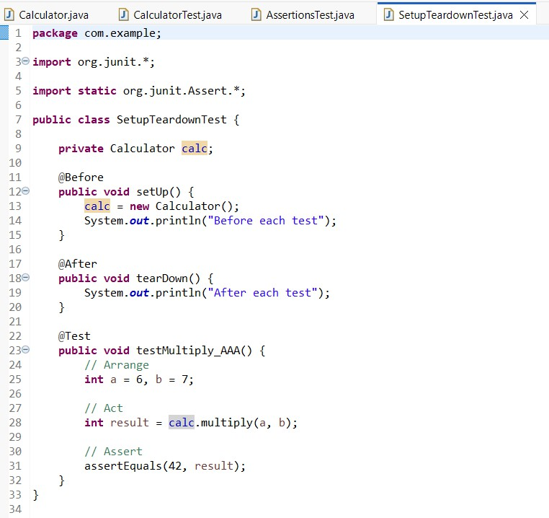SetupTeardownTest.java – AAA Pattern + Setup/Teardown

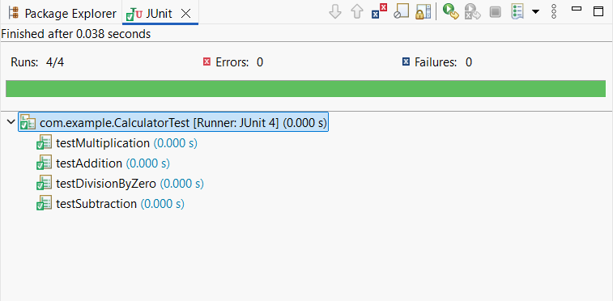Output: