**WEEK - 2**

SKILL : Mockito Exercises Mandatory Hands-on exercises

Complete Project Structure

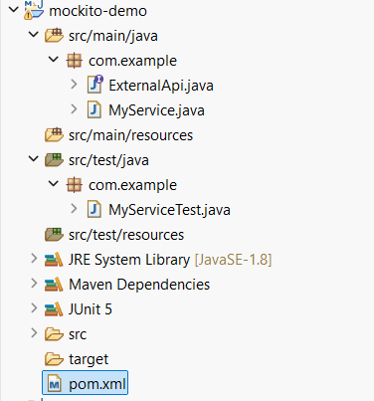

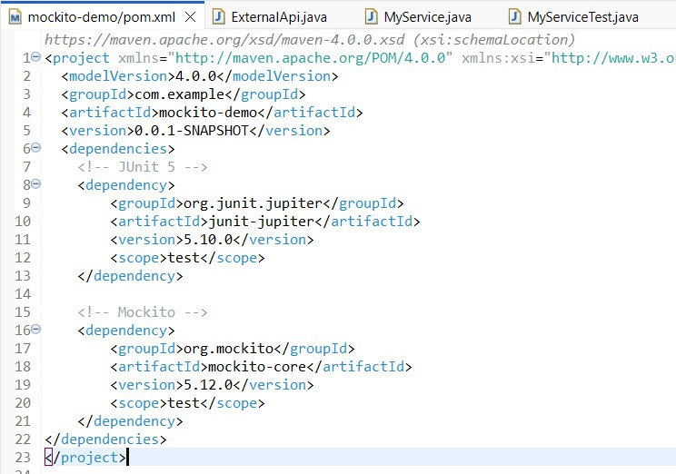Adding dependencies to pom.xml

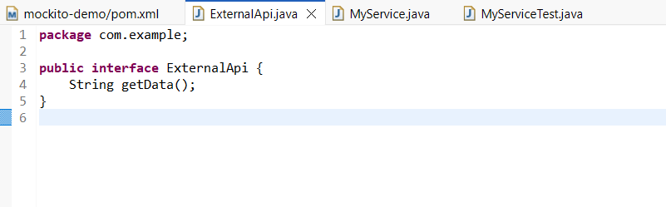ExternalApi Interface

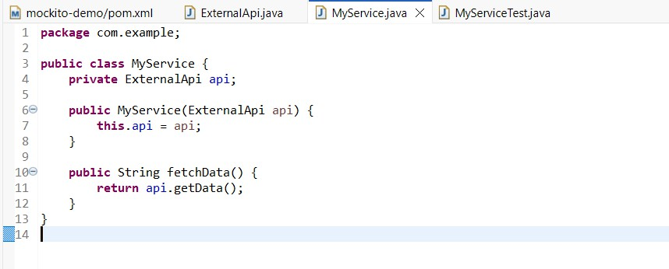MyService Class

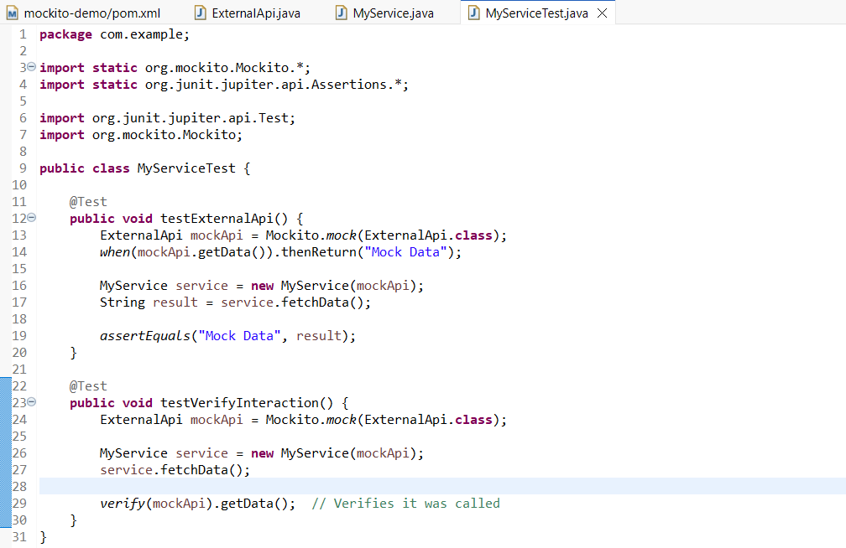MyServiceTest Class

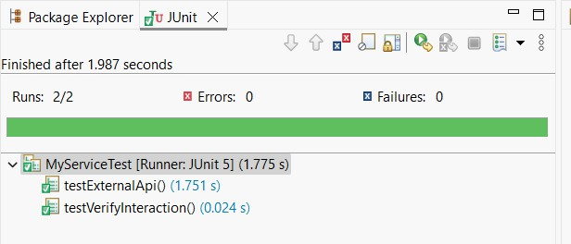Output: