**WEEK - 2**

SKILL : SLRJ Logging Exercises Mandatory Hands-on exercises

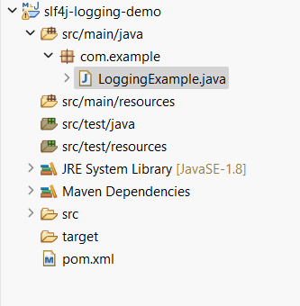Exercise-1 : Logging Error Messages and Warning Levels Complete Project Structure

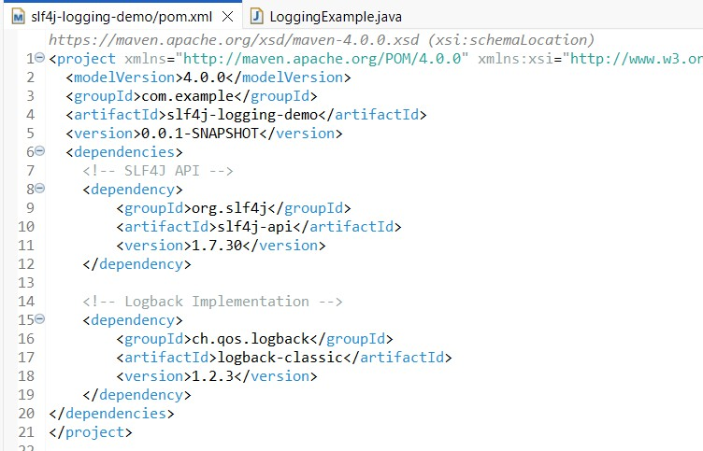Adding dependencies to pom.xml

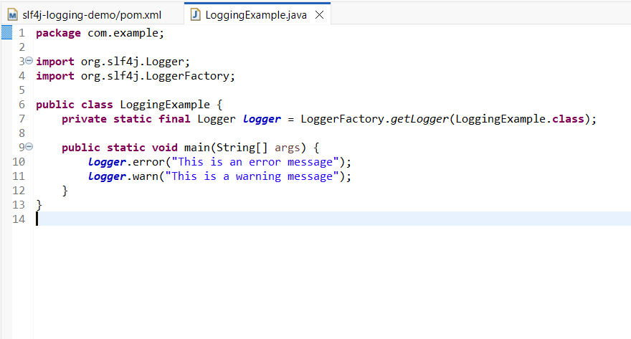LoggingExample Class

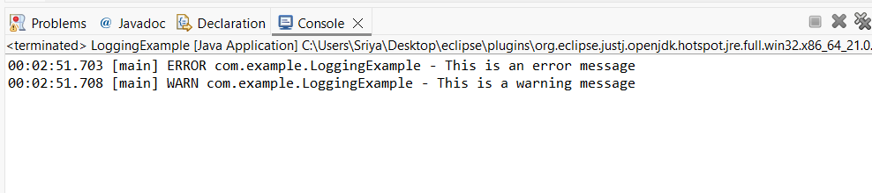Output: