**WEEK - 5**

SKILL : Microservices with Spring Boot 3 and Spring Cloud Mandatory Hands-on exercises

# Exercise: Creating Microservices for account and loan

Project Structure:

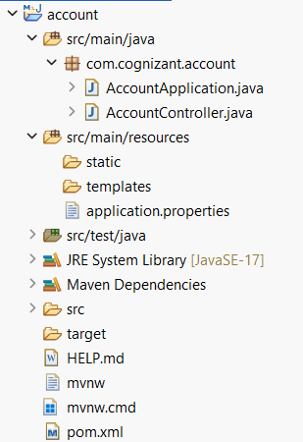

AccountController.java:

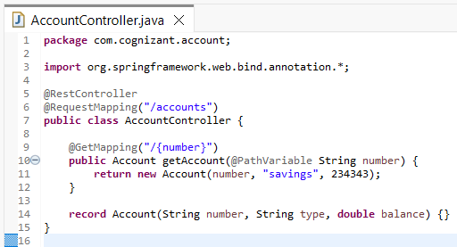

AccountApplication.java:

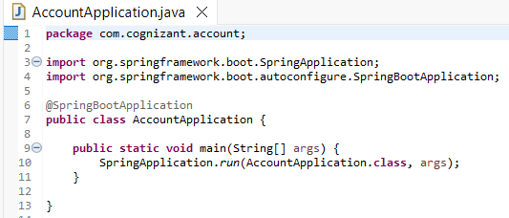

Output:

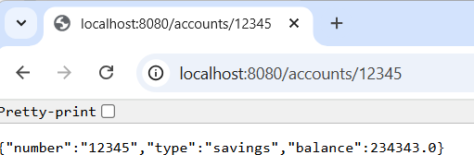

ProjectStructure:

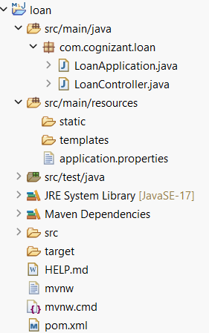

LoanApplication.java:

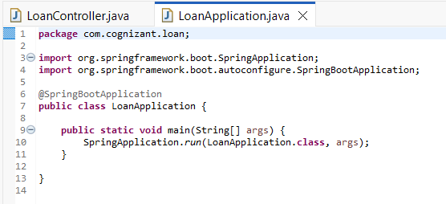

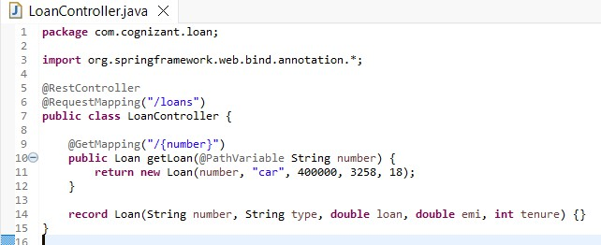LoanController.java:

application.properties:

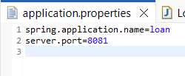

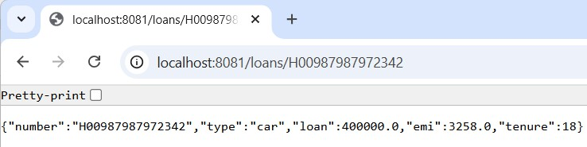Output:

# Exercise: Create Eureka Discovery Server and register microservices

Project Structure:

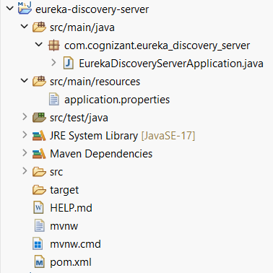

Updated AccountApplication.java:

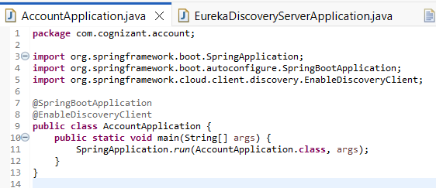

Updated application.properties:

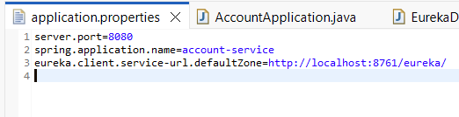

eureka-discovery-server application.properties:

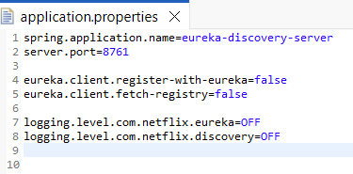

EurekaDiscoveryServerApplication.java:

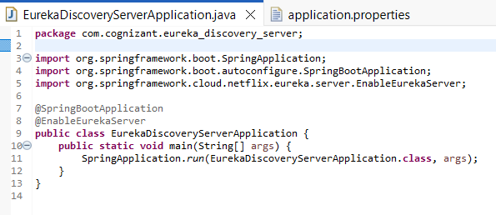

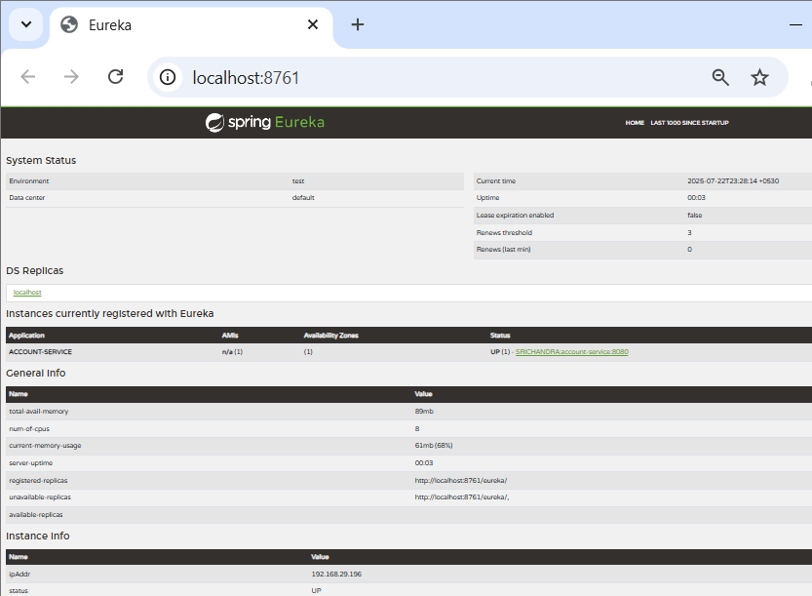Output: