**WEEK - 6**

**SKILL : React Mandatory Hands-on exercises**

Exercise: Create a new React Application with the name “myfirstreact”, Run the application to print “welcome to the first session of React” as heading of that page.

**App Structure:**

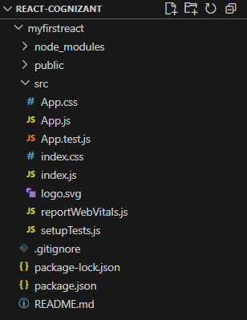

**App.js:**

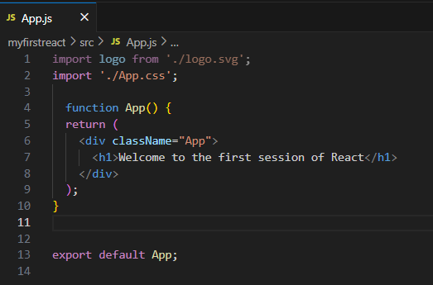

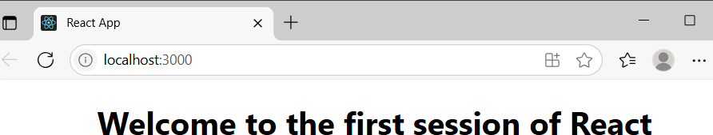**Output:**

Exercise: Create a react app for Student Management Portal named StudentApp and create a component named Home which will display the Message “Welcome to the Home page of Student Management Portal”. Create another component named About and display the Message “Welcome to the About page of the Student Management Portal”. Create a third component named Contact and display the Message “Welcome to the Contact page of the Student Management Portal”. Call all the three components

**App Structure:**

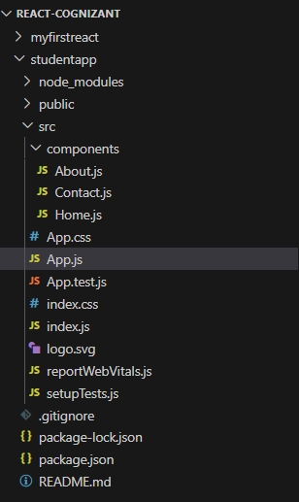

**Home.js:**

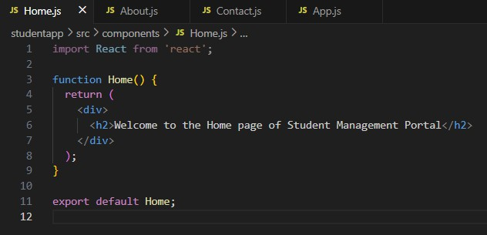

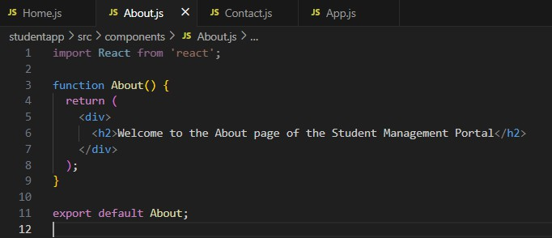**About.js:**

**Contact.js:**

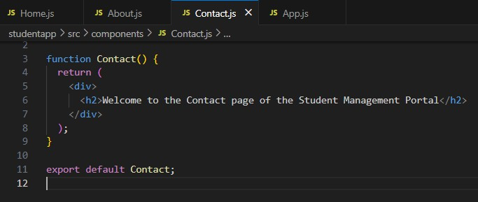

**App.js:**

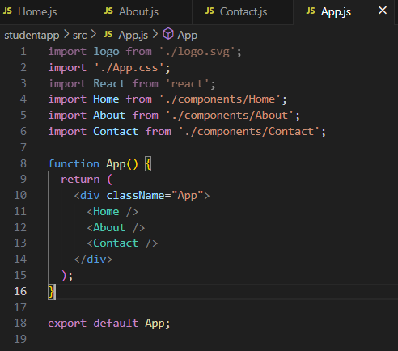

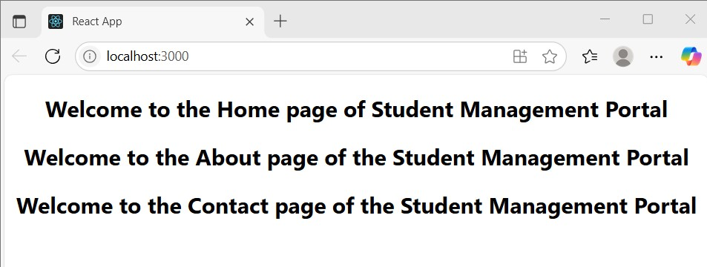**Output:**

Exercise: Create a react app for Student Management Portal named scorecalculatorapp and create a function component named “CalculateScore” which will accept Name, School, Total and goal in order to calculate the average score of a student and display the same.

**Project Structure:**

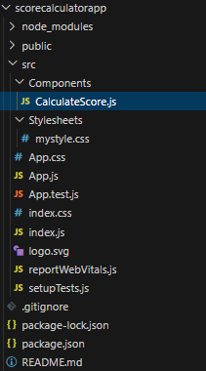

**CalculateScore.js:**

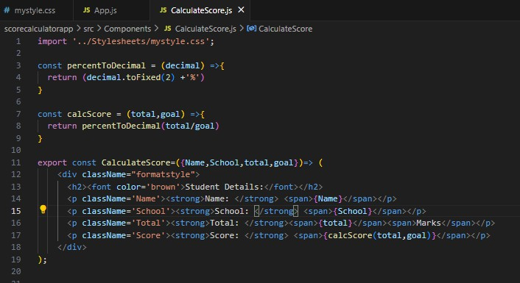

**App.js:**

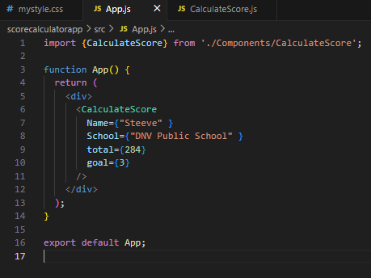

**mystyle.css:**

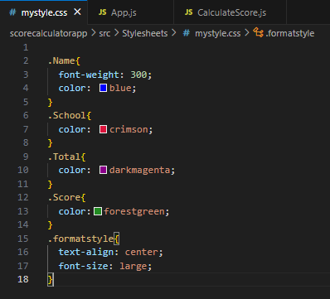

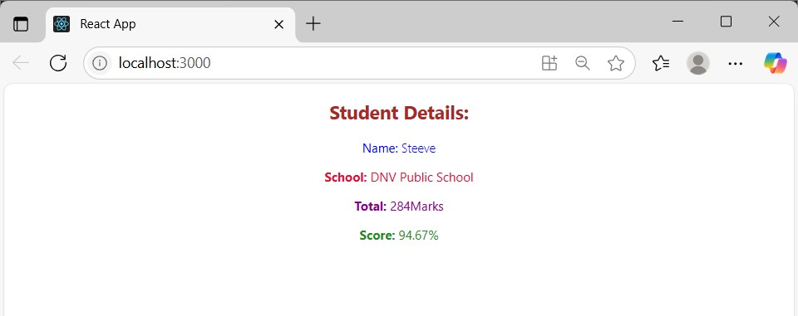**Output:**

Exercise: Create a new react application using *create-react-app* tool with the name as “blogapp” that explains the need and Benefits of component life cycle and identifies various life cycle hook methods and lists the sequence of steps in rendering a component. To get the posts use the url

(<https://jsonplaceholder.typicode.com/posts>)

**App Structure:**

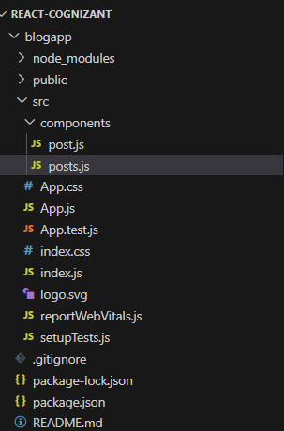

[**post.js**](http://post.js/)**:**

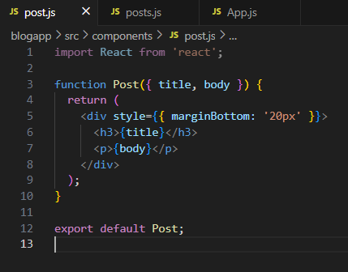

[**posts.js**](http://posts.js/)**:**

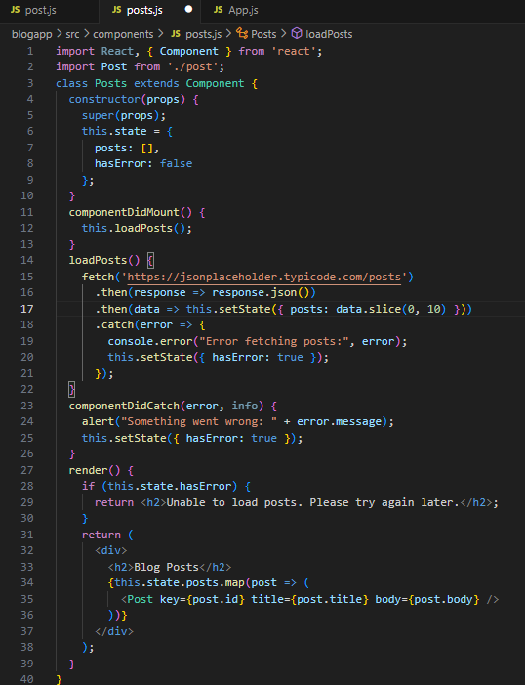

**App.js:**

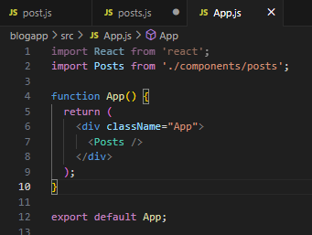

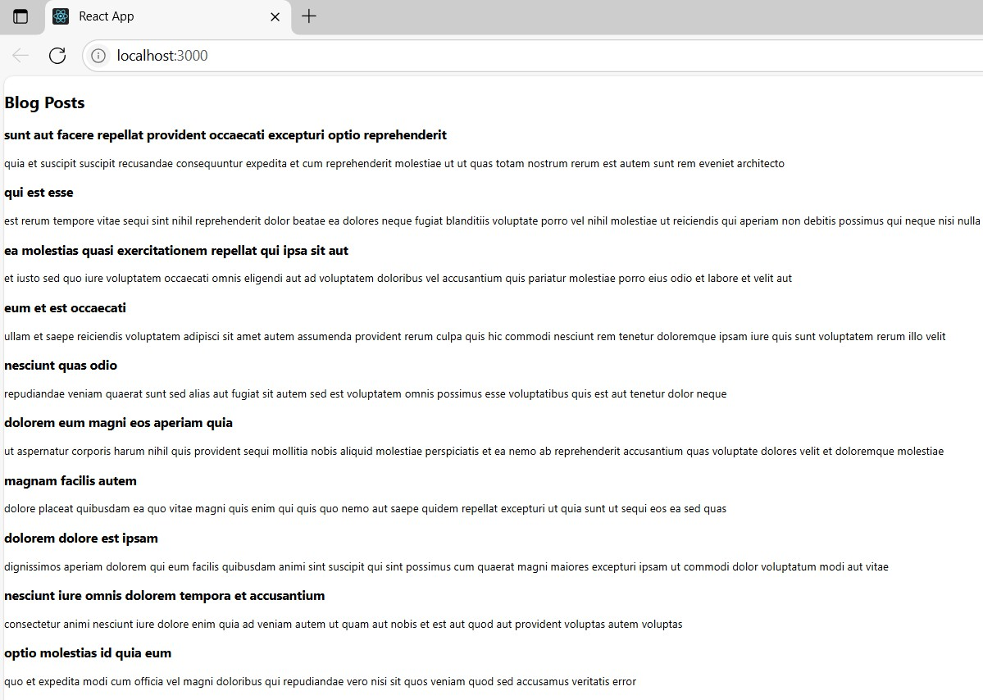**Output:**

Exercise: My Academy team at Cognizant want to create a dashboard containing the details of ongoing and completed cohorts. A react application is created which displays the detail of the cohorts using react component. You are assigned the task of styling these react components.

App Structure:

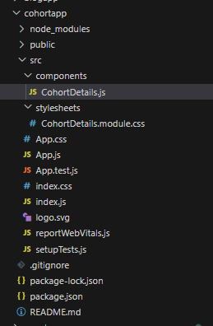

CohortDetails.module.css:

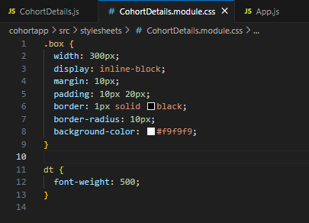

App.js:

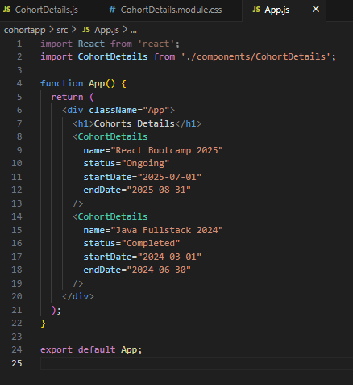

CohortDetails.js:

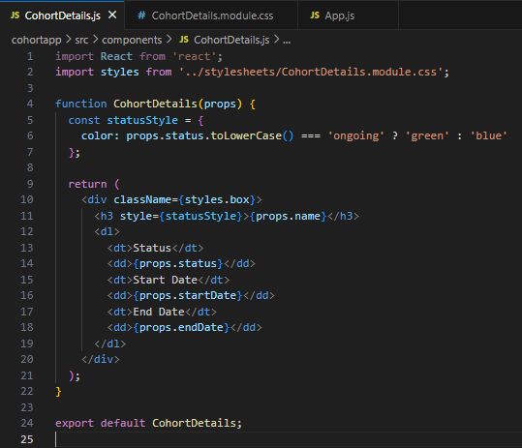

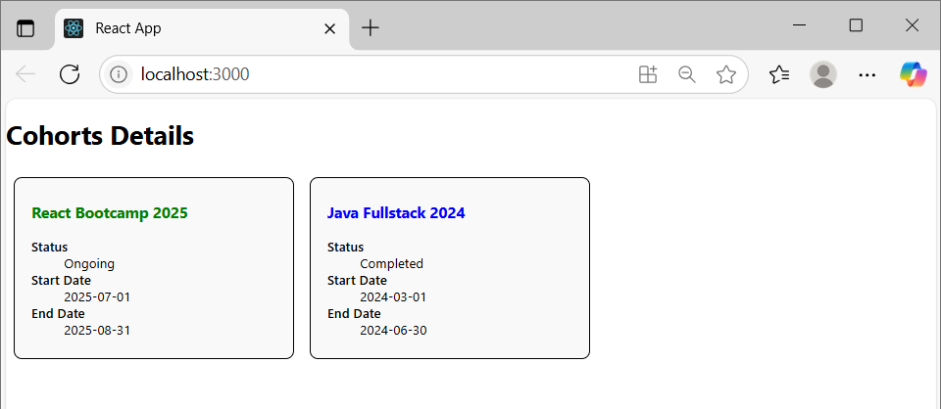**Output:**

Exercise: Cognizant Academy teams want to maintain a list of trainers along with their expertise in a SPA using React as the technology. You are assigned the task of creating this React app.

The following trainers’ data application will deal.

1. **T-ID**
2. **Name**
3. **Phone**
4. **Email**
5. **Stream**
6. **Skills**

**App Structure:**

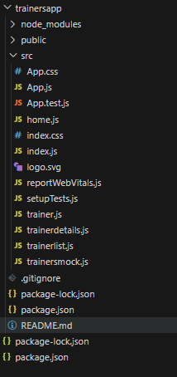

**trainer.js:**

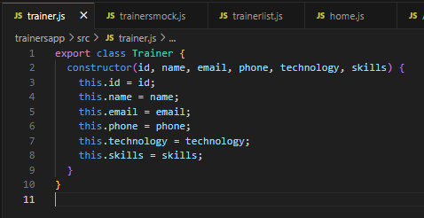

[**trainersmock.js**](http://trainersmock.js/)**:**

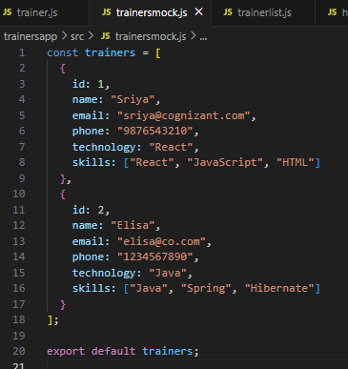

**trainerlist.js:**

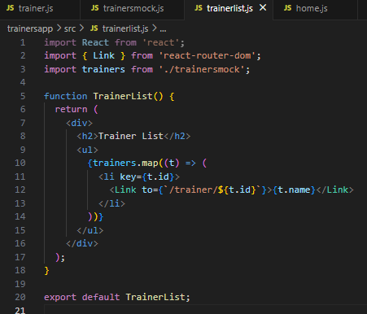

[**trainerdetails.js**](http://trainerdetails.js/)**:**

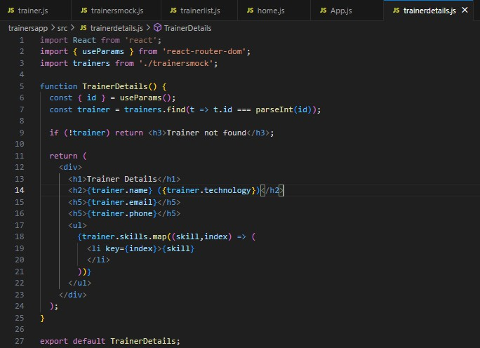

**App.js:**

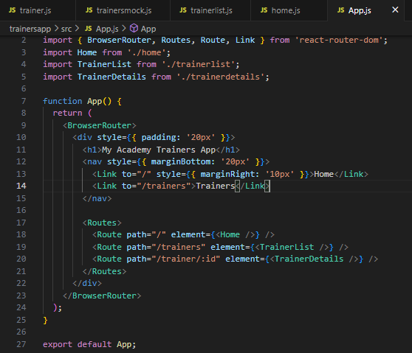

[**home.js**](http://home.js/)**:**

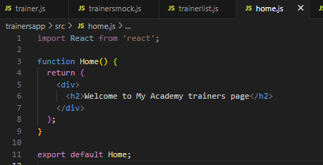

**Output:**

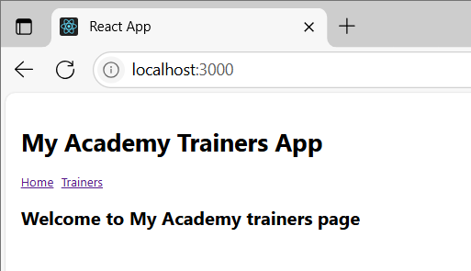

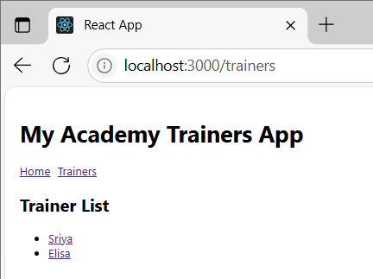

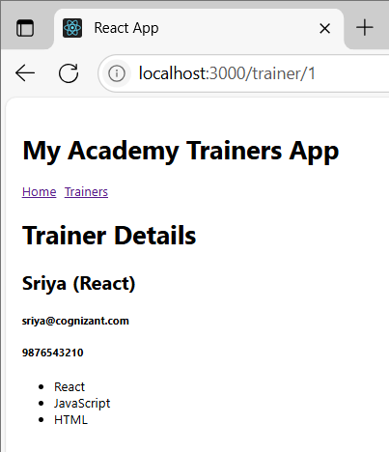

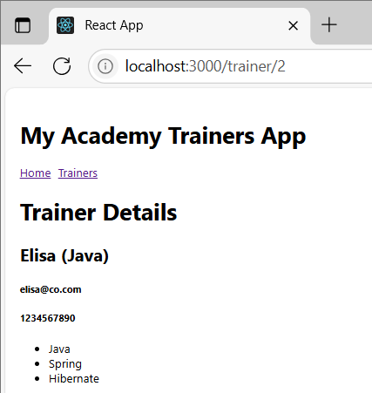

**Exercise: Create a React Application named “shoppingapp” with a class component named “OnlineShopping” and “Cart”.**

**App Structure:**

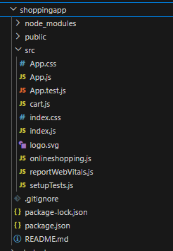

[**onlineshopping.js**](http://onlineshopping.js/)**:**

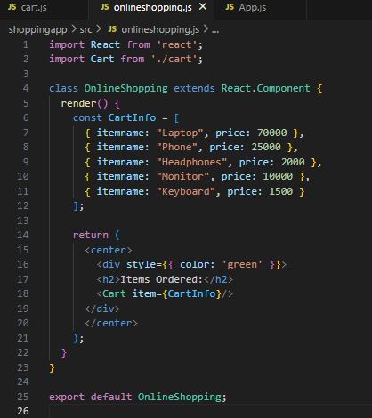

[**cart.js**](http://cart.js/)**:**

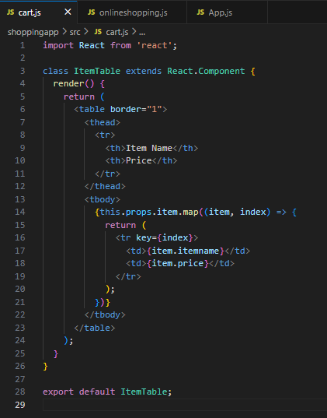

[**App.js**](http://app.js/)**:**

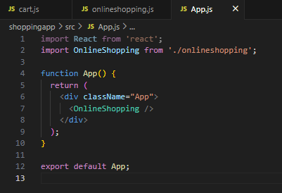

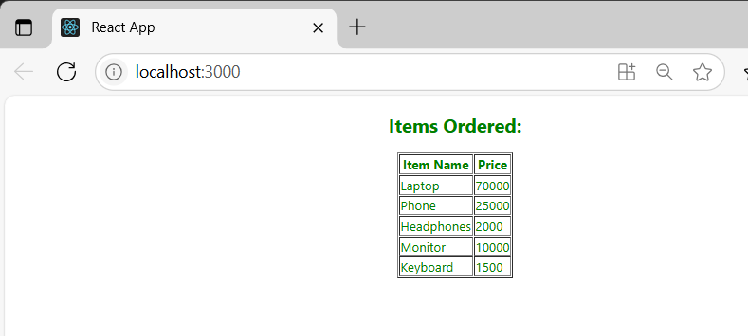**Output:**

Exercise: Create a React App “counterapp” which will have a component named “CountPeople” which will have 2 methods.

UpdateEntry() ◻ which will display the number of people who entered the mall. UpdateExit() ◻ which will display the number of people who exited the mall.

**App Structure:**

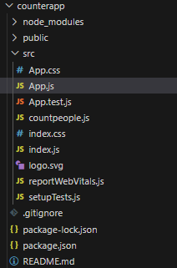

[**Countpeople.js**](http://countpeople.js/)**:**

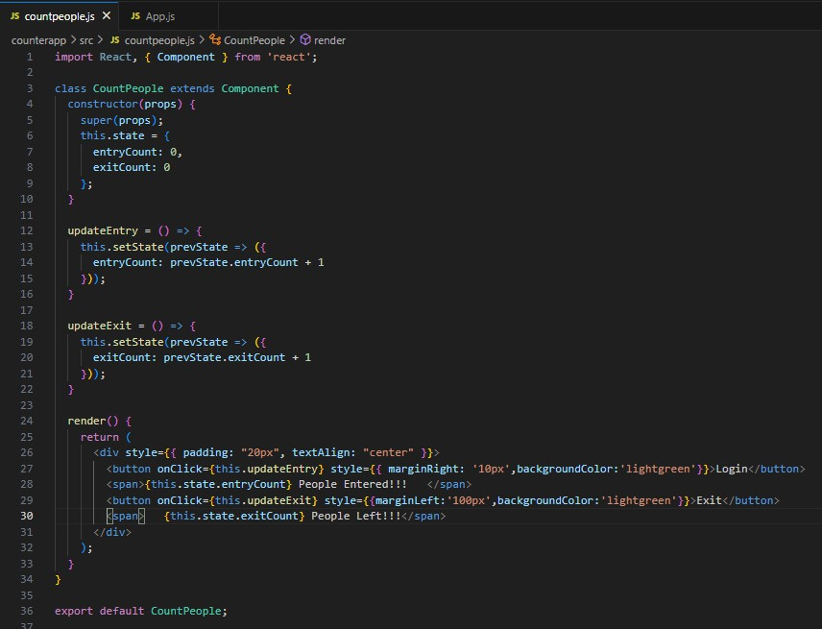

[**App.js**](http://app.js/)**:**

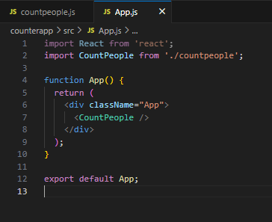

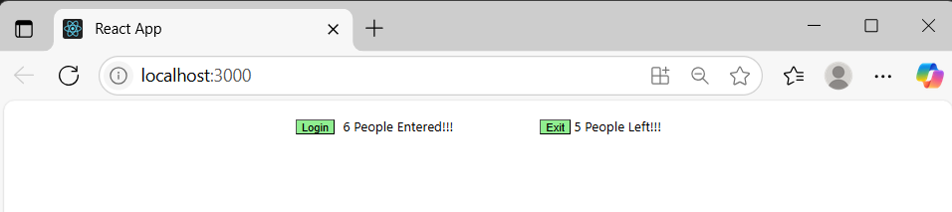**Output:**