**WEEK - 8**

# SKILL : GIT

**Mandatory Hands-on exercises**

Exercise: Familiar with Git commands like git init, git status, git add, git commit, git push, and git pull.

In this hands-on lab, you will learn how to

* **Setup your machine with Git Configuration**
* **Integrate notepad++.exe to Git and make it a default editor**
* **Add a file to source code repository**

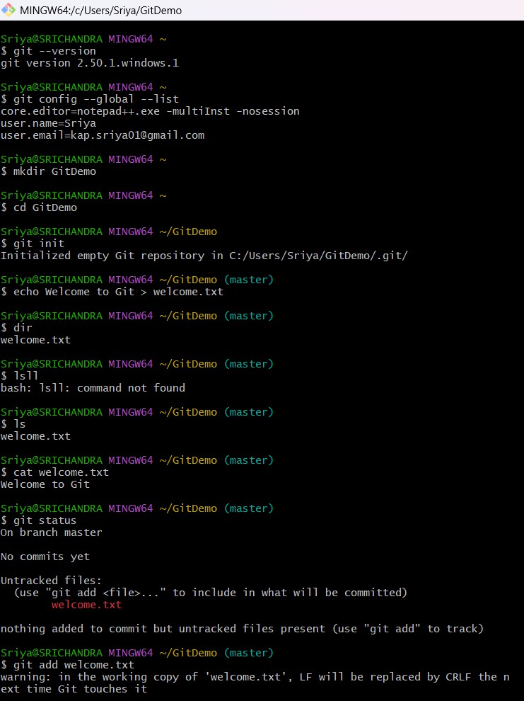

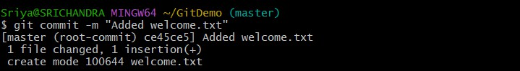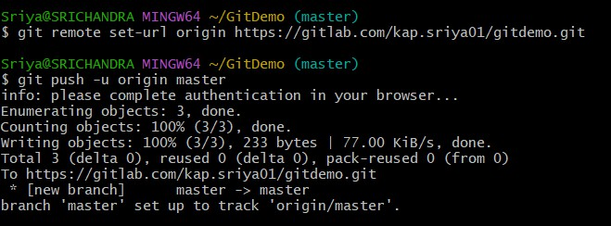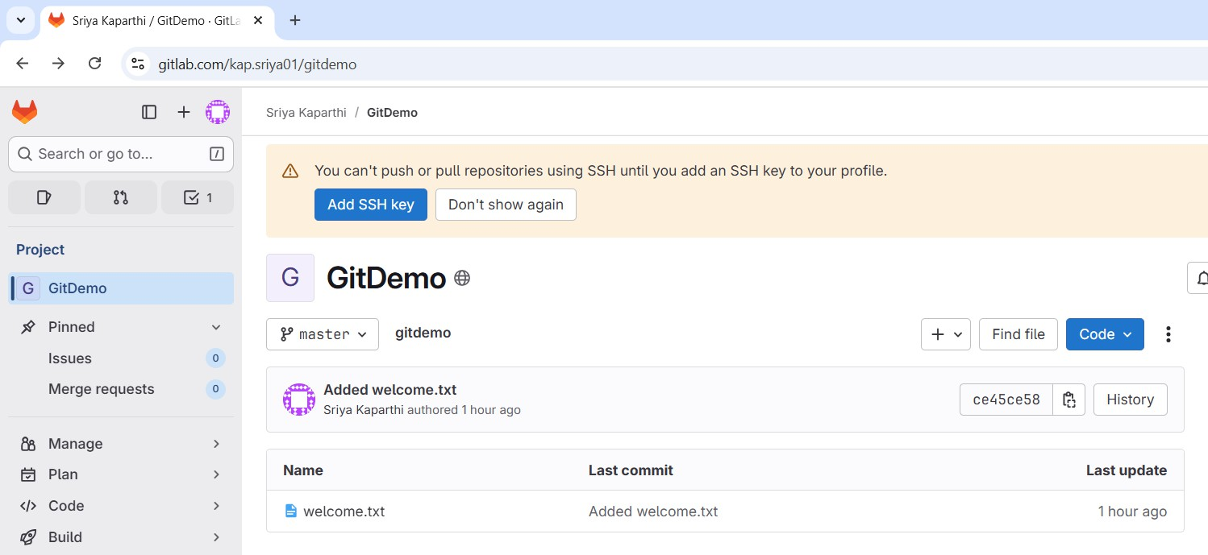

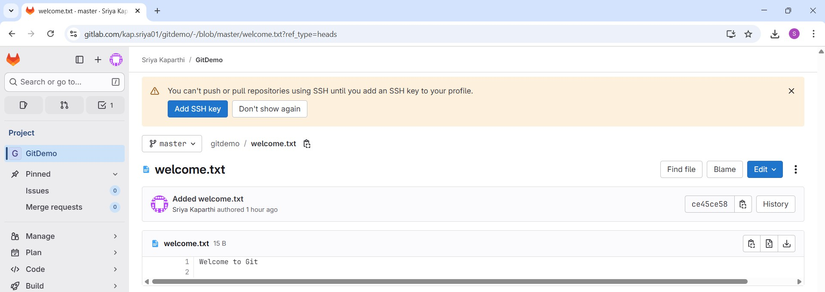

# Exercise:

* **Explain git ignore**
* **Explain how to ignore unwanted files using git ignore**

In this hands-on lab, you will learn how to:

* 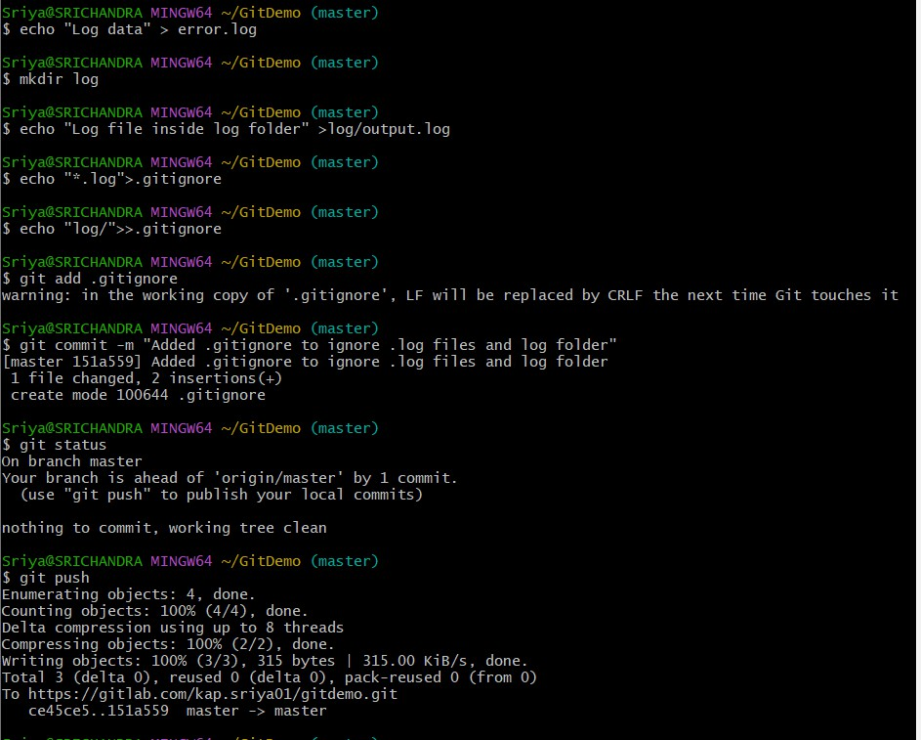**Implement git ignore command to ignore unwanted files and folders**

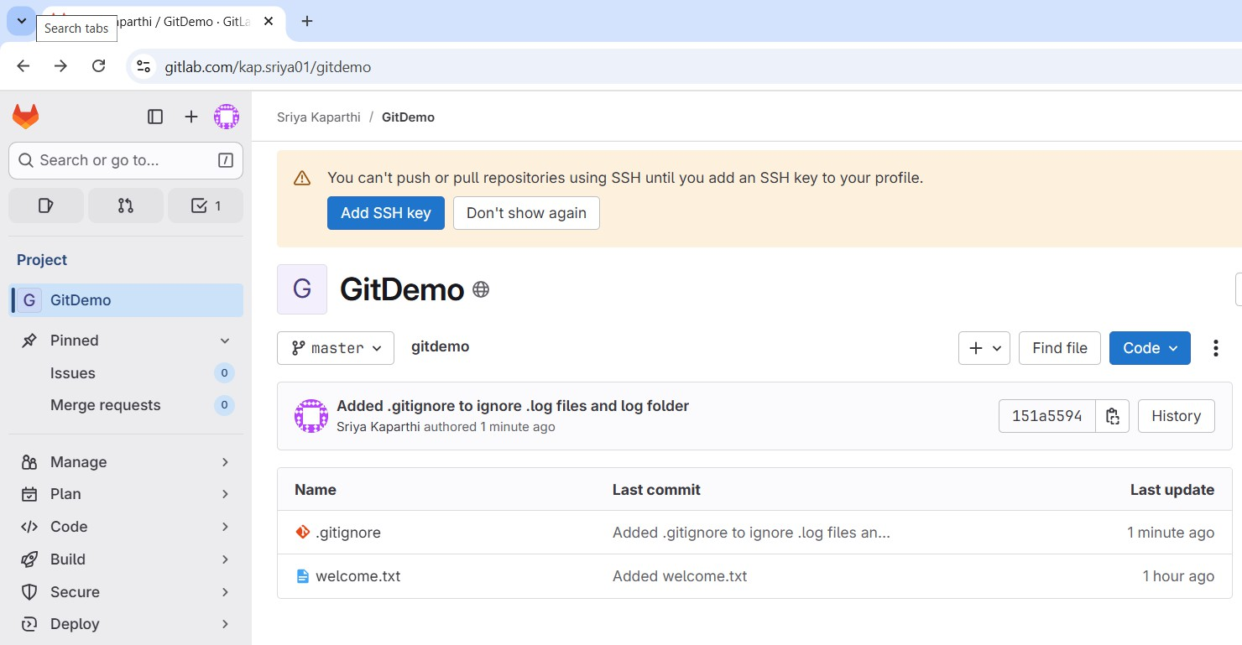

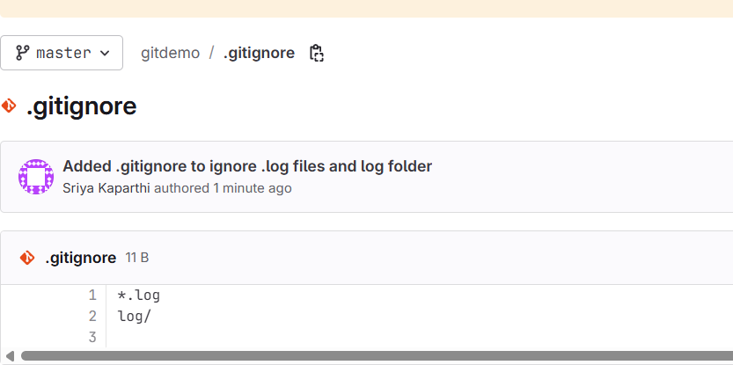

# Exercise:

* **Explain branching and merging**
* **Explain about creating a branch request in GitLab**
* **Explain about creating a merge request in GitLab**

In this hands-on lab, you will learn how to:

* 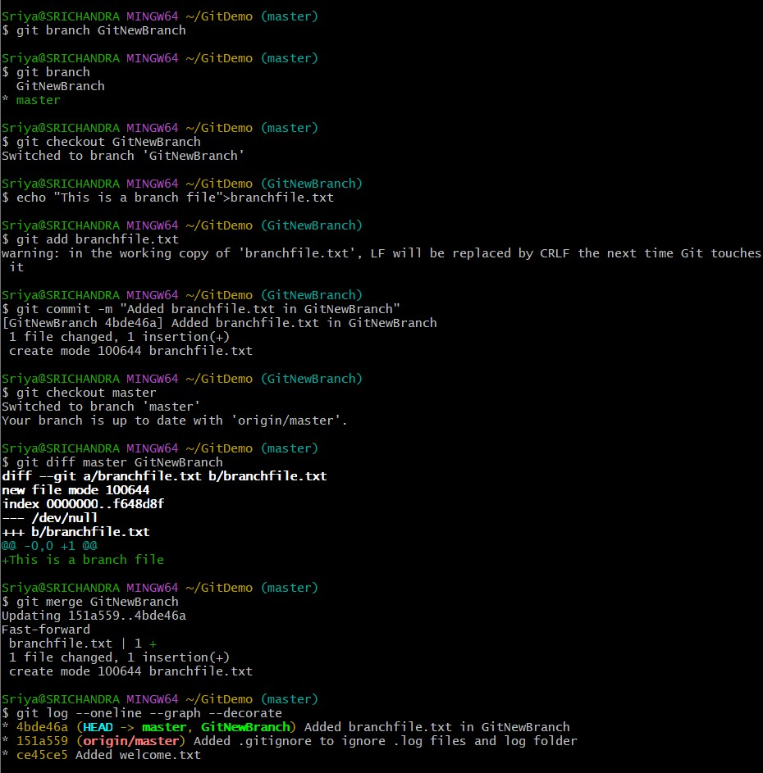**Construct a branch, do some changes in the branch, and merge it with master (or trunk)**

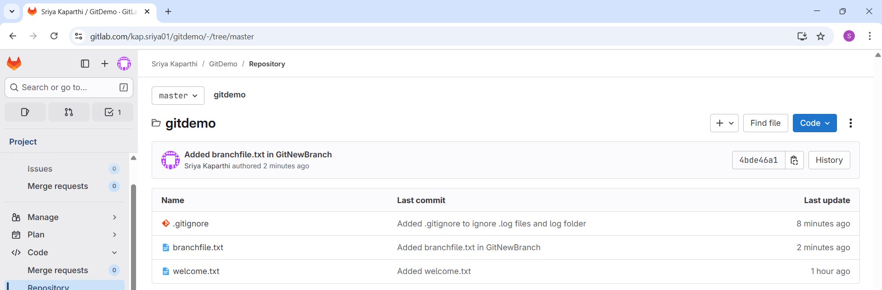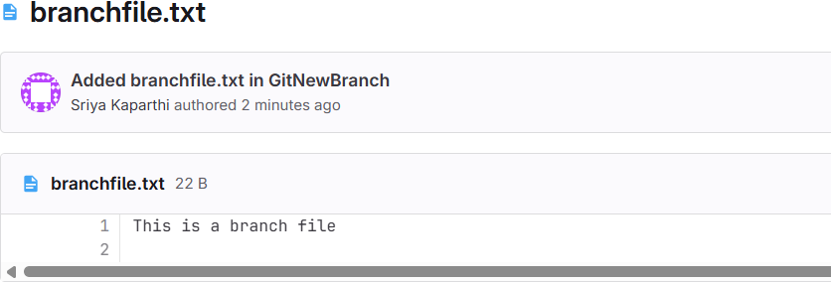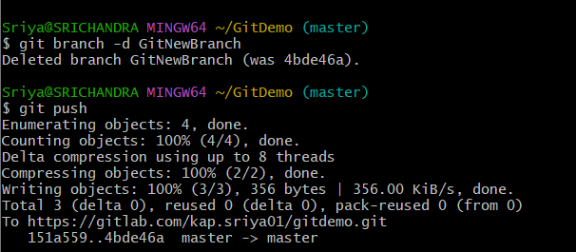

Exercise: Explain how to resolve the conflict during merge.

In this hands-on lab, you will learn how to:

* 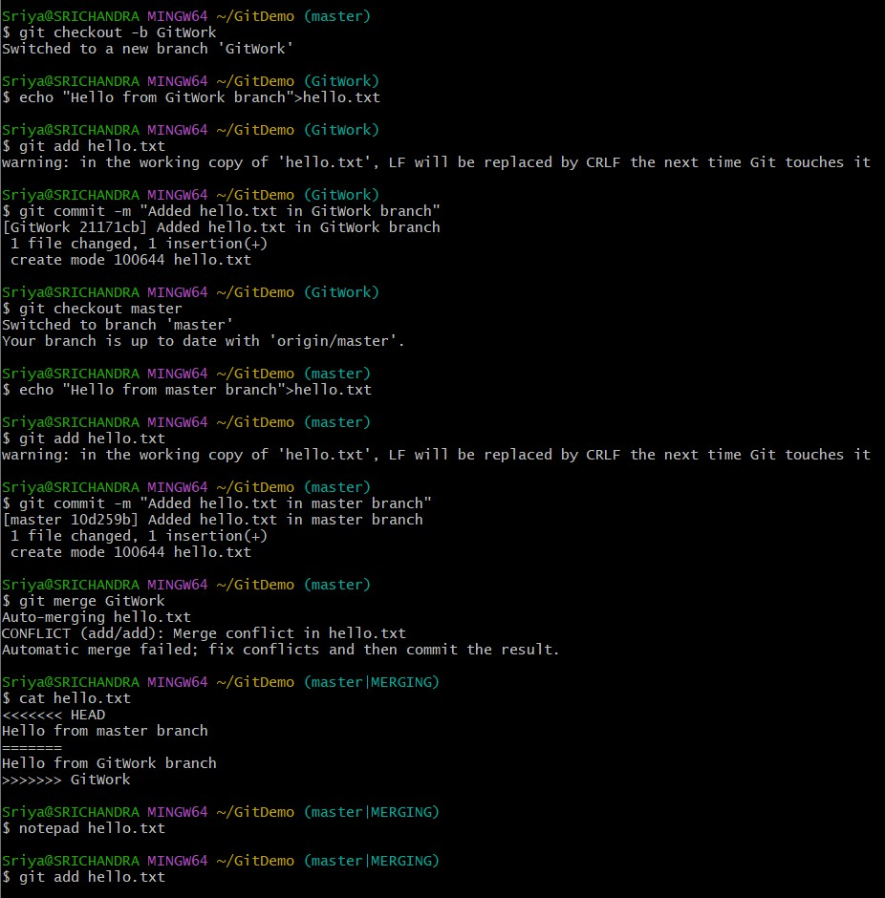**Implement conflict resolution when multiple users are updating the trunk (or master) in such a way that it results into a conflict with the branch’s modification**

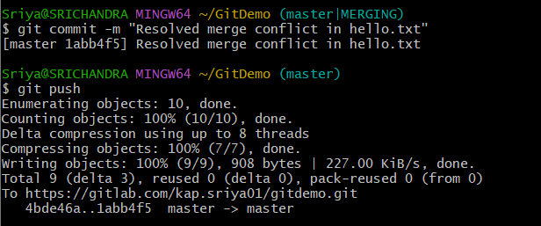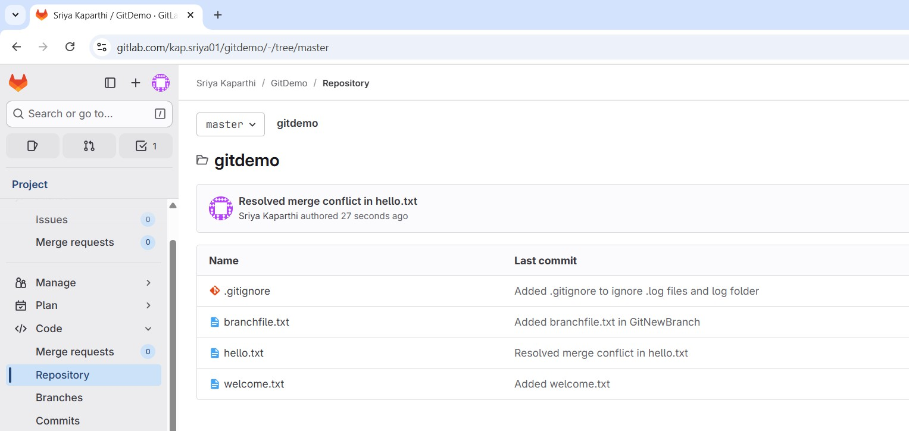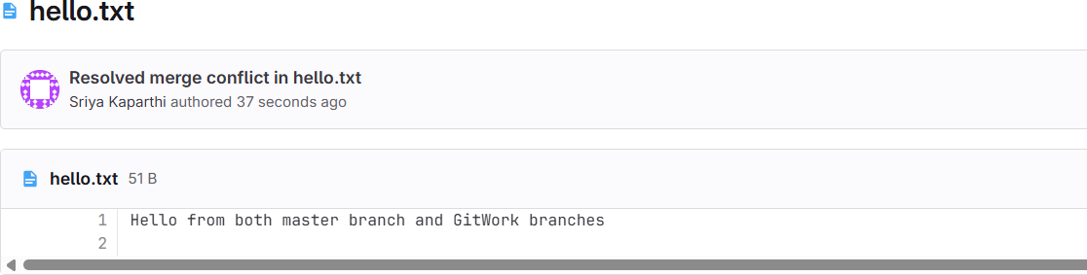

# Exercise:

* **Explain how to clean up and push back to remote Git**

In this hands-on lab, you will learn how to:

* **Execute steps involving clean up and push back to remote Git.**

