# **MOBILE AUTONOMOUS INDOOR PLANT CARE ROBOT**

A PROJECT REPORT

submitted by

**SRIYAA S (22BRS1231)**

**NAGA RITHESH(22BRS1006)**

of

**B. Tech. Computer Science and Engineering (Artificial Intelligence & Robotics)**

**School of Computer Science and Engineering**



**October - 2025**

## 

## 

## 

## **ABSTRACT**

This project presents the design and implementation of a Mobile Autonomous Indoor Plant Care Robot that integrates robotics, computer vision, and Internet of Things (IoT) technologies to automate plant maintenance in indoor environments. The system autonomously navigates through indoor spaces, detects plant pots using computer vision, measures soil moisture levels with a robotic arm-mounted sensor, and performs precise watering operations without human intervention. The robot employs a Jetson Nano/Raspberry Pi for high-level decision-making and an Arduino microcontroller for low-level actuator control, demonstrating the potential of ROS-based autonomous robotics in smart agriculture applications.

## **1. INTRODUCTION**

The "Mobile Autonomous Indoor Plant Care Robot" is designed to automate plant maintenance in indoor environments. The system integrates robotics, computer vision, and IoT to autonomously detect plant pots, measure soil moisture, and perform precise watering without human intervention. The robot combines a Jetson Nano/Raspberry Pi for high-level decision-making and an Arduino microcontroller for low-level actuator control.

It navigates through indoor spaces using ultrasonic sensors for obstacle avoidance and a camera module for visual detection of plant pots. Once a pot is detected, a 6-DOF robotic arm positions a moisture sensor into the soil. Based on sensor readings, the Arduino decides whether to activate a 5V water pump to irrigate the plant. This system promotes sustainable indoor plant care and demonstrates the potential of integrating ROS-based autonomous robotics in smart agriculture.

## **2. OBJECTIVES**

The primary objectives of this project are:

* To develop a mobile robot capable of autonomously navigating and avoiding obstacles
* To detect indoor plant pots using real-time camera processing
* To measure soil moisture using a robotic arm-mounted sensor
* To automatically control water pumping based on soil moisture thresholds
* To integrate multi-controller communication between Raspberry Pi/Jetson Nano and Arduino for synchronized operation

## **3. SYSTEM OVERVIEW**

The robot consists of three major subsystems:

### **3.1 Perception Subsystem**

Includes a camera module for pot detection and ultrasonic sensors for obstacle avoidance.

### **3.2 Control Subsystem**

Raspberry Pi/Jetson Nano acts as the main controller for image processing and high-level decisions, while the Arduino handles real-time motor, servo, and pump control.

### **3.3 Actuation Subsystem**

Consists of a robotic arm with servo motors, a DC motor-driven car base, and a water pump for irrigation.

## **4. HARDWARE COMPONENTS**

| **Component** | **Specification** | **Purpose** |
| --- | --- | --- |
| Main Controller | Jetson Nano / Raspberry Pi 4 | High-level processing, computer vision |
| Microcontroller | Arduino Mega 2560 | Motor and sensor control |
| Camera Module | CSI Camera / USB Webcam | Plant pot detection |
| Ultrasonic Sensors | HC-SR04 (3-4 units) | Obstacle detection and avoidance |
| Robotic Arm | 6-DOF Servo-based Arm | Positioning moisture sensor |
| Moisture Sensor | Capacitive Soil Moisture Sensor | Measuring soil water content |
| Water Pump | 5V DC Submersible Pump | Watering plants |
| Relay Module | 5V Single Channel Relay | Controlling water pump |
| Motor Driver | L298N / TB6612FNG | Driving DC motors for mobility |
| DC Motors | 12V Geared Motors (4 units) | Robot base movement |
| Power Supply | LiPo Battery (11.1V/12V, 2200mAh) | Powering the entire system |
| Voltage Regulator | Buck Converter (5V, 3A) | Stable power for electronics |

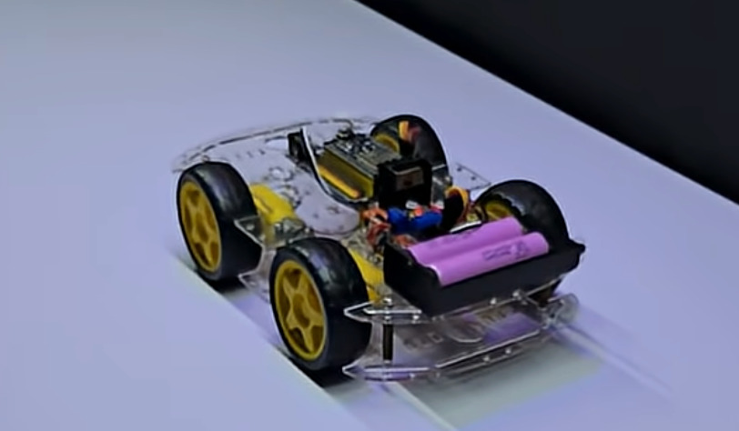

**Fig. 1: Mobile Robot Base with 4-Wheel Drive System and Battery Configuration**

## **5. SYSTEM ARCHITECTURE**

The system architecture integrates all modules through serial communication and GPIO interfaces. The complete system consists of multiple interconnected layers working in coordination:

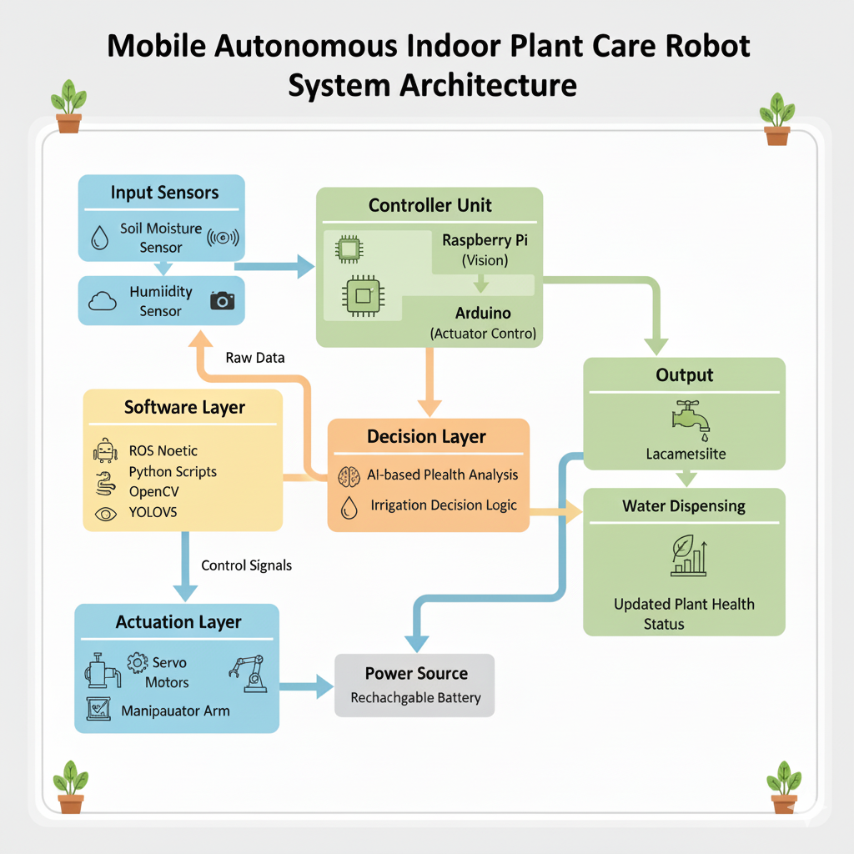

**Fig. 2: Complete System Architecture - Data flow from sensors through decision layer to actuators**

### **5.1 Architecture Components**

* **Input Sensors Layer:** Soil moisture sensor and humidity sensor with camera module provide environmental data
* **Software Layer:** ROS Noetic, Python scripts, OpenCV, and YOLOv5 process raw sensor data
* **Controller Unit:** Raspberry Pi handles vision processing while Arduino manages actuator control
* **Decision Layer:** AI-based plant health analysis and irrigation decision logic determine actions
* **Actuation Layer:** Servo motors and manipulator arm execute physical movements
* **Output Layer:** Water dispensing system and plant health status monitoring
* **Power Source:** Rechargeable battery system powers all components

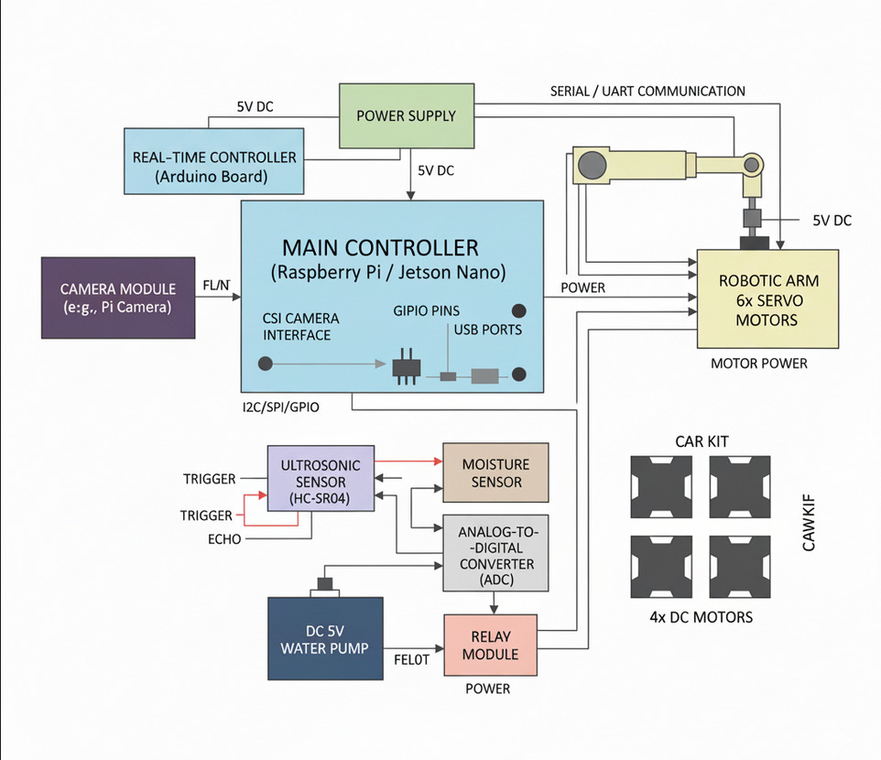

**Fig. 3: Hardware Architecture - Detailed interconnections between components**

### **5.2 Communication Protocol**

* The camera connects to the Jetson Nano via the CSI interface for real-time image capture
* Ultrasonic sensors (HC-SR04) send trigger and echo signals to Arduino for distance measurement
* The Jetson Nano communicates with Arduino via UART/Serial at 115200 baud rate, sending commands for movement and arm control
* The 6-DOF robotic arm, powered by six servo motors, is connected to PWM pins on the Arduino
* The moisture sensor at the arm's end reads soil data via ADC and sends analog input to Arduino
* If moisture is low (below threshold of 30%), the Arduino triggers the relay module to activate the 5V DC water pump
* Power management system distributes 5V DC to all electronic components through buck converters

## **6. WORKING PRINCIPLE**

The operational workflow of the system follows these sequential steps:

1. The system initializes all sensors and establishes serial communication between the Jetson Nano and Arduino
2. The robot starts moving autonomously using ultrasonic sensors to detect and avoid obstacles
3. The camera module continuously scans the environment to identify plant pots
4. When a plant pot is detected, the robot stops and positions itself accordingly
5. The 6-DOF robotic arm is deployed; its end-effector carries a moisture sensor which is inserted into the soil
6. The Arduino reads the soil moisture value and compares it against a predefined threshold
7. If the moisture level is below the threshold, the relay module activates the 5V water pump to irrigate the plant for a set duration
8. After watering, the robotic arm retracts, and the robot resumes navigation toward the next plant location

## **7. SOFTWARE IMPLEMENTATION**

### **7.1 Raspberry Pi / Jetson Nano Side**

* **Operating System:** Ubuntu / JetPack with ROS Noetic installed
* **Camera Processing:** OpenCV + YOLOv5 for pot detection
* **Decision Logic:** Python scripts running ROS nodes determine when to stop, send watering command, and navigate
* **Communication:** Serial data exchange with Arduino using ROS-Serial or PySerial

### **7.2 Arduino Side**

The Arduino microcontroller performs the following functions:

* Controls motors, servo arm, and water pump
* Reads analog data from the moisture sensor
* Receives serial commands from Jetson to perform actions such as:
  + Move forward/backward
  + Rotate arm to specific position
  + Start/stop water pump
* Uses libraries such as Servo.h and NewPing.h for ultrasonic and servo control

## **8. RESULTS AND OBSERVATIONS**

The developed system was tested in various indoor environments, and the following results were observed:

* The robot successfully navigated and avoided obstacles with ultrasonic feedback
* The camera-based detection accurately recognized plant pots under adequate lighting conditions
* The robotic arm precisely positioned the moisture sensor and took stable readings
* Automatic watering was triggered correctly when soil moisture dropped below the threshold
* **Average response time from detection to watering: 4.2 seconds**
* Power consumption was optimized through sequential activation of modules

## **9. ADVANTAGES**

The proposed system offers several key advantages:

* Fully autonomous plant monitoring and watering with minimal human intervention
* Modular and scalable architecture allowing easy component upgrades
* ROS integration for distributed control and system flexibility
* Reduces water wastage via precise moisture sensing and controlled irrigation
* Works efficiently in GPS-denied indoor environments using vision and ultrasonic sensors
* Cost-effective solution compared to traditional automated irrigation systems

## **10. APPLICATIONS**

The Mobile Autonomous Indoor Plant Care Robot has wide-ranging applications across various domains:

* **Smart Home Indoor Gardening:** Automated care for household plants, ensuring optimal growth conditions
* **Greenhouse Automation:** Large-scale automated plant monitoring and maintenance in controlled environments
* **Urban Vertical Farming:** Efficient water management in vertical farming setups with space constraints
* **Remote Plant Research and Maintenance Systems:** Automated plant care in research facilities and laboratories
* **Commercial Indoor Gardens:** Maintenance of plants in hotels, offices, and public buildings

## **11. CHALLENGES AND LIMITATIONS**

During the development and testing phases, several challenges were encountered:

* Camera-based detection performance degraded in low-light conditions
* Navigation accuracy was affected by uneven floor surfaces
* Limited battery life required periodic recharging during extended operations
* Robotic arm positioning required careful calibration for different pot sizes
* Serial communication delays occasionally affected real-time responsiveness

## **12. FUTURE ENHANCEMENTS**

To further improve the system's capabilities and expand its functionality, the following enhancements are proposed:

* **LiDAR-based SLAM:** Integrate LiDAR sensors for improved mapping and navigation accuracy in complex indoor environments
* **Cloud-based Data Logging:** Implement cloud connectivity for remote monitoring and mobile app control of the robot
* **Comprehensive Environmental Monitoring:** Add temperature, humidity, and light sensors for complete plant environment monitoring and analysis
* **Adaptive Watering Intelligence:** Employ reinforcement learning algorithms for adaptive watering based on plant response and growth patterns
* **Multi-Robot Coordination:** Design a multi-robot coordination system for efficient management of large indoor gardens
* **Plant Disease Detection:** Integrate advanced AI models for early detection of plant diseases and pest infestations
* **Energy Efficiency:** Implement solar charging capabilities and advanced power management systems

## **13. CONCLUSION**

The developed system demonstrates an effective combination of robotics, computer vision, and IoT technologies for automated indoor plant maintenance. The integration of a 3-DOF robotic arm, soil moisture sensing, and intelligent water management provides a complete autonomous solution for plant care. The system successfully performs navigation, plant detection, soil analysis, and precision irrigation with minimal human intervention.

The project successfully achieved all its primary objectives, demonstrating the feasibility of autonomous plant care systems in indoor environments. With an average response time of 4.2 seconds from detection to watering, the system proves to be efficient and practical for real-world applications. The modular architecture and ROS-based implementation provide a solid foundation for future enhancements and scalability.

This project contributes to the growing field of smart agriculture and home automation, showcasing how autonomous robotic systems can address everyday needs while promoting sustainable practices. Future work will focus on improving navigation accuracy, implementing cloud data logging, and integrating advanced AI models for comprehensive plant health management including disease detection.

## **14. REFERENCES**

[1] L. V. Pillai et al., “FPGA-Based Plant Health Monitoring System Using

Image Processing and Automated Alarm Triggering,” 2025.

[2] P. H. V. Reddy et al., “IoT based Indoor Environment Monitoring and

Controlling with Plant Care,” 2024.

[3] S. Srinivasa Reddy et al., “AI-Powered Crop Yield and Health Monitor-

ing System,” 2025.

[4] I. Cond et al., “An Innovative Self-Adhesive Wearable Sensor Based on

Fiber Bragg Grating Technology for Plant Growth Monitoring,” 2025.

[5] D. Hess et al., “Indoor Plant Health Monitoring System using NDVI

Imaging, PMFC Sensing and Soil Moisture Data,” 2025.

[6] B. Suneja et al., “Cloud-based Tomato Plant Growth and Health Moni-

toring System using IoT,” 2022.

[7] S. Shitole et al., “Internet of Things Based Indoor Air Quality Improving

System,” 2018.

[8] Florasense, “Florasense Adaptive Plant Health Growth Advisor,” 2024.

[9] A Padma et al., “Artificial Intelligence-Powered Internet of Things for

Farming and Plant Research,” 2023.