INTERNSHIP REPORT  
Submitted by:  
Sriya B  
GITAM (University)Btech(AIML)  
  
Project Title:  
Stock Price Trend Prediction using LSTM  
  
Internship Organization:  
Elevate Lab – 04 AIML Internship  
  
Duration: 1 Month (JUNE 22-06-2025)

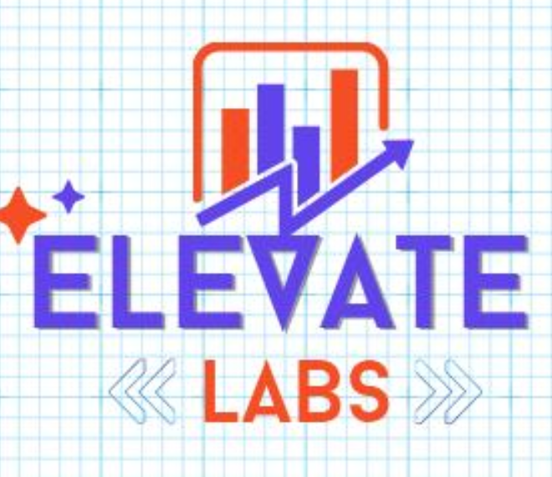

# Certificate

This is to certify that Ms. Sriya B, a student of GITAM University, has successfully completed a one-month internship at Elevate Lab under the 04 AIML Internship Program. During this period, she completed nine weekly tasks involving AI/ML techniques and submitted a final project titled "Stock Price Trend Prediction using LSTM." Her contribution, enthusiasm, and performance were commendable.  
  
We wish her all the best for her future endeavors.  
  
  
Authorized Signatory  
Elevate Lab

Acknowledgement

I would like to express my sincere gratitude to Elevate Lab for giving me the opportunity to work on real-world projects in Artificial Intelligence and Machine Learning. I thank my mentors and coordinators for their constant support, as well as GITAM University for facilitating this internship program. This experience has enhanced my technical skills, confidence, and understanding of how AI/ML is applied in practice.

Table of Contents

1. Introduction

2. Company Profile – Elevate Lab

3. Internship Objectives

4. Weekly Task Summary

5. Final Project: Stock Price Trend Prediction using LSTM

6. Tools and Skills Acquired

7. Challenges Faced

8. Learning Outcomes

9. Conclusion

10. References

11. Daily Task Log and Core Concepts

1. Introduction

Internships are essential to bridge the gap between classroom learning and practical application. This one-month internship with Elevate Lab allowed me to explore various AI/ML concepts using Python and real datasets. I was exposed to supervised,unsupervised, and deep learning models, culminating in a capstone project using LSTM for stock price forecasting.

2. Company Profile – Elevate Lab

Elevate Lab is an ed-tech and research platform that provides internships and hands-on training in Artificial Intelligence, Machine Learning, and Data Science. Their 04 AIML Internship includes structured weekly tasks, guided projects, and real-world tools to help students become industry-ready.

3. Internship Objectives

- Learn and apply machine learning techniques using Python.

- Explore real-time datasets for training and testing models.

- Gain hands-on experience in supervised and unsupervised learning.

- Develop a deep learning model using LSTM for time-series prediction.

- Improve problem-solving and analytical thinking.

4. Weekly Task Summary

- TASK1 – Data Cleaning & Preprocessing: Cleaned raw data, handled missing values using imputation, applied label encoding, normalization, and outlier removal.

- TASK 2 – Exploratory Data Analysis (EDA): Created histograms, boxplots, and correlation matrices. Used visuals to understand data patterns.

- TASK 3 – Linear Regression: Built and evaluated simple and multiple regression models using MAE, MSE, R².

- TASK 4 – Logistic Regression: Developed binary classifiers, interpreted sigmoid output, ROC curves, and confusion matrix.

- TASK 5 – Decision Trees & Random Forests: Built tree-based models, controlled overfitting, and used feature importance.

- TASK 6 – K-Nearest Neighbors (KNN): Implemented KNN, normalized features, tuned K, and visualized decision boundaries.

- TASK 7– Support Vector Machines (SVM): Trained SVMs with linear and RBF kernels, optimized hyperparameters.

- TASK 8 – K-Means Clustering: Used Elbow method and Silhouette Score to evaluate clusters, visualized clusters in 2D.

- Final Project: Built and trained LSTM model to predict stock price trends.

11. Daily Task Log and Core Concepts

This section provides a day-wise breakdown of work completed during the internship along with the core Machine Learning concepts learned.

TASK 1 – Data Cleaning & Preprocessing

|  |  |  |
| --- | --- | --- |
| Day | Tasks Performed | Concepts Learned |
| Mon | Imported datasets and explored data types | Feature types, null values |
| Tue | Handled missing values | Imputation, mean/median filling |
| Wed | Encoded categorical variables | Label encoding, One-hot |
| Thu | Scaled numerical features | Normalization, Standardization |
| Fri | Visualized outliers | Boxplots, z-score filtering |

## TASK 2 – Exploratory Data Analysis (EDA)

|  |  |  |
| --- | --- | --- |
| Day | Tasks Performed | Concepts Learned |
| Mon | Generated summary statistics | Mean, median, std, skewness |
| Tue | Created histograms and density plots | Distribution shapes |
| Wed | Used pairplots, correlation matrix | Feature relationships |
| Thu | Detected patterns and anomalies | Data storytelling |
| Fri | Interpreted graphs and | Data-driven insights |