INTERNSHIP REPORT

**STOCK PRICE TREND PREDICTION WITH LSTM**Submitted by:  
Sriya B  
GITAM University  
  
Project Title:  
Stock Price Trend Prediction using LSTM  
  
Internship Organization:  
Elevate Lab – 04 AIML Internship  
  
Duration: 1 Month (JUNE-JULY 2025)

**Submitted by**Sriya B  
  
04 AIML Internship – Elevate Lab  
Date: 22-06-2025

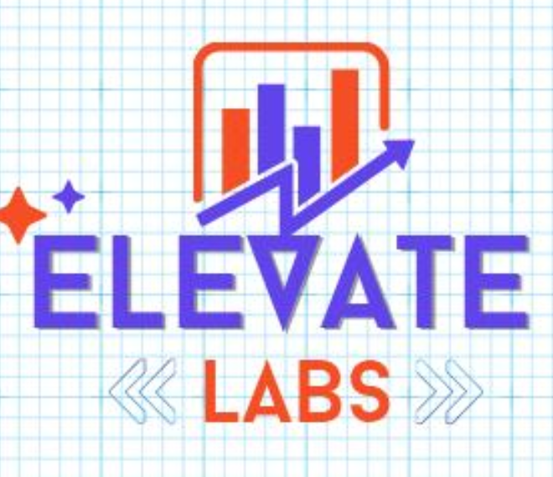

Introduction

The stock market is a dynamic and volatile financial environment, influenced by various economic, political, and psychological factors. Predicting stock price movements is a complex task due to the nonlinear and noisy nature of financial time series data. Traditionally, statistical models like ARIMA and moving averages have been used for forecasting, but they often fall short in capturing long-term dependencies.

With the rise of Artificial Intelligence, deep learning models like **Long Short-Term Memory (LSTM)** networks have gained popularity for sequence-based predictions. LSTM, a type of Recurrent Neural Network (RNN), is specifically designed to handle time-series data and long-term dependencies, making it suitable for financial forecasting.

In this project, an LSTM model is built to predict the **future stock price trend** based on historical price data. Additionally, the project integrates **technical indicators** like:

* **Moving Average (MA)** – to smooth out short-term fluctuations.
* **Relative Strength Index (RSI)** – to assess market momentum and trend reversal points.

These features enhance the model’s understanding of market conditions. The dataset is collected using the **Yahoo Finance API**, and the entire workflow is implemented in **Python** using libraries such as Keras, Pandas, NumPy, and Matplotlib.

This project not only demonstrates the effectiveness of LSTM in time-series forecasting but also sets the stage for **future enhancements**, such as:

* **Real-time price prediction and dashboard deployment** using Streamlit or Flask.
* **Incorporating multiple stock features** (volume, news sentiment).
* **Hybrid models** combining LSTM with other architectures like GRU or Transformer models.

Thus, the project bridges the gap between academic understanding and practical implementation in AI-powered financial forecasting.

Certificate

This is to certify that Ms. Sriya B, a student of GITAM University, has successfully completed a one-month internship at Elevate Lab under the 04 AIML Internship Program. During this period, she completed nine weekly tasks involving AI/ML techniques and submitted a final project titled "Stock Price Trend Prediction using LSTM." Her contribution, enthusiasm, and performance were commendable.  
  
We wish her all the best for her future endeavorTable of Contents

1. Abstract

2. Introduction

3. Problem Statement

4. Objectives

5. Tools and Technologies Used

6. Methodology

7. Results and Discussion

8. Conclusion

9. Future Work

10. References

1. Abstract

This project aims to predict stock prices using deep learning techniques. A Long Short-Term Memory (LSTM) network, a type of recurrent neural network, is trained on historical stock data collected using the Yahoo Finance API. The model is capable of identifying trends and forecasting future stock values. Python libraries such as Keras, Pandas, and Matplotlib are used for model building, data manipulation, and visualization respectively. The results show that LSTM networks can learn time-based patterns and provide useful insights for stock price trends.

# 2. Introduction

Stock market prediction has always been a challenging task due to the complex, non-linear, and dynamic nature of financial data. With advancements in Artificial Intelligence, especially deep learning, forecasting time-series data has seen significant improvements. LSTM models are particularly suited for such tasks due to their ability to retain long-term dependencies.

# 3. Problem Statement

To build a deep learning model using LSTM that can learn from historical stock data and predict future stock prices accurately. This project also explores the use of indicators like moving averages to enhance model input.

# 4. Objectives

- To collect and preprocess historical stock data using Yahoo Finance API.

- To create sequences suitable for training LSTM models.

- To develop and train an LSTM network using Keras.

- To evaluate and visualize the model’s performance.

- To compare predicted stock trends with actual trends.

# 5. Tools and Technologies Used

- Programming Language: Python

- Libraries: Pandas, NumPy, Matplotlib, Keras, TensorFlow, yfinance

- Environment: Jupyter Notebook, VS Code

# 6. Methodology

1. Data Collection: Data is collected using `yfinance.download()` for a specific stock.  
2. Preprocessing: The data is scaled using MinMaxScaler and converted into sequences.  
3. Model Building: A sequential LSTM model is built using Keras.  
4. Training and Evaluation**: The model is trained and validated using Mean Squared Error.  
5. Prediction and Visualization**: Predictions are plotted against actual stock prices.

# 7. Results and Discussion

The LSTM model was successful in learning the stock price trends and provided a reasonable prediction for short-term future values. Graphs indicated that predicted prices closely followed actual prices, demonstrating the model’s effectiveness in pattern recognition.

# 8. Conclusion

This project demonstrated how LSTM neural networks can be applied for stock price prediction. Although not perfect, the model captured essential patterns and provided insights into price movements. LSTM is a strong candidate for time-series forecasting problems.

# 9. Future Work

Future improvements may include:  
- Using more complex architectures like Bidirectional LSTM.  
- Including technical indicators such as RSI, MACD.  
- Deploying the model into a real-time dashboard using Streamlit or Flask.

# 10. References

- https://keras.io/

- https://pandas.pydata.org/

- https://www.tensorflow.org/

- https://pypi.org/project/yfinance/

- <https://matplotlib.org/>