FinancialForecasting.csproj
<Project Sdk="Microsoft.NET.Sdk">

<PropertyGroup>
<OutputType>Exe</OutputType>
<TargetFramework>net10.0</TargetFramework>
<ImplicitUsings>enable</ImplicitUsings>
<Nullable>enable</Nullable>
</PropertyGroup>

</Project>

/FinancialForecasting.slnx
<Solution>
<Project Path="FinancialForecasting.csproj" />
</Solution>
Program.cs
﻿using System;

namespace FinancialForecasting
{
internal class Program
{
static void Main(string[] args)
{
double presentValue = 10000;
double growthRate = 10;
int years = 5;

double futureValue = PredictFutureValue(presentValue, growthRate, years);

Console.WriteLine("Present Value : " + presentValue);
Console.WriteLine("Growth Rate : " + growthRate + "%");
Console.WriteLine("Years : " + years);
Console.WriteLine("Future Value : " + futureValue);
}

static double PredictFutureValue(double value, double rate, int years)
{
if (years == 0)
return value;

return PredictFutureValue(value * (1 + rate / 100), rate, years - 1);
}
}
}
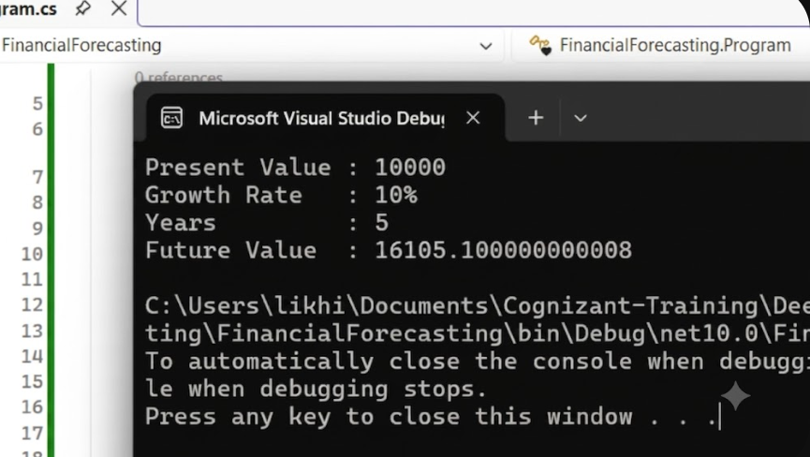

Ecommerce SearchFunction
﻿<Project Sdk="Microsoft.NET.Sdk">

<PropertyGroup>
<OutputType>Exe</OutputType>
<TargetFramework>net10.0</TargetFramework>
<ImplicitUsings>enable</ImplicitUsings>
<Nullable>enable</Nullable>
</PropertyGroup>

</Project>
ECommerceSearchFunction.slnx
<Solution>
<Project Path="ECommerceSearchFunction.csproj" />
</Solution>
Product.cs
﻿namespace ECommerceSearchFunction
{
internal class Product
{
public int ProductId { get; set; }
public string ProductName { get; set; }
public string Category { get; set; }

public Product(int productId, string productName, string category)
{
ProductId = productId;
ProductName = productName;
Category = category;
}
}
}
Program.cs
﻿using System;

namespace ECommerceSearchFunction
{
internal class Program
{
static void Main(string[] args)
{
Product[] products =
{
new Product(101, "Laptop", "Electronics"),
new Product(102, "Mobile", "Electronics"),
new Product(103, "Shoes", "Fashion"),
new Product(104, "Watch", "Accessories"),
new Product(105, "Backpack", "Bags")
};

Console.WriteLine("===== Linear Search =====");

Product linearResult = LinearSearch(products, 103);

if (linearResult != null)
{
Console.WriteLine("Product Found");
Console.WriteLine("ID: " + linearResult.ProductId);
Console.WriteLine("Name: " + linearResult.ProductName);
Console.WriteLine("Category: " + linearResult.Category);
}
else
{
Console.WriteLine("Product Not Found");
}

Array.Sort(products, (a, b) => a.ProductId.CompareTo(b.ProductId));

Console.WriteLine();

Console.WriteLine("===== Binary Search =====");

Product binaryResult = BinarySearch(products, 103);

if (binaryResult != null)
{
Console.WriteLine("Product Found");
Console.WriteLine("ID: " + binaryResult.ProductId);
Console.WriteLine("Name: " + binaryResult.ProductName);
Console.WriteLine("Category: " + binaryResult.Category);
}
else
{
Console.WriteLine("Product Not Found");
}
}

static Product LinearSearch(Product[] products, int id)
{
foreach (Product product in products)
{
if (product.ProductId == id)
{
return product;
}
}

return null;
}

static Product BinarySearch(Product[] products, int id)
{
int left = 0;
int right = products.Length - 1;

while (left <= right)
{
int mid = (left + right) / 2;

if (products[mid].ProductId == id)
{
return products[mid];
}
else if (products[mid].ProductId < id)
{
left = mid + 1;
}
else
{
right = mid - 1;
}
}

return null;
}
}
}
Output:
