CREATE DATABASE OnlineRetailStore;
GO

USE OnlineRetailStore;
GO

-- Step 2: Create Products Table

CREATE TABLE Products (
ProductID INT PRIMARY KEY,
ProductName VARCHAR(100),
Category VARCHAR(50),
Price DECIMAL(10,2)
);
INSERT INTO Products VALUES
(1,'Laptop A','Electronics',80000),
(2,'Laptop B','Electronics',75000),
(3,'Laptop C','Electronics',80000),
(4,'Phone A','Electronics',50000),
(5,'Chair','Furniture',12000),
(6,'Table','Furniture',15000),
(7,'Sofa','Furniture',35000),
(8,'Bed','Furniture',35000),
(9,'Notebook','Stationery',100),
(10,'Pen','Stationery',50),
(11,'Marker','Stationery',80),
(12,'Printer Paper','Stationery',250);
SELECT * FROM Products;
-- ROW_NUMBER()

SELECT
ProductID,
ProductName,
Category,
Price,
ROW_NUMBER() OVER (
PARTITION BY Category
ORDER BY Price DESC
) AS Row_Num
FROM Products;
-- RANK()

SELECT
ProductID,
ProductName,
Category,
Price,
RANK() OVER (
PARTITION BY Category
ORDER BY Price DESC
) AS Rank_Num
FROM Products;
-- DENSE_RANK()

SELECT
ProductID,
ProductName,
Category,
Price,
DENSE_RANK() OVER (
PARTITION BY Category
ORDER BY Price DESC
) AS Dense_Rank
FROM Products;
-- Top 3 Most Expensive Products in Each Category

SELECT *
FROM
(
SELECT
ProductID,
ProductName,
Category,
Price,
ROW_NUMBER() OVER
(
PARTITION BY Category
ORDER BY Price DESC
) AS Row_Num
FROM Products
) AS RankedProducts
WHERE Row_Num <= 3;
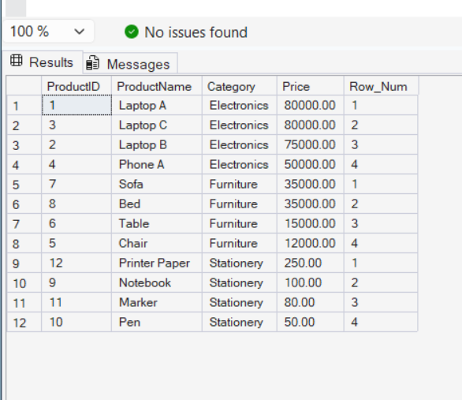
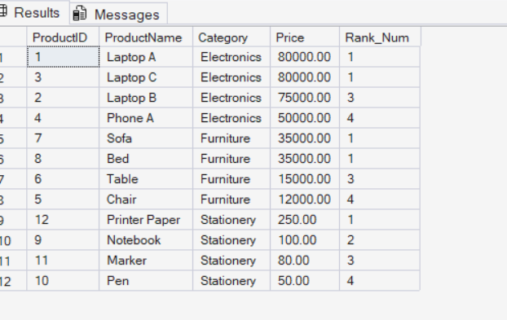
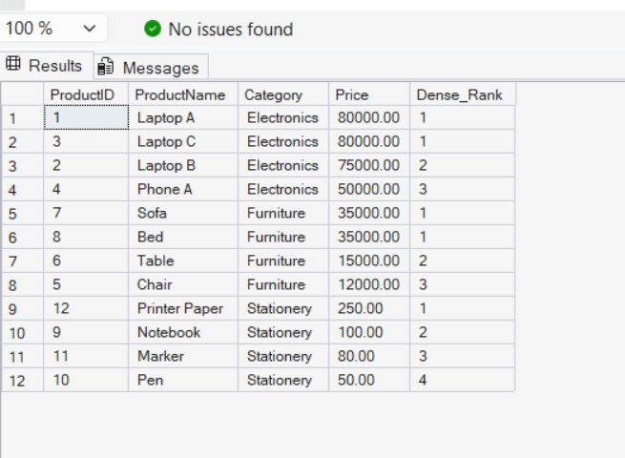
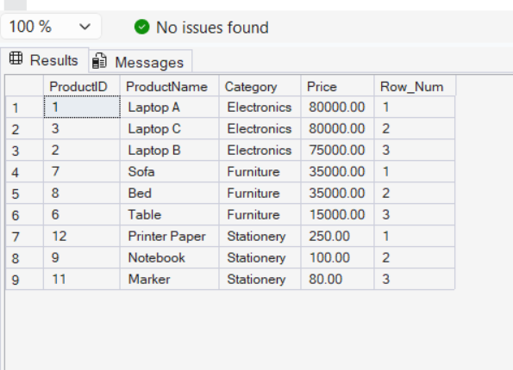

StoredProcedures:
CREATE DATABASE EmployeeManagementSystem;
GO

USE EmployeeManagementSystem;
GO
CREATE TABLE Departments
(
DepartmentID INT PRIMARY KEY,
DepartmentName VARCHAR(100)
);
CREATE TABLE Employees
(
EmployeeID INT IDENTITY(1,1) PRIMARY KEY,
FirstName VARCHAR(50),
LastName VARCHAR(50),
DepartmentID INT,
Salary DECIMAL(10,2),
JoinDate DATE,

FOREIGN KEY (DepartmentID)
REFERENCES Departments(DepartmentID)
);
INSERT INTO Departments
VALUES
(1,'HR'),
(2,'Finance'),
(3,'IT'),
(4,'Marketing');
INSERT INTO Employees
(
FirstName,
LastName,
DepartmentID,
Salary,
JoinDate
)
VALUES
('John','Doe',1,5000.00,'2020-01-15'),
('Jane','Smith',2,6000.00,'2019-03-22'),
('Michael','Johnson',3,7000.00,'2018-07-30'),
('Emily','Davis',4,5500.00,'2021-11-05');
SELECT * FROM Employees;
CREATE PROCEDURE sp_GetEmployeesByDepartment
@DepartmentID INT
AS
BEGIN
SELECT *
FROM Employees
WHERE DepartmentID = @DepartmentID;
END;
GO
EXEC sp_GetEmployeesByDepartment 3;
CREATE PROCEDURE sp_InsertEmployee
@FirstName VARCHAR(50),
@LastName VARCHAR(50),
@DepartmentID INT,
@Salary DECIMAL(10,2),
@JoinDate DATE
AS
BEGIN
INSERT INTO Employees
(
FirstName,
LastName,
DepartmentID,
Salary,
JoinDate
)
VALUES
(
@FirstName,
@LastName,
@DepartmentID,
@Salary,
@JoinDate
);
END;
GO
EXEC sp_InsertEmployee
'Robert',
'Brown',
3,
6500.00,
'2022-05-10';
SELECT * FROM Employees;
ReturnDataForm:
-- Exercise 5: Return Data from a Stored Procedure

-- Step 1: Create Database
CREATE DATABASE EmployeeManagementSystem_Ex5;
GO

USE EmployeeManagementSystem_Ex5;
GO

-- Step 2: Create Departments Table
CREATE TABLE Departments
(
DepartmentID INT PRIMARY KEY,
DepartmentName VARCHAR(100)
);
GO

-- Step 4: Create Employees Table
CREATE TABLE Employees
(
EmployeeID INT IDENTITY(1,1) PRIMARY KEY,
FirstName VARCHAR(50),
LastName VARCHAR(50),
DepartmentID INT,
Salary DECIMAL(10,2),
JoinDate DATE,
FOREIGN KEY (DepartmentID) REFERENCES Departments(DepartmentID)
);
GO

-- Step 5: Insert Sample Data into Departments
INSERT INTO Departments
VALUES
(1,'HR'),
(2,'Finance'),
(3,'IT'),
(4,'Marketing');
GO

-- Step 6: Insert Sample Data into Employees
INSERT INTO Employees
(
FirstName,
LastName,
DepartmentID,
Salary,
JoinDate
)
VALUES
('John','Doe',1,5000.00,'2020-01-15'),
('Jane','Smith',2,6000.00,'2019-03-22'),
('Michael','Johnson',3,7000.00,'2018-07-30'),
('Emily','Davis',4,5500.00,'2021-11-05');
GO

-- Step 7: Create Stored Procedure
CREATE PROCEDURE sp_GetEmployeeCountByDepartment
@DepartmentID INT
AS
BEGIN
SELECT COUNT(*) AS TotalEmployees
FROM Employees
WHERE DepartmentID = @DepartmentID;
END;
GO

-- Step 8: Execute Stored Procedure
EXEC sp_GetEmployeeCountByDepartment 3;
GO
