Exercise 1 – Create Your First React Application
Aim
To create a React application named myfirstreact and display the heading "Welcome to the First Session of React" on the web page.
Software Required
- Node.js
- npm
- Visual Studio Code
- Google Chrome / Microsoft Edge
Prerequisites
- Install Node.js (npm is installed automatically with it).
- Install Visual Studio Code.
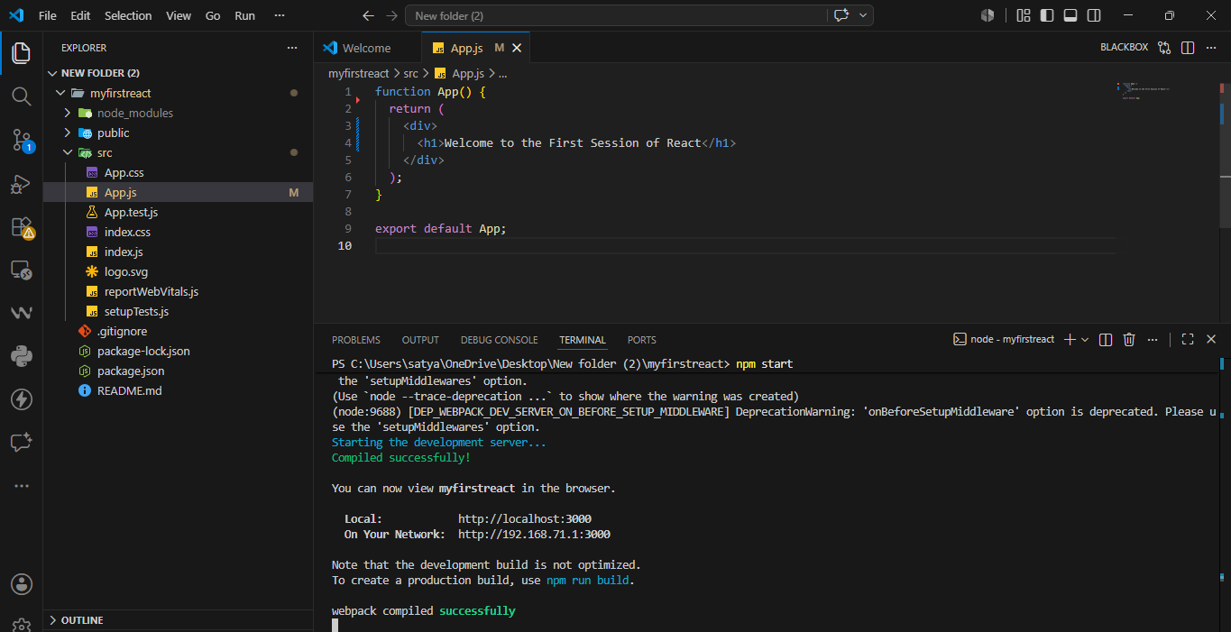

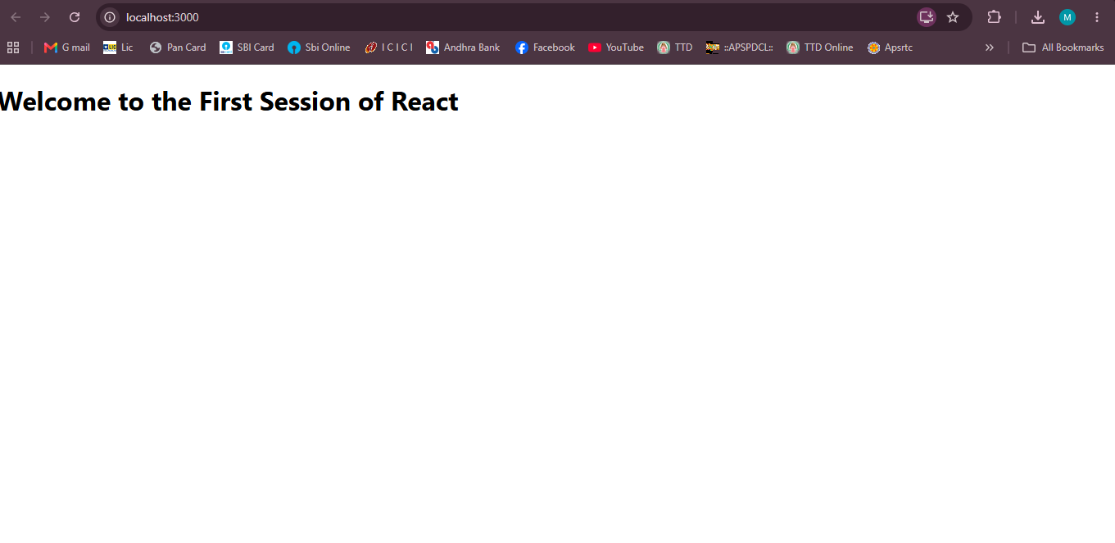

Exercise 2 – React Components (Student Management Portal)
Aim
To create a React application named StudentApp, create three class components (Home, About, and Contact), and render all the components on a single page.
Software Required
- Node.js
- npm
- Visual Studio Code
- Google Chrome / Microsoft Edge
Prerequisites
- Install Node.js
- Install Visual Studio Code
- Basic knowledge of React Components
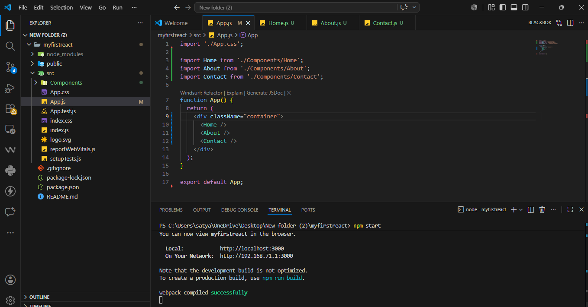
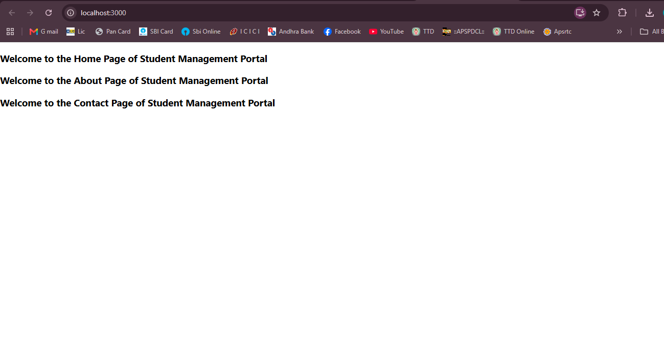
Exercise 3 – Functional Component (Score Calculator)
Aim
To create a React application named scorecalculatorapp using a functional component named CalculateScore that accepts Name, School, Total, and Goal as props, calculates the average score, and displays the student details with CSS styling.
Software Required
- Node.js
- npm
- Visual Studio Code
- Google Chrome / Microsoft Edge
Prerequisites
- Install Node.js
- Install Visual Studio Code
- Basic knowledge of React Functional Components
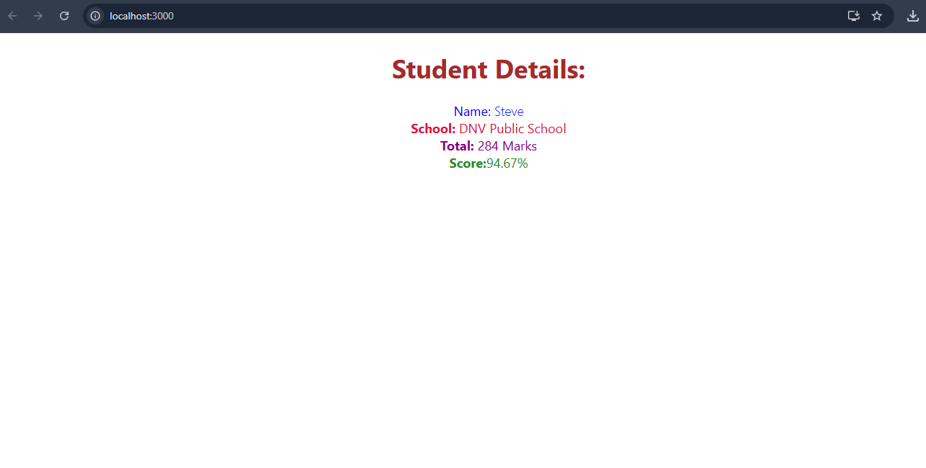
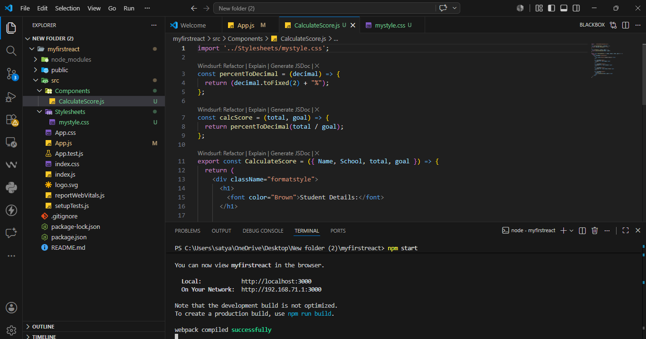
Exercise 4 – React Component Lifecycle (componentDidMount & componentDidCatch)

Aim
To create a React application named blogapp that fetches posts from an online API using the componentDidMount() lifecycle method and handles runtime errors using componentDidCatch().
Software Required
- Node.js
- npm
- Visual Studio Code
- Google Chrome / Microsoft Edge
Prerequisites
- Install Node.js
- Install Visual Studio Code
- Internet connection (for Fetch API)

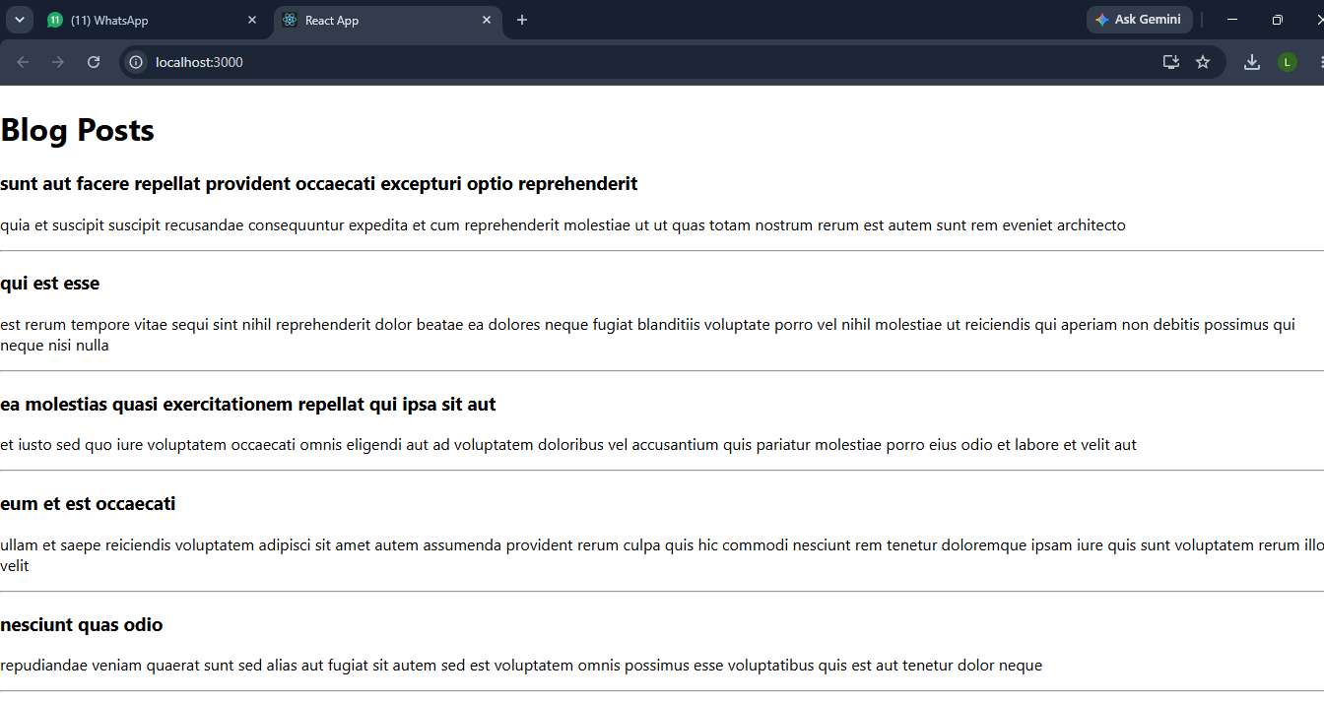
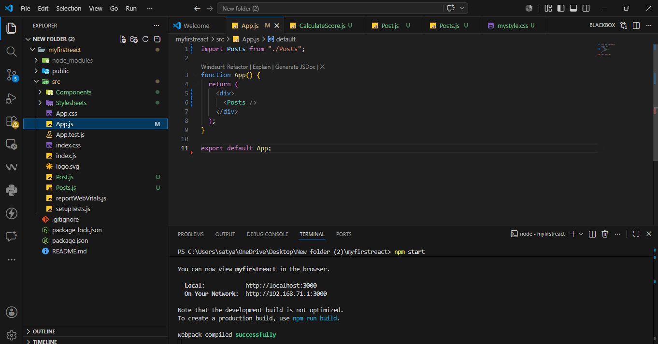
Exercise 5 – Styling React Components using CSS Modules
Aim
To style React components using CSS Modules and inline styles, and display the cohort details with different heading colors based on the cohort status.
Software Required
- Node.js
- npm
- Visual Studio Code
- Google Chrome / Microsoft Edge
Prerequisites
- Install Node.js
- Install Visual Studio Code
- Download and extract the provided React application (cohorttracker.zip).
Exercise 6 – React Router (Trainers App)
Aim
To create a React application named TrainersApp that uses React Router for navigation between pages and displays trainer details using URL parameters (useParams).
Software Required
- Node.js
- npm
- Visual Studio Code
- Google Chrome / Microsoft Edge
Prerequisites
- Install Node.js
- Install Visual Studio Code
- Basic knowledge of React Router.
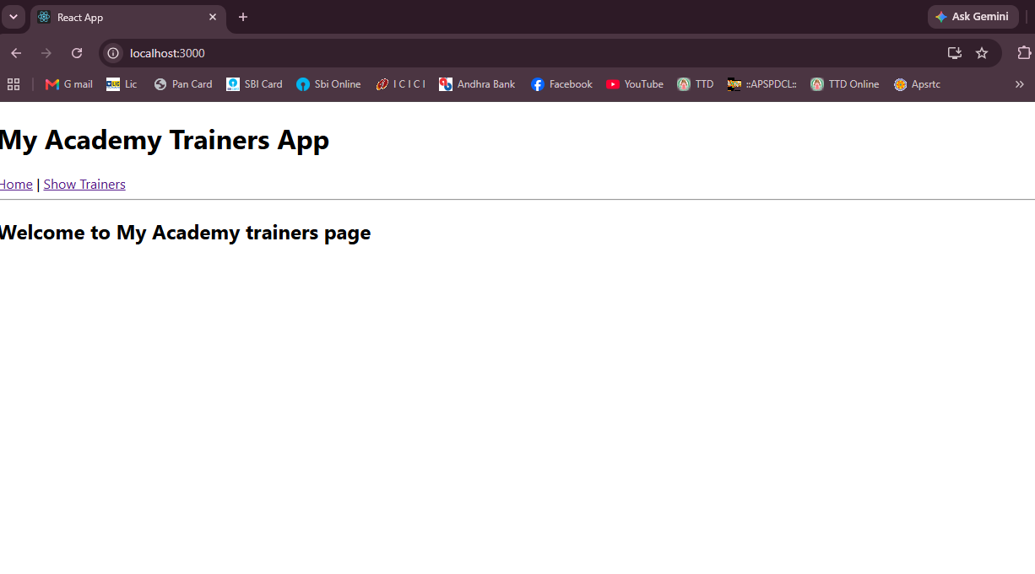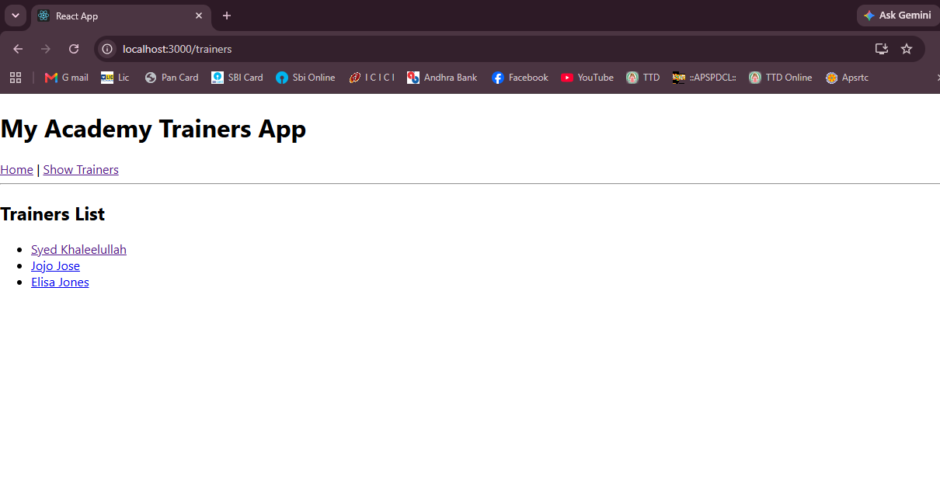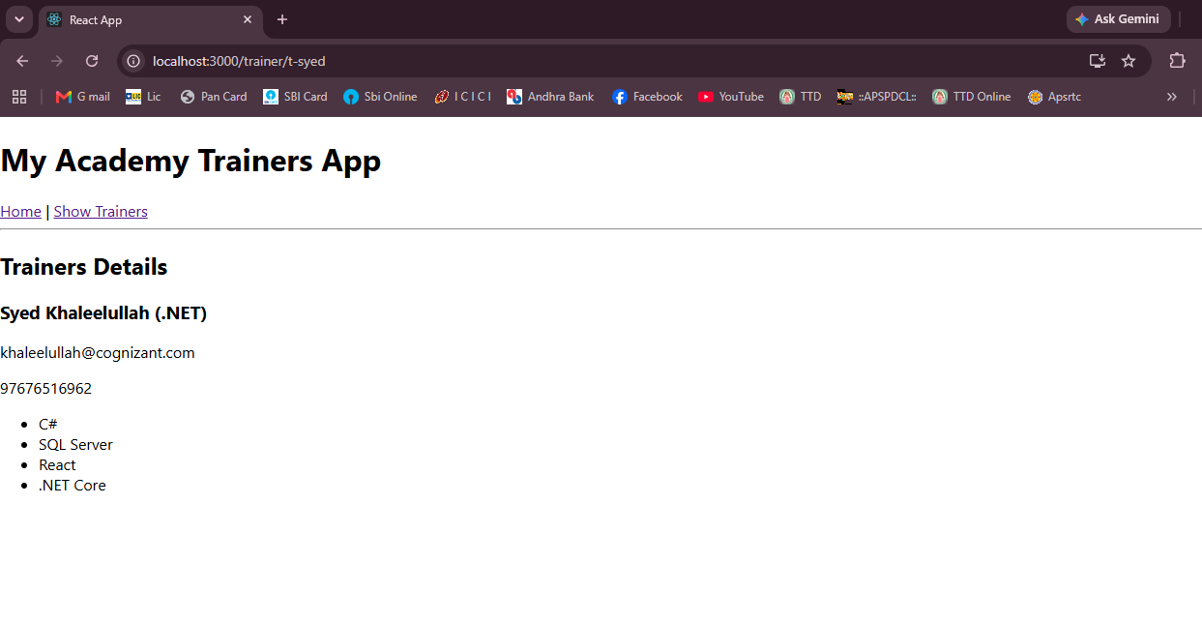
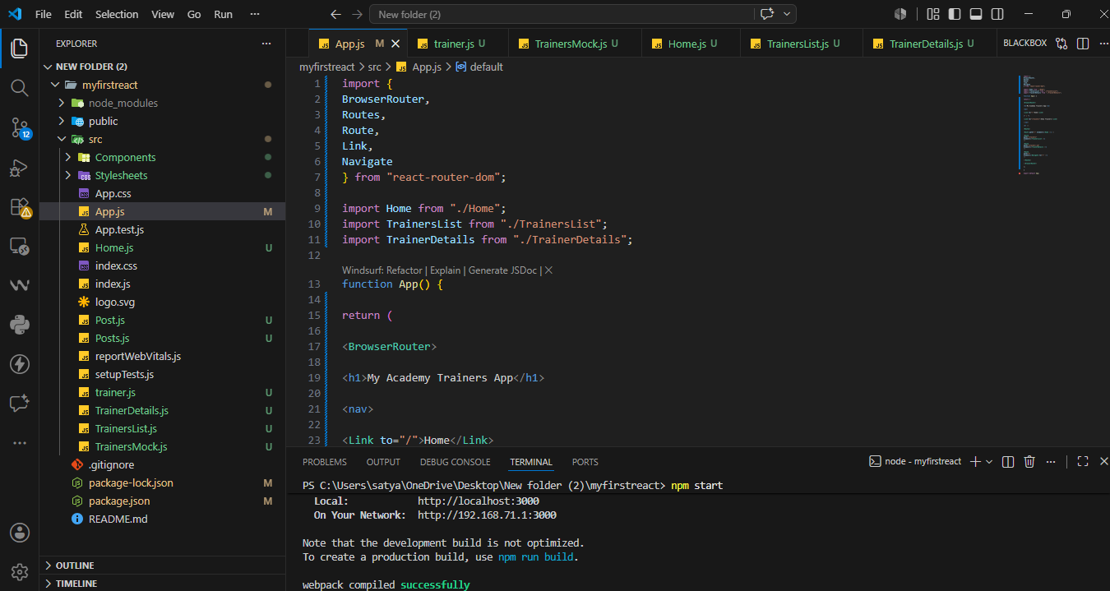
Exercise 7 – React Props (Shopping Cart)
Aim
To create a React application named shoppingapp that demonstrates the use of Props by passing an array of shopping cart items from a parent component (OnlineShopping) to a child component (Cart) and displaying them in a table.
Software Required
- Node.js
- npm
- Visual Studio Code
- Google Chrome / Microsoft Edge
Prerequisites
- Install Node.js
- Install Visual Studio Code
- Basic knowledge of React Props.

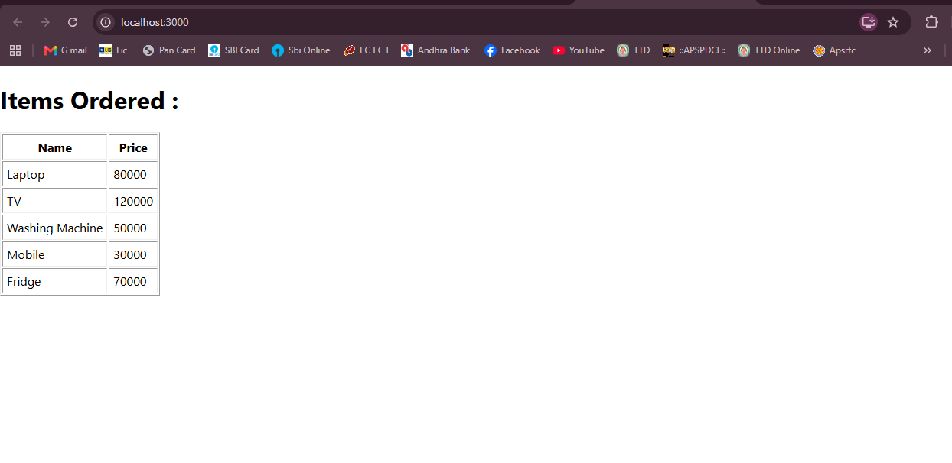
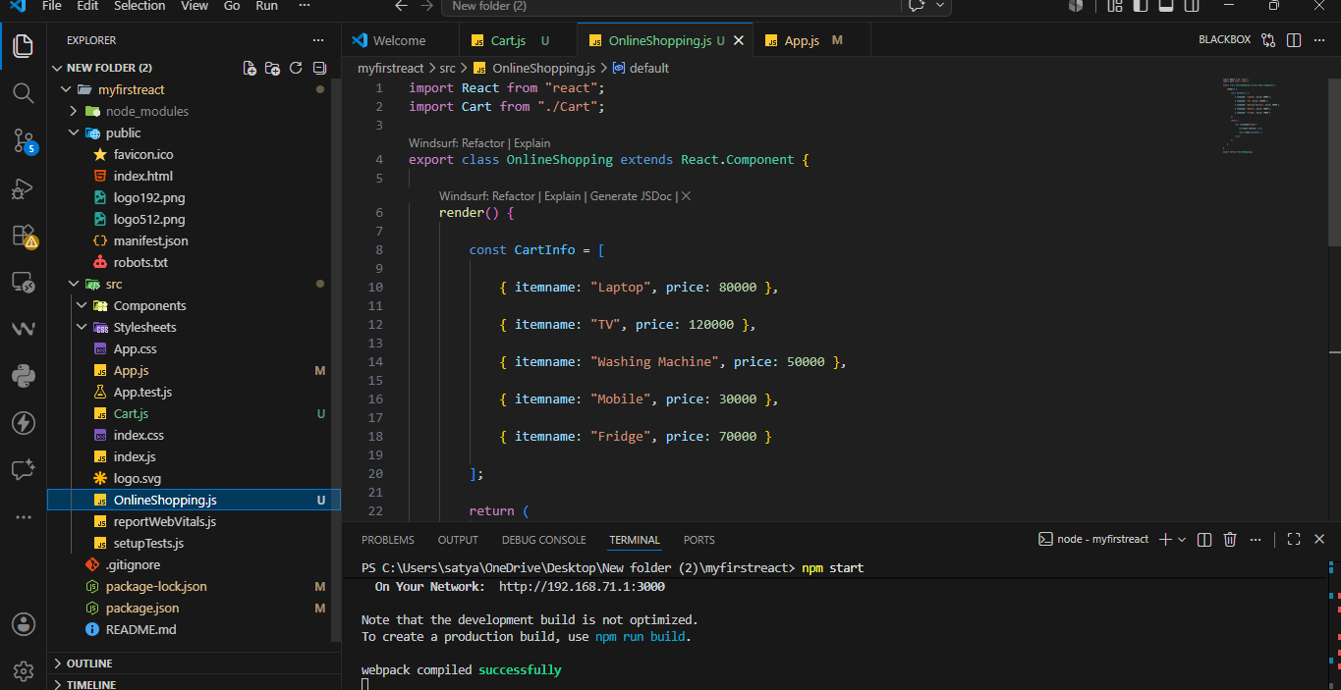
Exercise 8 – React State (Counter App)
Aim
To create a React application named counterapp that demonstrates the use of the React State object by maintaining the count of people entering and exiting a mall using two buttons.
Software Required
- Node.js
- npm
- Visual Studio Code
- Google Chrome / Microsoft Edge
Prerequisites
- Install Node.js
- Install Visual Studio Code
- Basic knowledge of React State.
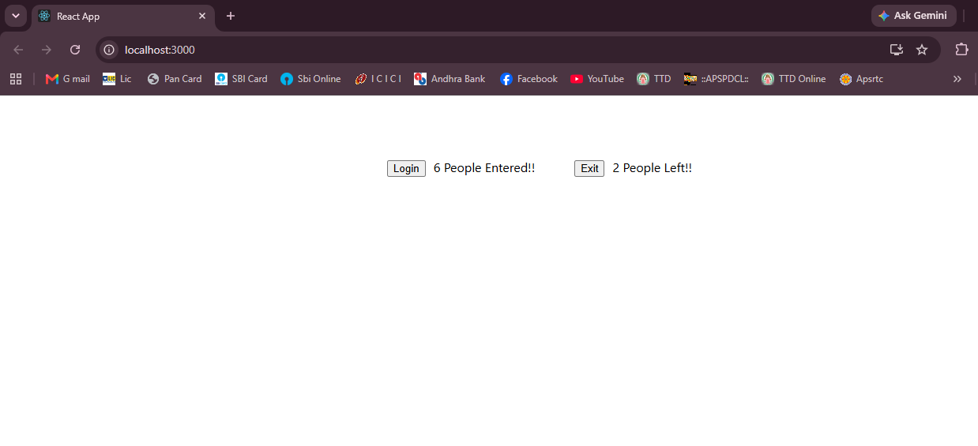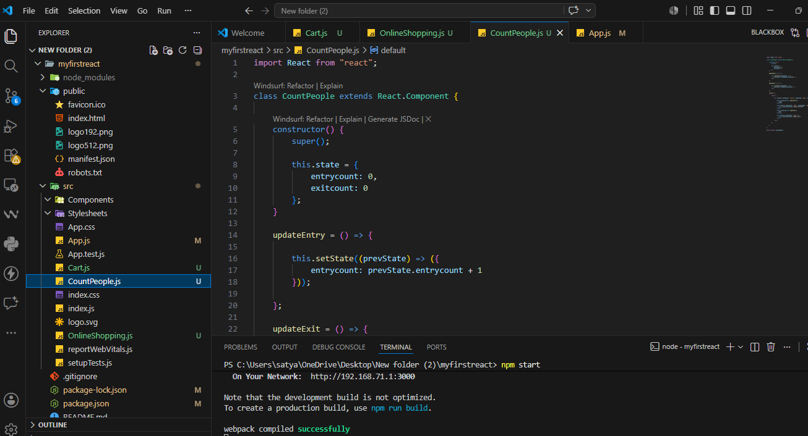
Exercise 9 – ES6 Features in React (Cricket App)
Aim
To create a React application named cricketapp that demonstrates various ES6 features such as map(), arrow functions, destructuring, and the spread operator to display cricket player details.
Software Required
- Node.js
- npm
- Visual Studio Code
- Google Chrome / Microsoft Edge
Prerequisites
- Install Node.js
- Install Visual Studio Code
- Basic knowledge of ES6 features and React.
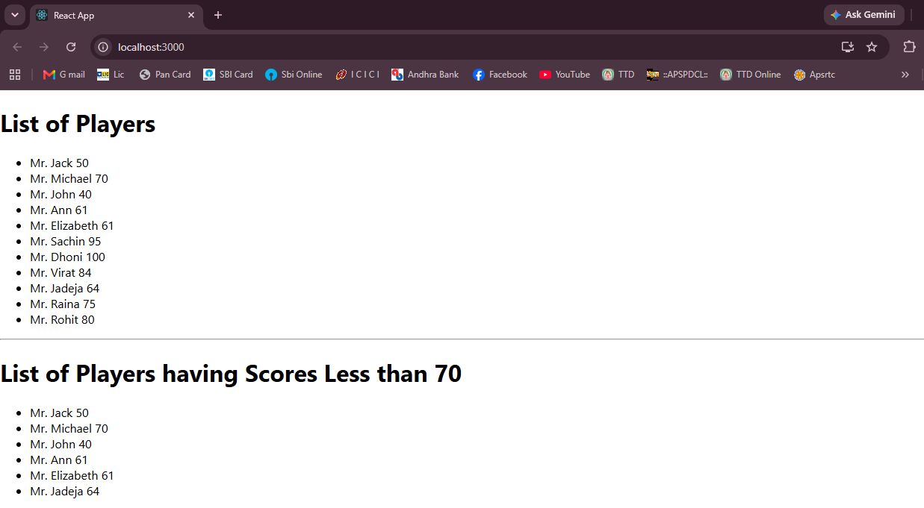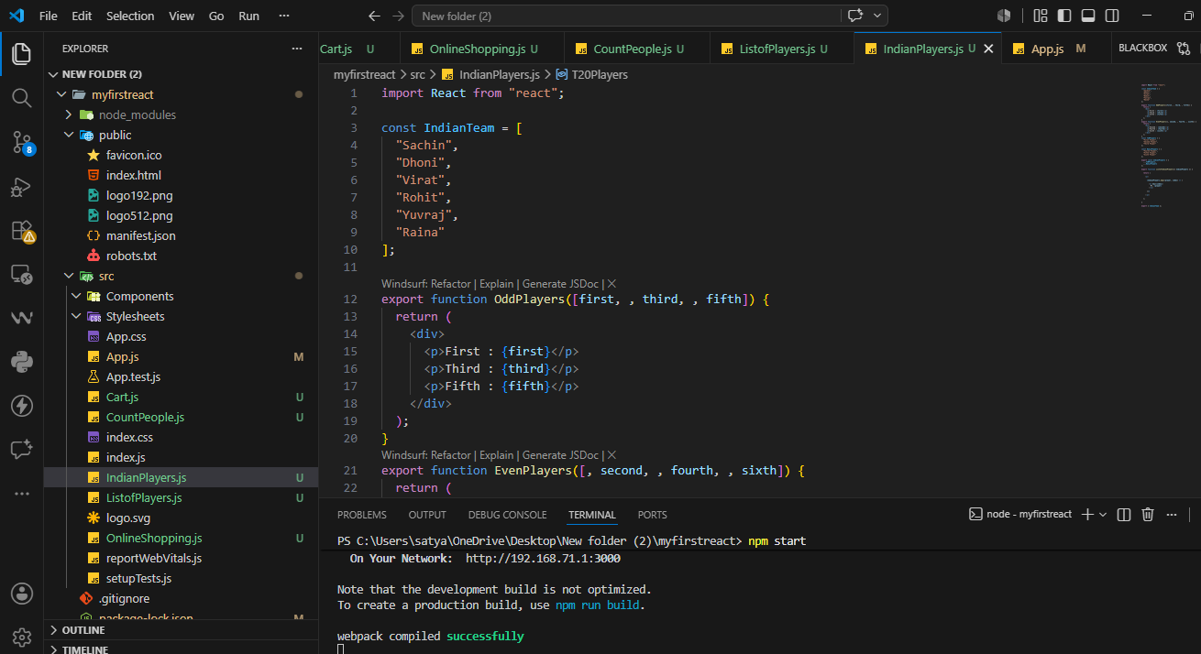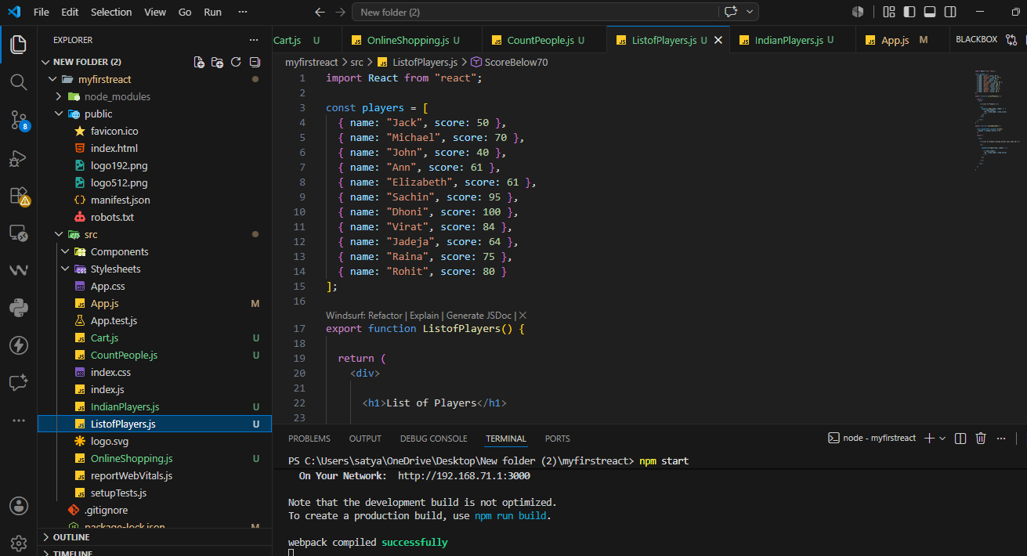-------------------------------------------------------------------------------------------------------
Exercise 10 – JSX in React (Office Space Rental App)
Aim
To create a React application named officespacerentalapp that uses JSX to display office space details, apply inline CSS, and dynamically change the rent color based on its value.
Software Required
- Node.js
- npm
- Visual Studio Code
- Google Chrome / Microsoft Edge
Prerequisites
- Install Node.js
- Install Visual Studio Code
- Basic knowledge of JSX and React.
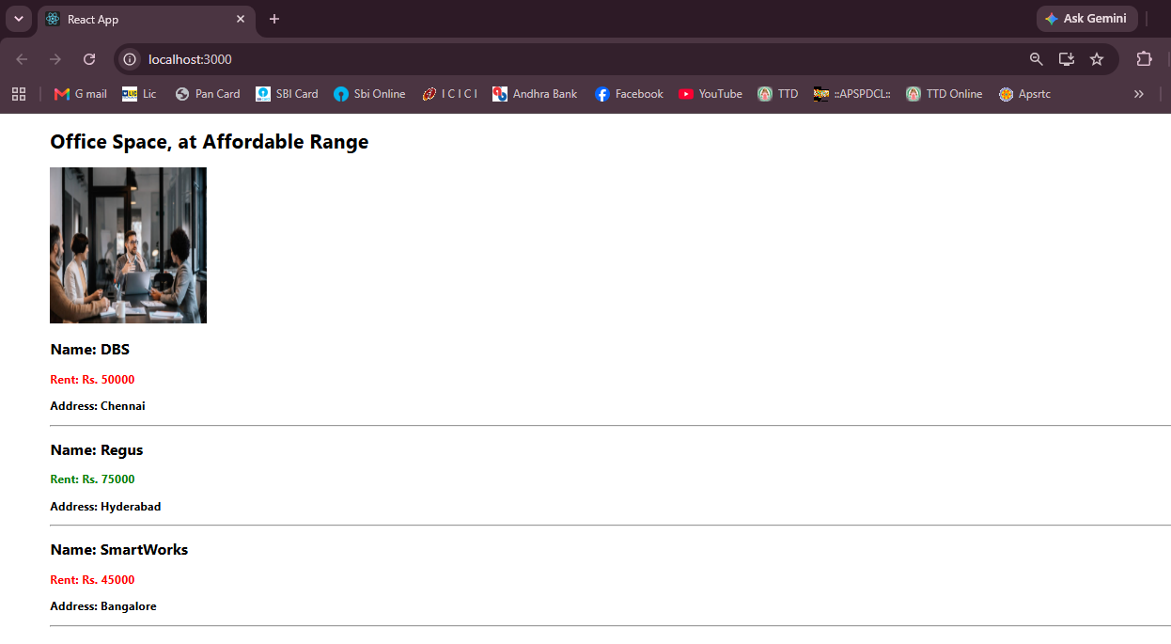
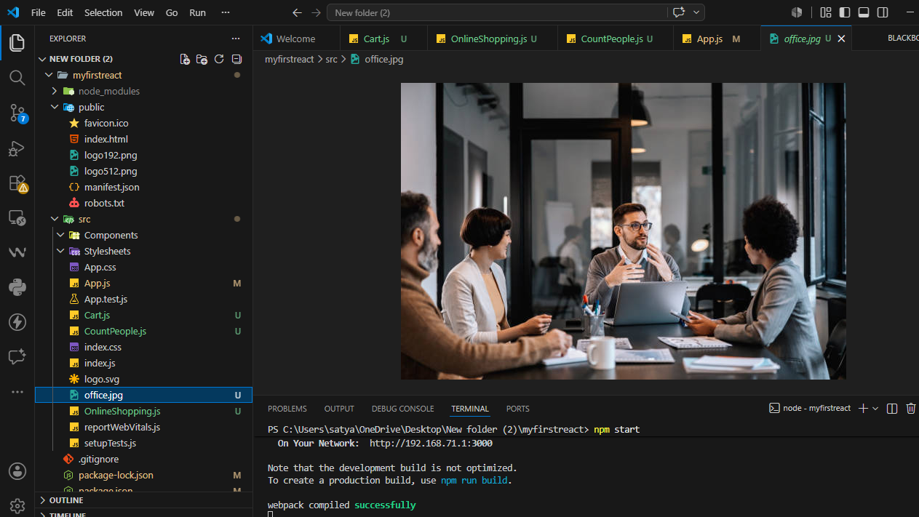
Exercise 11 – React Event Handling
Aim
To create a React application named eventexamplesapp that demonstrates React event handling, including multiple event handlers, passing arguments to event functions, handling synthetic events, and implementing a simple currency converter.
Software Required
- Node.js
- npm
- Visual Studio Code
- Google Chrome / Microsoft Edge
Prerequisites
- Install Node.js
- Install Visual Studio Code
- Basic knowledge of React Events.
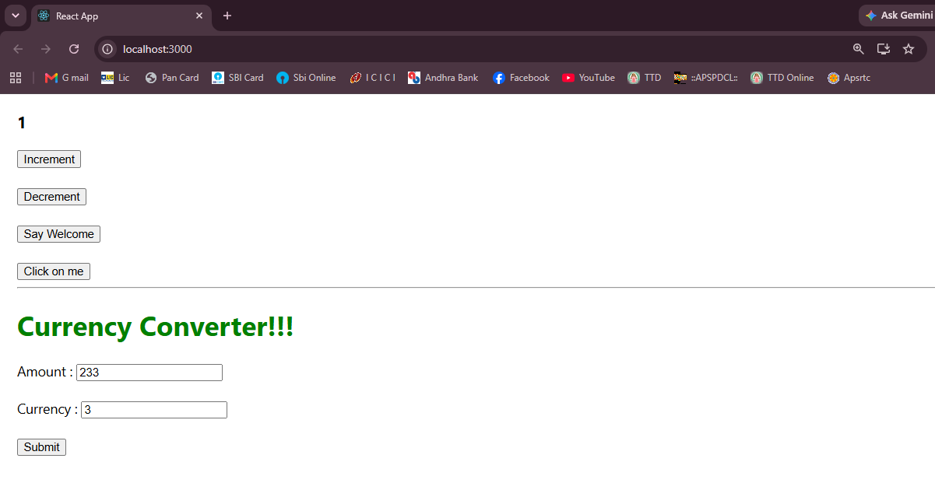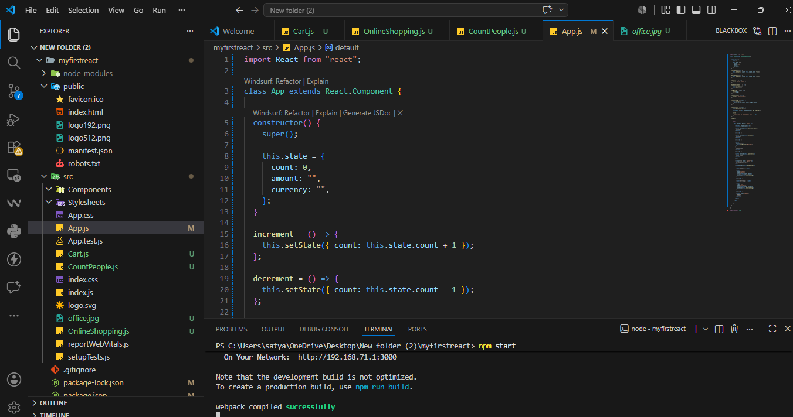

Exercise 12 – Conditional Rendering (Ticket Booking App)
Aim
To create a React application named ticketbookingapp that demonstrates conditional rendering by displaying different pages for guest users and logged-in users using Login and Logout buttons.
Software Required
- Node.js
- npm
- Visual Studio Code
- Google Chrome / Microsoft Edge
Prerequisites
- Install Node.js
- Install Visual Studio Code
- Basic knowledge of React conditional rendering.

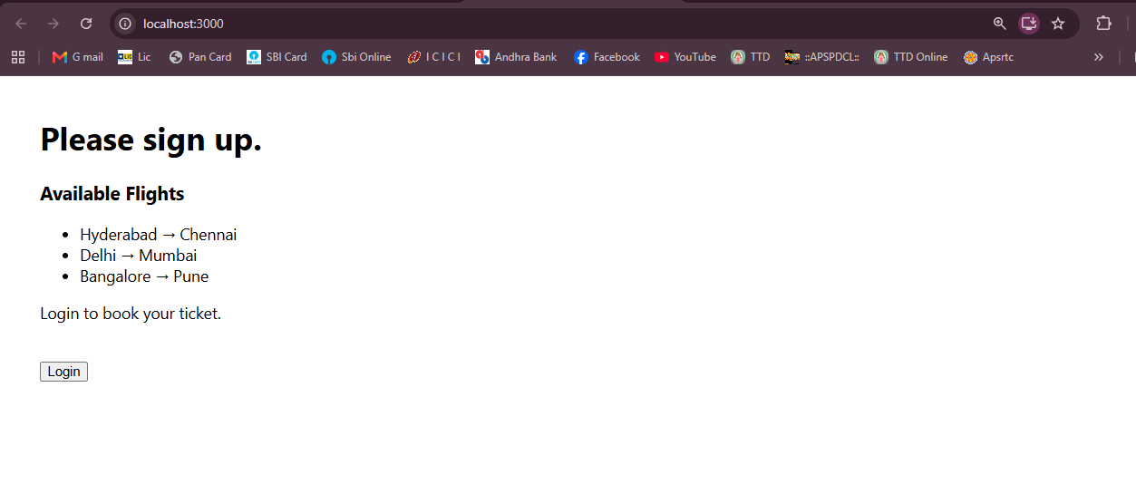
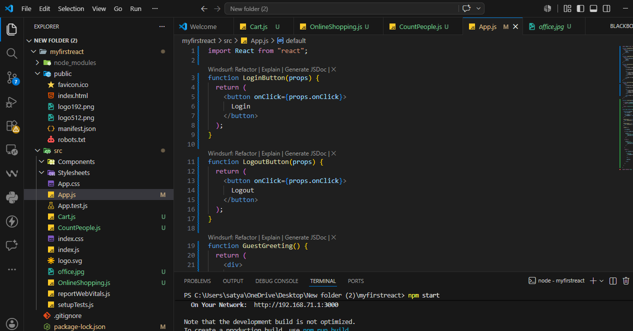
Exercise 13 – React Lists and Conditional Rendering (Blogger App)
Aim
To create a React application named bloggerapp that demonstrates conditional rendering, rendering multiple components, using the map() function, and displaying lists with keys.

Software Required
- Node.js
- npm
- Visual Studio Code
- Google Chrome / Microsoft Edge

Prerequisites
- Install Node.js
- Install Visual Studio Code
- Basic knowledge of React Components and Lists.
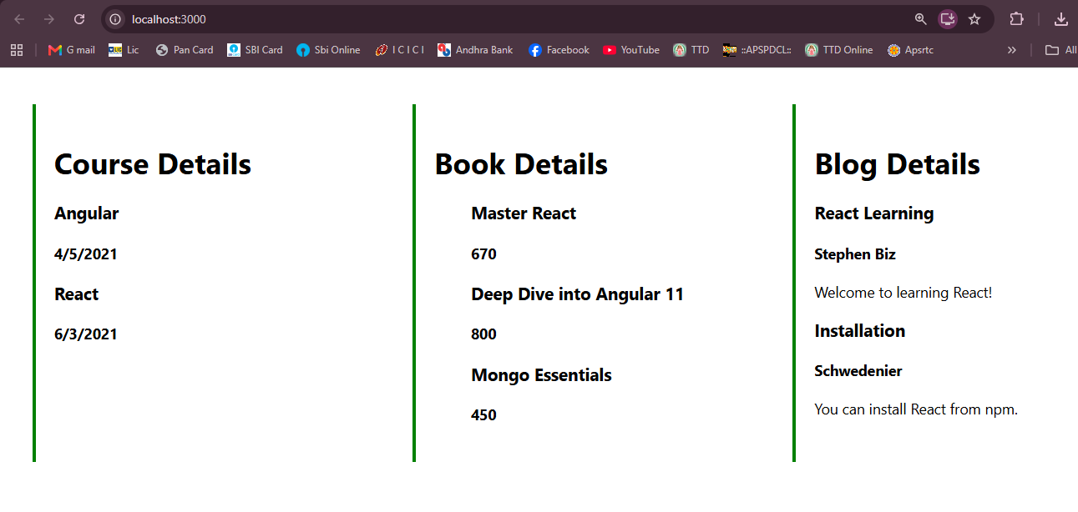
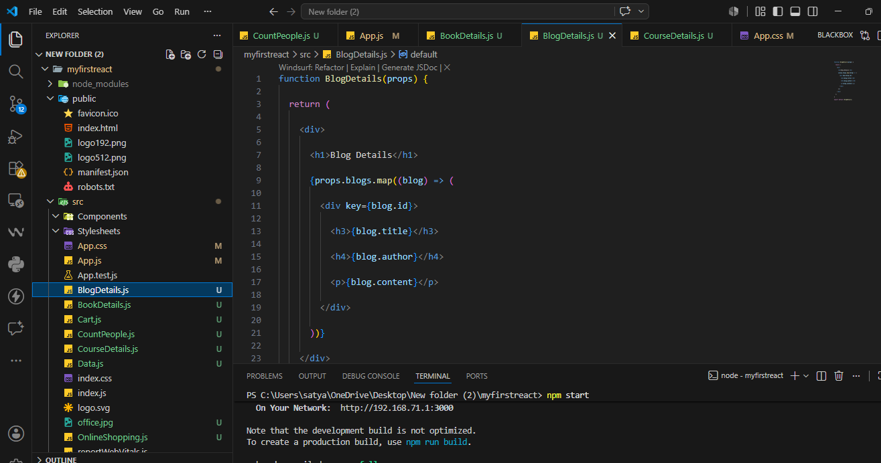
Exercise 14 – React Context API (Employee Management App)
Aim
To modify an existing Employee Management Application to use the React Context API instead of passing the theme name through props, thereby sharing the theme with nested child components efficiently.
Software Required
- Node.js
- npm
- Visual Studio Code
- Google Chrome / Microsoft Edge
Prerequisites
- Install Node.js
- Install Visual Studio Code.
- Download and extract the provided employeesapp.zip project.
Exercise 15 – React Forms (Ticket Raising App)
Aim
To create a React application named ticketraisingapp that demonstrates React Forms by allowing users to register a complaint using a textbox and textarea. On submission, the application generates a complaint reference number and displays it in an alert box.
Software Required
- Node.js
- npm
- Visual Studio Code
- Google Chrome / Microsoft Edge
Prerequisites
- Install Node.js
- Install Visual Studio Code
- Basic knowledge of React Forms and Controlled Components.
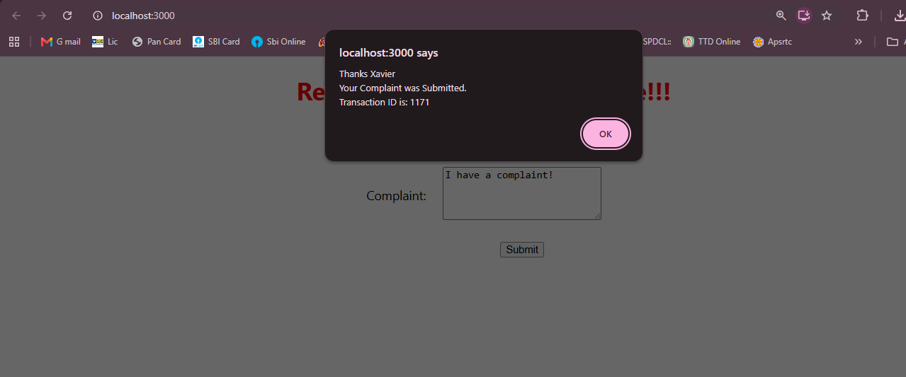
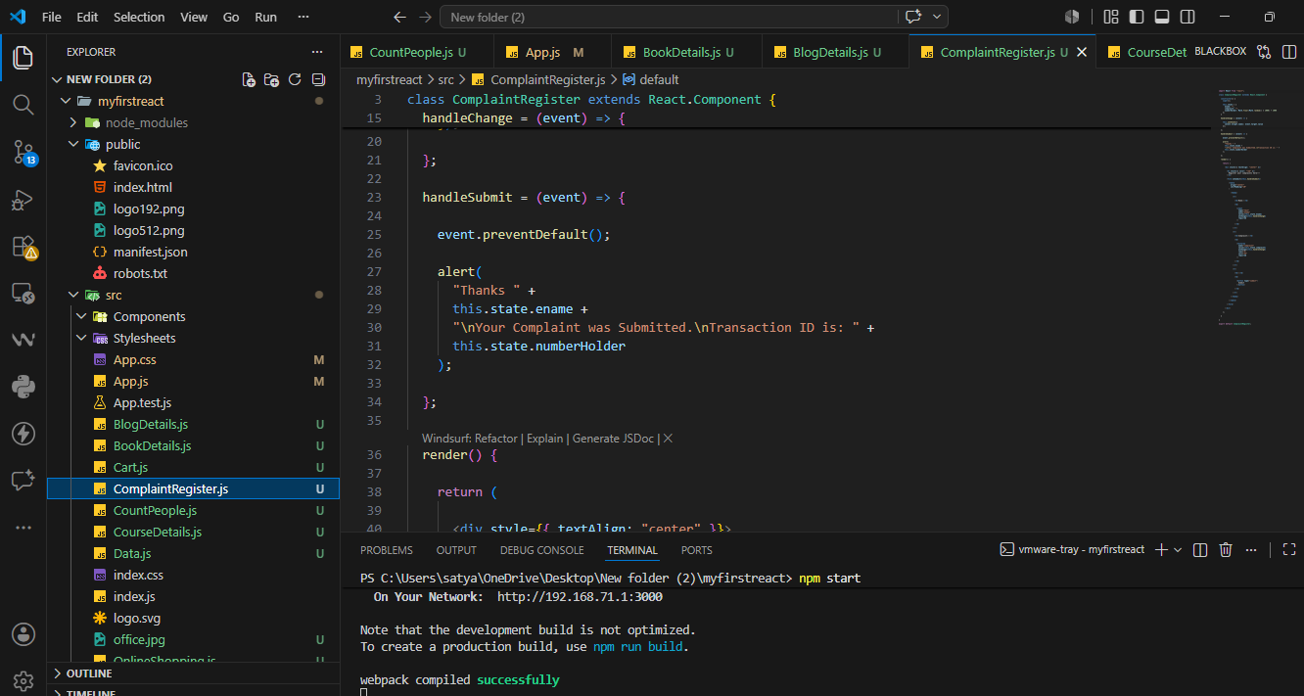
Exercise 16 – React Form Validation (Mail Register App)
Aim
To create a React application named mailregisterapp that validates a registration form containing Name, Email, and Password fields using React event handlers before form submission.
Software Required
- Node.js
- npm
- Visual Studio Code
- Google Chrome / Microsoft Edge
Prerequisites
- Install Node.js
- Install Visual Studio Code
- Basic knowledge of React Forms and Form Validation.
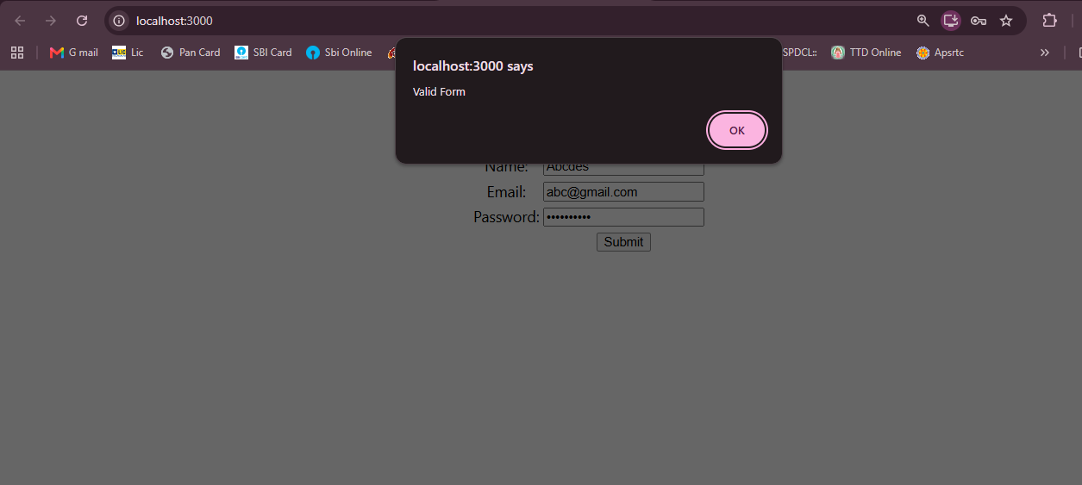
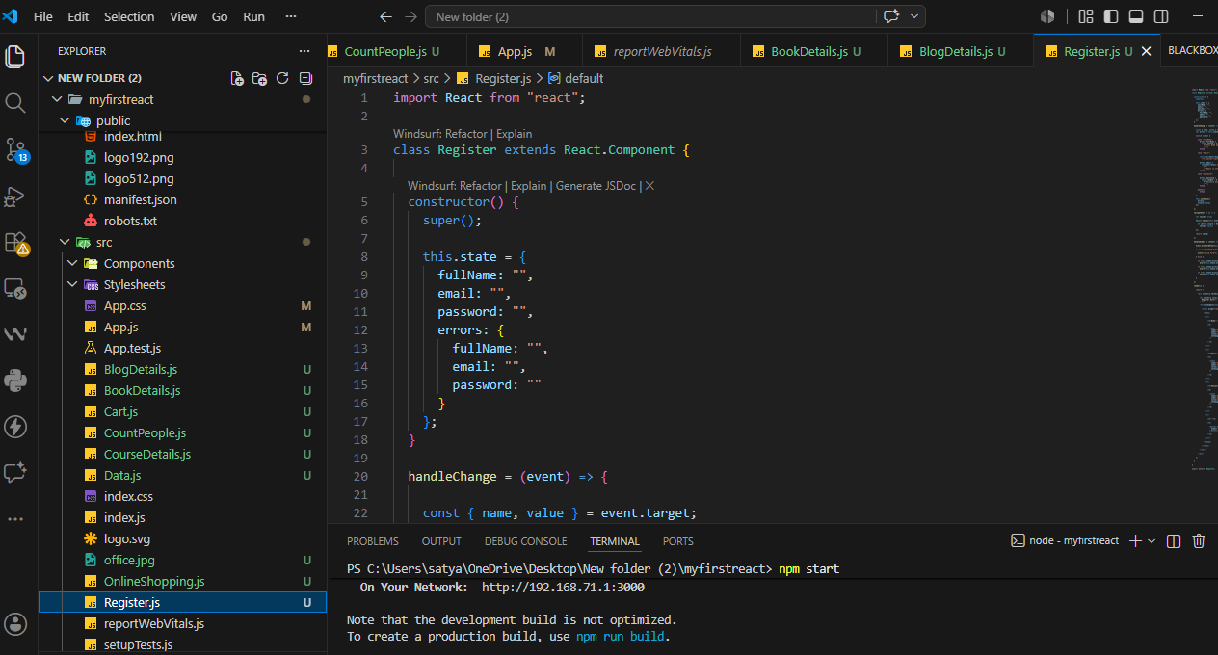
Exercise 17 – Fetching Data from REST API (Fetch User App)
Aim
To create a React application named fetchuserapp that consumes a REST API using the fetch() method inside the componentDidMount() lifecycle method and displays the user's title, first name, and profile image.
Software Required
- Node.js
- npm
- Visual Studio Code
- Google Chrome / Microsoft Edge
Prerequisites
- Install Node.js
- Install Visual Studio Code
- Internet connection (to access the Random User API).
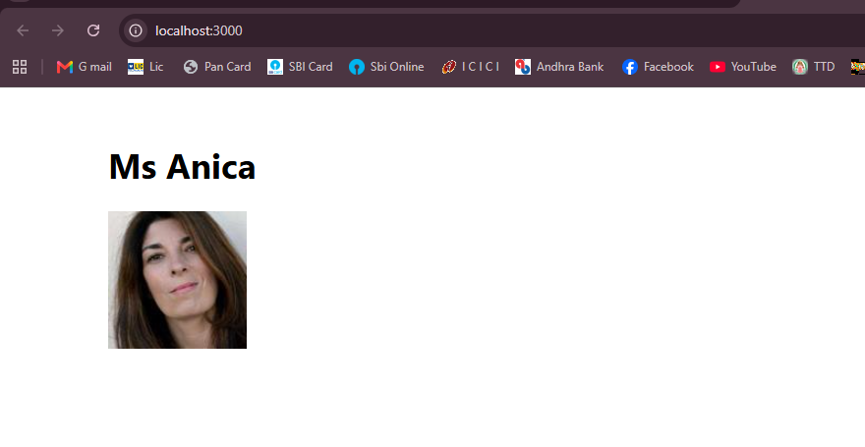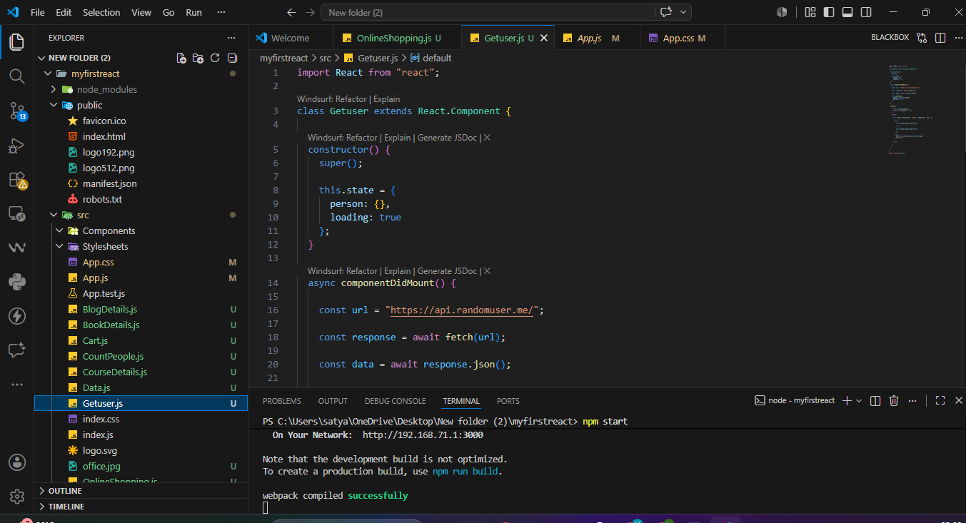
Exercise 18 – Unit Testing using Jest and Enzyme
Aim
To perform Unit Testing on the CohortDetails React component using Jest and Enzyme, and verify the component through unit tests and snapshot testing.
Software Required
- Node.js
- npm
- Visual Studio Code
- Jest
- Enzyme
- Google Chrome / Microsoft Edge
Prerequisites
- Install Node.js
- Install Visual Studio Code
- Download and extract the provided cohortstracker.zip project.
Exercise 19 – Unit Testing with Jest Mocking (Git Client App)
Aim
To create a React application named gitclientapp that fetches GitHub repository names using the Axios library and performs unit testing with Jest Mocking to test the API module without making actual API calls.
Software Required
- Node.js
- npm
- Visual Studio Code
- Axios
- Jest
- Google Chrome / Microsoft Edge
Prerequisites
- Install Node.js
- Install Visual Studio Code
- Basic knowledge of React, Axios, and Jest.
