Assignment:

1. Use PodAntiAffinity along with NodeAffinity with 2 Replicas and observe both pods running in which nodes (kubectl get pods -o wide)

apiVersion: apps/v1

kind: Deployment

metadata:

  name: nginx-deployment

spec:

  replicas: 2

  selector:

    matchLabels:

      app: nginx

  template:

    metadata:

      labels:

        app: nginx

    spec:

      affinity:

        podAntiAffinity:

          requiredDuringSchedulingIgnoredDuringExecution:

          - labelSelector:

              matchExpressions:

              - key: app

                operator: In

                values:

                - nginx

            topologyKey: "kubernetes.io/hostname"

        nodeAffinity:

          requiredDuringSchedulingIgnoredDuringExecution:

            nodeSelectorTerms:

            - matchExpressions:

              - key: zone

                operator: In

                values:

                - us-east

      containers:

      - name: nginx-container

        image: nginx:latest

        ports:

        - containerPort: 80

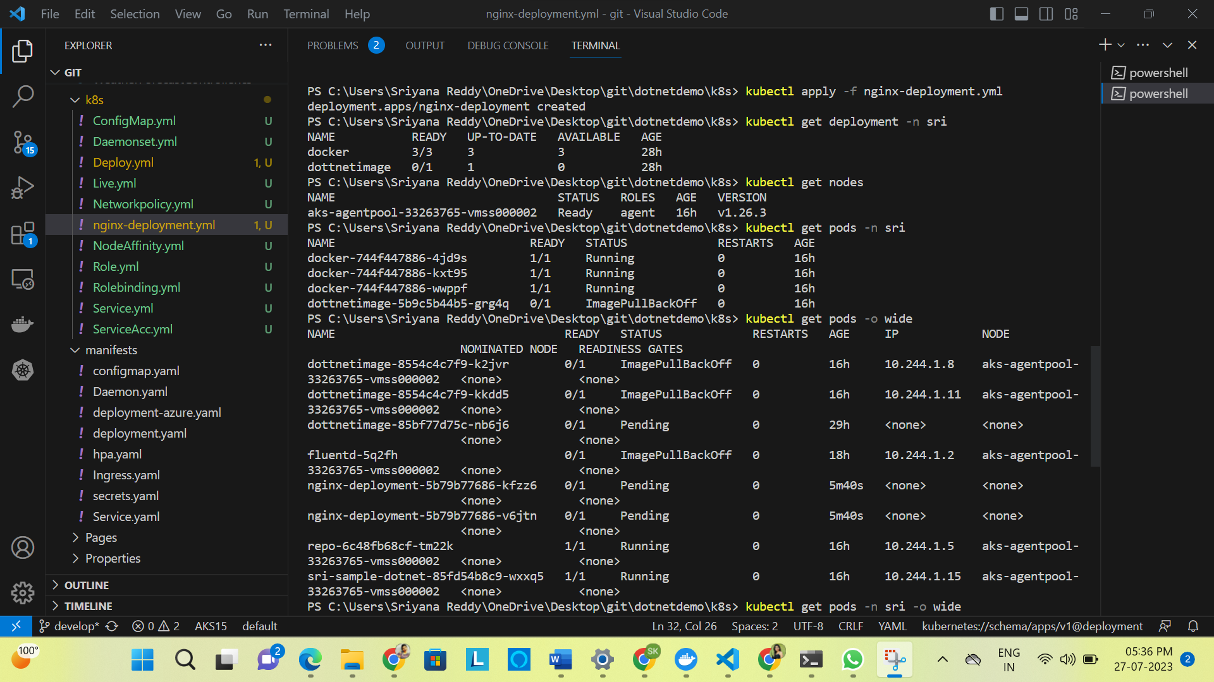

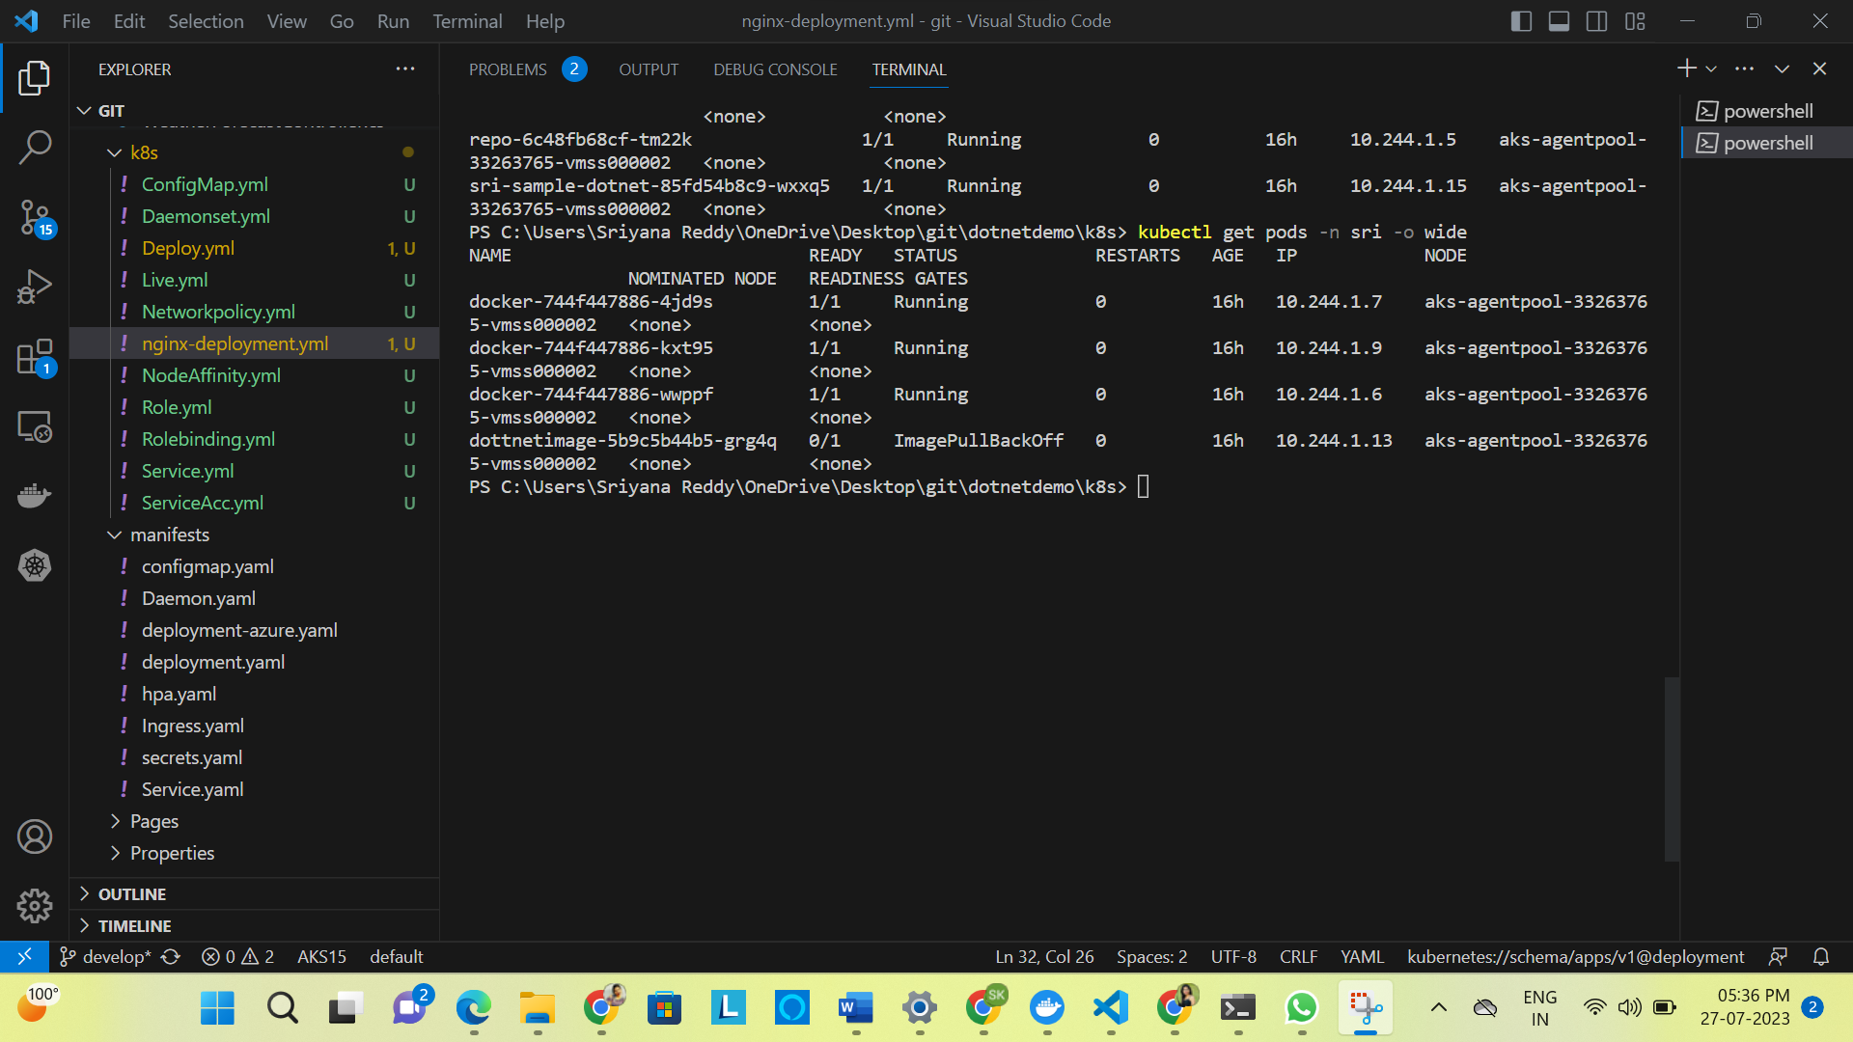

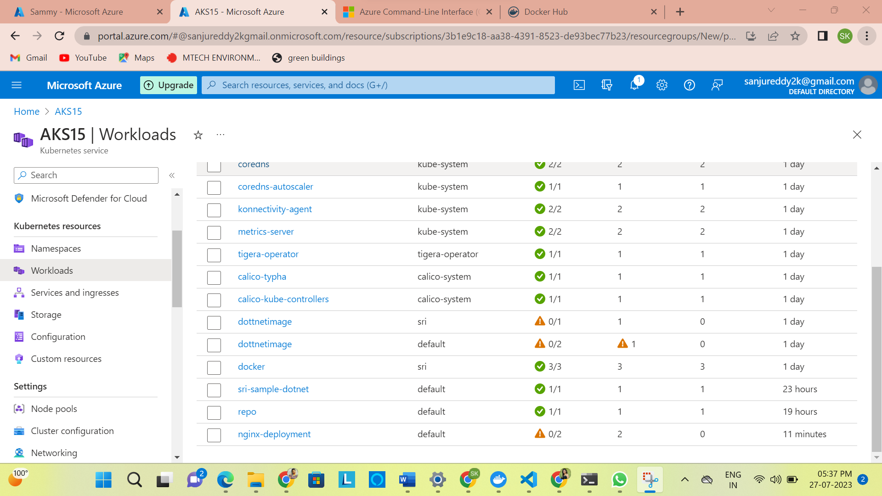

2) Create PDB for Pods:

apiVersion: policy/v1

kind: PodDisruptionBudget

metadata:

  name: sun-app-pdb

  namespace: sri

spec:

  minAvailable: 1

  selector:

    matchLabels:

      app: sun-app

