1. Installation of Jenkins

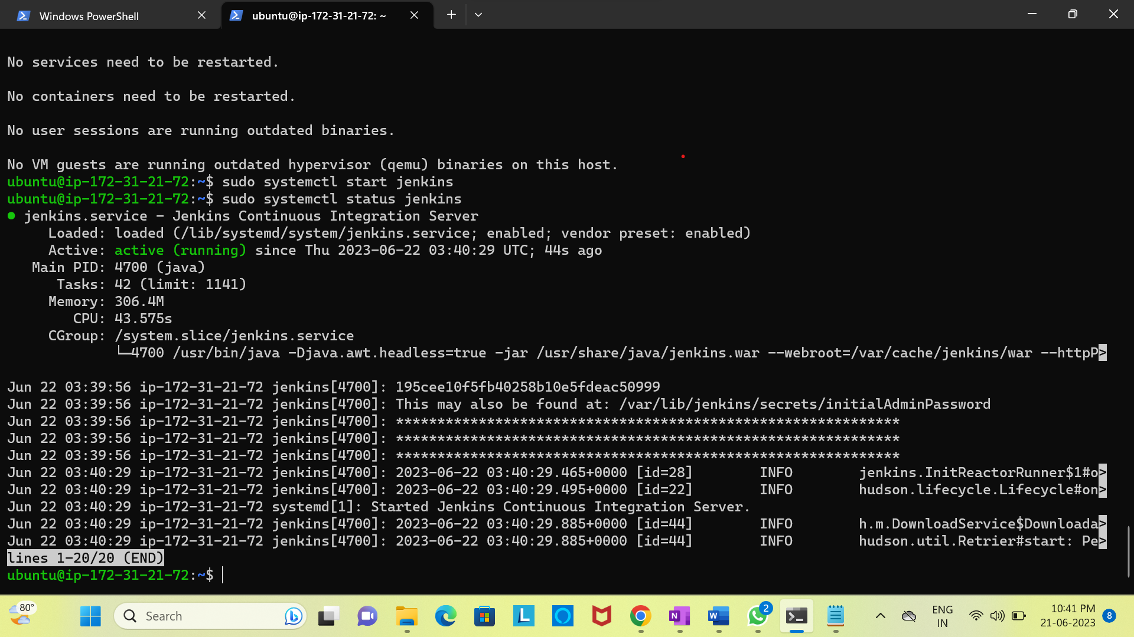

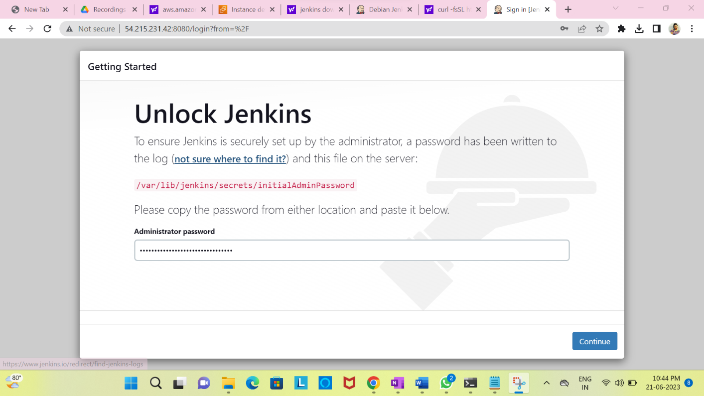

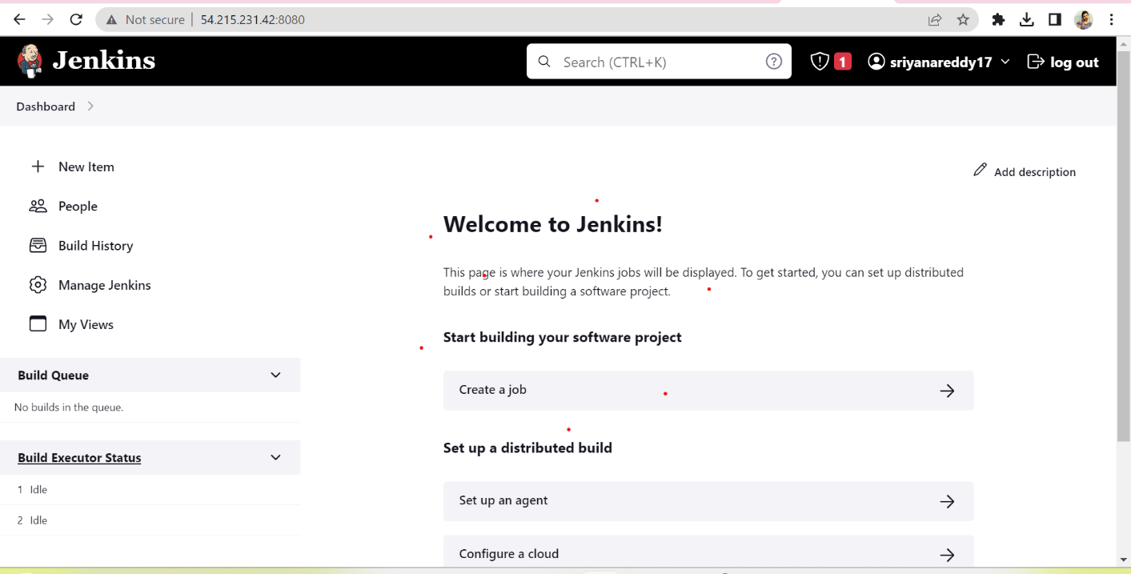

1. Set up New Multi-branch pipeline with private git repo

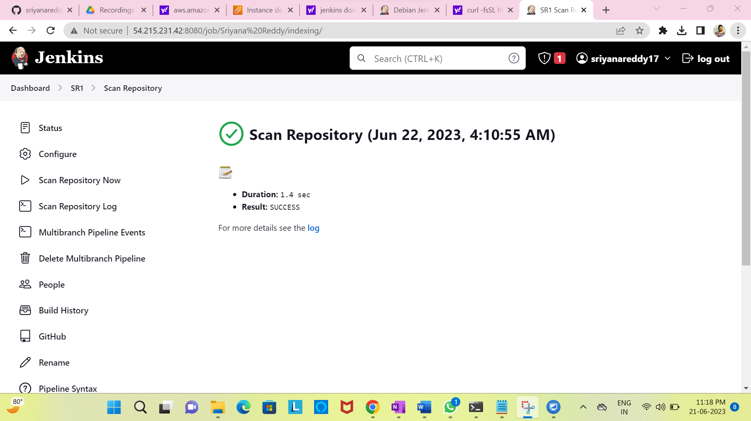

1. Setup WebHook for automatic scanning and triggering pipeline

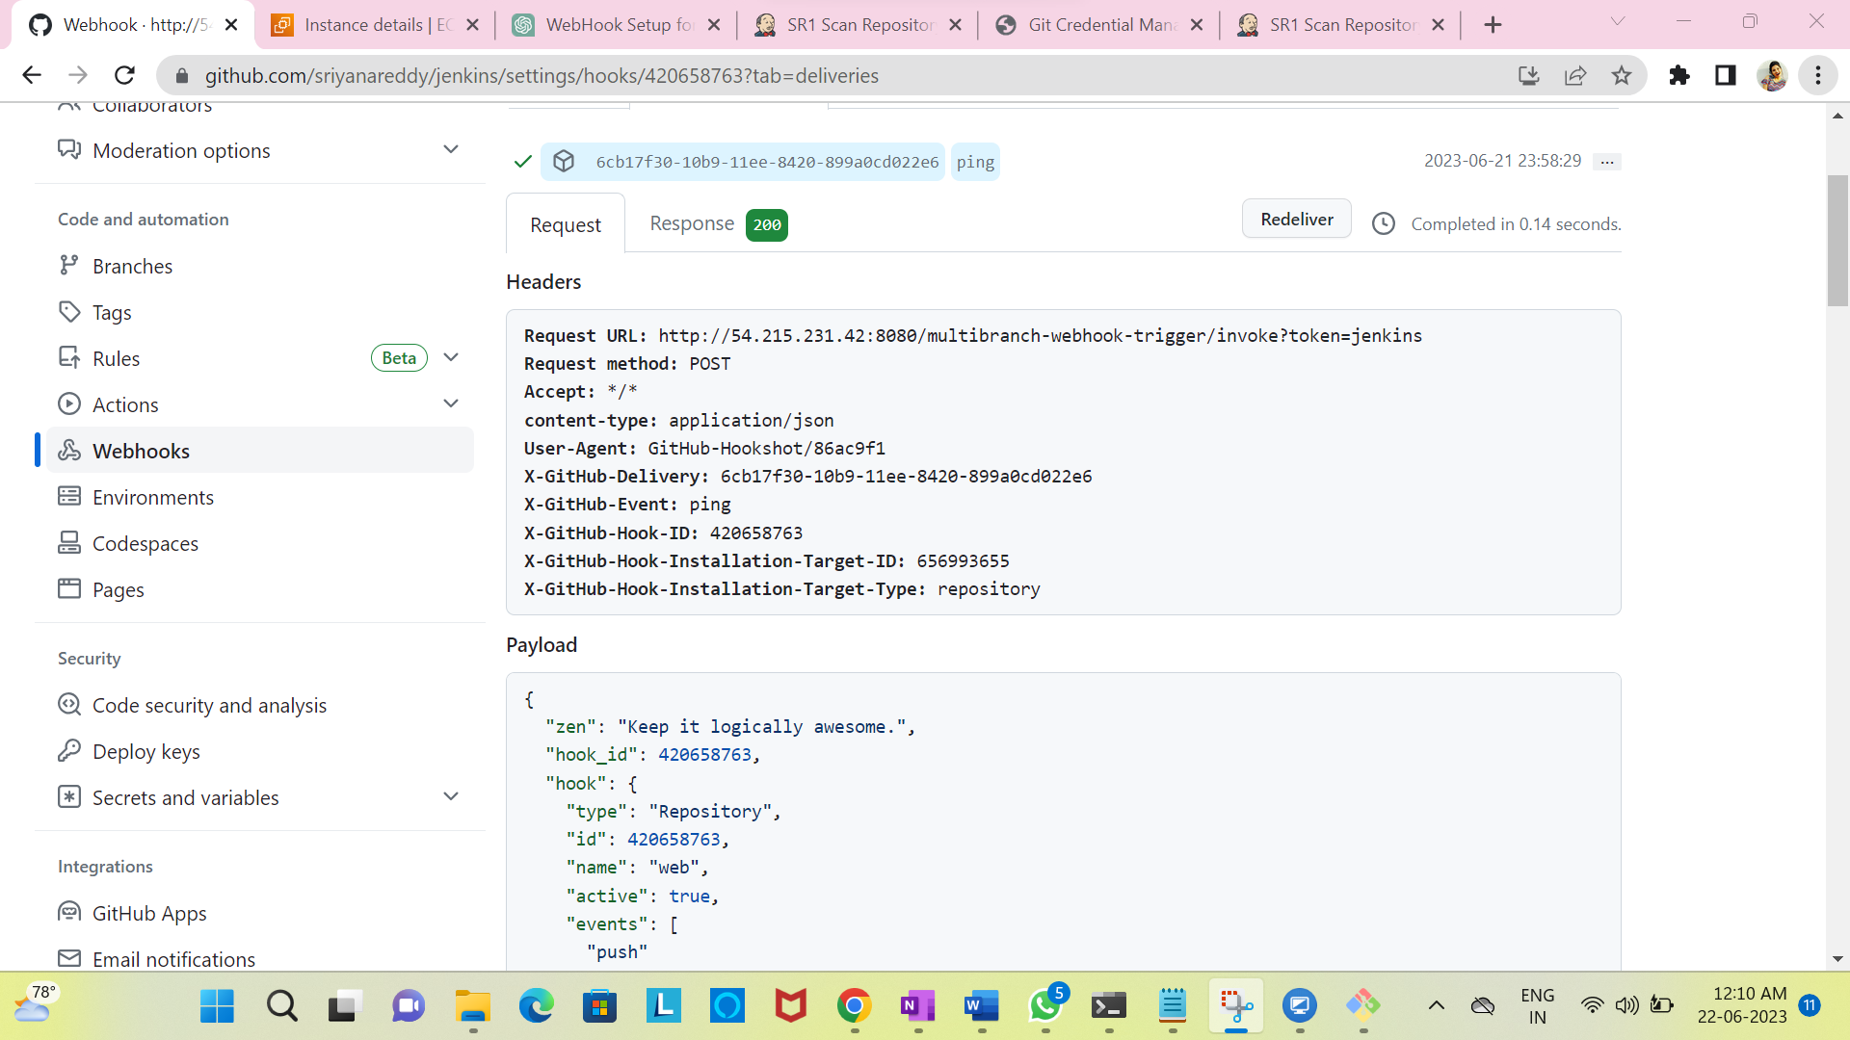

4)Create a new branch in git repo and commit changes, pipeline should be automatically triggered

