Software Requirements Specification (SRS)
Chat Application using Socket Programming

Field | Details
Project | Chat Application using Socket Programming
Version | 1.0
Authors | <Team Members>
Course / Class | <Course / Class>
Date | 04-09-2026
Status | Approved / Final Draft

Revision history
Version | Date | Author | Change summary | Approval
1.0 | 04-09-2026 | <Team> | Complete SRS with detailed requirements, security, UML diagrams and RTM | <Pending>

Approvals
Role | Name | Signature / Email | Date
Course Coordinator | <Name> | <Signature / Email> | <Date>
Project Guide | <Name> | <Signature / Email> | <Date>

Table of Contents
- 1. Introduction
- 2. Overall Description
- 3. External Interface Requirements
- 4. System Features (Detailed)
- 5. Non-functional Requirements (Detailed)
- 5.1 Security
- 6. Quality Attributes & Acceptance Tests
- 7. System Models and Diagrams
- 8. Requirements Traceability Matrix (RTM)

1. Introduction

1.1 Purpose
This Software Requirements Specification (SRS) defines the functional, non-functional, interface, security, quality, and verification requirements for a Chat Application using Socket Programming. The document provides a common reference for development, testing, demonstration, and academic evaluation.

1.2 Scope
The system enables registered users to connect to a central chat server through sockets and exchange text messages in real time. It supports authentication, connection management, chat rooms, message routing, permitted chat history, user/room administration, logging, and graceful disconnection. Voice/video calling, payments, and social-network features are outside the baseline scope.

1.3 Audience
Student developers, project guides, testers, server operators, course coordinators, and assessment evaluators.

1.4 Definitions
Term | Definition
Socket | Network endpoint used for client-server communication.
Client | Application used by a user to connect to the chat server.
Server | Central program that accepts connections, authenticates users, and routes messages.
Chat Room | Logical group for exchanging messages.
Session | Authenticated period during which a client is connected.
TCP | Reliable, ordered transport protocol used in the baseline design.
FR | Functional Requirement.
NFR | Non-Functional Requirement.
RTM | Requirements Traceability Matrix.
RBAC | Role-Based Access Control.

2. Overall Description

2.1 Product Perspective
The application uses a client-server architecture. Multiple clients connect to one central socket server. The server maintains active sessions, validates requests, manages room membership, and routes messages to intended recipients. A relational database may store accounts, rooms, messages, and audit information.

2.2 Major Product Functions (Detailed)
- User registration and login.
- Role-based access for User and Administrator.
- TCP socket connection and disconnection.
- Online-user and connection-status display.
- Chat-room creation, joining and leaving.
- Real-time text message sending and receiving.
- Message validation and size control.
- Message history storage/retrieval when persistence is enabled.
- Join/leave notifications.
- Unexpected-disconnection handling.
- Administrator user management.
- Administrator room management and moderation.
- Server monitoring and protected logging.
- Search/filter of supported history.
- Clean logout and session cleanup.

2.3 User Roles and Characteristics
Role | Characteristics / Responsibilities
User | Registers/logs in, connects, joins rooms, sends/receives messages, views permitted history, and logs out.
Administrator | Manages users and rooms, performs moderation, and reviews operational/security logs.
Server Operator | Runs/configures the server, monitors connections, and investigates technical failures.

2.4 Operating Environment
Clients shall run on standard computers using the selected programming language/runtime. The server shall run on a computer/server with TCP/IP networking. Development and deployment may use Windows, Linux, or macOS. A relational database may be used for persistent data.

2.5 Constraints
- TCP sockets are the baseline communication mechanism.
- Server host and port shall be configurable.
- Protected functions require authentication.
- Capacity depends on the selected runtime and hardware.
- Message size and room limits shall be configurable.
- Production communications should use encrypted transport.
- Voice/video communication is outside the baseline project.

3. External Interface Requirements

3.1 User Interfaces
The client shall provide registration/login, server connection status, room/user list, chat display, message input, send control, error/status notifications, history view, and logout/disconnect controls. Sent and received messages shall be visually distinguishable.

3.2 Hardware Interfaces
No specialized hardware is required. Standard computer display, keyboard/mouse or touch input, processor, memory, storage, and network interface are sufficient.

3.3 Software Interfaces
- Socket/networking API of the selected programming language.
- Database interface where persistence is implemented.
- Operating-system networking services.
- Optional logging/monitoring libraries.

3.4 Communications
The baseline system shall communicate using TCP/IP sockets. The client shall connect to a configured server address and port. Application messages shall use a documented format containing message type and required fields. Production deployment should protect the socket transport using TLS or another approved secure mechanism.

4. System Features (Detailed)
Each requirement is written as a verifiable 'shall' statement. IDs follow CHAT-F-###.
Req ID | Requirement | Type | Priority | Source / Stakeholder | Acceptance criteria / Test case ref | Comments / Dependencies
CHAT-F-001 | The system shall allow a new user to register with a unique username and valid account information. | Functional | High | User/Admin | Valid registration succeeds and duplicates are rejected. TC-REG-01 | User store required.
CHAT-F-002 | The system shall authenticate a registered user before allowing protected chat functions. | Functional | High | Security/User | Valid credentials permit access; invalid credentials are rejected. TC-AUTH-01 | Authentication required.
CHAT-F-003 | The system shall establish a socket connection between an authenticated client and the configured chat server. | Functional | High | User | Client connects and receives confirmation. TC-CONN-01 | Server must be available.
CHAT-F-004 | The system shall display connection status and permitted online users. | Functional | Medium | User | Status/user list updates after connection changes. TC-USER-01 | Session tracking required.
CHAT-F-005 | The system shall allow an authorized user to create a chat room with a unique room name. | Functional | Medium | User/Admin | Valid room is created; duplicate name is rejected. TC-ROOM-01 | Room manager required.
CHAT-F-006 | The system shall allow users to join and leave chat rooms according to configured permissions. | Functional | High | User | Authorized membership changes succeed. TC-ROOM-02 | Membership tracking required.
CHAT-F-007 | The system shall allow an authenticated user to send a text message to a permitted recipient or room. | Functional | High | User | Valid message reaches intended destination. TC-MSG-01 | Active socket required.
CHAT-F-008 | The system shall deliver valid messages to connected intended recipients in send order for a given sender connection. | Functional | High | User | Recipients receive messages in order. TC-MSG-02 | TCP and routing required.
CHAT-F-009 | The system shall reject messages exceeding the configured size or containing invalid fields. | Functional | High | Security/Server | Malformed/oversized input is rejected safely. TC-MSG-03 | Validation required.
CHAT-F-010 | The system shall display an appropriate status when a message cannot be delivered because the recipient is unavailable. | Functional | Medium | User | Unavailable recipient produces defined status. TC-MSG-04 | Delivery policy required.
CHAT-F-011 | The system shall store chat messages when persistence is enabled. | Functional | Medium | Admin/User | Stored messages can be retrieved for permitted conversations. TC-HIST-01 | Database required.
CHAT-F-012 | The system shall allow authorized users to retrieve permitted chat history for a selected room or conversation. | Functional | Medium | User | Authorized history is shown chronologically. TC-HIST-02 | Depends on persistence.
CHAT-F-013 | The system shall notify applicable room members when a user joins or leaves a room. | Functional | Low | User | Join/leave event is displayed. TC-NOTIF-01 | Room events required.
CHAT-F-014 | The system shall gracefully handle unexpected client disconnections and release socket/session resources. | Functional | High | Server Operator | Disconnected client is removed without crashing the server. TC-DISC-01 | Exception handling required.
CHAT-F-015 | The system shall allow an administrator to activate, deactivate, or restrict user accounts according to permissions. | Functional | High | Admin | Restricted account cannot authenticate. TC-ADMIN-01 | RBAC required.
CHAT-F-016 | The system shall allow administrators to create, rename, restrict, or remove chat rooms according to permissions. | Functional | Medium | Admin | Authorized room management succeeds. TC-ADMIN-02 | Room manager required.
CHAT-F-017 | The system shall provide server logs for connections, authentication outcomes, room events, errors, and administrative actions without recording passwords. | Functional | High | Security/Operator | Required events are logged and passwords absent. TC-LOG-01 | Protected logging required.
CHAT-F-018 | The system shall allow an authenticated user to log out and disconnect cleanly from the server. | Functional | High | User | Session invalidates and socket closes cleanly. TC-LOGOUT-01 | Session cleanup required.

5. Non-functional Requirements (Detailed)
NFRs are measurable and tied to test plans. IDs follow CHAT-NF-###.
Req ID | Requirement | Category | Priority | Acceptance criteria / Measurement
CHAT-NF-001 | For the defined test network, 90% of valid messages shall be delivered to connected recipients within 1 second under normal load. | Performance | High | 90th percentile delivery latency <= 1s. TC-PERF-01
CHAT-NF-002 | The server shall support at least 50 simultaneous authenticated client connections in the defined test environment without critical failure. | Scalability | High | 50 clients connect and exchange messages successfully. TC-LOAD-01
CHAT-NF-003 | The server shall recover from an individual client disconnect without terminating unrelated active sessions. | Reliability | High | Other sessions remain active after forced disconnect. TC-REL-01
CHAT-NF-004 | The client interface shall provide clear connection, error, and message status information and support common desktop screen sizes. | Usability | Medium | Representative users complete core workflow. TC-UX-01
CHAT-NF-005 | Production communications shall use approved encrypted transport and sensitive account data shall not be stored or logged in plaintext. | Security/Privacy | High | Security review confirms encryption and no plaintext secrets. TC-SEC-01
CHAT-NF-006 | The system shall maintain message and user data integrity through validation, unique identifiers, and consistent database operations where persistence is enabled. | Data Integrity | High | Integrity tests find no malformed/orphan records. TC-DATA-01
CHAT-NF-007 | The system shall be modular so socket handling, authentication, message routing, persistence, and UI components can be maintained independently. | Maintainability | Medium | Code review confirms modular separation. TC-MAINT-01

5.1 Security

5.1.1 Security Objectives
- Confidentiality: Protect credentials, private chat content, and account information from unauthorized access.
- Integrity: Prevent unauthorized modification, malformed-message injection, and tampering with user/message records.
- Availability and Accountability: Keep the server resilient to ordinary client failures and retain sufficient logs to trace important actions without exposing secrets.

5.1.2 Security Requirements
Req ID | Requirement (shall...) | Type | Priority | Acceptance criteria / Test case ref
CHAT-SR-001 | The system shall use an encrypted transport such as TLS for production client-server communication. | Security | High | Security configuration confirms encrypted transport. TC-SEC-02
CHAT-SR-002 | The system shall store passwords only as salted strong one-way hashes and shall never store or log plaintext passwords. | Security | High | Database/log review finds no plaintext passwords. TC-SEC-03
CHAT-SR-003 | The system shall enforce role-based authorization on protected user, room, moderation, and administrative operations. | Security | High | Unauthorized actions are rejected. TC-SEC-04
CHAT-SR-004 | The system shall validate message types, lengths, identifiers, and user-controlled fields before processing or forwarding them. | Security | High | Malformed/oversized payloads are rejected safely. TC-SEC-05
CHAT-SR-005 | The system shall protect audit/server logs from ordinary user modification and record security-relevant events with actor/session and timestamp information where applicable. | Security | High | Users cannot alter protected logs. TC-SEC-06
CHAT-SR-006 | The system shall expire or invalidate inactive authenticated sessions according to a configurable session policy. | Security | Medium | Inactive session is rejected after timeout. TC-SEC-07

6. Quality Attributes & Acceptance Tests
Acceptance requires all high-priority functional requirements to be implemented and verified, no critical defects to remain open, security tests to pass, and RTM coverage to be complete.
Quality Attribute | Acceptance Test / Exit Criterion
Functionality | All high-priority FR test cases pass.
Performance | TC-PERF-01 meets message-delivery target.
Scalability | TC-LOAD-01 supports at least 50 concurrent clients.
Reliability | TC-REL-01 and TC-DISC-01 pass.
Security | TC-SEC-01 through TC-SEC-07 pass with no critical security defect.
Usability | Core user workflow can be completed without blocking UI defects.
Data Integrity | No orphan records; persistent data remains consistent.
Traceability | Every requirement maps to a module/design reference and test case.

Acceptance Test Suites
- Registration/authentication
- Socket connection/disconnection
- Room creation/join/leave
- Message routing/order
- Invalid/oversized message handling
- History retrieval
- Admin/moderation
- Logging/audit
- Performance/load/reliability
- Security/privacy

7. System Models and Diagrams

7.1 UML Use-Case Diagram 1 – User Chat Operations
The following UML-style use-case diagram represents the main interactions between the User and the Chat Server.
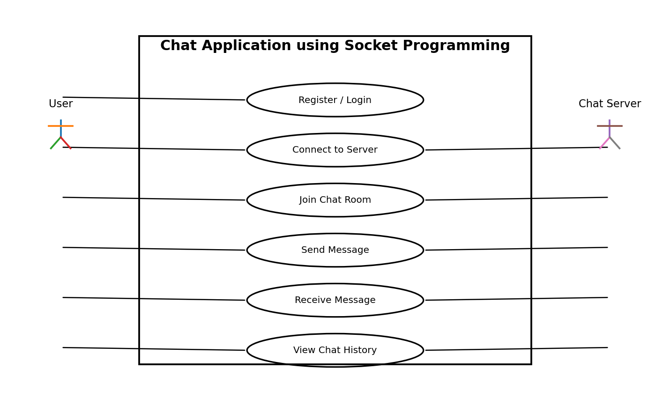

7.2 UML Use-Case Diagram 2 – Administration and Server Operations
The following UML-style use-case diagram represents administration and server-management interactions.
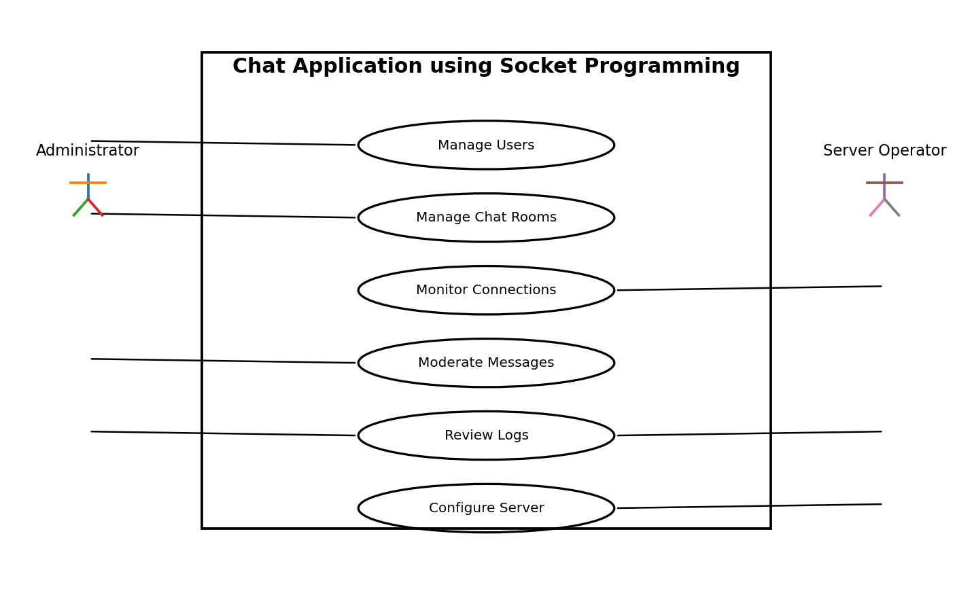

8. Requirements Traceability Matrix (RTM)
Status: N = Not implemented/not tested, P = Partially implemented/tested, A = Accepted. Initial SRS status is N.
Req ID | Requirement short | Section ref / Design Spec | Module | Test case(s) | Status (N/P/A) | Comments
CHAT-F-001 | The system shall allow a new user to register wi | 4 / DS-AuthModule | AuthModule | Valid registration succeeds and duplicates are rejected. TC-REG-01 | N
CHAT-F-002 | The system shall authenticate a registered user | 4 / DS-AuthModule | AuthModule | Valid credentials permit access; invalid credentials are rejected. TC-AUTH-01 | N
CHAT-F-003 | The system shall establish a socket connection b | 4 / DS-SocketModule | SocketModule | Client connects and receives confirmation. TC-CONN-01 | N
CHAT-F-004 | The system shall display connection status and p | 4 / DS-PresenceModule | PresenceModule | Status/user list updates after connection changes. TC-USER-01 | N
CHAT-F-005 | The system shall allow an authorized user to cre | 4 / DS-RoomModule | RoomModule | Valid room is created; duplicate name is rejected. TC-ROOM-01 | N
CHAT-F-006 | The system shall allow users to join and leave c | 4 / DS-RoomModule | RoomModule | Authorized membership changes succeed. TC-ROOM-02 | N
CHAT-F-007 | The system shall allow an authenticated user to | 4 / DS-MessageModule | MessageModule | Valid message reaches intended destination. TC-MSG-01 | N
CHAT-F-008 | The system shall deliver valid messages to conne | 4 / DS-MessageRouter | MessageRouter | Recipients receive messages in order. TC-MSG-02 | N
CHAT-F-009 | The system shall reject messages exceeding the c | 4 / DS-ValidationModule | ValidationModule | Malformed/oversized input is rejected safely. TC-MSG-03 | N
CHAT-F-010 | The system shall display an appropriate status w | 4 / DS-DeliveryModule | DeliveryModule | Unavailable recipient produces defined status. TC-MSG-04 | N
CHAT-F-011 | The system shall store chat messages when persis | 4 / DS-HistoryModule | HistoryModule | Stored messages can be retrieved for permitted conversations. TC-HIST-01 | N
CHAT-F-012 | The system shall allow authorized users to retri | 4 / DS-HistoryModule | HistoryModule | Authorized history is shown chronologically. TC-HIST-02 | N
CHAT-F-013 | The system shall notify applicable room members | 4 / DS-NotificationModule | NotificationModule | Join/leave event is displayed. TC-NOTIF-01 | N
CHAT-F-014 | The system shall gracefully handle unexpected cl | 4 / DS-ConnectionManager | ConnectionManager | Disconnected client is removed without crashing the server. TC-DISC-01 | N
CHAT-F-015 | The system shall allow an administrator to activ | 4 / DS-AdminModule | AdminModule | Restricted account cannot authenticate. TC-ADMIN-01 | N
CHAT-F-016 | The system shall allow administrators to create, | 4 / DS-AdminModule | AdminModule | Authorized room management succeeds. TC-ADMIN-02 | N
CHAT-F-017 | The system shall provide server logs for connect | 4 / DS-LoggingModule | LoggingModule | Required events are logged and passwords absent. TC-LOG-01 | N
CHAT-F-018 | The system shall allow an authenticated user to | 4 / DS-SessionModule | SessionModule | Session invalidates and socket closes cleanly. TC-LOGOUT-01 | N
CHAT-NF-001 | For the defined test network, 90% of valid messa | 5 / DS-NFR-001 | PerformanceModule | 90th percentile delivery latency <= 1s. TC-PERF-01 | N
CHAT-NF-002 | The server shall support at least 50 simultaneou | 5 / DS-NFR-002 | ScalabilityModule | 50 clients connect and exchange messages successfully. TC-LOAD-01 | N
CHAT-NF-003 | The server shall recover from an individual clie | 5 / DS-NFR-003 | ReliabilityModule | Other sessions remain active after forced disconnect. TC-REL-01 | N
CHAT-NF-004 | The client interface shall provide clear connect | 5 / DS-NFR-004 | UsabilityModule | Representative users complete core workflow. TC-UX-01 | N
CHAT-NF-005 | Production communications shall use approved enc | 5 / DS-NFR-005 | Security/PrivacyModule | Security review confirms encryption and no plaintext secrets. TC-SEC-01 | N
CHAT-NF-006 | The system shall maintain message and user data | 5 / DS-NFR-006 | Data IntegrityModule | Integrity tests find no malformed/orphan records. TC-DATA-01 | N
CHAT-NF-007 | The system shall be modular so socket handling, | 5 / DS-NFR-007 | MaintainabilityModule | Code review confirms modular separation. TC-MAINT-01 | N
CHAT-SR-001 | The system shall use an encrypted transport such | 5.1 / DS-SEC-001 | SecurityModule | Security configuration confirms encrypted transport. TC-SEC-02 | N
CHAT-SR-002 | The system shall store passwords only as salted | 5.1 / DS-SEC-002 | SecurityModule | Database/log review finds no plaintext passwords. TC-SEC-03 | N
CHAT-SR-003 | The system shall enforce role-based authorizatio | 5.1 / DS-SEC-003 | SecurityModule | Unauthorized actions are rejected. TC-SEC-04 | N
CHAT-SR-004 | The system shall validate message types, lengths | 5.1 / DS-SEC-004 | SecurityModule | Malformed/oversized payloads are rejected safely. TC-SEC-05 | N
CHAT-SR-005 | The system shall protect audit/server logs from | 5.1 / DS-SEC-005 | SecurityModule | Users cannot alter protected logs. TC-SEC-06 | N
CHAT-SR-006 | The system shall expire or invalidate inactive a | 5.1 / DS-SEC-006 | SecurityModule | Inactive session is rejected after timeout. TC-SEC-07 | N

Appendix A – Suggested Database Entities
Entity | Purpose | Key fields (illustrative)
User | Account and role information | UserID, Username, PasswordHash, Role, Status, CreatedAt
ChatRoom | Logical chat group | RoomID, RoomName, CreatedBy, Status
RoomMember | Room membership | RoomID, UserID, JoinedAt, Status
Message | Persisted message | MessageID, SenderID, RoomID/RecipientID, Content, Timestamp
Session | Active client session | SessionID, UserID, SocketID, ConnectedAt, DisconnectedAt
AuditLog | Security/administrative events | AuditID, UserID, Action, Entity, Timestamp

Appendix B – Suggested Socket Message Format
The application-level message format may contain message type, sender/session identifier, recipient or room identifier, timestamp or sequence information where needed, and message content. The team shall document the exact serialization format used by the implementation.

Appendix C – Assumptions
- Users have network connectivity to the configured server.
- Server address and port are configurable.
- Baseline communication is text-based.
- The institution defines any required retention/moderation policy.
- Test/demo data is used during development.
- Message persistence is implemented only if included in the selected project scope.

