Software Architecture and Design Specification

Project: Chat Application using Socket Programming
Authors: Sriya Yashita Chandu; Abhishek B Khanapur; Thai Rishi Saran Datta; Sukriti Deep Date: 06-10-2026

Revision History
Version | Date | Author | Change Summary

Approvals
Role | Name | Signature/Date

Introduction
  - Purpose
This document describes how the chat application is built: the main parts of the system, how they talk to each other, the technology we are using and the risks we have planned for. It is based on the requirements in our SRS. Coding has not started yet, so this is the design the implementation will follow. If the code ever needs to differ, we update this document first.
  - Scope
It covers both the desktop client and the central server: signing up and logging in, secure connections, seeing who is online, chat rooms, sending and receiving messages in real time, rejecting bad input, saving chat history, join and leave notifications, dealing with clients that drop off unexpectedly, admin tools, logging and session handling. Voice and video calls, payments and social features are out of scope.
  - Audience
Mainly the developers building the client and server, and the testers writing test cases against it. It is also meant for our project guide, the course coordinator, anyone checking that the design covers the requirements, and whoever ends up running the server.
  - Definitions
Terms already defined in the SRS (socket, client, server, chat room, session, TCP, FR, NFR, RTM, RBAC) mean the same thing here. A few extra terms used in this document:

Term | Definition
ADR | Architecture Decision Record: a short write-up of a design decision, what we considered and why we chose it.

Term | Definition
Component | A self-contained part of the system with one clear job.
Frame | One message as it travels over the network: a 4-byte length followed by a JSON body.
Outbound queue | Each connection’s own line of messages waiting to be sent to that client.
Session token | A random value the server hands out after login to recognise that user’s connection.
TLS | Transport Layer Security; encrypts the connection between client and server.
Certificate pinning | The client only trusts the exact server certificate it was shipped with, so nobody can sit in the middle with a fake one.
scrypt | A slow-by-design password hashing function built into Python, used with a random salt for each user.
WAL | A SQLite mode that lets the database be read while something is being written.
STRIDE | A checklist of threat types: spoofing, tampering, repudiation, information disclosure, denial of service and elevation of privilege.
PlantUML | The tool we used to draw the diagrams.

Document Overview
  - How to use this document
The architecture part explains what the system is made of and why we chose this structure. The design part goes a level deeper into the messages the client and server exchange and how a request moves through the system. Requirement IDs such as CHAT-F-001 come straight from the SRS, and the traceability table shows where each one is handled and which test checks it.
  - Related Documents

Document | Version / Date | Relevance
Software Requirements Specification (SRS) | v1.0, 04-09-2026 | Where all the requirements come from
Software Test Plan (STP) | v1.0, 28-09-2026 | Test case IDs used in the traceability table
Requirements Traceability Matrix (RTM) | Part of the SRS | Original requirement-to-module mapping
Source repository | To be linked | Code layout follows the module layout in this document

Architecture

Goals & Constraints
Each goal comes from a measurable requirement in the SRS, so we can actually test whether we hit it.

Goal | Target | Source
Low-latency delivery | 90% of valid messages delivered to connected recipients within 1 s under normal load | CHAT-NF-001
Concurrency | At least 50 simultaneous authenticated clients without critical failure | CHAT-NF-002
Fault isolation | One client’s disconnect or error never terminates other sessions | CHAT-NF-003, CHAT-F-014
Confidentiality | All client–server traffic encrypted; no plaintext passwords stored or logged | CHAT-NF-005, SR-001, SR-002
Robust input handling | Malformed or oversized input rejected without affecting the server | CHAT-F-009, CHAT-SR-004
Data integrity | No malformed or orphan records in persistent storage | CHAT-NF-006
Maintainability | Socket handling, authentication, routing, persistence and UI independently maintainable | CHAT-NF-007

Constraints
- Communication runs over TCP sockets, with TLS on top for encryption.
- Server host, port, message size and room limits must be configurable.
- Everything is written in Python 3.11 or later and runs on Windows, Linux or macOS.
- Chat history is saved, so storage and data integrity are part of the design.
- There is one central server with no clustering; we accept this as a known limitation.
- No paid services or extra infrastructure; we stick to Python’s standard library wherever we can.

Stakeholders & Concerns

Stakeholder | Primary concerns | Addressed by
User | Fast, reliable delivery; privacy of messages and credentials; clear connection status | Message Router, TLS transport, Client UI status bar
Administrator | Ability to restrict users and manage rooms; visibility of abuse | Admin Service, Audit Logger
Server Operator | Server stays up when clients misbehave; configurable deployment; usable logs | Connection Manager isolation, config file, rotated logs
Development team | Clear module boundaries, testable units, simple dependencies | Layered structure and a clear module layout
Testers | Every requirement verifiable and traceable | Traceability table and clear error codes
Project guide / evaluators | Consistency with SRS and STP; justified decisions | Documented design decisions and traceability

Component (UML) Diagram
The server is split into four layers. A request comes in through the transport layer, gets checked by the protocol layer, is handled by one of the services, and anything that needs

saving goes through the persistence layer. Replies and notifications go back out through each client’s own outgoing queue, and anything security-related is written to the audit log.
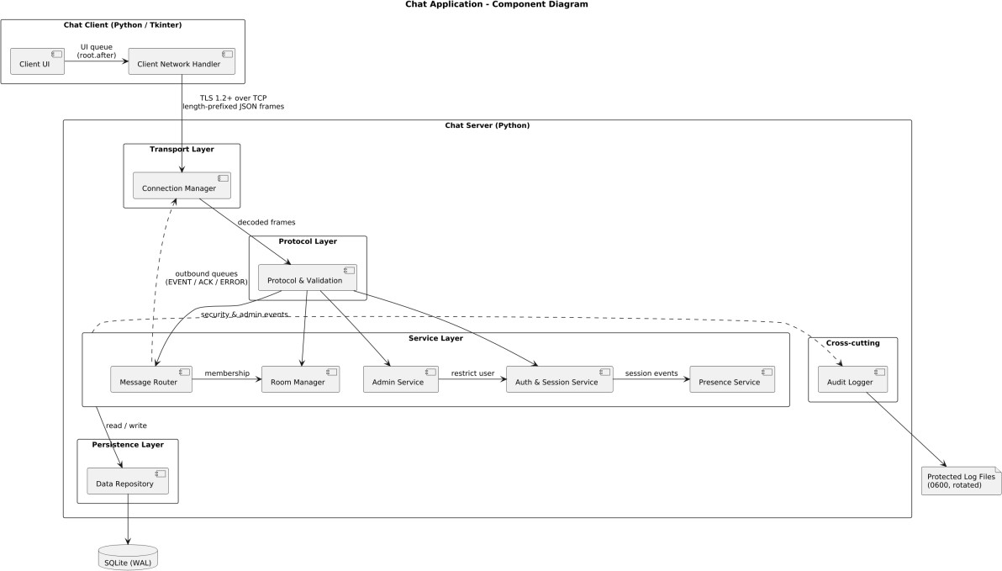
Figure 1. Component diagram of the chat client and server

Component Descriptions
Component | Layer | Responsibility | Req.
Client UI | Client | The Tkinter windows the user sees: sign-up and login, room list, who is online, the chat itself, history and a status bar. It only updates from the main thread and picks up network events from a queue every 50 ms. Your own messages look different from everyone else’s. | F-004, NF-004
Client Network Handler | Client | Opens the encrypted connection, checks it is talking to the real server, packs and unpacks messages, listens in the background, sends a heartbeat every 30 s and tells the UI if the connection drops. | F-003, F-018, SR-001
Connection Manager | Transport | Accepts new connections and limits how many can be open at once. Each client gets one thread reading from it and one writing to it, plus its own outgoing queue. When a client disconnects or errors out, it cleans up that client only, without touching anyone else. | F-003, F-014, NF-002, NF-003
Protocol & Validation | Protocol | Reads each message’s length first and throws away anything too big before reading the rest. Checks the JSON, the message type and every field. Before login it only allows register, login and ping. Valid requests are passed to the right service. | F-009, SR-004
Auth & Session Service | Service | Handles sign-up (unique usernames, hashed passwords), login, blocked accounts, session tokens and logout. A background thread closes sessions that have been idle too long. | F-001, F-002,  F-015, F-018, SR-002, SR-006
Presence Service | Service | Keeps track of who is online and lets everyone know when someone logs in, logs out or drops off. | F-004

Component | Layer | Responsibility | Req.
Room Manager | Service | Creates rooms with unique names, handles joining and leaving, checks permissions and announces when people come and go. | F-005, F-006, F-013
Message Router | Service | Makes sure the sender is allowed to post, timestamps the message, sends it off to be saved, delivers it to everyone who should get it and tells the sender whether it went through. Also serves chat history. | F-007, F-008, F-010, F-012
Admin Service | Service | Admin-only actions: activating, deactivating or restricting users (and kicking them off if they are online), and creating, renaming, restricting or removing rooms. Every action checks the user really is an admin. | F-015, F-016, SR-003
Data Repository | Persistenc e | The only part of the system that touches the database. All writes go through one thread to avoid conflicts, every query is parameterised, and foreign keys are enforced. | F-011, F-012, NF-006
Audit Logger | Cross-cutting | Records logins, admin actions, errors and other important events with who, when and what happened. Passwords and tokens are stripped out before anything is written, and only the server can write to the log files. | F-017, SR-002, SR-005
SQLite database | Data store | Stores users, rooms, room members, messages, sessions and the audit trail. | F-011, NF-006

The SRS lists a few module names (such as MessageModule, DeliveryModule and NotificationModule) that we have merged into the components above. The traceability table shows which is which.

Chosen Architecture Pattern and Rationale

Decision record: client–server, with a layered server and one thread pair per connection
Status: Accepted
Context. We need one central place to handle logins, message routing, moderation and logging. The system also has to handle at least 50 users at once, deliver messages within a second, keep one client’s crash from affecting anyone else, and stay easy to maintain as separate pieces. We are building it in Python from scratch.

Decision.
- Overall style: client–server. Every client connects to one central server, which holds all the state and enforces the security rules.
- Server structure: four layers: transport (connections), protocol (reading and checking messages), services (login, presence, rooms, routing, admin) and persistence (the database). Each layer only talks to the one directly below it.
- Handling many users: each connection gets one thread for reading and one for writing, with its own outgoing queue, and there is a cap on total connections (100 by default).

Alternatives considered.

Alternative | Reason rejected
Peer-to-peer messaging | No central place for logins, moderation or logging, which the SRS needs.
One shared lock for sending instead of a writer per client | One slow client would hold up messages for everyone.
asyncio event loop | More than we need for 50 users, and the database, password hashing and Tkinter all block, so we would be working around asyncio constantly.
Microservices | Far too much setup and overhead for a single-server project.

Consequences.
- Each layer can be tested on its own by faking the layer below it.
- Because only one thread writes to each connection, messages never get mixed together, and each sender’s messages stay in order.
- Threads grow with the number of users (about 100 at 50 users), which is fine for this kind of work, and the connection cap stops it getting out of hand.
- If the one server goes down, chat goes down. For a project of this size we accept that.

Supporting decisions.

Concern | Decision | Rationale
Message framing | 4-byte big-endian length prefix + UTF-8 JSON body; max frame 8 KB | TCP is just a stream of bytes, so we need to mark where each message ends. Reading the length first lets us reject oversized messages before reading them.
Database | SQLite in WAL mode; single writer thread | It is relational as the SRS asks, needs no separate database server, and one writer avoids locking problems.
Persistence timing | Forward first, write asynchronously | Saving to disk never slows down delivery.
Password storage | hashlib.scrypt, 16-byte random salt per user | A strong one-way hash that comes with Python, so no extra library.
Transport security | TLS 1.2+, self-signed server certificate pinned in client | Encrypts all traffic. Pinning matters because a self-signed certificate on its own would not stop someone intercepting the connection.
Client threading | Network thread passes events to UI through a queue | Tkinter crashes if you update it from another thread.

Technology Stack & Data Stores
Concern | Technology | Notes
Language / runtime | Python 3.11+ | Same runtime for client and server
Networking | socket, ssl, struct | TLS 1.2 minimum; length-prefix framing
Concurrency | threading, queue | Reader/writer thread per connection; DB writer thread; session sweeper
Serialisation | json | UTF-8 JSON message bodies

Concern | Technology | Notes
Security | hashlib.scrypt, hmac.compare_digest, secrets | Password hashing, constant-time comparison, session tokens
Persistence | sqlite3 (SQLite, WAL mode) | Parameterised queries only; foreign keys ON
Logging | logging, RotatingFileHandler | Redaction filter; 0600 file permissions
Client UI | tkinter | Bundled with Python
Testing | pytest | Only third-party dependency
Diagrams | PlantUML | Sources kept in the repository docs folder

Apart from pytest, everything comes from Python’s standard library, so there is nothing extra to install and fewer outside dependencies to worry about.

Data store (SQLite)

Table | Key fields | Integrity rules
User | UserID (PK), Username (UNIQUE), PasswordHash, Salt, Role, Status, CreatedAt | Role ∈ {USER, ADMIN}; Status ∈  {ACTIVE, RESTRICTED, DEACTIVATED}
ChatRoom | RoomID (PK), RoomName (UNIQUE), CreatedBy (FK User), Status | Status ∈ {OPEN, RESTRICTED, REMOVED}
RoomMember | RoomID (FK), UserID (FK), JoinedAt, Status | Composite PK (RoomID, UserID)
Message | MessageID (PK), SenderID (FK), RoomID (FK, nullable), RecipientID (FK, nullable), Content, SenderSeq, Timestamp | Exactly one of RoomID / RecipientID set; Content length ≤ max_text_chars
Session | SessionID (PK), UserID (FK), TokenHash, ConnectedAt, LastActivity, DisconnectedAt | Only a hash of the token is stored
AuditLog | AuditID (PK), UserID (FK, nullable), Action, Entity, Outcome, Timestamp | Insert-only from the server; no update/delete path

Configuration settings

Setting | Default | What it controls
host / port | 0.0.0.0 / 5050 | Where the server listens
max_frame_bytes | 8192 | Largest message the server will accept
max_text_chars | 2000 | Longest chat message text
max_connections | 100 | How many clients can be connected at once
max_rooms | 50 | How many rooms can exist
idle_timeout_seconds | 900 | How long before an idle session is closed
heartbeat_seconds | 30 | How often client and server check the connection is alive
tls_cert_path / tls_key_path | certs/server.crt, certs/server.key | Server certificate and private key
db_path / log_path | data/chat.db, logs/server.log | Where the database and logs are stored

Risks & Mitigations
ID | Risk | Impact | Mitigation | Req.
R1 | Slow or stalled recipient blocks fan-out | Latency target missed for all users | Per-client outbound queue and writer thread; client dropped if its queue exceeds a bound | NF-001
R2 | Thread exhaustion under many connections | Server stops accepting clients | max_connections cap; excess connections get ERROR SERVER_BUSY and are closed | NF-002
R3 | Partial reads on the TCP stream corrupt framing | Garbled or merged messages, crashes | recv_exact() reads exactly N bytes; malformed-frame and fuzz tests in the unit suite | F-009, SR-004
R4 | Crashed clients leave ghost sessions | Wrong presence list, leaked resources | PING/PONG heartbeat, socket timeouts, idle-session sweeper | F-014, SR-006
R5 | Database writes or locking delay delivery | Latency target missed | Forward-then-persist; single DB writer thread; WAL mode | NF-001, NF-006
R6 | Passwords or tokens appear in logs | Credential exposure | Redaction filter on all handlers; TC-LOG-01 and TC-SEC-03 inspect logs | SR-002, F-017
R7 | Self-signed certificate accepted without verification | Traffic can be intercepted | Client pins the server certificate and refuses any other | SR-001
R8 | Tkinter updated from the network thread | Random client crashes | All UI updates go through a queue drained on the Tk main thread | NF-004
R9 | Login errors reveal whether a username exists | Account enumeration | Same AUTH_FAILED code for wrong password and restricted account; reason logged only | SR-003, F-015
R10 | Single central server | Server outage stops all chat | Accepted for a project of this size; the server restarts quickly and picks up its data from the database | NF-003
R11 | Implementation not yet started | Schedule pressure on high-priority features | Build in the order of the sequence diagrams: connecting and logging in first, then messaging, then rooms, history and admin | High-priority FRs

Traceability to Requirements
This table links every requirement in the SRS to the part of the system that handles it and the test that checks it. We have kept the module name the SRS uses alongside ours so the two documents line up.

Req ID | Requirement | SRS module name | Handled by | Test case
CHAT-F-001 | User registration | AuthModule | Auth & Session Service; Data Repository | TC-REG-01
CHAT-F-002 | Authentication | AuthModule | Auth & Session Service; Protocol & Validation | TC-AUTH-01
CHAT-F-003 | Socket connection | SocketModule | Connection Manager; Client Network Handler | TC-CONN-01
CHAT-F-004 | Status / online users | PresenceModule | Presence Service; Client UI | TC-USER-01
CHAT-F-005 | Create room | RoomModule | Room Manager | TC-ROOM-01

Req ID | Requirement | SRS module name | Handled by | Test case
CHAT-F-006 | Join / leave room | RoomModule | Room Manager | TC-ROOM-02
CHAT-F-007 | Send message | MessageModule | Message Router | TC-MSG-01
CHAT-F-008 | Ordered delivery | MessageRouter | Message Router; Connection Manager | TC-MSG-02
CHAT-F-009 | Reject invalid / oversized | ValidationModule | Protocol & Validation | TC-MSG-03
CHAT-F-010 | Unavailable recipient | DeliveryModule | Message Router | TC-MSG-04
CHAT-F-011 | Store messages | HistoryModule | Data Repository | TC-HIST-01
CHAT-F-012 | Retrieve history | HistoryModule | Message Router; Data Repository | TC-HIST-02
CHAT-F-013 | Join / leave notifications | NotificationModule | Room Manager | TC-NOTIF-01
CHAT-F-014 | Unexpected disconnection | ConnectionManager | Connection Manager; Auth & Session Service | TC-DISC-01
CHAT-F-015 | Admin account control | AdminModule | Admin Service; Auth & Session Service | TC-ADMIN-01
CHAT-F-016 | Admin room management | AdminModule | Admin Service; Room Manager | TC-ADMIN-02
CHAT-F-017 | Protected logging | LoggingModule | Audit Logger | TC-LOG-01
CHAT-F-018 | Logout | SessionModule | Auth & Session Service; Connection Manager | TC-LOGOUT-01
CHAT-NF-001 | Latency ≤ 1 s (p90) | PerformanceModule* | Decision: outbound queues, async persistence | TC-PERF-01
CHAT-NF-002 | 50 concurrent clients | ScalabilityModule* | Decision: thread-per-connection + cap | TC-LOAD-01
CHAT-NF-003 | Failure isolation | ReliabilityModule* | Connection Manager | TC-REL-01
CHAT-NF-004 | Usability | UsabilityModule* | Client UI | TC-UX-01
CHAT-NF-005 | Encryption, no plaintext secrets | Security/PrivacyMod ule* | Connection Manager; Auth & Session; Audit Logger | TC-SEC-01
CHAT-NF-006 | Data integrity | Data IntegrityModule* | Data Repository | TC-DATA-01
CHAT-NF-007 | Modularity | MaintainabilityModul e* | Decision: layered architecture | TC-MAINT-01
CHAT-SR-001 | Encrypted transport | SecurityModule | Connection Manager; Client Network Handler | TC-SEC-02
CHAT-SR-002 | Salted password hashes | SecurityModule | Auth & Session Service; Audit Logger | TC-SEC-03
CHAT-SR-003 | Role-based authorisation | SecurityModule | Admin Service; Room Manager; Message Router | TC-SEC-04
CHAT-SR-004 | Input validation | SecurityModule | Protocol & Validation | TC-SEC-05
CHAT-SR-005 | Protected audit logs | SecurityModule | Audit Logger | TC-SEC-06
CHAT-SR-006 | Session expiry | SecurityModule | Auth & Session Service | TC-SEC-07

* These are quality requirements rather than pieces of code, so they are met by design choices (such as the per-client queues and the thread model) instead of a single component.

Security Architecture

Security Objectives
The security architecture protects the confidentiality, integrity and availability of the chat application. Security controls are implemented across the client, network, server services and persistence layers.
The main security objectives are:
      - Protect client-server communication from interception.
      - Protect user passwords from disclosure.
      - Prevent unauthorized access to rooms, messages and administrative functions.
      - Reject malformed or oversized client input.
      - Protect security and audit logs from unauthorized modification.
      - Prevent the reuse of expired or invalid sessions.
      - Prevent one malicious or faulty client from affecting other active sessions.

Threat Model
The system uses a STRIDE-based threat model to identify threats at the client, transport, service and persistence layers. The main assets are user credentials, session tokens, chat messages, account and room information, and audit records.

Asset / Area Threat Required Protection

Authentication Credential theft or account impersonation

Network communication Interception or modification
of traffic
Chat messages Unauthorized access or malformed input

Administration Unauthorized privileged actions
Logs Exposure or modification of security records
Password hashing, authentication checks and session security
TLS and server certificate verification/pinning
Session validation, authorization and input validation
Role-based authorization

Redaction and protected server-side logging

Sessions Reuse of stale or invalid sessions
Session tokens, timeout and invalidation

STRIDE Analysis
Threat Potential Attack Security Control

Spoofing Attacker attempts to impersonate a user or server.
Tampering Attacker attempts to modify messages during transmission.
Repudiation A user denies performing a security or administrative action.
Information Disclosure Credentials, session
information or chat messages are exposed.
Denial of Service Malformed/oversized input or excessive connections affect the server.
Elevation of Privilege A normal user attempts
administrative operations.
User authentication, session tokens, TLS and certificate pinning
TLS-protected communication and server-side validation
Protected audit logging with user, action, outcome and timestamp
TLS encryption, password hashing and log redaction

Input limits, validation and maximum connection limits

RBAC and server-side authorization checks

Authentication
Authentication is performed by the server. Before successful authentication, an unauthenticated connection is permitted to perform only REGISTER, LOGIN and PING operations. After successful login, the server creates an authenticated session and provides a session token to the client.
User passwords are never stored in plaintext. The design uses hashlib.scrypt with a random 16-byte salt for each user. Password comparisons use hmac.compare_digest. Only a hash of the session token is stored in the database.

Authorization / RBAC
The server enforces Role-Based Access Control (RBAC). The two defined roles are USER and ADMIN. Normal users can perform permitted chat operations, while administrative operations are restricted to authenticated administrators.

Every administrative request is checked by the server before execution. Unauthorized protected operations return the FORBIDDEN error code.

Secure Communication
Each client communicates with the server over a TCP connection protected using TLS 1.2 or higher. The client verifies the configured server certificate using certificate pinning, preventing an unexpected certificate from being accepted. This protects credentials, session information and chat messages while in transit.

Input Validation
All client input passes through the Protocol & Validation component before reaching application services. The server validates the frame length, JSON format, message type, required fields, field values and message size.
The default maximum frame size is 8192 bytes and the maximum chat text length is 2000 characters. Malformed, invalid or oversized requests are safely rejected.

Protected Logging
The Audit Logger records important security and operational events such as login attempts, administrative actions and errors. Passwords and session tokens are removed before data is written to logs. Only the server can write to the log files, and audit records are insert-only.
Log files use a redaction filter and restricted file permissions. Security logs therefore provide traceability without exposing sensitive credentials or tokens.

Session Security
Authenticated sessions are invalidated when the user logs out, the configured idle timeout is reached, the connection is lost, a heartbeat fails, or an administrator restricts the account. The default idle timeout is 900 seconds and the heartbeat interval is 30 seconds.
The server returns SESSION_EXPIRED when a session token is missing, invalid or inactive beyond the configured timeout.

Design

Design Overview
The client and server talk over a single encrypted TCP connection per user. Every message is sent as a 4-byte length followed by a JSON body like the one below. The client numbers each request with seq, the server echoes that number back in its reply, and recipients use it to check that messages from each sender arrive in order.
{ "type": "MSG", "session": "<token>", "seq": 42, "payload": { "room": "general", "text": "hello" } }

Message types

Type | Direction | Payload fields | Req.
REGISTER | Client → Server | username, password | F-001
LOGIN | Client → Server | username, password | F-002
CREATE_ROOM | Client → Server | room | F-005
JOIN / LEAVE | Client → Server | room | F-006
MSG | Client → Server | room or to, text | F-007
HISTORY | Client → Server | room or with, before_ts, limit | F-012
ADMIN | Client → Server | action, target, args | F-015, F-016
LOGOUT | Client → Server | — | F-018
PING / PONG | Both | — | F-014, SR-006
ACK | Server → Client | ref_seq, status, data | —
ERROR | Server → Client | ref_seq, code, reason | F-009, F-010
EVENT | Server → Client | kind (msg | presence | join | leave | room), data | F-004, F-007, F-013

Error codes

Code | Meaning
INVALID_MESSAGE | Frame too large, not valid JSON, unknown type, or field fails validation
AUTH_FAILED | Wrong credentials or a blocked account (kept the same on purpose so usernames cannot be guessed)
SESSION_EXPIRED | Token missing, invalid or idle beyond timeout
FORBIDDEN | Authenticated but not authorised (not a room member, not an admin)
DUPLICATE | Username or room name already exists
NOT_FOUND | Room or user does not exist
SERVER_BUSY | Connection cap reached

Connection states

State | Allowed message types | Transition
UNAUTHENTICATED | REGISTER, LOGIN, PING | → AUTHENTICATED on successful LOGIN
AUTHENTICATED | All client types (ADMIN only for admin role) | → CLOSING on LOGOUT, idle timeout, heartbeat loss, socket error or admin restriction
CLOSING | None | Session invalidated, presence removed, socket closed → CLOSED

Module layout (repository)

Component | Package path
Connection Manager | server/transport/connection_manager.py
Protocol & Validation | server/protocol/framing.py, server/protocol/validator.py
Auth & Session Service | server/services/auth.py, server/services/sessions.py
Presence Service | server/services/presence.py

Component | Package path
Room Manager | server/services/rooms.py
Message Router | server/services/router.py
Admin Service | server/services/admin.py
Data Repository | server/persistence/repository.py, server/persistence/schema.sql
Audit Logger | server/audit/audit_logger.py
Client UI / Client Network Handler | client/ui/, client/net/
Tests / diagrams | tests/, docs/diagrams/

UML Sequence Diagrams

Sequence Diagram 1: User Login / Connection
The connection is set up and encrypted before the user logs in, but until login succeeds the server only accepts register, login and ping messages, so nothing else can happen on an unauthenticated connection. Whether the password is wrong or the account is blocked, the user sees the same “login failed” message, so nobody can use it to find out which usernames exist. The real reason only goes into the audit log, and passwords are never logged.
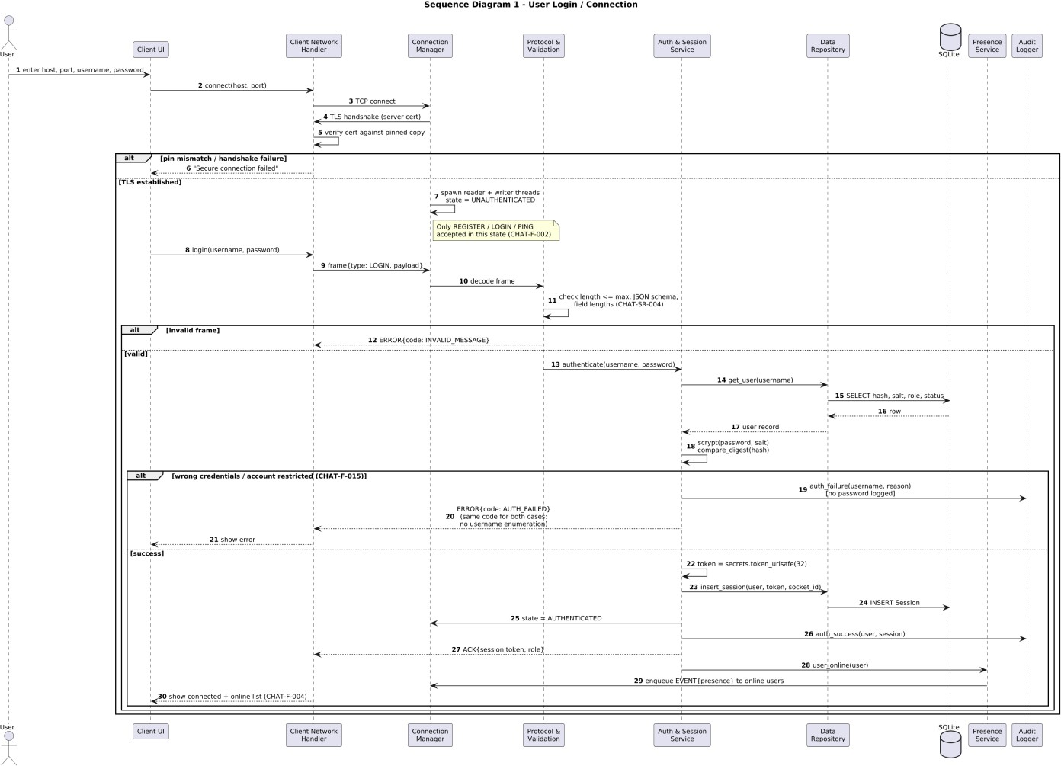

Sequence Diagram 2: Sending a Chat Message
Every message is checked first, then the session, then whether the sender is actually in the room. The message is saved in the background and sent straight away to everyone online in the room, so writing to the database never slows delivery down. Each connection has a single thread writing to it, so messages never get jumbled, and the receiving client checks that each sender’s messages arrive in order.
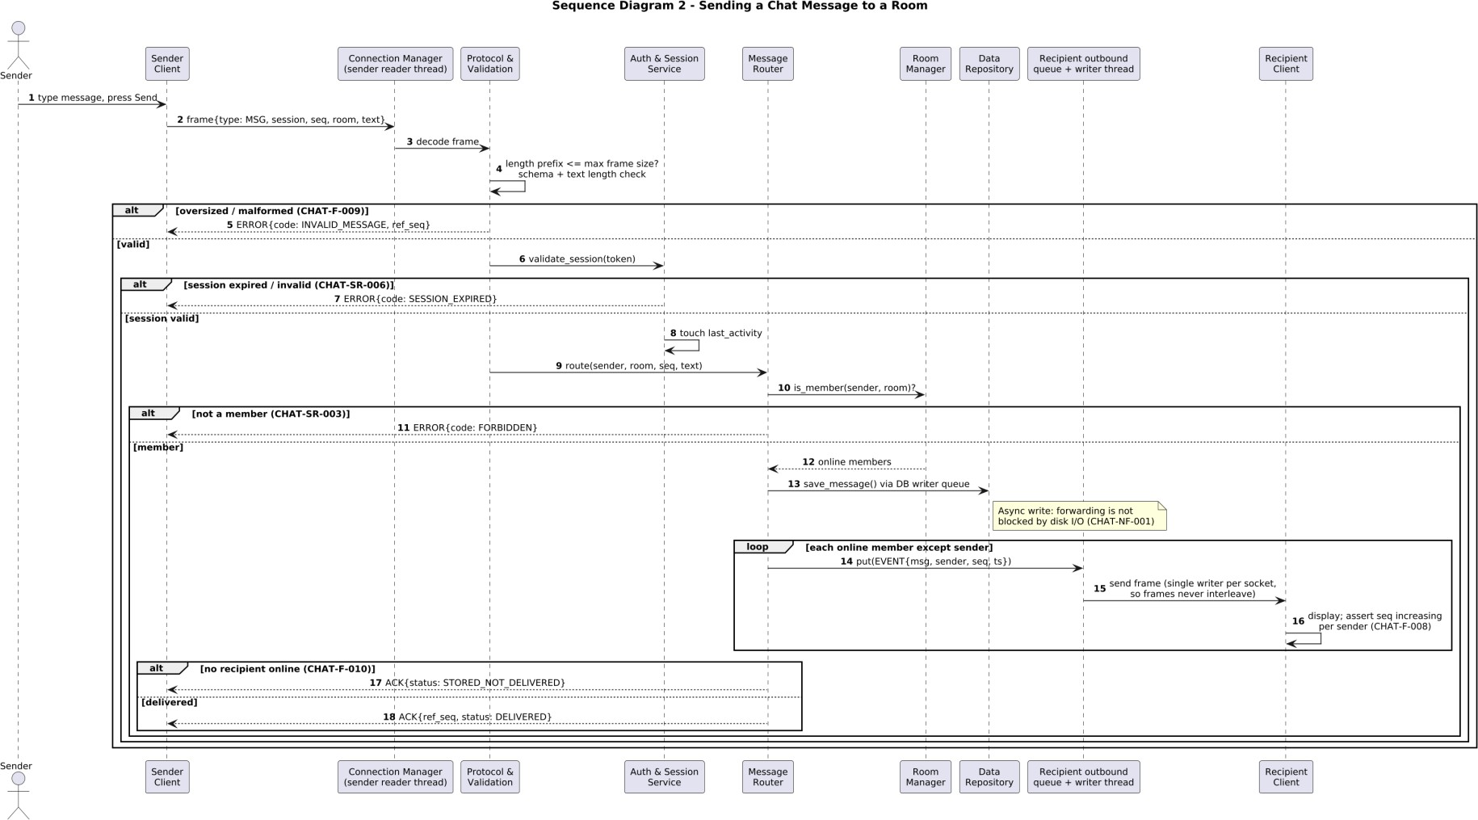

API Design
The chat application uses a socket-based client-server interface rather than a REST API. Messages are exchanged as UTF-8 JSON bodies preceded by a 4-byte length field. The following interfaces define the main communication between the client and server components.

Client-Server Communication Interface
Interface Direction Purpose Main Data

Client Network Handler ↔ Connection Manager
Bidirectional Establish, maintain and close the encrypted client connection.
TCP/TLS connection, framed JSON messages

Client ↔ Protocol & Validation Client → Server Send requests for validation and
processing.
Server → Client Server → Client Return results, errors and asynchronous events.
Message type, fields, session information, sequence number
ACK, ERROR, EVENT messages

Authentication Interface
Message Direction Request Fields Response / Result
REGISTER Client → Server username, password ACK or ERROR
LOGIN Client → Server username, password Authenticated session or AUTH_FAILED
LOGOUT Client → Server No payload Session invalidation and connection cleanup
PING / PONG Both No payload Connection/session liveness check
Authentication requests are processed by the Auth & Session Service. Passwords are handled only for authentication and are not written to logs. The server deliberately uses the same AUTH_FAILED response for incorrect credentials and blocked accounts to avoid exposing whether a username exists.

Message / Chat Interface
Message | Direction | Request Fields | Purpose
CREATE_ROOM | Client → Server | room | Create a unique chat room
JOIN / LEAVE | Client → Server | room | Join or leave a chat room
MSG | Client → Server | room or recipient, text, seq | Send a chat message
HISTORY | Client → Server | room or recipient, before_ts, limit | Retrieve permitted chat history
ADMIN | Client → Server | action, target, args | Perform an authorized administrative operation
ACK | Server → Client | ref_seq, status, data | Confirm request processing
ERROR | Server → Client | ref_seq, code, reason | Report a rejected request
EVENT | Server → Client | kind, data | Deliver message, presence, join, leave or room events
Every incoming message is validated before the corresponding service processes it. For chat messages, the server checks the session and the sender's room membership before routing the message.

Error Handling, Logging & Monitoring
The system uses standardized error codes so that clients receive predictable responses without exposing unnecessary internal information.

Error Code Meaning Handling

INVALID_MESSAGE Frame too large, invalid JSON, unknown type or invalid field.
Reject request safely before service processing.

AUTH_FAILED Incorrect credentials or blocked account. Use the same response to reduce username enumeration.
SESSION_EXPIRED Missing, invalid or expired session token. Reject request and require a new authenticated session.

FORBIDDEN Authenticated user is not authorized. Reject the protected operation.
DUPLICATE Username or room name already exists. Reject duplicate creation.
NOT_FOUND Requested room or user does not exist. Return standardized error.
SERVER_BUSY Connection limit has been reached. Reject the excess connection and close it.
Security-relevant events are recorded by the Audit Logger. Passwords and session tokens are redacted before logging. The log records who performed an action, when it occurred, what action was attempted and the outcome.
Monitoring focuses on connection failures, authentication failures, invalid requests, administrative actions, session expiry, server errors and connection capacity. Rotating logs are used so that operational logging remains manageable.

UX Design
The client uses a Tkinter desktop interface containing sign-up and login screens, a room list, online-user information, the chat area, chat history and a connection status bar.
- Authentication failures are shown using a generic login-failed message rather than revealing whether a username exists.
- Expired or invalid sessions are reported using a clear session-expired status and require the user to authenticate again.
- Unauthorized actions display a clear permission error without exposing server internals.
- Connection loss and server availability are reflected in the client status information.
- The chat interface visually distinguishes the user's own messages from messages received from other users.
- Network events are passed to the UI through a queue so that the Tkinter main thread remains responsible for UI updates.

Open Issues & Next Steps
The implementation has not yet started, so the main open issue is completing the design in the repository without deviating from the approved requirements.
- Implement connection establishment and authentication first.
- Implement message validation, routing and delivery next.

- Implement room management and chat history persistence.
- Implement administrative operations and protected audit logging.
- Add and execute the security test cases TC-SEC-01 through TC-SEC-07 from the Software Test Plan.
- Verify the 50-client scalability target and the message delivery latency requirement during testing.
- Document and update the SAD if implementation decisions differ from the current design.
The single-server architecture remains a known project limitation: if the central server goes down, chat service becomes unavailable. For the current project scope this is an accepted architectural constraint.

Appendices

Glossary

Term Definition
Socket A network endpoint used for client-server communication.
TCP Transmission Control Protocol used to provide reliable, ordered
communication.
TLS Transport Layer Security used to encrypt communication between client and server.
Certificate Pinning A mechanism where the client accepts only the configured server certificate.
Session Token A random value issued after successful login to identify an authenticated session.
RBAC Role-Based Access Control used to restrict operations according to user roles.

scrypt A password hashing function used with a unique random salt for each user.
STRIDE A threat-modeling framework covering spoofing, tampering, repudiation, information disclosure, denial of service and elevation of privilege.
Audit Log A protected record of important security and operational events.
Frame A network message consisting of a 4-byte length followed by a JSON body.

References
- Software Requirements Specification (SRS), Chat Application using Socket Programming, v1.0, 04-09-2026.
- Software Test Plan (STP), Chat Application using Socket Programming, v1.0, 28-09-2026.
- Requirements Traceability Matrix (RTM) associated with the SRS.
- IEEE 42010 – Architecture Description standard.
- OWASP security guidance.
- NIST SP 800-160 – Systems Security Engineering.

Tools

Tool / Technology Purpose
Python 3.11+ Implementation language and runtime for the client and server.
socket / ssl / struct TCP networking, TLS protection and message framing.
threading / queue Connection handling and communication between network and UI threads.
sqlite3 Persistent storage using SQLite and WAL mode.

hashlib.scrypt / hmac / secrets Password hashing, secure comparison and session-token generation.
logging / RotatingFileHandler Protected and rotating server/audit logs.
Tkinter Desktop client user interface.
pytest Automated testing.
PlantUML Architecture and UML sequence diagrams.

