Output:

1. Webcam Pic person 1.

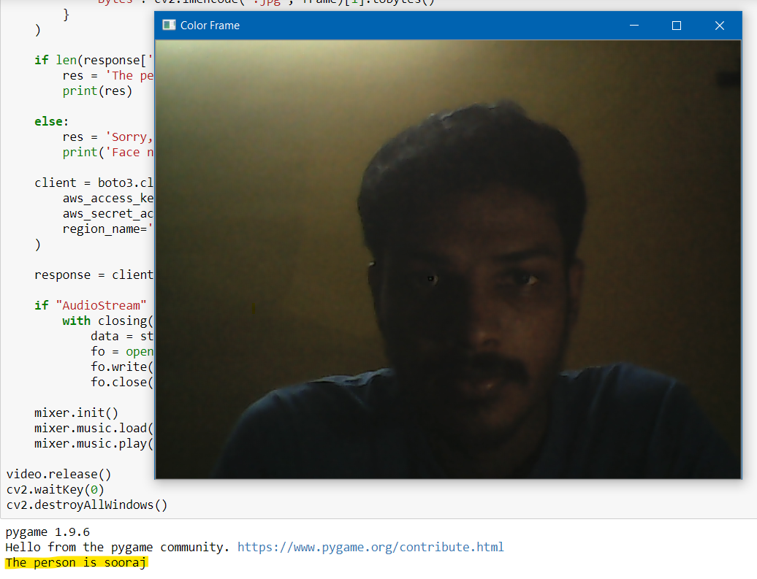

1. Webcam Pic person 2.

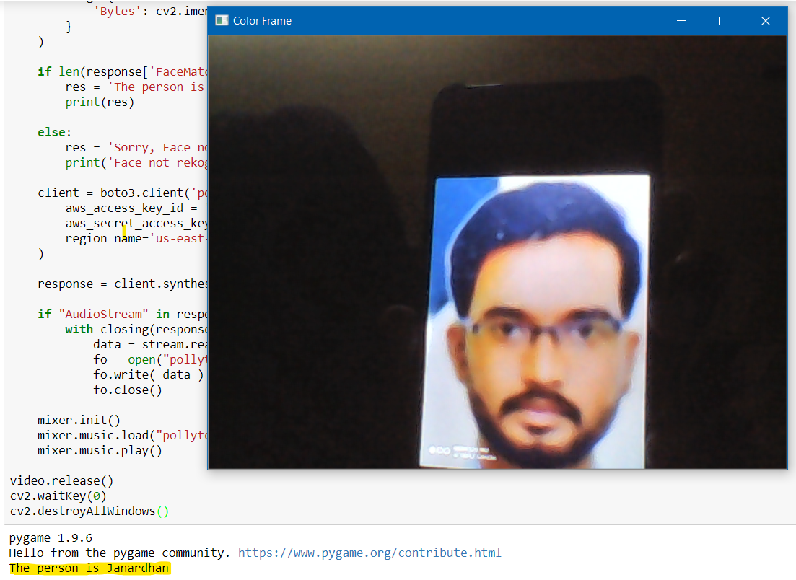

1. Webcam Pic person 3.

